PortSwigger Academy – OS Command Injection
- A web security vulnerability that allows an attacker to execute arbitrary OS commands on the server that is running the application. Will result in the full compromisation of the application and all of its data.
- Usually allows an attacker to compromise other parts of the hosting infrastructure by exploiting trust relationships between different systems.
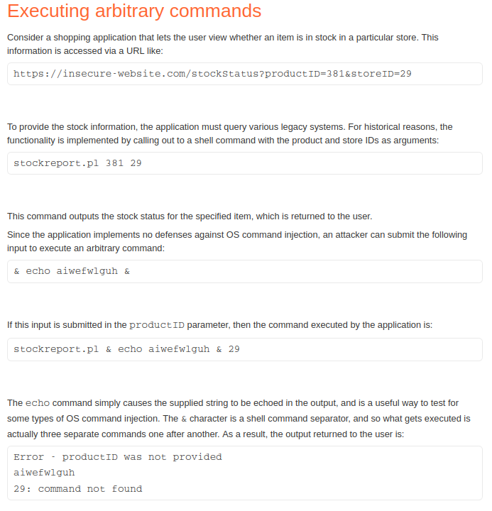
Executing arbitraty commands

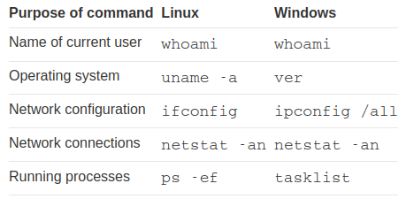

Blind OS command injection
- Blind OS command injection can be carried out through a range of different methods.
- Time delays can be created by using the ping command and specifying the number of ICMP packets to send. This equates to the time taken to run the command.
- Redirecting the output can be also be used. This involves redirecting the output to a file within the web root that you can then retrieve using your browser.
- OAST techniques allow you to interact with systems that you control. For example, you could perform the ‘nslookup‘ command onto a doman that you control. You could then monitor your domains network traffic and search for and packets related to the nslookup which shows the command has been carried out.

