PortSwigger Academy – XML External Entity (XXE) injection
- A vulnerability that allows an attacker to interfere with an application’s processing of XML data. It can allow an attacker to view files on the application server filesystem + interact with any back-end or external systems that the application itself can access.
- It can lead to server-side request forgery attacks (SSRF)
Exploiting XXE to retrieve files
- To perform an XXE injection that retrieves files you need to modify the submitted XML in two ways. Introduce (or edit) a DOCTYPE element that defines an external entity containing the path to the file. Edit a data value in the XML that is returned in the application’s response, to make use of the defined external entity.
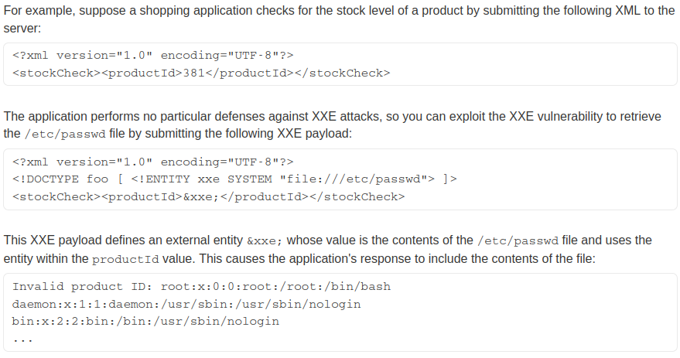
Exploiting XXE to perform SSRF attacks
- Aside from retrieving files/data, XXE attacks can be used to perform server-side request forgery (SSRF). This vulnerability involves making the server-side application make HTTP requests to any URL that the server can access.

Blind XXE Vulnerabilities
- Blind XXE is where the application is vulnerable to XXE injection but does not return the values of any defined external entities within its responses.
- The two ways to exploit blind XXE vulnerabilities are triggering out-of-band network interactions and triggering XML parsing errors in a way that the error messages contain sensitive data.
- You can detect blind XXE using the same technique as for XXE SSRF attacks, by triggering the out-of-band network to a system that you control.
- In some cases, XXE attacks using regular entities are blocked, due to some input validation by the application or some hardening of the XML parser being used. In this situation, you might be able to use XML parameter entities instead. XML parameter entities are a special kind of XML entity which can only be referenced elsewhere within the DTD (Document type definition).
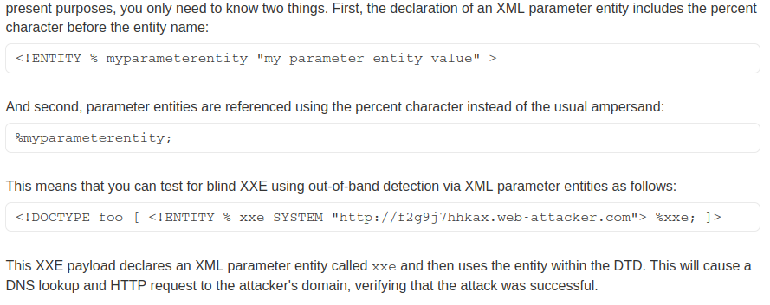
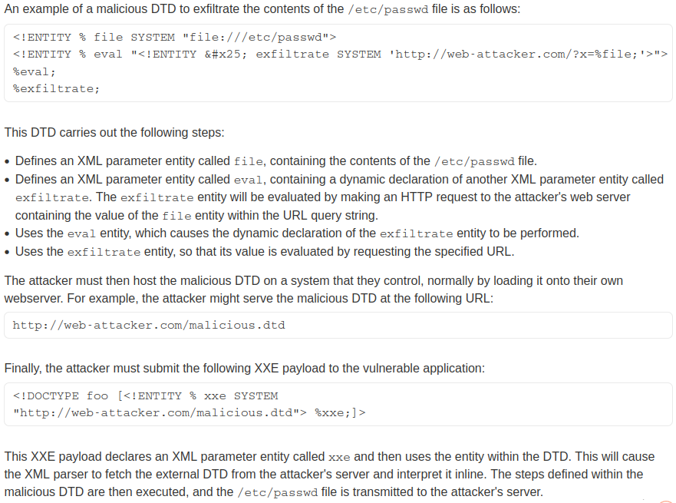
- Detecting a blind vulnerability via out-of-band techniques doesn’t demonstrate how the vulnerability could be exploited. An attacker wants to exfiltrate sensitive data which can be done by hosting a malicious DTD on a system that they control and then invoking the external DTD from within the in-band XXE payload.
- An alternative approach to exploiting blind XXE is to trigger an XML parsing error where the error message contains the error message contains the sensitive data that you wish to retrieve.
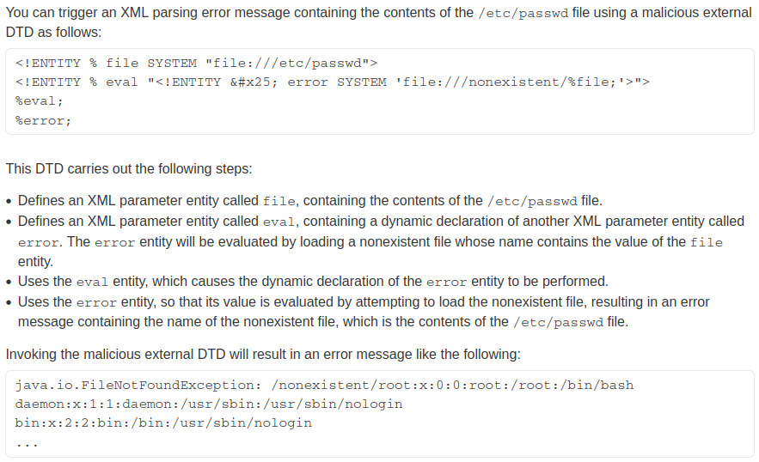
Finding hidden attack surface for XXE injection
- Attack surface for XXE injection is obvious in many cases because the application’s normal HTTP traffic includes requests that contain data in XML format. However, you can also find XXE attack surfaces in requests that don’t contain XML
- Some applications receive client-submitted data, embed it into an XML document on the server-side and then parse it. This means the attacker cannot control the entire XML document and so cannot define/modify a DOCTYPE element. However, you might be able to use XInclude instead. XInclude allows an XML document to be built from sub-documents.
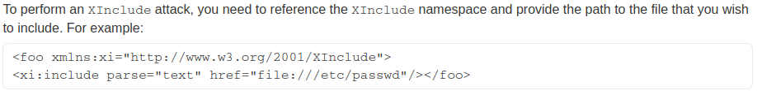
- Some applications allow users to upload files which are then processed server-side. Even if the application expects to receive a format such as PNG or JPEG, the image processing library being used might support SVG images. Since SVG files use XML, an attacker can submit a malicious SVG image and so reach the hidden attack surface.
- Most POST requests use a default content type that is generated by HTML forms. Some websites expect to receive requests in this format but will tolerate other content types, including XML.
