Week 1

Work on research raylib to see if I was interested in using it for project and started to think about the ins and out of my game with a mood board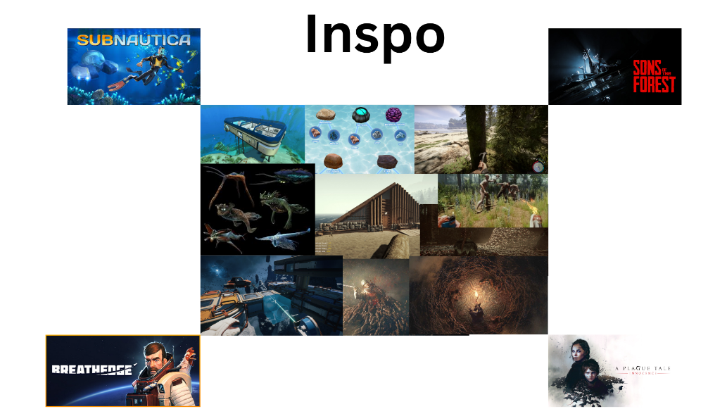

Week 2

Though more about my idea and decided to change it to a scifi shooter, where you can build your own ship, each part will change the functionality of you ship which you will fight with. Things like accelarition, rotation speed, types of weapons you use. This will then also allow for rnadomized unique enemy ships.

You can defeat and board other ships where it will turn into a hotline miama sort of game play and you can loot their ship. There will alos be a hanger/ base you will build customize. A collage of video game

Week 3 ( 31/10/2024)

This week worked on creating the editot for the ship, I have pieces clicking intogether. I also started to create assets by cutting up images of ships so I can have different parts for each ship

Week 4

November 5th:

Got started om the parts library class, this is a library of all the ship parts that can be created. The UI editor is going to copy from this library when creating pieces.

November 6th:

Work on part library and the beginning of the UI.

November 12th:

Got you Ui visually Set up for editor scene and how it would extract ship parts from the parts library. Which is a singleton class I made that constructs each ship part. UI still not functional, can flick through the different tabs but no contents

Week 5

November 12th :

Got the UI functions, has contents with user to grab from and construct a ship, and library is fully integrated with editor to allow this to happen.

November 13th

Added Doxygen and moved game class functionality into the individual editor scene class, stuff like the update, render and process events.

Novemeber 14th

Worked on getting the scene Manager working so you can easily switch between scenes. Getting circular include issues so I am trying to figure out how to get ti to work. Reason I am getting circular include issuers is because I want the scene Manager to have an instance of the current scene and I want the scene to have access to the scene manager so it is easier to switch to a new scene from within the scene

Novemeber 15th:

Got the scene manager to to work with inheritance, where the base class Scene holdes a variable of Scene, which is the derived class, which will also have a member variable of Scene which is the Scene manager so it can be changed within the scene. This need to be changed as it is over complicate.

Week 6:

November 16th:

Got Rid of messy inheritance I had for the scene manager and made it a seperate class, which holds a scene, which gets swapped out, indicated by Enums. Made a base UI class which can create text boxed for pieces of text and screen borders derived UI classes. Which will be different for each Scene. Started work on how I will transition from Editor to gameplay.

Week 7:

January 1st :

Did some work on UI Buttons for menu so I can switch between scenes from with in the game easier and be

January 2nd:

Worked on base building scene, got camera fully working so I can zoom in and out and move around the scene with the mouse

January 3rd:

Refactored movable camera into class. Cleaned up and easily reusable. Start work on creating rooms and jobs for npcs to to work at.

January 5th:

Made representation of in game world with grid, Have set up the selection box to select different tiles to place.

January 7th:

Added to loader, can now load an image and split it into cells, so the cells can be assigned a sub part of a texture. It cuts up a picture into rectangles of a desired size;

January 9th:

Fixed issue with loading an asset, started work on system where I can put pngs in a folder and depending on the name of the folder the assets will be loaded in and give a certain attribure. Right have all the assets in a folder loading in. need to make manager which will create a tile depending with relevant information.

January 14th

Got map creator working, any tile can be loaded in from folder with out specifying path, just place in folder and it will be created a tile relative to the folder it is placed in. started saving map to file so it can be reloaded

January 15th:

Got saving created map by user fully saved to file. Saves to text file and reloads map and is fully working. Having big bug with transferring between scenes