Rat (mouse)

עַכְבָּר = 70+20+2+200 = 292
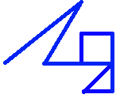
square tessellation hexagon tessellation 0 → 460 = (כֶּתֶם): fine gold
292 = 17×17+3; row 18 col 3 292 ⬡ 271+21 Layer 11
3×18 = 54 → 7+5+2 = 14 (זָהָב):gold [10][1001][10] ⬡ [10]71+21 Layer 11
3+18 = 21 ~ speed of light (1/c)^2 =
075 → 570 = (עֹשֶׁר): wealth 1.112⬡5005×[10]^−17
2→10; 1,8→1,1000→10,100 → 10,4 ~ note: 292 = (בֶּצֶר):gold ore
[1.0]54571817×10^-34 → reduced Planck constant (ℏ)

~ constants (1/c)^2: inverse of light speed^2 & ℏ: reduced Planck constant
~ variables: ω: angular frequency & m: mass
m=(ℏω)/c^2
ℏ×ω = E = mc^2 → ℏ/c^2 = m/ω
Remaining Values (given values):
292 = 17×17+3; row 18 col 3 & 3
ℏ/c^2 = (1.054571817×10^-34*1.11265005×10^−17) = 1.173369... ×10^-51
3,9 → 11,1001 → 10,101,1 → 10,5,1
2,2,1,8 → 10,10,1,1000 → 110,1001,0,0 → 6,9 & R: 0,0: place it appropriately, next to gold
1.173369...×10^-51 → 196 : gold
or 2,2,1 → 10,10,1 → 11,100 → 3,4
1.17336938491...×10^-51 → 196.9 : gold

μῦς = 40+400+200 = 640
square tessellation hexagon tessellation
640 = 25×25+15; row 26 col 15 640 ⬡ 631+9 Layer 16
26×15 = 390 → רִאשׁוֹן:first = 200+1+300+6+5 (一:1) & 90°:y=1 6.6...×10^-34 Planck constant (ℎ)
26+15 = 041 → "; like hypotenuse √(1^2+1^2) = 1.414) ~ note: 19⬡ = gold & p:6 g:11 = gold
431 → 390+431+41+1+1 = 864 = γωνία (angle) 1,9,6 →1,1001,110 →10,110,0 & R:11→(Γ = 3)
6,11,11 & 3 → 110,11,11,3 →1,2,1,7 & 3→ R:7,3
2,11 → 10,3 6.6260×10^-34 kg^1*m^2*s^-1
6.6260×[10]^−34 → ℎ Connect both A. Greek & Hebrew ⬡:
9,3 → 1001, 11 → 101,101 → 5,5 m=(ℎν)/c^2
1.0545×[10^−34] → ℏ : anglular relation ℎ×ν = E = mc^2 → ℎ/c^2 = m/ν
2,6,1,5 → 10,110,1,101 → 10,11,1,100,1 → 2,3,1,4,1 Remaining Values:
2*π = 2*3.1415926535 292 = 17×17+3; row 18 col 3 & 3
5,5,2,5,2,5,1,5 → 101,101,10,101,10,101,1,101 ℎ/c^2=(6.6260×10^-34*1.11265005×10^-17)
→ 101,1001,10,110,101,11,101 = 7.3724192313 ×10^-51 kg^1*s^1
2*π = 2*3.1415926535 1,1,1,3 → 111,11 → 7,1,1
ℎ = 2πℏ 3,9 → 11,1001 → 10,101,1 → 10,5,1
~ note: the units of both ℎ & ℏ are kg^1*m^2*s^-1 8,2,7,3 → 1000,10,111,11 →
→ from π ending: 535 → 15,15 → 1,10,1 & 1,10,1 100,1,1001,11,1 → 4,1,9,1,3
7.3724192313 ×10^-51 kg^1*s^1
~ convert known units: 1,2,1 → 10,11→2,3
7.3724192313 ×10^-51 kg^1*s^1

~ Chinese zodiac: 1: 一
The values are 1 Planck unit; the smallest unit possible

Endings (the given values):
ℏ/c^2 = (1.054571817×10^-34*1.11265005×10^−17) = 1.173369... ×10^-51
ℎ/c^2 = (6.6260×10^-34*1.11265005×10^-17) = 7.3724192313 ×10^-51
~ 234 = (זָהָב טָהוֹר):pure gold
~ note: all Hebrew words for gold used: 14+292+570+460+234 = 1570 = Χρυσός:gold (A. Greek)
ℎ/c^2 = (6.62607015×10^-34)*(1.11265005×10^-17) = 7.3724972837010075*10^-51
382 = 5+100+5+2+70+200 = Ἔρεβος:darkness (A. Greek) 70100 5 [2] 5
200: 2nd 7 in 00, 1 value
gold = 196.9 & 79

Endings (full value of light, (1/c)^2):
Reduced Planck constant/c^2:
ℏ/c^2 = ((1.054571817×10^-34)*(1/299792458)^2) = 1.1733693912976162...×10^-51
292 = 17×17+3; row 18 col 3 & 3
2,3,8 → 10,11,1000 → 10,101,1 → 10,5,1 & R: 0,0
= (1.054571817×10^-34)*(1.11265005605...×10^−17) = 1.1733693912976162...×10^-51
~ 196.96 = gold
~ 73 = (גָּמָל):camel → 1 sigma σ flag
~ 219 = (κάμηλον):camel → 1 sigma σ flag

~ note: using (1/299792458)^2 for light in the Hebrew version, Yahweh (יהוה‎) = 10+5+6+5 = 26
162 & 0056053618432 → 1500 = 500+800+200 = φῶς:light (A. Greek)
digit 8

Planck constant/c^2:
ℎ/c^2 = ((6.6260×10^-34)*(1/299792458)^2) = 7.3724192714112757...×10^-51
292 = 17×17+3; row 18 col 3 & 3
1,1,1,8,3 → 1,1,1,1000,11 → 111,100,0,1,1 → 7,4,0,1,1
2,3 → 10,11→ 101,1 → 5 & R:1
ℎ/c^2 = ((6.62607015×10^-34)*(1/299792458)^2) = 7.3724973238...×10^-51 & R:1
ℎ/c^2 = ((6.6260×10^-34)*(1/299792458)^2) = 7.37241927...×10^-51
digit 10 → 207 = light:(אוֹר) (Hebrew)
Ox
שׁוֹר = 300+6+200 = 506
square tessellation hexagon tessellation
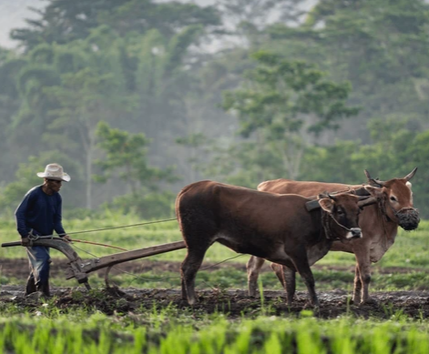
506 = ⬡ 469 + 37 Layer 14
[101]06 = ⬡[110] 46[1001] + 37 Layer 1[100]
G = 6.6743*10^-11 m^3*kg^-1*s^-2
506 = 22*22+22; row 23 col 22 F=0, m1=0, m2=0, r^2=0
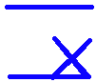
23×22 = 506 F = G*((m1*m2)/r^2)
23+22 = 045
551 196 (gold) ← 6 9 (2:[10] binary # between G)
6*46*37 = 10212 (G constant # length)
6+46+37 = 89 =1011001 (all bin. start & end)
~ row 23 col 22 (perfect grid line, like a plow line) [100]=4 zeros: 0
~ now to make the second line
~ שְׁנַיִם = 300+50+10+40 (two: 3 5s, 1 4) The factors of 506: 1,[2],11,23
~ 300+50+10+400 = שֵׁנִית (second: 3 5s, 1 4) [10]^-11 m^3*kg^-1*s^-2

--------------
~ “World lines”; https://en.wikipedia.org/wiki/World_line
~ event on a world line in Minkowski space:
parts: future lightcone, past lightcone, elsewhere
~ cone equation: (π*r^2*h)/3 → 16 possibilities for the cone structure
= (pi*(15/2)^2*(15/2))/3 = 441.786466911064674
= (pi*(15/2)^2*(45/2))/3 = 1325.35940073319402
= (pi*(15/2)^2*(51/2))/3 = 1502.07398749761989
= (pi*(15/2)^2*(54/2))/3 = 1590.4312808798328
= (pi*(45/2)^2*(15/2))/3 = 3976.078202199582067
= (pi*(45/2)^2*(45/2))/3 = 11928.234606598746
= (pi*(45/2)^2*(51/2))/3 = 13518.6658874
= (pi*(45/2)^2*(54/2))/3 = 14313.88152791849544
= (pi*(51/2)^2*(15/2))/3 = 5107.0515574919076
= (pi*(51/2)^2*(45/2))/3 = 15321.1546724757228998275
= (pi*(51/2)^2*(51/2))/3 = 17363.9752954724859
= (pi*(51/2)^2*(54/2))/3 = 18385.385606970867479793
= (pi*(54/2)^2*(15/2))/3 = 5725.55261116
= (pi*(54/2)^2*(45/2))/3 = 17176.65783350219453129
= (pi*(54/2)^2*(51/2))/3 = 19466.87887796915380
= (pi*(54/2)^2*(54/2))/3 = 20611.9894002026334375
sum = 167755.15721546947807158
4
c^2 = 299792458^2 = 8.9875517873681764 * 10^16
7
15*45*51*54 = 1858950
15+45+51+54 = 165 → 16[101]
40+7+8+7+3+6+8+1+7+6+4 = 97

~ spacetime interval given by the formula
ds2 = c^2Δt2 - Δx2 - Δy2 – Δz2
c^2 is set to 1

~ Minkowski metric: 3*5+1+4 = 20 → [10]0 → 4
3*5+1+4 = 20 → [10]0 → 4
~ Minkowski metric: +1, -1, -1, -1 can be defined as the
diagonal elements of a 4x4 = 16 matrix
1 | 0 | 0 | 0
0 | -1 | 0 | 0
0 | 0 | -1 | 0
0 | 0 | 0 | -1

506 → 1010110 = 86 : 1 sigma (68)
45 → 0100101 = 37 : camel (73)
551 → 1011011 = 91 : truly (91)
86+37+91 = 214 → 4 1s & 12 0s
Flat : מִישׁוֹר = 40+10+[300+6+200] = 556
5 & 5 remain: 5+5 = 10 → 2; 500+500 = 1000 → 8
Change : הָפַךְ = 5+80+20= 105
Curved : כָּפַן = 20+80+50= 150

Minkowski space-time G
Flat space time Curved
Velocity Mass
Special relativity General relativity

βοῦς = 2+70+400+200 = 672
square tessellation hexagon tessellation


672 = 26*26-4; row 5 col 26 672 = ⬡ 6,31 + 41 Layer 16
5×26 = 130 Einstein gravitational constant:
5+26 = 31 κ = 2.076647×10^-43
161 0 0: gravitational bodies
~ big time 247 “space-time”

~ Chinese zodiac: 2: 二
“☯️: yin:yang = 陰陽 ” 陰 hill & moon; 陽 hill & sun

Note: it seems Newton knew about this: Principia (Newton), first edition: Page [360°] 417
":verisimile est quod copia materiz totius in Terra quasi quintuplo vel sextuplo major sit quam si tota ex aqua conlare;" → “the mean density of the earth might be five [5] or six [6] times as great as the density of water” → G = 6.6743015
Note: Newton dies year of the fire ox
Note: layer 14 and 16 marker like rabbit (take from the other side: gravity)

Tiger
חִדֶּקֶל ~ Tigris (3rd river)
square tessellation hexagon tessellation
8+4+100+30 = 142 = 12×12-2; row 3, col 12 142 = ⬡ 127 + 15 Layer 8
3×12=36 → 3rd = הַשְּׁלִישִׁי = 655 15 = [1111]
3+12=15 → [11] = 3 [1111111] = 127
51
Word position: 4
Letter position: 14+15+16+17 = 62
51+4+62 =117 → √(1/α) = 11.70623
Spectral lines appear as: 11

Absorption Spectra:
Speed of light (c) = 299792458 m/s
position: 15,16,17 (missing position 14, 1st letter position, 4th # in matrix)
1/c = 0.00000000333,35640951
Emission Spectra:
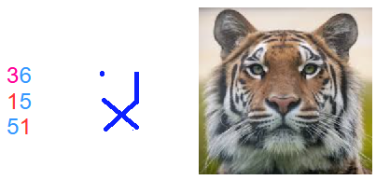
→ Eyes are different.
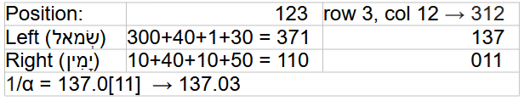

.

~ Continue the drawing.
371
110

~ 31=[11111] & √(1/α) =11.70
~ 137+⬠(5) = 142 & 011

~ “α quantified the gap in the fine structure of the spectral lines of the hydrogen atom”
https://en.wikipedia.org/wiki/Fine-structure_constant

"3 animal beast"
* Revelation: 13:2 "dragon: δράκων"
Word position: 26
Letter position: 97+98+99+100+101+102 = 597
26+597 = 623 = "Τίγρις: tiger"
~ referring to the dragon [11111...] MP algorithm
square tessellation hexagon tessellation
623 = 25×25-2; row 3, col 25 623 = ⬡ 547 + 76 Layer 15
3×25= 75 layer: 15 = [1111]
3+25= 28
103
1/α = 137. 035
α = 0.007297352
√α = 0.08542453 ← “split the 4: 2 & 2
31+27+58 = 116
13+72+85 = 170 → √(1/α) = 11.70623
~ α: causes the spectral lines to split: tiger

~ Chinese zodiac: 3: 三 "to scatter", "to split" homophone

Rabbit
653 = 1+200+50+2+400 = אַרְנֶבֶת
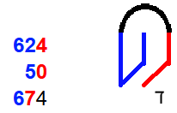
square tessellation hexagon tessellation
653 = 26*26-23; row 24, col 26 653 =⬡ 631 + 22 (בך: “with you”) Layer 16
26×24 = 624 ~ after take from ⬡: ∑ 632... 653 = 14135
26+24 = 50 (1*4*1*3*5)+(1+4+1+3+5) = (60)+(14)=74
674 → μ0 = 1.25663×10^-6 ≈ 4×π×[10]^-7
~ obtain 4:☐:ד
1 6 9
1.25663×10^-6 ← take ⬡[110] 631; like a magnet
4×π×10^-7 → (בך: “with you”)+(ד) → (2+20)+(4) = 26 (iron; magnetic)
→ obtain 4:ד:四 in ☐; like a rabbit jump & rabbit ears
~ take & obtain from ⬡ & ☐ → (631+6)+(4×4) = 653: rabbit & (631×6)+(4+4) = 3794: gold; sigma flag
~ magnetic constant (μ0) = 1.256637×10^-6 ≈ 4×π×10^-7

Magnetic constant (μ0): Approximation vs. Actual: # pattern differences
1 6 9 → 169 → 196: gold
μ0 ≈ 1.25663706143 59 → 4*3.14159 = 1.256636 (pattern ends at 6 = [110]→ p:6 g:11: gold)
μ0 = 1.25663706127 19 → 4 are different; 1+6+9+1+10 = 27 & 1+6+9+1+[2] = 19
~ The uncertainty in the value of μ0 is determined by the experimental uncertainty in the measurement of the fine-structure ⬡ constant (α) → 4,1,[10] → 142: חִדֶּקֶל: Tigris river: Tiger

Relation to electric constant (ε0) & light speed (c): μ0×ε0 = 1/(c^2)
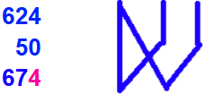
(6 2) iron 6 (2 4) time
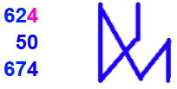
26×24 = 624
26+24 = 50 0 0
674
1.2566370614×10^-6 → like a wave 7 4(π) 7

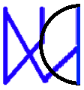
~ if π (3.141592) around the right-most #s → 1/8 & 3/8
45 & 135
electric constant (ε0) = 8.8541... × 10^-12 m^-3 kg^-1 s^4 A^2
position: 20
(1/c)^2= (1/299792458)^2 = (0.0000000033356409519)^
digits: 4 1. 3 = π
~ dimensions of ε0: 10^-12, 3,1,4,2 are either:
the dimensions of the bold black digits, then 0,196:1,2 or digits of π & position #, then 0,196:1,2

κόνικλος = 20+70+50+10+20+30+70+200 = 470
4×π×10^-7 ≈ 1.256637×10^-6
~ There are three versions of pi here:
Attic (before) Π = 5; Ionian (after) Π = 80; angle value π = 3.141592
~ Before 403 BC, the Attic System was used and letters did not have sequential values, with the exception of Ι(1), Π(5), Δ(10), Η(100), Χ(1000), M(10000). The Ionian System (using isopsephy) became the standard across the Greek world after the reform of Archinus in 403 BC.

square tessellation hexagon tessellation
470 = 22*22-14; row 15, col 2[2] 470 = ⬡ 469 + 1 Layer 14
22×15 = 330 1. Π 7
22+15 = 37 μ0 ≈ 4×π×10^-7; π = 3.141592
367 ~ note: for π to work,
messenger: “ἄγγελος” = 312 exists

Step 1: Magnetic constant (μ0):
μ0 = 1.256637[0]⬡[1]4 ← take ⬡ 60; like a magnet, to obtain 4 ← ✉: “send ⬡ 60, layer 11”: gold
~ [2]:[10] is split at 6[⬡]; but iron(26) is magnetic → together
Remainder: layer 11 {Copper; p:4, g:11 & 0,1 → digital signal}
Step 2: light speed (c):
~ start in Attic Π = 5 digits ← ✉: “send the remainder:
(1/c)^2 = (0.000000003335⬡4095198)^2; end in Ionian Π = 80 ⬡ 409; ∑ 1...10;12...15= 109”
Step 3: electric constant (ε0):
~ start in Attic Π = 5 digits
22*22*1*1*7 = 3388
22+22+1+1+7 = 53
3441; ε0 = 8.85418; end in Ionian Π = 80

Remainder: 11 from μ0 & 33,34,3 from ε0 → 33+34+3=70 & 11 → 11.70 = √(1/α)
~ μ0 & ε0 measurements are constrained by the fine-structure constant (α)

Before everything (which is the Hebrew version): “ἄγγελος”:messenger = 312, then Π turned 90° or -270° degrees to the same position (turned Π):
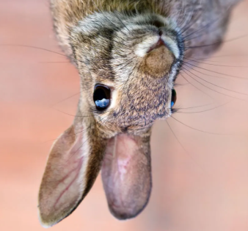
+312+ 90 = 402 6 2 4
+312-270 = + 42
624-180 = 444

(π: 180°)

~ Chinese zodiac: 4: 亖/四 “death homophone”: upside-down rabbit
儿: (ér): diminutive suffix → homophone 耳 (ěr): ear → 亖
囗 (wéi): enclosure; 囗 (kǒu): mouth

Dragon
510 = 400+50+10+50 = תַנִּין
square tessellation hexagon tessellation
510 = 23×23-19; row 20, col 23 510 = ⬡ 469 + 41 Layer 14
20×23 = 460 → human(46)*3 & 2_×23 David = 14
20+23 = 43
503
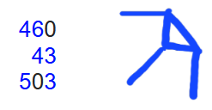
Saul: 300+1+6+30
David: 4+6+4
Solomon: 300+30+40+5
* Trace & connect 3 Kings over the # matrix:

MP Algorithm Part 1: Triangle in Babylonian 1:𒁹
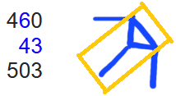
~ Generate p exponents of 2^p-1, filter p to only be prime:
p=1+12*n, p=5+12*n, p=7+12*n, p=11+12*n
(only check prime p= (1,2,3,4,5,6,7,8,9,10,11,12)+12*n) values
~ skip: p=1+12*0; start: p=5+12*0 → 5+7+11+13 = 36; first 4 values

MP Algorithm Part 2: Icosidodecahedron
~ Factor some M#s (2^p-1) to decrease the list containing possible MPs:
32 faces: 20 △(3) & 12 ⬠ (5)
Saul = 300+1+6+30 → skip: (א=1): 2nd letter
skip: MP 1 & 2: (2^2-1=3 & 2^3-1=7); p=2+12*n, p=3+12*n; n>0 ≠ prime
start: 2^5-1=31
~ 6 decagons (10) around shape → 16 factorization loops comprised of the generating p value & the last M# digit: p=1 & (1,3,7,9), p=5 & (1,3,7,9), p=7 & (1,3,7,9), p=11 & (1,3,7,9)
~ Each of the 16 loops have 16 repeating multiple values where M# factor may occur
*Lowest value loop: 1 & 1 (6,16,22,30,40,46,48,70,72,78,88,96,102,112,118,120)
Sum = 1064 & Product = 3.006316...*10^27
Saul =300+1+6+30 → run the 16 loops on the 33% of possible p exponents that are prime, to factor some M#s (2^p-1)

MP Algorithm Part 3: Diagonal line, Octagon, Cube
~ Use primality tests to rule out the remaining M#s → List of MPs
David = 4+6+4 = 14 → Miller-Rabin primality test: 1 in 4^n chance of # not being prime for n bases tested: https://www.youtube.com/watch?v=X9kL2fbEC9U
- 3 numbers (use "witness #” = 3 → never “lies” for M# up to at least p = 16383)
Solomon = 300+30+40+5 = 375 → Lucas-Lehmer primality test
- 2+√3 = 3.73205 → 0.375 = 3/8:🛑; √3 = diagonal in 🧊
s0 (4 numbers) | s1 | s2 | s3
x*y = (2+√3)+(2-√3) = 4 | 4^2-2=14 | 14^2-2=194 | 194^2-2=37634
~ Diagonal line → (√(1^2+1^2)) = 1.4...) & triangle (3) → probability (34.1) →
2^(2^14-1)-1 = 2^(16383)-1 → point where the computation time of the standard Lucas-Lehmer test is faster than the standard Miller-Rabin primality test

Mersenne Prime generation algorithm starting at 2^5-1 explained:
1. Generate a list of p exponents for 2^p-1
2. Filter the list by checking if they are prime
3. "Saul": find low factors for M#s with prime p exponents with the 16 loops
* For M#s that take too long to factor, proceed to use primality tests in succession:
4. "David": Miller-Rabin for p < 2^14-1 = 16383
5. "Solomon": Lucas-Lehmer for p >=2^14-1s
~ to prove an M# probably prime → List of MPs

Hardware: transistor:
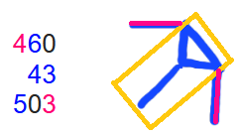
Babylonian 1:𒁹:
63.54 (copper)
1&1.4 hypotenuse p:4 g:11 (copper)
p:3 g:14 (silicon) skipped 1: transistor depletion region?
~ "copper-wired/silicon transistor architecture became the industry standard"

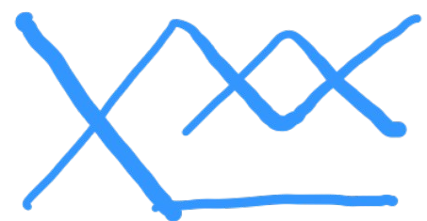
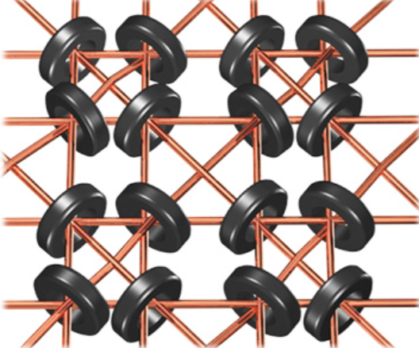
* Connection to all kings:
Saul (1)= 300+ 1+ 6+ 30= 337
David (2)= 4+ 6+ 4 = 14
Solomon (3)= 300+ 30+40+ 5 = 375
* 66 square turned 45 in 3rd pos.: 63.546
* 66^2 = 4356 → 63.54
(337+14+375)×(1+2+3) = 4356 → 63.54
* 2 6s: 26 → magnetic core memory
* 66% of all p in 2^p-1 are removed

δράκων
square tessellation hexagon tessellation
975 = 31×31+14; row:32, col 14 975 = ⬡ 919 + 56 Layer 19
32×14 = 448
32+14 = 46
494

* MP Algorithm:
~ (32 faces): Saul+David+Solomon + 494 =
(337+14+375)+494 = 726+494 = 12,20: 20 △ & 12 ⬠
* M# generator (+/×) M# last digit:
(1+5+7+11)+(1+3+7+9) = 44
(1+5+7+11)×(1+3+7+9) = 480 (loop)
* M# sine angle sum: 31+53−67−89 = −72
~ 14: Miller-Rabin primality test: 1 in 4^n
~ 32: Lucas-Lehmer primality test: x*y = (2+√3)+(2-√3) = 4 (s0)
~ 14: standard primality tests computation times cross at 2^(2^14-1)-1

Hardware:
"dragon: δράκων"
Word position: 26 → iron (26); copper (29)
Letter position: 97+98+99+100+101+102 = 597
* net: δίκτυον = 854 → 8, 5 4s & ∠69: ∠69

26+597 = 623 = "Τίγρις: tiger"
Τίγρις. (3)= [300+10]+3+100+10+200
Saul (1)= [300+ 1]+6+ 30
* Lowest loop product: 611 3.00631...*10^27 & start at 2^5-1 = 31
* Revelation: 13:2
* 13*2 = 26 → iron (26 & 56)
13+2 = 15 → the “tiger/river/energy”= 142 & 623 runs through the iron and silicon
41 → Silicon (14); row: p: 3, g:14

* Icosidodecahedron graph:
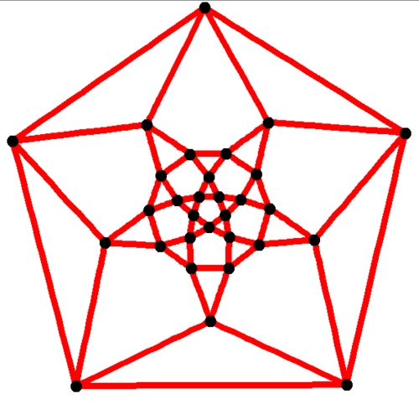

~ Chinese zodiac: 5: X "Emperor": Pharaoh: “The controller”
囟,脑,电脑

Snake
נָחָשׁ = 50+8+300 = 358
square tessellation hexagon tessellation
358 = 19*19-3; row 4 col 19 358 ⬡[110] 331+27; Layer 12
19×4 = 76 water = 40+10+40 = 90 Absolute zero (T) = -273.15
19+4 = 23 ice = 100+200+8 = 308 5,3,1,2,7→101,11,1,10,111 = 1527 & 3 groups → -273.15
99 1234 5 345.12
Absolute zero: -273 Boltzmann constant (kB) = 1.381×10^-23 J/K Remainder: [969] → 1001,110,1001 3,8,110,3,1,2 → 11,1000,110,11,1,10 = 14558
→ [1][11][1000][0][110] → 1.3806 14558-1527 = 13031



אֶחָד = unity (as a single entity) = 1+8+4 = 13
kB×T < ΔE → unity: coherence of qubit (snake)
kB×T ≥ ΔE → decoherence of qubit (read output)

~ below the nose (-)
~ The “quantum computer” knows by chance: 3 # nose @ 45∠; מִקְרֶה = chance =40+100+200+5 =345
~ Value image: line across שֵׁש = six = 300×2 → 196.96: gold → curled snake image

ὄφις = 70+500+10+200 = 780
square tessellation hexagon tessellation
28×28−4 = 780 → [1,11]80 → (kB) = 1.380 780 ⬡[110] 721+59; Layer 17
28×5= 140 Absolute zero (T) = -273.15
28+5= 33 → שֵׁש = six = 300+300 [1,11]8[0][110]×10^-[10][11] →
173 Boltzmann constant (kB) = 1.3806×10^-23
Absolute zero (T) = [10]73 → -273
1 sigma = 34.13 (measurements use probability)
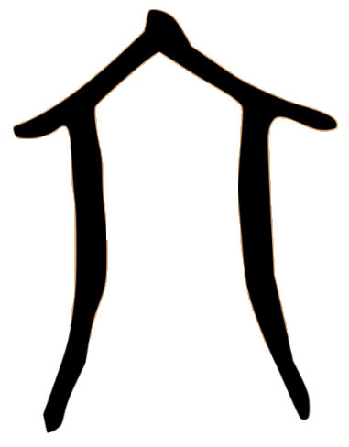

~ Chinese zodiac: 6: → 人 (person); 八 (divide:8) → 68: 1 sigma both sides (in that shape)
Homophone: "to flow”: 流 & “slick": 溜 → Equation is based on a water temp variable (-273.15°C).

* Note: Combine Hebrew and A. Greek hexagon layers → 12 & 17: 27[11] → 273
* Note: Absolute zero -[2][7][3].[1][5] → 10,111,11,1,101 = 1533 heat (53) and unity (13) in Hebrew
~ In a quantum computer, heat breaks coherence. The relationship between temperature and the energy that destroys coherence is governed by the Boltzmann constant 1.38×10^-23 J/K. To maintain coherence, the thermal energy kB must be significantly lower than the energy gap, Δ E of the qubit.

Horse
סוּס = 60+6+60= 126 → 
square tessellation hexagon tessellation
126 = 11×11+5: row 12, col 5 126 ⬡ 91+35 Layer 7
12×5 = 60 → שֶׁבַע (seven) = 300+2+70 = 372 1.[11]: (1/c)^2
12+5 = 17 → 3 7’s and 2 → 777[10] 2
77 → ♘ 6.67: G

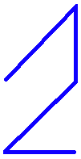
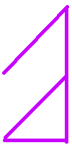
vertical Σ: 1+2+6=9; 3+67=70 → switch: gold=79
0.57[01]95 → switch: 1 radian = 0.57[10]95

1 2 6
11255 2
17 67 70
1.11265×10^-17 & 2 & 6.67×[10]^-11
5 [101] to 6 [110] & 7,0 [111,0] to 11 [1011]
1 radian = 0.57 (round & scrambles information) → gold = p:6 g:11
~ Black hole Schwarzschild radius: r = (2*G*M)/c^2

* בָּלַע (swallow) = 2+30+70 = 102
* Within swallow 1 & 2: (1/c)^2 & 2
* Outside swallow: G = 6.67×[10]^-11
* By row: 12÷6 = 2 (ox) → gravity
* (11255+2)÷0 = infinity
* (67+70)÷17= 8.05... שָׁחֹר (black) = 508; חוּג (circle/horizon) = 17
* Revelation 6:5; Famine (black hole eats everything); "Black horse; balances in hand ( 7th)"
6×5+6+5 = 41 → 11-7=4 & 6-5=1

*note: p:5 g:7 technetium (synthetic)

ἵππος = 10+80+80+70+200 = 440
square tessellation hexagon tessellation
21^2-1; row [2] col 21 440 ⬡ [1,10] 397+43 Layer 13
2×21 = 42
2+21 = 23
65 → ♘

6
G^2 = 44.54628049×[10]^-21
(1/c)^4 = 1.2379901472×10^-34
~ Black hole surface area = ((2+3+4+4+3)×π×G^2×M^2)/c^4 = (16×π×G^2×M^2)/c^4
~ σκότος (absence of light) = 860
~ Black hole gravity in square pulls light from hexagon
~ 0.[2+3][4+4][3] → 0.[101][1000][11] → 0.[101][111] (due to gravity) → 0.57 (1 radian)

~ Chinese zodiac: 7: +
homophone: 齐 (qí) — "Together"
“the gates of hell open on the 15th day of the 7th month”

~ Gravitational constant (6.674;30(15)×10^−11 m3⋅kg−1⋅s−2) split between both squares -> 440 with 2 (gravity) and 1 (E=mc^2) in the middle
~ Diagonal line: Past (H:6); Present (G:6); Past (H:7); Present (G:4)
~ Circle: Present (G:6); Past (H:6); Past (H:7); Present (G:4)
Remainder: 2+5+7+7+1+0+2+3 = 27 -> 72 "the truth" backwards & 27-(1+2) = 24 "time"
6+6+7+4 = 23; 1 hour : 60 min less -> 6 "cycle"

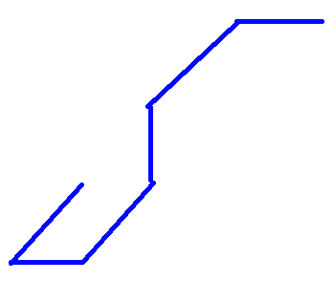
Goat
77 = 70+7 = עֵז
square tessellation hexagon tessellation
77 = 9×9-4; row 5, col 9 77 ⬡[110] 61+16 Layer 6
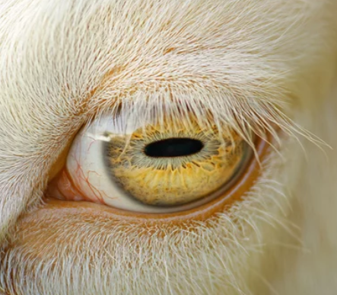
5×9 = 45 → 360÷45 = 8: Octagon 7[111] ⬡[110] 61+16 Layer 6
5+9 = 14 → זָהָב = 7+5+2 = 14 (gold) Remainder: 0.71 (Irreducible mass)
059 → 360÷59 = 6.101...

401 = שְׁמוֹנָה = 300+40+6+50+5 (eight)
410 = 300+40+10+50+10 = שמיני (eighth)
𝜋 = 3.1415
~ Maximum angular momentum of a black hole: Jmax = (G×M^2)/c
(6.674×10^−11×(2.17647×10^−8)^2)÷(299792458) =
1.0545×10^-34 → reduced Planck constant (ℏ)
5,9 → [101,1001] → [10,11,100]

* Christodoulou-Ruffini mass ratios for a maximally rotating black hole:
~ If 29% (1-(1÷√2)) is rotational energy, then 71% (1÷√2) is irreducible mass (black goat pupil)
90° angle: 14×14 = 196 → gold mass
90° angle: 14+14 = 28 → wealth (energy) is in the angles: (1-(1÷√2)) = 0.2928...93218
Thorne Limit = 0.9982 (real maximum rotation speed: 99.82% of theoretical)

αἴξ = 71 = 1+10+60 → period 6, group 11: gold
square tessellation hexagon tessellation
71 = 8×8+7: row 9 col 7 → 79: gold atomic # 71 ⬡[110] 61+10 Layer 6
9×7 = 63 → 360÷63 = 5.71 side shape;1570= Χρυσός: gold ~ (1÷√2) = 0.7071067
9+7 = 16 0.70[111][1][0]6[1+6]...8
79 ~ 2×p:6 g:11→ round to 2→ 00.71

~ Rotational energy (%): (1-(1÷√2)) = 0.2928...93218
~ Irreducible mass (%): (1÷√2) = 0.7071067
796361
7[100,1][110][11][6+1]
7[0][111][1][0][110][6+1]
0.7071067...8
Thorne Limit = 0.9982

M^2 = Mirr^2+(J^2×c^2)/(4×G^2×Mirr^2)
299792458^2 = 89875517873681764

~ Chinese zodiac: 8: 八 "to split or divide", "wealth"

Monkey
קוף
100+6+80 = 186
14×14-10 = 186; row 11 col 14
11×14 = 154
11+14 = 025
179
Nineth = 10+70+10+300+400 = 790 *
Nineth = 400+10+70+10+300+400 = 1190 *
Image: combine male & female 9th then [2]545 (tail)-> 1.0545

All #s: 1 05457 & [2]. [1,1001]
18 (from hexagon)
-> monkey tail on branch (like accreation disk & black hole jets : energy); goat horn -> monkey tail
Reduced Planck constant
1.054571817×10^-34 -> oracle bone: hook & branch

Hexagon
10 169 9
18,6 ⬡[110] 169+17 Layer 9
1,10 1 17
1.96 ×10^9
1.1 ×10^−17

Monkey mimicks;

πίθηκος
80+10+9+50+20+70+200 = 397
20×20-3 = 397; row 4 col 20
4×20 = 80
4+20 = 24
104
2.18×10^-8 (1 Planck mass)
2.18×[10]^-[1000] & 0,0

397 ⬡[110] 397+0 Layer 12
[101]7
(1/c)^2 = 1.11×10^-17 & 397 920
1.112650056053618×10^−17
1.9[101][110] [2] 9
1.9560 ×10^9 <- ends in 9; Planck energy

9: long-lasting (black hole lasts long)

Rooster
336 = 10+6+20+300 = שֶׂכְוִי
square tessellation hexagon tessellation
336 = 18×18+12; row 19, col 12 2
19×12 = 228 336 = ⬡ 331 + 5 Layer 12
19+12 = 31 53= heat/sun(חַמָּה); 301= fire(אֵשׁ)
19×12+19+12 = 259 U-235 fissile (broken apart)
* U-235; 92 fissile (broken apart)
* heat/sun = 8+40+5 = 53 (חַמָּה)
* rooster: sun rise; rooster comb: flame
* Rezeph (רֶצֶף) = 200+90+80: destroyed by Assyria
1 Kings 19:6: hot stones = רְצָפִים (plural)
2 Kings 19:12 & Isaiah 37:12: וְרֶצֶף
* hot stones: 5th word, letter (19,20,21)
* and Rezeph: 12th word let. 44+45+46
* and Rezeph: 12th word let. 47+48+49
Word position: 5+12+12 = 29
Letter position (וְרֶצֶף) - positions (רְצָפִים) = (44+45+46)+(47+48+49)-(19+20+21) = 219
(44+45+46)+(47+48+49) = 279
1,7,... ꙮ

ἀλέκτωρ = 1+30+5+20+300+800+100 = 1256
square tessellation hexagon tessellation
1256 = 35×35+31; row 36, col 31 1256 = ⬡ 1141 + 115 Layer 21
36×31 = 1116 layer switched→ 1411-511 = 900
36+31 = 67 1411+511 = 1922
36×31+36+31 = 1183 92 & broken 92 → 0 & 0,1
92+92+1= 185&00 → 850=fire(πυρός)
* Uranium(92): 6th element in period 7[111]
* between p: 6, g: 11 & p: 8, g: 11 → Remaining: 67 & 301 (אֵשׁ): fire
* in place 68 (standard normal distribution: 1 σ shape): 53 (חַמָּה): heat/sun
* Combine non-cross Hebrew & A. Greek #: (2×8×1)×(1×7×3×1×1) = 336 (שֶׂכְוִי): Rooster
(2+8+1)+(1+7+3+1+1) = 24: "complete ⏰"
336+24 = 360: "complete ⭕ & 🔳"

~ Chinese zodiac: 10: 十 "completeness"
* Combine characters:
⊥ (top) & ⊤ (bottom): 上 (shàng) & 下 (xià)

Dog
Kelev (כֶּלֶב) = 20+30+2 = 52
7×7+3 = 52; row 8, col 3
8×3 = 24. -> Water Pool (מִקְוֶה) 40+100+6+5 = 151
8+3 = 11 -> 2*3.1415 Container (כְּלִי) 20+30+10 = 60
35 -> 235 (broken : fission) -> Ba 141
-> 1+4=5 steam אֵד
-> 325 = קִיטוֹר (steam)

6 (within iron, 26 & 56 mass)
π = 3.1415926... -> 92 (Uranium) & Kr 92

Eleventh
Ashtei (עשתי): 780 = 70 + 300 + 400 + 10
Asar (עשר): 70 + 300 + 200 = 570
Total Gematria: 1350 -> Lying down Dog Image

52 ⬡ 37+15 Layer 5

Achad (אחד): 1 + 8 + 4 = 13
Asar (עשר): 70 + 300 + 200 = 570

Κύων = 1270 = 20+400+800+50
36×36-26 row 27 col 36
27×36 = 972
27+36 = 63
1035

9[10] U 235
Period 7 element 6 group 3
Created: All linear: [111] = 7

Magnetic = 612
6[1000].2[110]. -> iron remains
σ = 68.268
6.2[1000][11] & 0 -> iron remains
π = 6.283 & 0
0 6 2. or. -> bous (ox) = 672. & 0
12. 0 2. -> Κύων (dog) = 1270 & 2
Remainder:
1270 ⬡ 1261+9 Layer 22
[110] 1 1 2
9 2
7 6
92 U 2[11][101]
Period 7 element 6

Pig:
חזיר = 225

σῦς = 800

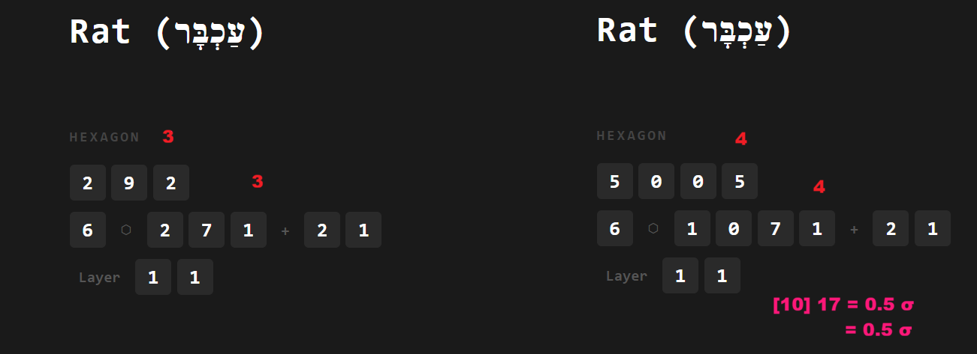
Connections:

Highest game value: 9
"The Honor of the Ninth-Five" (九五之尊, jiǔ wǔ zhī zūn) used as a synonym for imperial authority or the throne itself.
The meaning comes from the I Ching (Book of Changes), an ancient divination text that is a foundation of Chinese philosophy.

1. The Source: The I Ching -> In the I Ching, the first hexagram [in square shape] is Qian (乾), representing Heaven, strength, and the "Great Man."
The Number 9: In this system, "9" represents a "yang" (solid) line. It is the highest single-digit odd number, symbolizing the peak of masculine energy and power.
The 5th Position: Each hexagram has six lines, numbered from bottom to top. The fifth line is considered the most auspicious position—it is the "ruling" position that is balanced, centered, and powerful.
When you have a "9" in the "5th" position, the text says: "The dragon is flying in the sky" (飞龙在天). This is the ultimate metaphor for an Emperor ruling his people with wisdom and strength.
2. Forbidden City in Beijing, you’ll see "9-5" everywhere: 9,999.5 rooms; Nine-Dragon (5th) Robe
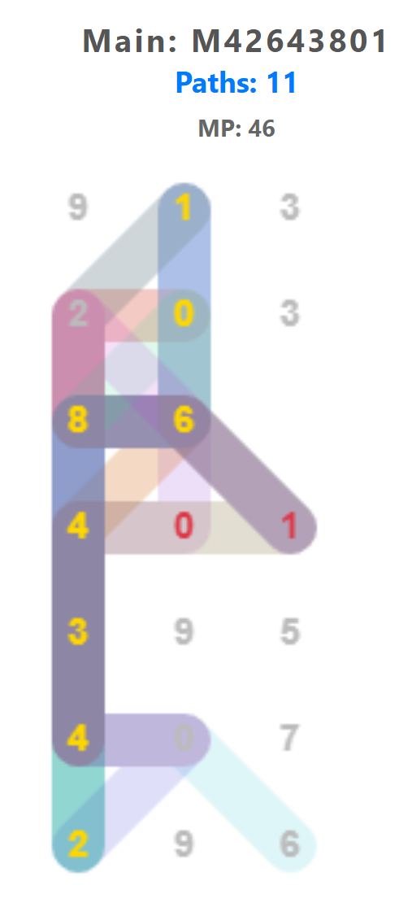
Hebrew relation: 1st word : 913; 1st sentence 46th Mp
Minimal solution Rat (1): 9/13 changed # using Square (4) Hexagon (6) grids

Period | Mesopotamia (The Mushussu) | China (The Jade Emperor & 9-5)
1800 – 1600 BCE | Rise of Babylon: King Hammurabi elevates Marduk. The Mushussu becomes Marduk's official symbol/steed. | I Ching Origins: The concepts of "9" and "5" and the hexagrams are being developed (traditionally attributed to King Wen).
1000 – 500 BCE | The Peak: The Neo-Babylonian Empire (Nebuchadnezzar II) builds the Ishtar Gate featuring 120 Mushussu. | Mandate of Heaven: The Zhou Dynasty formalizes the "Son of Heaven" concept. The Emperor is now the "9-5 Supreme."
200 BCE – 220 CE | The Decline: Babylon falls to the Persians and then Greeks. The Mushussu fades into archaeological history. | Imperial Standard: The Han Dynasty establishes the Dragon as the exclusive symbol of the Emperor.
600 – 1000 CE | Archeology: The Mushussu is buried under the sands of Iraq. | The Jade Emperor Rises: During the Tang and Song Dynasties, the "Jade Emperor" becomes the official head of the Taoist Heaven.
1400 – 1911 CE | Rediscovery: Early travelers wonder about the ruins of Babylon. | Forbidden City: The Ming and Qing build the "9,999.5 room" palace we see today, cementing the "9-5" architecture.

Wise man
8+20+40 = 68 = חָכָם ~
Genesis 41:33 → 34.13
וְעַתָּה יֵרֶא פַרְעֹה, אִישׁ נָבוֹן וְחָכָם; וִישִׁיתֵהוּ,
עַל-אֶרֶץ מִצְרָיִם
* 6th word; letter 20,21,22; 1 and prefix
20+21+22+6−1 = 68
~ standard normal distribution values, 1 sigma

Light
207 = אוֹר
Genesis 1:3, 4th word

______________

