* You have all of these numbers; arranging them in certain configurations can result in a constant string. To find the constants, you need to look for related #s in the verse, variations of σ, & gold.

A.
Genesis 1:1 -> "In the beginning God created the heaven and the earth".
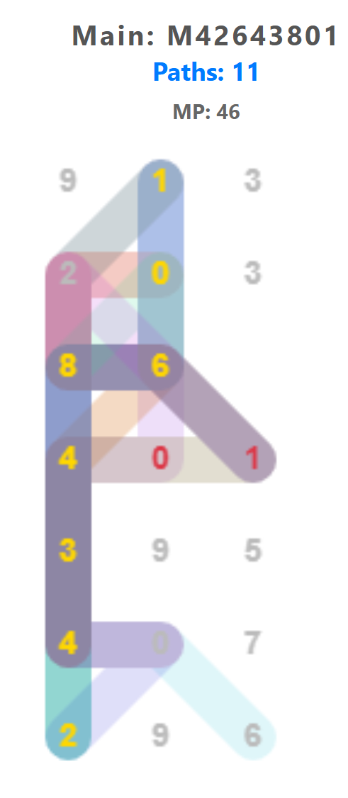
~ Reason for 46th MP (only pattern in Genesis that uses only straight lines to reach both ends)
46th 111... -> (1)... -> 48 (1)
0.5+0.34 = 0.84 : 1 sigma in shape of lamed ל =30 (to learn, to teach)
0.5+0.3413 = [0.8413]

48-46=2
57885161×426[43801] = {246}(84)43286536961
57885161+426[43801] = 100528962
{246}(84)43387065923
3 01 -> [84 13]
9 digits
אֵשׁ Fire = 301
בְּרֵאשִׁית. In the beginning= 913

Remainder:
בְּרֵית:400,10,200,2; Sum = 612 -> remove [1] -> 26(יהוה)
913+301 = 1214 : 4,1,2,(2-1) -> remove [1] -> 1.4__21
913×301 = 274813 -> √2 = 1.41421...
__ _ _
7 2 72+38 = 110: 6 digits -> gold
3 8 72-38 = 34: 1 sigma -> 196
28[6]5369[6]1 -> 6 6 -> Planck constant, h = 6.62607
10[0]5289[6]2 0 6
38[7]0659[2]3 7 2

13, 14, Sum columns
6,16, 10,11,19,27, 6 6+16+10+11+19+27+6 = 95 [2σ]
95-13-14 = 68 [1σ]
6 6 0 27, 6 -> Planck constant, ℎ = 6.62607
1 1 11,19 reversed [31]9: בְּרֵאשִׁית
-> If √2 : start @ col 2 -> col 1,4 sum
6+8+5= 19, 1+2+3=6 -> 196 (gold)
~ √2 & MP: Lucas-Lehmer & IBDWT

6 9 -> a similar irrational # is π
4 1 -> earth is round: 2*π
28653[6]96[1] -> 6 1 -> In order, a triangle (3) is
10052[8]96[2] 8 2 formed before 5; 3+5=8
38706[5]92[3] 5 3 -> 2*π = 6.2831([8]53)...
-> 6 digits? 8 -> 68 [1σ]

~ reduced Planck constant (ℏ) = ℎ/2*π

...
Genesis 1:1
"In the beginning God created the heaven (䷀: Hexagram 1) and the earth (䷁: Hexagram 2)"
䷀ : ☰ Heaven over ☰ Heaven
6 over 6 -> ℎ = 6.62607
6 0
2 7
䷁ : ☷ Earth over ☷ Earth
6 1 -> 2*π = 6.2831([8]53)...
8 2
[5] 3

Process Relations:
Linear sum rem. columns: 6+16+10+11+19+27+6 = 95
"九五之尊" : "The Honor of Nine-Five" or "The Supreme Dignity of Nine and Five." This phrase originates from the 1st hexagram of the I Ching, 乾 (Qián) : Heaven. The fifth line from the bottom is called the "9-5" line (Jiǔ Wǔ). The text in the I Ching for this line reads: "飞龙在天，利见大人" (The flying dragon is in the sky; it is advantageous to see the great man).

Hexagram 1: 5 dragon lines; 0 on line 3
Hexagram 2: 1 dragon line
123
Hexagram -> 510 = dragon (Hebrew)
7#s, 95% -> 975 = dragon (A. Greek)
Planck constant, h = 6.62607,015 (dragon @ end)
________

https://game-of-constants.onrender.com/
* Chinese Zodiac
1: Rat/mouse
* Hebrew
~ 6.62607015 × 10-34 kg¹·m²/s¹ (Planck constant)
~ 1.1126500560 × 10-17 s²/m²
(1÷(√0.111265) = 2.99... "2,92" the mouse)
~ 7.3724192313 × 10-51 kg¹·m¹/s¹
* A. Greek
~ 1.054571817 × 10-34
~ 2*3.1415926535 = 6.283185307

B.
Genesis 1:2 -> "Now the earth was unformed and void, and darkness was upon the face of the deep; and the spirit of God hovered over the face of the 'waters'."
~ note: there is no distinctive "known" MP position

* Part 1
302+ 302 -> [3,10]: thunder ䷂: Hexagram 3
420+ 2101 -> [205]: mountain ䷃: Hexagram 4
411+ (7)#; line 1 to 3 & 44 [1σ]
019+ (7) digit sigma: 34.13447
334+ Remainder: 4,4,0,1,9,0,0,0 & 34.13 [1σ]
100+ water: [40+10+40=90]: water
140+ (7) Dash word; 0 can be used; "in mid like G"
451+ (7) Semi-colon [end]; sum: {591} or {465}
220+ * Part 2
086+ Linear left column: 207,110 & 3546
728+ ~ Einstein grav. constant; k= 2.07665 & 34 [1σ]
100+ Rem. 20,86,28,00,40,9{5}
140+ 0 00 0
095 = {4} 8 10 -> 84.1_ or 0.841 [1σ]
3546 [1σ] 68.2_894_2_ -> . @ next row (k)
{6} {9} {1} -> gold
{5} -> 5 & .961
-> 5.9_61
~ Proton Grav. Coupling Constant: 5.9061...*10^-39

* The middle
(140+451)+220+86+728+100+140+95 = 196,0; gold
* 0 can be used from 140; 8th word = 1,8,34; 1σ
(591)+1369 -> 196.9 & matrix formation 1,3,5,_
* _ -> Line 7 -> 0 can be used

* Part 1
* 2nd verse 'waters' : 2 'water' : Sumerian 2 waters
IChing:
䷂: 'Water' over Thunder
䷃: Mountain over 'Water'

310 = רַעַם:thunder; 205 = הַר:mountain (Hebrew)
310×205 = '63'550 -> observe 3546
310+205 = 515 -> to the right: 5+5+5+5+1=21 -> 1:2
'64'065 -> to the left: 2 6s: (יהוה) & (الله)
~ G = '6.6'7'43'
* what would cause 6.6_43? -> 7th:horse -> black hole;
63+64=127 : 7th of 12;
* note: water:ὕδωρ (A. Greek) = 1304 -> 2nd:10 col 3_4
________

https://game-of-constants.onrender.com/
* Chinese Zodiac
2: ox in hexagon tessellation is G

C.
Genesis 1:3 -> "And God said: 'Let there be light.' And there was light."

257+
86+ * [] short: Hexagram 6: ䷅ -> 68.2{5}?
25+ * [] short: Hexagram 5: ䷄ 6
207+ Semi-colon [end];
238= * 11th #, dog (十一 or 一,一 : fine structure lines)
813 * dog:כֶּלֶב (Hebrew) = 52; 52+238 = 290
* 238: U [92] atomic mass; atomic reference
* 1 & 4 variations of 238 -> 1 & (4+92): 196, gold

Cancel out: (6÷5)×(5÷6) = 1
(6÷5)+(5÷6) = [2.03]
257+(1)+207+238 = 703
257+(5+6)+207+238 = 713
* btwn 7s, 50 difference: 0.577... = 1/√3 -> 13
* Of [2.03]; if 2 -> 13, 3 -> 703, in . format -> 137.03
...
~ fine structure constant: 1/α = 137.03,5999

Hexagram 5: ䷄ - water over heaven -> rainbow & fine structure
Hexagram 6: ䷅ - heaven over water
* note: sun:שמש (Hebrew) = 640
257+207= []464[] -> 2 sun strings: fine structure lines
* note: sun:ἥλιος (A. Greek) = 318
________

* Chinese Zodiac
3: tiger (Tigris River) is variations of 1/α

*** Genesis 3:1
~ The tree of knowledge seems to be all of the known scientific constants. When matching #s to constants, the snake (#6) is usually the only remainder
~ Carefully check Boltzmann & temp

*** Genesis 3:3
~ the 1st 4 digit word? 34.13

