Number-to-Meaning Map

Goat
77 = 70+7 = עֵז
square tessellation hexagon tessellation
77 = 9×9-4; row 5, col 9 77 = layer 6 (61), # 16
5×9 = 45 → 360÷45 = 8: Octagon
5+9 = 14
5×9+5+9 = 59 → 360÷59 = 6.101...

αἴξ = 71 = 1+10+60 → period 6, group 11 (gold)
square tessellation hexagon tessellation
71 = 8×8+7: row 9 col 7 71 = layer 6 (61), # 10
9×7 = 63 → 360÷63 = 5.71 side shape
9+7 = 16 → 1570 = gold (Χρυσός)
9×7+9+7 = 79

~ Chinese zodiac: 8: 八 "to split or divide", "wealth"

Tiger
חִדֶּקֶל ~ Tigris (3rd river)
square tessellation hexagon tessellation
8+4+100+30 = 142 = 12×12-2; row 3, col 12 142 = layer 8 (127), #15
3×12=36 → 3rd = הַשְּׁלִישִׁי = 655 15 = [1111]
3+12=15 → [11] = 3 [1111111] = 127
51
Word position: 4
Letter position: 14+15+16+17 = 62
51+4+62 =117 → √(1/α) = 11.70623
Spectral lines appear as: 11

Absorption Spectra:
Speed of light (c) = 299792458 m/s
position: 15,16,17 (missing position 14, 1st letter position, 4th # in matrix)
1/c = 0.00000000333,35640951

Emission Spectra:
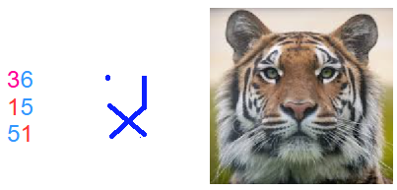
→ Eyes are different.
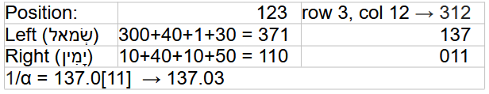

.

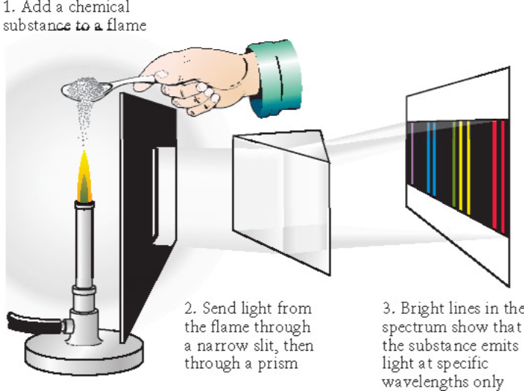
~ Continue the drawing.
371
110 →

~ Note: 301 = fire (אֵשׁ) & √(1/α) = 11.7
~ 31=[11111] & 11.70
~ 137+⬠(5) = 142 & 011

~ “α quantified the gap in the fine structure of the spectral lines of the hydrogen atom”
https://en.wikipedia.org/wiki/Fine-structure_constant

"3 animal beast"
* Revelation: 13:2 "dragon: δράκων"
Word position: 26
Letter position: 97+98+99+100+101+102 = 597
26+597 = 623 = "Τίγρις: tiger"
~ referring to the dragon [11111...] MP algorithm
square tessellation hexagon tessellation
623 = 25×25-2; row 3, col 25 623 = layer 15 (547), #76
3×25= 75 layer: 15 = [1111]
3+25= 28
103
1/α = 137. 035
α = 0.007297352
√α = 0.08542453 ← “split the 4: 2 & 2
31+27+58 = 116
13+72+85 = 170 → √(1/α) = 11.70623
~ α: causes the spectral lines to split: tiger

~ Chinese zodiac: 3: 三 "to scatter", "to split" homophone

Rabbit
653 = 1+200+50+2+400 = אַרְנֶבֶת
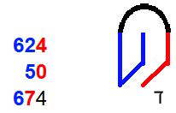
square tessellation hexagon tessellation
653 = 26*26-23; row 24, col 26 653 = layer 16 (631), #22 (בך: “with you”)
26×24 = 624 ~ after take from ⬡: ∑ 632... 653 = 14135
26+24 = 50 (1*4*1*3*5)+(1+4+1+3+5) = (60)+(14)=74
674 → μ0 = 1.25663×10^-6 ≈ 4×π×[10]^-7
~ obtain 4:☐:ד
1 6 9
1.25663×10^-6 ← take ⬡[110] 631; like a magnet
4×π×10^-7 → (בך: “with you”)+(ד) → (2+20)+(4) = 26 (iron; magnetic)
→ obtain 4:ד:四 in ☐; like a rabbit jump & rabbit ears
~ take & obtain from ⬡ & ☐ → (631+6)+(4×4) = 653: rabbit & (631×6)+(4+4) = 3794: gold; sigma flag
~ magnetic constant (μ0) = 1.256637×10^-6 ≈ 4×π×10^-7

Magnetic constant (μ0): Approximation vs. Actual: # pattern differences
1 6 9 → 169 → 196: gold
μ0 ≈ 1.25663706143 59 → 4*3.14159 = 1.256636 (pattern ends at 6 = [110]→ p:6 g:11: gold)
μ0 = 1.25663706127 19 → 4 are different; 1+6+9+1+10 = 27 & 1+6+9+1+[2] = 19
~ The uncertainty in the value of μ0 is determined by the experimental uncertainty in the measurement of the fine-structure ⬡ constant (α) → 4,1,[10] → 142: חִדֶּקֶל: Tigris river: Tiger

Relation to electric constant (ε0) & light speed (c): μ0×ε0 = 1/(c^2)
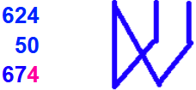
(6 2) iron 6 (2 4) time
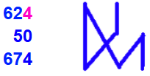
26×24 = 624
26+24 = 50 0 0
674
1.2566370614×10^-6 → like a wave 7 4(π) 7

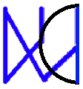
~ if π (3.141592) around the right-most #s → 1/8 & 3/8
45 & 135
electric constant (ε0) = 8.8541... × 10^-12 m^-3 kg^-1 s^4 A^2
position: 20
(1/c)^2= (1/299792458)^2 = (0.0000000033356409519)^
digits: 4 1. 3 = π
~ dimensions of ε0: 10^-12, 3,1,4,2 are either:
the dimensions of the bold black digits, then 0,196:1,2 or digits of π & position #, then 0,196:1,2

κόνικλος = 20+70+50+10+20+30+70+200 = 470
4×π×10^-7 ≈ 1.256637×10^-6
square tessellation hexagon tessellation
470 = 22*22-14; row 15, col 2[2] 470 = layer 15 (469), #1
22×15 = 330 4×π×10^-7
22+15 = 37 π = 3.141592
367 312 = “ἄγγελος”: messenger
μ0 = 1.2566370×[10]^-⬡ ← take ⬡ 60; like a magnet ← “send ⬡ 60; layer 11”
(1/c)^2 = (0.000000003335⬡4095198)^2; in the shape of Π=80 ← R: ⬡ 409; ∑ 1...10;12...15= 109
22*22*1*1*7 = 3388
22+22+1+1+7 = 53
3441; ε0 = 8.85418 in the shape of Π=80
Remainder: 11 from μ0 message & 33,34,3 from ε0 → 33+34+3=70 & 11 → 11.70 = √(1/α)
~ μ0 & ε0 measurements are constrained by the fine-structure constant (α)

Before everything (which is the Hebrew version): messenger: 312, then Π turned 90° or -270° degrees to the same position (turned Π):
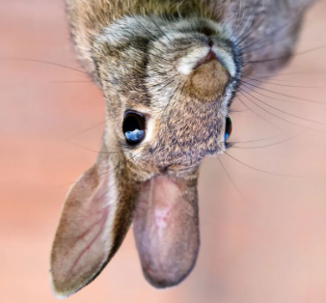
+312+ 90 = 402 6 2 4

+312-270 = + 42
624-180 444

(Π: 180)

~ Chinese zodiac: 4: 亖/四 “death homophone”: upside-down rabbit
囗 (wéi): enclosure; 囗 (kǒu): mouth
儿: (ér): diminutive suffix → homophone 耳 (ěr): ear → 亖 (ancient 4 form similarity)
回 (huí): to circle or go back
先: (xiān) before

Dragon
510 = 400+50+10+50 = תַנִּין
square tessellation hexagon tessellation
510 = 23×23-19; row 20, col 23 510 = layer 14, #41 → David =14
20×23 = 460 → human(46)*3 & 2_×23
20+23 = 43
503
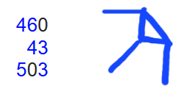
Saul: 300+1+6+30
David: 4+6+4
Solomon: 300+30+40+5
* Trace & connect 3 Kings over the # matrix:

MP Algorithm Part 1: Triangle in Babylonian 1:𒁹
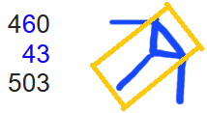
~ Generate p exponents of 2^p-1, filter p to only be prime:
p=1+12*n, p=5+12*n, p=7+12*n, p=11+12*n
(only check prime p= (1,2,3,4,5,6,7,8,9,10,11,12)+12*n) values
~ skip: p=1+12*0; start: p=5+12*0 → 5+7+11+13 = 36; first 4 values

MP Algorithm Part 2: Icosidodecahedron
~ Factor some M#s (2^p-1) to decrease the list containing possible MPs:
32 faces: 20 △(3) & 12 ⬠ (5)
Saul = 300+1+6+30 → skip: (א=1): 2nd letter
skip: MP 1 & 2: (2^2-1=3 & 2^3-1=7); p=2+12*n, p=3+12*n; n>0 ≠ prime
start: 2^5-1=31
~ 6 decagons (10) around shape → 16 factorization loops comprised of the generating p value & the last M# digit: p=1 & (1,3,7,9), p=5 & (1,3,7,9), p=7 & (1,3,7,9), p=11 & (1,3,7,9)
~ Each of the 16 loops have 16 repeating multiple values where M# factor may occur
*Lowest value loop: 1 & 1 (6,16,22,30,40,46,48,70,72,78,88,96,102,112,118,120)
Sum = 1064 & Product = 3.006316...*10^27
Saul =300+1+6+30 → run the 16 loops on the 33% of possible p exponents that are prime, to factor some M#s (2^p-1)

MP Algorithm Part 3: Diagonal line, Octagon, Cube
~ Use primality tests to rule out the remaining M#s → List of MPs
David = 4+6+4 = 14 → Miller-Rabin primality test: 1 in 4^n chance of # not being prime for n bases tested: https://www.youtube.com/watch?v=X9kL2fbEC9U
- 3 numbers (use "witness #” = 3 → never “lies” for M# up to at least p = 16383)
Solomon = 300+30+40+5 = 375 → Lucas-Lehmer primality test
- 2+√3 = 3.73205 → 0.375 = 3/8:🛑; √3 = diagonal in 🧊
s0 (4 numbers) | s1 | s2 | s3
x*y = (2+√3)+(2-√3) = 4 | 4^2-2=14 | 14^2-2=194 | 194^2-2=37634
~ Diagonal line → (√(1^2+1^2)) = 1.4...) & triangle (3) → probability (34.1) →
2^(2^14-1)-1 = 2^(16383)-1 → point where the computation time of the standard Lucas-Lehmer test is faster than the standard Miller-Rabin primality test

Mersenne Prime generation algorithm starting at 2^5-1 explained:
1. Generate a list of p exponents for 2^p-1
2. Filter the list by checking if they are prime
3. "Saul": find low factors for M#s with prime p exponents with the 16 loops
* For M#s that take too long to factor, proceed to use primality tests in succession:
4. "David": Miller-Rabin for p < 2^14-1 = 16383
5. "Solomon": Lucas-Lehmer for p >=2^14-1s
~ to prove an M# probably prime → List of MPs

Hardware: transistor:
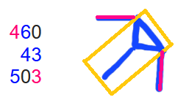
Babylonian 1:𒁹:
63.54 (copper)
1&1.4 hypotenuse p:4 g:11 (copper)
p:3 g:14 (silicon) skipped 1: transistor depletion region?
~ "copper-wired/silicon transistor architecture became the industry standard"

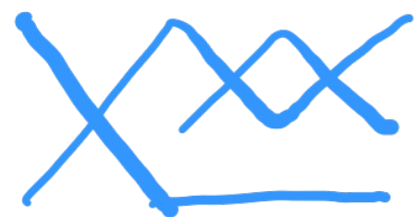
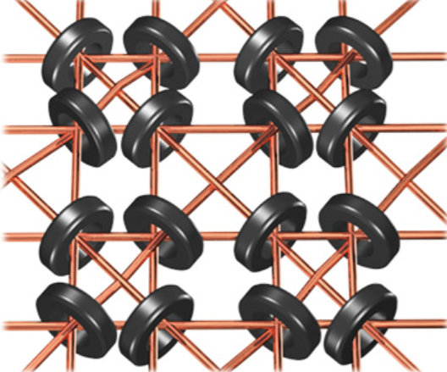
* Connection to all kings:
Saul (1)= 300+ 1+ 6+ 30= 337
David (2)= 4+ 6+ 4 = 14
Solomon (3)= 300+ 30+40+ 5 = 375
* 66 square turned 45 in 3rd pos.: 63.546
* 66^2 = 4356 → 63.54
(337+14+375)×(1+2+3) = 4356 → 63.54
* 2 6s: 26 → magnetic core memory
* 66% of all p in 2^p-1 are removed

δράκων
square tessellation hexagon tessellation
975 = 31×31+14; row:32, col 14 975 = layer 19, #56
32×14 = 448
32+14 = 46
494

* MP Algorithm:
~ (32 faces): Saul+David+Solomon + 494 =
(337+14+375)+494 = 726+494 = 12,20: 20 △ & 12 ⬠
* M# generator (+/×) M# last digit:
(1+5+7+11)+(1+3+7+9) = 44
(1+5+7+11)×(1+3+7+9) = 480 (loop)
* M# sine angle sum: 31+53−67−89 = −72
~ 14: Miller-Rabin primality test: 1 in 4^n
~ 32: Lucas-Lehmer primality test: x*y = (2+√3)+(2-√3) = 4 (s0)
~ 14: standard primality tests computation times cross at 2^(2^14-1)-1

Hardware:
"dragon: δράκων"
Word position: 26 → iron (26); copper (29)
Letter position: 97+98+99+100+101+102 = 597
* net: δίκτυον = 854 → 8, 5 4s & ∠69: ∠69

26+597 = 623 = "Τίγρις: tiger"
Τίγρις. (3)= [300+10]+3+100+10+200
Saul (1)= [300+ 1]+6+ 30
* Lowest loop product: 611 3.00631...*10^27 & start at 2^5-1 = 31
* Revelation: 13:2
* 13*2 = 26 → iron (26 & 56)
13+2 = 15 → the “tiger/river/energy”= 142 & 623 runs through the iron and silicon
41 → Silicon (14); row: p: 3, g:14

* Icosidodecahedron graph:
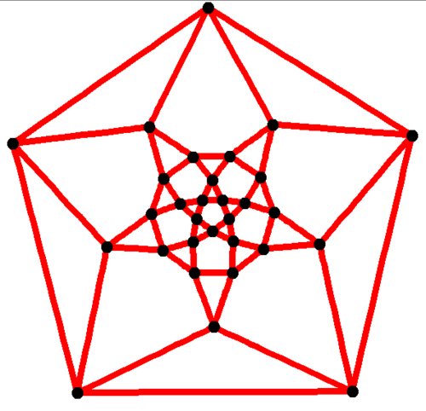

~ Chinese zodiac: 5: X "Emperor": Pharaoh: “The controller”
囟,脑,电脑
Rooster
336 = 10+6+20+300 = שֶׂכְוִי
square tessellation hexagon tessellation
336 = 18×18+12; row 19, col 12 2
19×12 = 228 336 = layer 12 (331), #5
19+12 = 31 53= heat/sun(חַמָּה); 301= fire(אֵשׁ)
19×12+19+12 = 259 U-235 fissile (broken apart)
* U-235; 92 fissile (broken apart)
* heat/sun = 8+40+5 = 53 (חַמָּה)
* rooster: sun rise; rooster comb: flame
* Rezeph (רֶצֶף) = 200+90+80: destroyed by Assyria
1 Kings 19:6: hot stones = רְצָפִים (plural)
2 Kings 19:12 & Isaiah 37:12: וְרֶצֶף
* hot stones: 5th word, letter (19,20,21)
* and Rezeph: 12th word let. 44+45+46
* and Rezeph: 12th word let. 47+48+49
Word position: 5+12+12 = 29
Letter position (וְרֶצֶף) - positions (רְצָפִים) = (44+45+46)+(47+48+49)-(19+20+21) = 219
(44+45+46)+(47+48+49) = 279
1,7,... ꙮ

ἀλέκτωρ = 1+30+5+20+300+800+100 = 1256
square tessellation hexagon tessellation
1256 = 35×35+31; row 36, col 31 1256 = layer 21 (1141), #115
36×31 = 1116 layer switched→ 1411-511 = 900
36+31 = 67 1411+511 = 1922
36×31+36+31 = 1183 92 & broken 92 → 0 & 0,1
92+92+1= 185&00 → 850=fire(πυρός)
* Uranium(92): 6th element in period 7[111]
* between p: 6, g: 11 & p: 8, g: 11 → Remaining: 67 & 301 (אֵשׁ): fire
* in place 68 (standard normal distribution: 1 σ shape): 53 (חַמָּה): heat/sun
* Combine non-cross Hebrew & A. Greek #: (2×8×1)×(1×7×3×1×1) = 336 (שֶׂכְוִי): Rooster
(2+8+1)+(1+7+3+1+1) = 24: "complete ⏰"
336+24 = 360: "complete ⭕ & 🔳"

~ Chinese zodiac: 10: 十 "completeness"
* Combine characters:
⊥ (top) & ⊤ (bottom): 上 (shàng) & 下 (xià)

Wise man
8+20+40 = 68 = חָכָם ~
Genesis 41:33 → 34.13
וְעַתָּה יֵרֶא פַרְעֹה, אִישׁ נָבוֹן וְחָכָם; וִישִׁיתֵהוּ,
עַל-אֶרֶץ מִצְרָיִם
* 6th word; letter 20,21,22; 1 and prefix
20+21+22+6−1 = 68
~ standard normal distribution values, 1 sigma

Light
207 = אוֹר ~
Genesis 1:3, 4th word

______________

