Number-to-Meaning Map

Goat
77 = 70+7 = עֵז
square tesselation hexagon tesselation
77 = 9×9-4; row 5, col 9 77 = layer 6 (61), # 16
5×9 = 45 → 360÷45 = 8: Octagon
5+9 = 14
5×9+5+9 = 59 → 360÷59 = 6.101...

αἴξ = 71 = 1+10+60 → period 6, group 11 (gold)
square tesselation hexagon tesselation
71 = 8×8+7: row 9 col 7 71 = layer 6 (61), # 10
9×7 = 63 → 360÷63 = 5.71 side shape
9+7 = 16 → 1570 = gold (Χρυσός)
9×7+9+7 = 79

~ Chinese zodiac: 8: 八 "to split or divide", "wealth"

Rooster
336 = 10+6+20+300 = שֶׂכְוִי
square tesselation hexagon tesselation
336 = 18×18+12; row 19, col 12 2
19×12 = 228 336 = layer 12 (331), #5
19+12 = 31 53= heat/sun(רֶצֶף); 301= fire(אֵשׁ)
19×12+19+12 = 259 U-235 fissile (broken apart)
* U-235; 92 fissile (broken apart)
* heat/sun = 8+40+5 = 53 (חַמָּה)
* rooster: sun rise; rooster comb: flame
* Rezeph (רֶצֶף) = 200+90+80: destroyed by Assyria
1 Kings 19:6: hot stones = רְצָפִים (plural)
2 Kings 19:12 & Isaiah 37:12: וְרֶצֶף
* hot stones: 5th word, letter (19,20,21)
* and Rezeph: 12th word let. 44+45+46
* and Rezeph: 12th word let. 47+48+49
Word position: 5+12+12 = 29
Letter position (וְרֶצֶף) - positions (רְצָפִים) = (44+45+46)+(47+48+49)-(19+20+21) = 219
(44+45+46)+(47+48+49) = 279
1,7,... ꙮ

~ ἀλέκτωρ = 1+30+5+20+300+800+100 = 1256
square tesselation hexagon tesselation
1256 = 35×35+31; row 36, col 31 1256 = layer 21 (1141), #115
36×31 = 1116 layer switched→ 1411-511 = 900
36+31 = 67 1411+511 = 1922
36×31+36+31 = 1183 92 & broken 92 → 0 & 0,1
92+92+1=185&00 → 850=fire(πυρός)
* Uranium(92): 6th element in period 7[111]
* between p: 6, g: 11 & p: 8, g: 11 → Remaining: 67 & 301 (אֵשׁ): fire
* in place 68 (standard normal distribution: 1 σ shape): 53 (חַמָּה): heat/sun
* Combine non-cross Hebrew & A. Greek #: (2×8×1)×(1×7×3×1×1) = 336 (שֶׂכְוִי): Rooster
(2+8+1)+(1+7+3+1+1) = 24: "complete ⏰"
336+24 = 360: "complete ⭕ & 🔳"

~ Chinese zodiac: 10: 十 "completeness"
* Combine:
⊥ (top) & ⊤ (bottom): 上 (shàng) & 下 (xià)

Dragon
510 = 400+50+10+50 = תַנִּין
square tesselation hexagon tesselation
510 = 23×23-19; row 20, col 23 510 = layer 14, #41 → David =14
20×23 = 460 → human(46)*3 & 2_×23
20+23 = 43
503
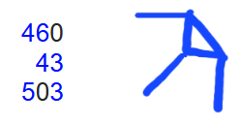
Saul: 300+1+6+30
David: 4+6+4
Solomon: 300+30+40+5
* Trace & connect 3 Kings over the # matrix:

MP Algorithm Part 1: Triangle in Babylonian 1:𒁹
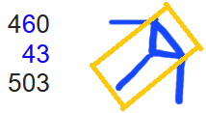
~ Generate p exponents of 2^p-1, filter p to only be prime:
p=1+12*n, p=5+12*n, p=7+12*n, p=11+12*n
(only check prime p= (1,2,3,4,5,6,7,8,9,10,11,12)+12*n) values
~ skip: p=1+12*0; start: p=5+12*0 → 5+7+11+13 = 36; first 4 values

MP Algorithm Part 2: Icosidodecahedron
~ Factor some M#s (2^p-1) to decrease the list containing possible MPs:
32 faces: 20 △(3) & 12 ⬠ (5)
Saul = 300+1+6+30 → skip: (א=1): 2nd letter
skip: MP 1 & 2: (2^2-1=3 & 2^3-1=7); p=2+12*n, p=3+12*n; n>0 ≠ prime
start: 2^5-1=31
~ 6 decagons (10) around shape → 16 factorization loops comprised of the generating p value & the last M# digit: p=1 & (1,3,7,9), p=5 & (1,3,7,9), p=7 & (1,3,7,9), p=11 & (1,3,7,9)
~ Each of the 16 loops have 16 repeating multiple values where M# factor may occur
*Lowest value loop: 1 & 1 (6,16,22,30,40,46,48,70,72,78,88,96,102,112,118,120)
Sum = 1064 & Product = 3.006316...*10^27
Saul =300+1+6+30 → run the 16 loops on the 33% of possible p exponents that are prime, to factor some M#s (2^p-1)

MP Algorithm Part 3: Diagonal line, Octagon, Cube
~ Use primality tests to rule out the remaining M#s → List of MPs
David = 4+6+4 = 14 → Miller-Rabin primality test: 1 in 4^n chance of # not being prime for n bases tested: https://www.youtube.com/watch?v=X9kL2fbEC9U
- 3 numbers (use "witness #” = 3 → never “lies” for M# up to at least p = 16383)
Solomon = 300+30+40+5 = 375 → Lucas-Lehmer primality test
- 2+√3 = 3.73205 → 0.375 = 3/8:🛑; √3 = diagonal in 🧊
s0 (4 numbers) | s1 | s2 | s3
x*y = (2+√3)+(2-√3) = 4 | 4^2-2=14 | 14^2-2=194 | 194^2-2=37634
~ Diagonal line → (√(1^2+1^2)) = 1.4...) & triangle (3) → probability (34.1) →
2^(2^14-1)-1 = 2^(16383)-1 → point where the computation time of the standard Lucas-Lehmer test is faster than the standard Miller-Rabin primality test

Mersenne Prime generation algorithm starting at 2^5-1 explained:
1. Generate a list of p exponents for 2^p-1
2. Filter the list by checking if they are prime
3. "Saul": find low factors for M#s with prime p exponents with the 16 loops
* For M#s that take too long to factor, proceed to use primality tests in succession:
4. "David": Miller-Rabin for p < 2^14-1 = 16383
5. "Solomon": Lucas-Lehmer for p >=2^14-1s
~ to prove an M# probably prime → List of MPs

Hardware: transistor:
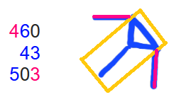
Babylonian 1:𒁹:
63.54 (copper)
1&1.4 hypotenuse p:4 g:11 (copper)
p:3 g:14 (silicon) skipped 1: transistor depletion region?
~ "copper-wired/silicon transistor architecture became the industry standard"

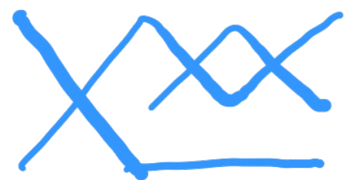
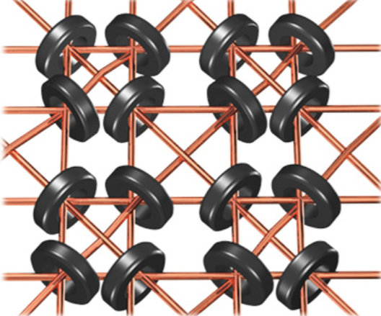
* Connection to all kings:
Saul (1)= 300+ 1+ 6+ 30= 337
David (2)= 4+ 6+ 4 = 14
Solomon (3)= 300+ 30+40+ 5 = 375
* 66 square turned 45 in 3rd pos.: 63.546
* 66^2 = 4356 → 63.54
(337+14+375)×(1+2+3) = 4356 → 63.54
* 2 6s: 26 → magnetic core memory
* 66% of all p in 2^p-1 are removed

~ δράκων
square tesselation hexagon tesselation
975 = 31×31+14; row:32, col 14 975 = layer 19, #56
32×14 = 448
32+14 = 46
494

* MP Algorithm:
~ (32 faces): Saul+David+Solomon + 494 =
(337+14+375)+494 = 726+494 = 12,20: 20 △ & 12 ⬠
* M# generator (+/×) M# last digit:
(1+5+7+11)+(1+3+7+9) = 44
(1+5+7+11)×(1+3+7+9) = 480 (loop)
* M# sine angle sum: 31+53−67−89 = −72
~ 14: Miller-Rabin primality test: 1 in 4^n
~ 32: Lucas-Lehmer primality test: x*y = (2+√3)+(2-√3) = 4 (s0)
~ 14: standard primality tests computation times cross at 2^(2^14-1)-1

Hardware:
"dragon: δράκων"
Word position: 26 → iron (26); copper (29)
Letter position: 97+98+99+100+101+102 = 597
* net: δίκτυον = 854 → 8, 5 4s & ∠69: ∠69

26+597 = 623 = "Τίγρις: tiger"
Τίγρις. (3)= [300+10]+3+100+10+200
Saul (1)= [300+ 1]+6+ 30
* Lowest loop product: 611 3.00631...*10^27 & start at 2^5-1 = 31
* Revelation: 13:2
* 13*2 = 26 → iron (26 & 56)
13+2 = 15 → the “tiger/river/energy”= 142 & 623 runs through the iron and silicon
41 → Silicon (14); row: p: 3, g:14

* Icosidodecahedron graph:
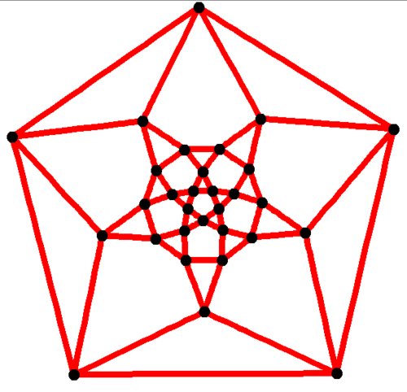

~ Chinese zodiac: 5: X "Emperor": Pharaoh: “The controller”
囟,脑,电脑
Tiger
חִדֶּקֶל ~ Tigris (3rd river)
square tesselation
8+4+100+30 = 142 = 12×12-2; row 3, col 12
3×12=36 → 3rd = הַשְּׁלִישִׁי = 655
3+12=15
51
Word pos: 4
Letter pos: 14+15+16+17 = 62
51+4+62 = 117
√(1/α) = 11.70623
Spectral lines appear as: 11

~ "3 animal beast"
* Revelation: 13:2 "dragon: δράκων"
Word position: 26
Letter position: 97+98+99+100+101+102 = 597
26+597 = 623 = "Τίγρις: tiger"
* Referring to dragon 11111... pattern
square tesselation
623 = 25×25-2; row 3, col 25
3×25= 75
3+25= 28
103
1/α = 137. 035999177
α = 0.0072973525643
√α = 0.0854245398
31+27+58 = 116
13+72+85 = 170
√(1/α) = 11.70623
α: causes the spectral lines : tiger

~ Chinese zodiac: 3: 三 (11=3) "san": "to scatter", "to split"

Wise man
8+20+40 = 68 = חָכָם ~
Genesis 41:33 → 34.13
וְעַתָּה יֵרֶא פַרְעֹה, אִישׁ נָבוֹן וְחָכָם; וִישִׁיתֵהוּ,
עַל-אֶרֶץ מִצְרָיִם
* 6th word; letter 20,21,22; 1 and prefix
20+21+22+6−1 = 68
~ standard normal distribution values, 1 sigma

Light
207 = אוֹר ~
Genesis 1:3, 4th word

______________

