CSE 212 – Programming with Data Structures
W01 Prove – Response Document

Name: | Joshua Flood
Date: | September 17, 2026
Teacher: | Porter McGary

It is a violation of BYU-Idaho Honor Code to post or share this document with others or to post it online. Storage into a personal and private repository (e.g. private GitHub repository, unshared Google Drive folder) is acceptable.

Question 1: For the rotate right problem, provide a description of how you solved the problem.
First, I made an int variable named index at 0 which will make sure that we only go through the while loop. Speaking of which, I make a while loop that will run as long as the index is less than the amount parameter. To start the loop, I make 3 int variables: saveEvenValue (set to 0), saveOddValue (set to the value of data at index 0), and saveLastValue (set to the value at the last index). Then, I make a for loop (with an int value I set to 0; goes as long as I is less than data List amount, and increases by 1 at the end of each loop). This will go through the array and determine what to do next based on the index (i). If it’s the last index, data[0] is set to saveLastValue. If it is an even index (i%2 == 0), then saveEvenValue is set to the next index’s value and the next index’s value is set to saveOddValue. If it is an odd index (i%2 == 1), then saveOddValue is set to the next index’s value and the next index’s value is set to saveEvenValue. This goes until i is equal to data.Count. Once it finishes, the index variable goes up by 1 (keeps the while loop from being infinite and making the amount to shifts needed as called by the method.
Question 2: For the rotate right problem, draw a picture of how you solved the problem.
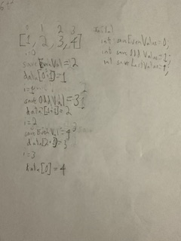

Remember: You need to commit all the changes to the prove-01-<username> repository along with this document. Then submit a link to the repository in I-Learn.

