AI eLearning Estimator
High-Level Design Document
Field | Detail
Document type | High-Level Design (HLD)
Project type | Internal web tool (single form with options)
Primary user | Laurie
Status | Draft for review
Date | June 15, 2026
Source inputs | Requirements Document (revised) + SME call transcript + Laurie's screen sketch
This revision | Corrected the additional-minutes model: one control per category on the header (not per row) that scales all Dynamic subtasks linearly off their defaults; Type is a per-subtask dropdown (Fixed/Dynamic); ADA toggle moved to the header top-middle; ADA flat 10% for Rise and Storyline; all “Team” subtasks reassigned to named owners; Laurie's rate confirmed at $75; blocks appear on selection and collapse/expand; Add and Remove-last subtask controls; categories spaced as cards; future-database note. This pass: header laid out as name · Total Time (enlarged) · Additional minutes box · ADA · Collapse/Expand, and Hours/Responsible shown as editable fields.

Contents

1. Overview
The AI eLearning Estimator is an internal web tool that helps the team produce eLearning project estimates faster and more consistently. Today an estimate takes roughly 5 hours of manual work; the tool aims to cut that to about 1 hour by automating the repetitive calculation and lookup work.
At its heart the tool is a single form. Laurie checks one or more category blocks (Microvideo, Rise 360, Storyline 360). Each checked category shows a checklist of subtasks pre-filled with the names, responsible people, and hours from the requirements. She adjusts as needed, optionally adds minutes or subtasks, and the tool calculates every cost live. One button exports the whole thing to a Word document.

1.1 Goals
- Reduce estimate creation time from ~5 hours to ~1 hour.
- Produce consistent, repeatable estimates that are easy to audit.
- Output a clear breakdown of hours per team member, internal cost, and client price.

1.2 Out of scope
- Integration with accounting, CRM, or proposal-generation systems.
- Multi-user accounts, permissions, or roles.
- Invoicing or any handling of actual payments.
- A database or saving the input — for the current version the tool is stateless and the Word export is the only saved output. (A database is anticipated in a later phase; see the note below.)
- An editable settings area — hourly rates are constant and built in (see Section 2).
Looking ahead — A database is likely in a future phase so Laurie can save and reopen estimates and statements of work (SOWs) rather than re-entering them. The current architecture is deliberately stateless and kept easy to extend; adding persistence later would not require rebuilding the form or the calculations.

2. Team & Rates (constant)
There is one user, Laurie. Three team members can be assigned to subtasks. Their hourly rates are fixed constants in the tool — there is no settings screen to change them:
Team member | Role | Hourly rate
Megan | Development / coordination | $50
Michelle | Design / storyboarding | $65
Laurie | Project management | $75

Each subtask's cost is its hours × the responsible person's rate (e.g. Laurie 4 hrs → 4 × $75 = $300).
Confirmed — Laurie's rate is confirmed at $75/hr (the earlier $75-vs-$85 question is resolved). It is kept as a single constant in the code so any future change is one line.

3. Core Concepts

3.1 Categories are multi-select
Three categories, each a checkable block. Laurie can select one, two, or all three. Each checked category contributes its subtasks to the combined estimate; unchecked categories are excluded entirely.
Category | Default length | Notes
Microvideo | 3 minutes | Short-form video with narration and captions
Rise 360 | 15 minutes | Avg. 6 lessons plus Welcome and Summary
Storyline 360 | 15 minutes | Avg. 6 lessons plus Welcome and Summary

3.2 Subtasks are simple and checkable
Within each category is a checklist of subtasks. A subtask is intentionally simple — just three things plus two controls:
- Name — what the task is (e.g. “Storyboard”).
- Responsible — who does it: Megan, Michelle, or Laurie.
- Hours — how many hours that person spends.
- Checkbox — include this subtask in the estimate or not.
- Fixed / Dynamic toggle — whether the hours scale with additional minutes (see 3.4).
The names, responsible people, and hours from the requirements document are loaded as the placeholder/default values for every field. They hold true unless Laurie edits them.

3.3 Adding subtasks
Each selected category has “+ Add subtask” and “− Remove last subtask” controls. Add appends a new row with the same simple shape — name, responsible person, hours, checkbox, and Fixed/Dynamic toggle — so its cost flows into that category's subtotal like any default subtask. Remove pops the bottom-most subtask off the list, stack-style (last on, first off). To exclude a default row without deleting it, simply uncheck it instead.

3.4 Fixed vs. Dynamic subtasks
Every subtask is marked either Fixed or Dynamic, chosen from a dropdown in the Type column on that row, and Laurie can change it per subtask:
- Fixed — the hours never change, no matter how many additional minutes are added (e.g. sales meetings, project management).
- Dynamic — the hours scale up linearly with the category's additional minutes (e.g. development). Example: a Storyline subtask at 3 hrs when the category is 15 min, with +5 min added (20 min total), becomes 3 × (20 ÷ 15) = 4 hrs automatically.

3.5 Additional minutes (one control per category)
Each category has a single “additional minutes” control (0–20) on its header — not on individual rows. It lengthens that category beyond its default runtime, and that increase scales the hours of every Dynamic subtask in the category linearly off its default; Fixed subtasks and other categories are unaffected. For example, taking a 15-min category to 20 min multiplies each Dynamic subtask's hours by 20÷15. The exact formula is in Section 6.

3.6 ADA compliance
Each applicable category has a prominent ADA toggle. When switched on it adds a flat 10% uplift to that category's cost rather than adding hours. The 10% rate is the same for both Rise 360 and Storyline 360; Microvideo has no ADA option. See Section 6.

3.7 Blocks appear on selection; collapse to stay tidy
A category's block only appears on screen once its checkbox is ticked — unchecked categories show no block at all, keeping the form short. Each visible block has two forms: collapsed (showing just a few subtasks with an Expand control, so several categories can be open at once without clutter) and expanded to full size (every subtask visible, with add/remove and per-row minutes). Categories are spaced apart so each block reads as a distinct card.

4. Screens
The app is two screens. There is no settings screen — rates are constant and all editing happens inline on the form.
Screen | Purpose
Estimator (home) | The form: check categories, adjust subtasks, set minutes, toggle ADA. Shows live per-subtask, per-category, and grand totals.
Export Preview | Review the combined estimate as it will appear in Word, then download the .docx.

4.1 Workflow at a glance
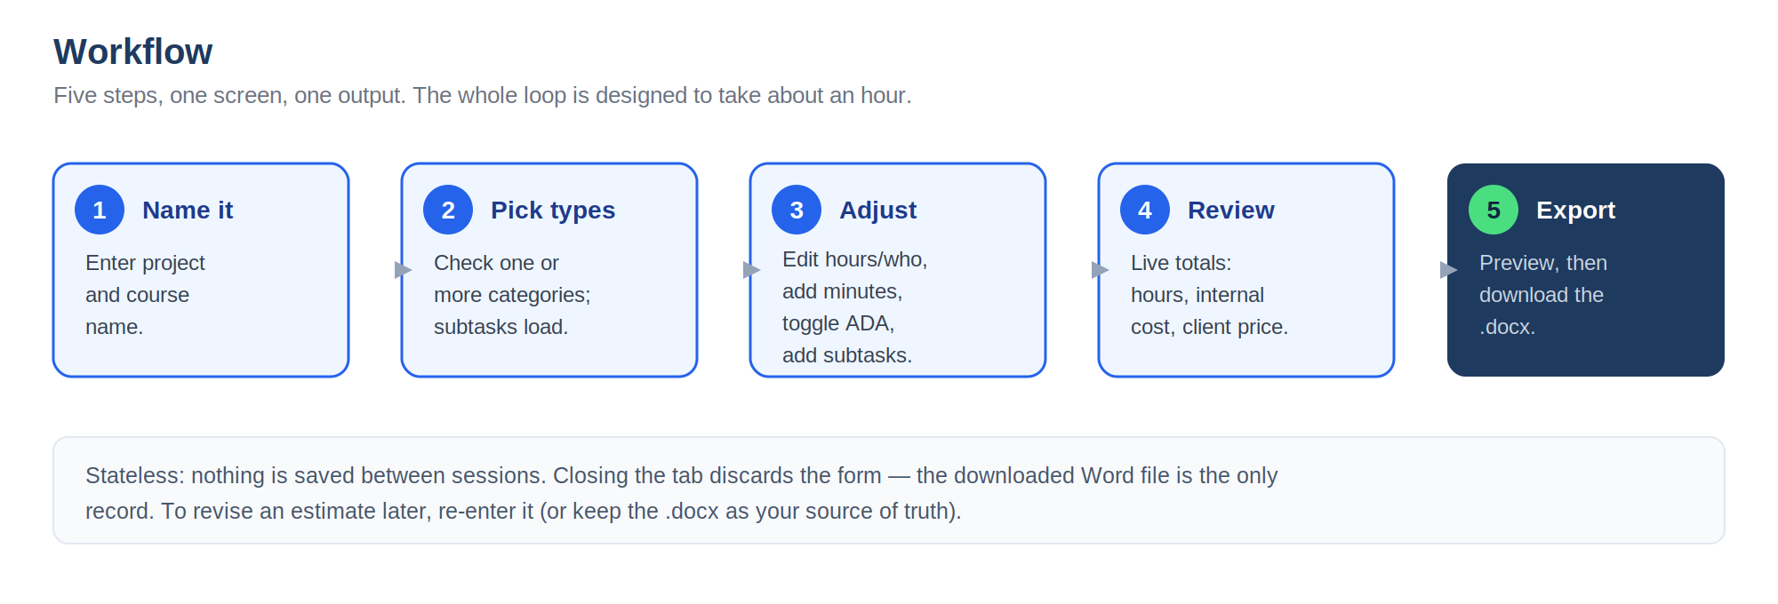
The five-step flow, start to finish, on a single screen plus a preview.

5. Screen 1 — Estimator (the form)
Project & course name at the top, then the category selector. A category's block appears only once it is checked, and the categories are spaced apart as distinct cards. Each block header reads left-to-right: the category name, then a large Total Time readout (default length plus any added minutes), then a clean Additional minutes (0–20) input box, then — where relevant — a prominent ADA compliant toggle (flat +10%, Rise/Storyline only), with the Collapse / Expand control in the top-right corner. Inside, each subtask row has an include checkbox, an editable name, an editable Responsible field, an editable Hours field, a Type dropdown (Fixed or Dynamic), and a live line cost. A block can be collapsed (a few subtasks plus Expand) or expanded to full size (all subtasks, plus Add / Remove). A combined grand total and the export button sit at the foot.
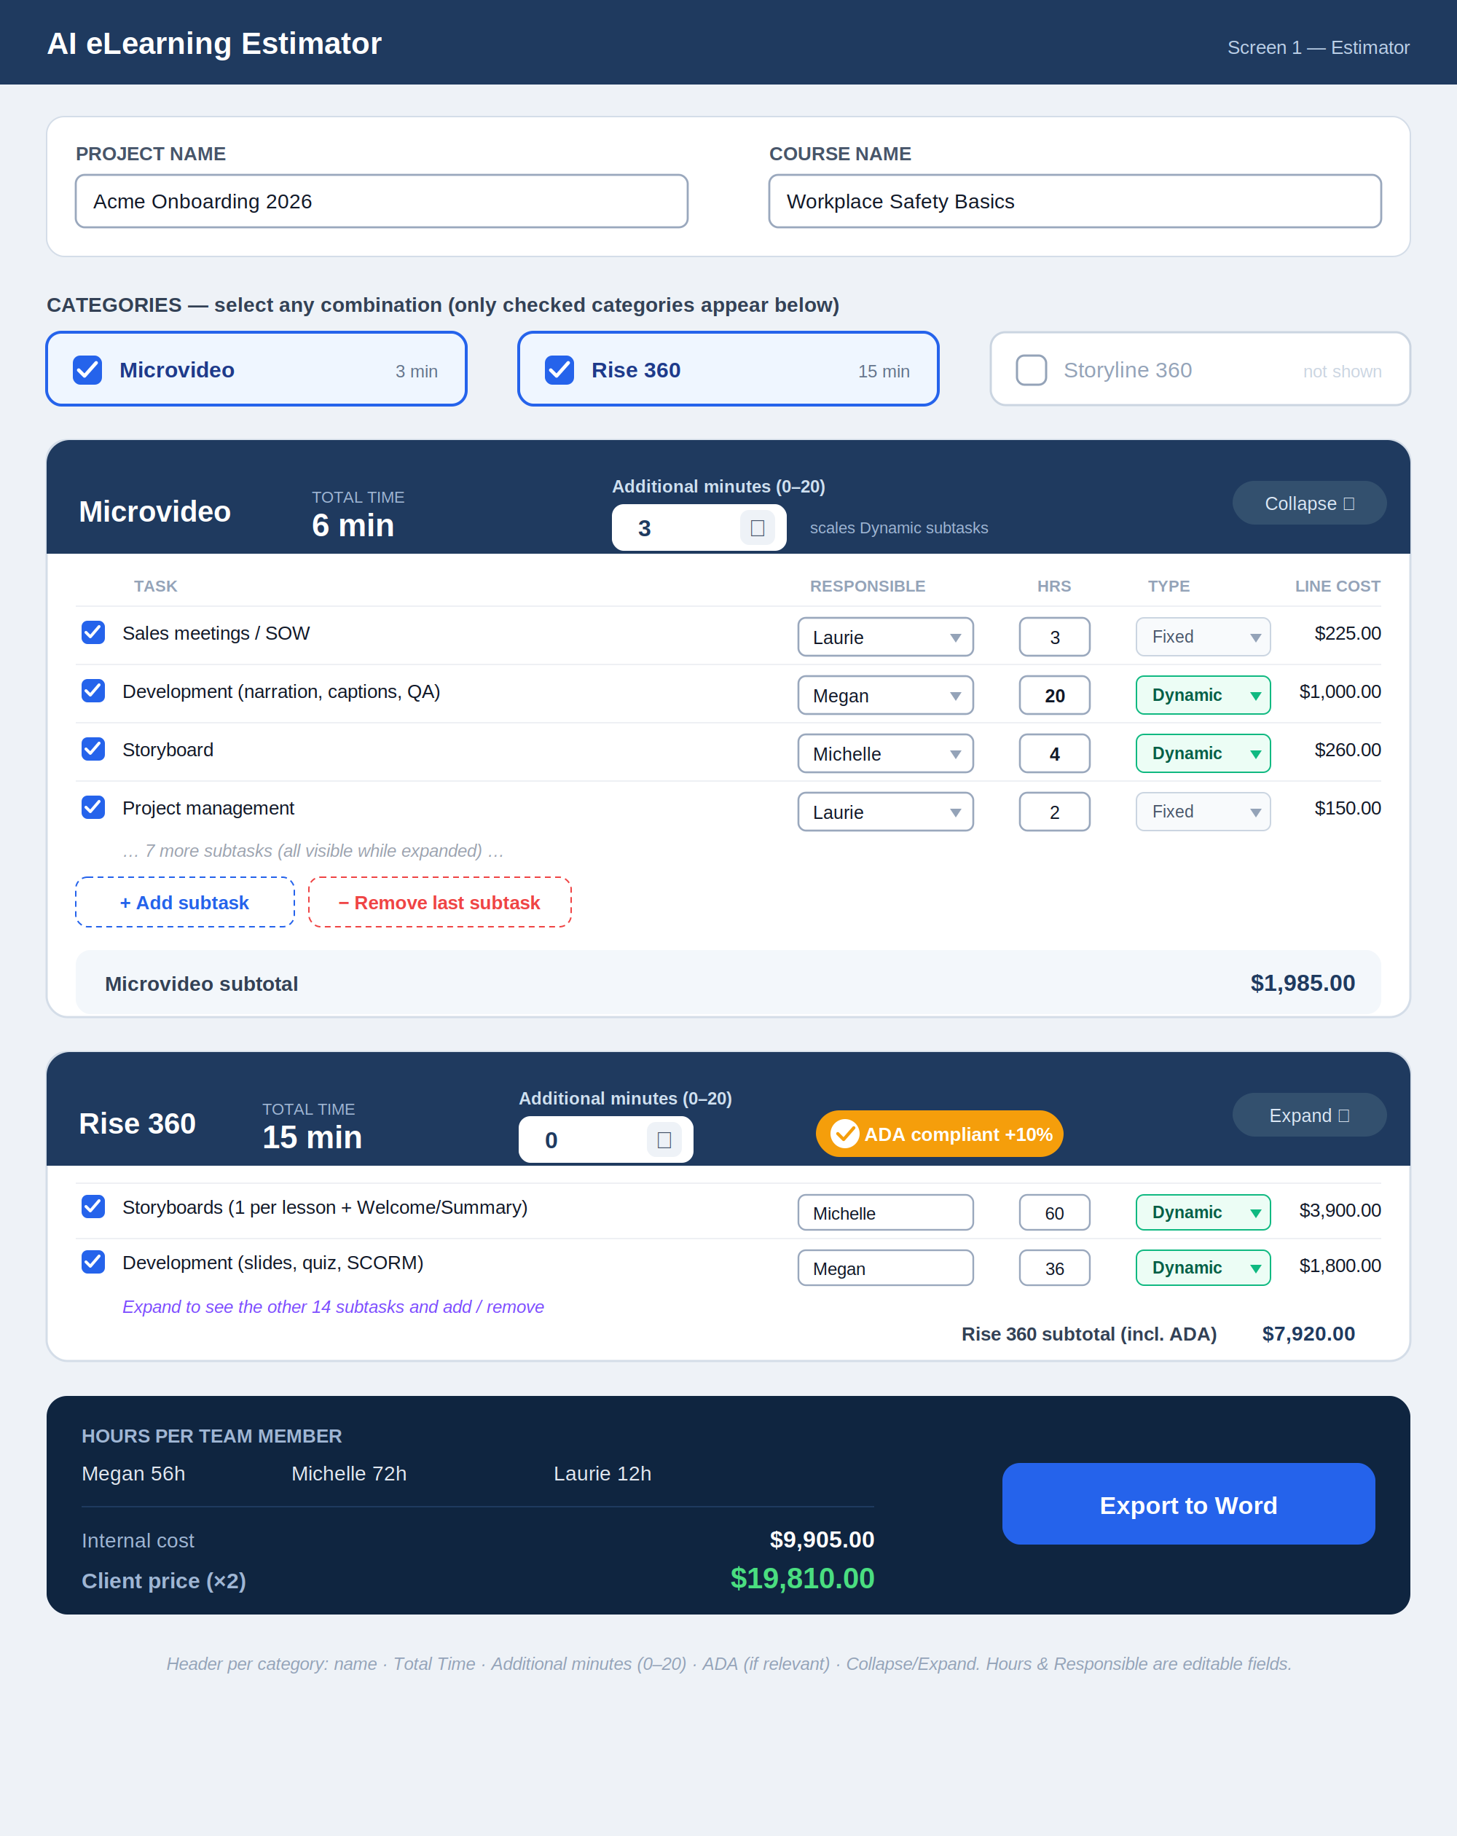
Estimator — each category header shows the name, a large Total Time, an Additional minutes box, an ADA toggle (Rise/Storyline), and Collapse/Expand. Hours and Responsible are editable fields; Type is a dropdown. Microvideo is expanded; Rise 360 is collapsed.

5.1 All options on this screen
- Project name and Course name (free text).
- Category checkboxes — Microvideo, Rise 360, Storyline 360 (any combination).
- Per category header (left→right): name, a large Total Time readout, an Additional minutes (0–20) input box, an ADA toggle where relevant, and a Collapse / Expand control top-right.
- Per category: a prominent ADA toggle (Rise / Storyline only), a flat +10%.
- Per subtask: include checkbox, editable name field, editable Responsible field (Megan / Michelle / Laurie), editable Hours field, and a Type dropdown (Fixed or Dynamic). Hours and Responsible are clearly editable input boxes, not static text.
- Per category: “+ Add subtask” and “− Remove last subtask” controls, plus a Collapse / Expand control on the block header.
- Live readouts: per-subtask line cost, per-category subtotal, combined grand total.
- “Export to Word” button.

5.2 Anatomy of a subtask row
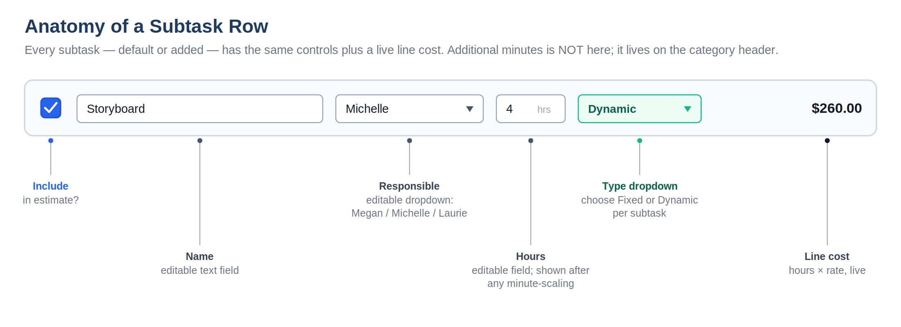
Every subtask row and what each control does. Name, Responsible, and Hours are editable input fields; Type is a dropdown (Fixed or Dynamic). Additional minutes is NOT on the row — it is one control on the category header. Line cost = effective hours × the responsible person's rate, recalculated live.

5.3 Category states
The same category block appears differently depending on what Laurie does. These are the states she will encounter:
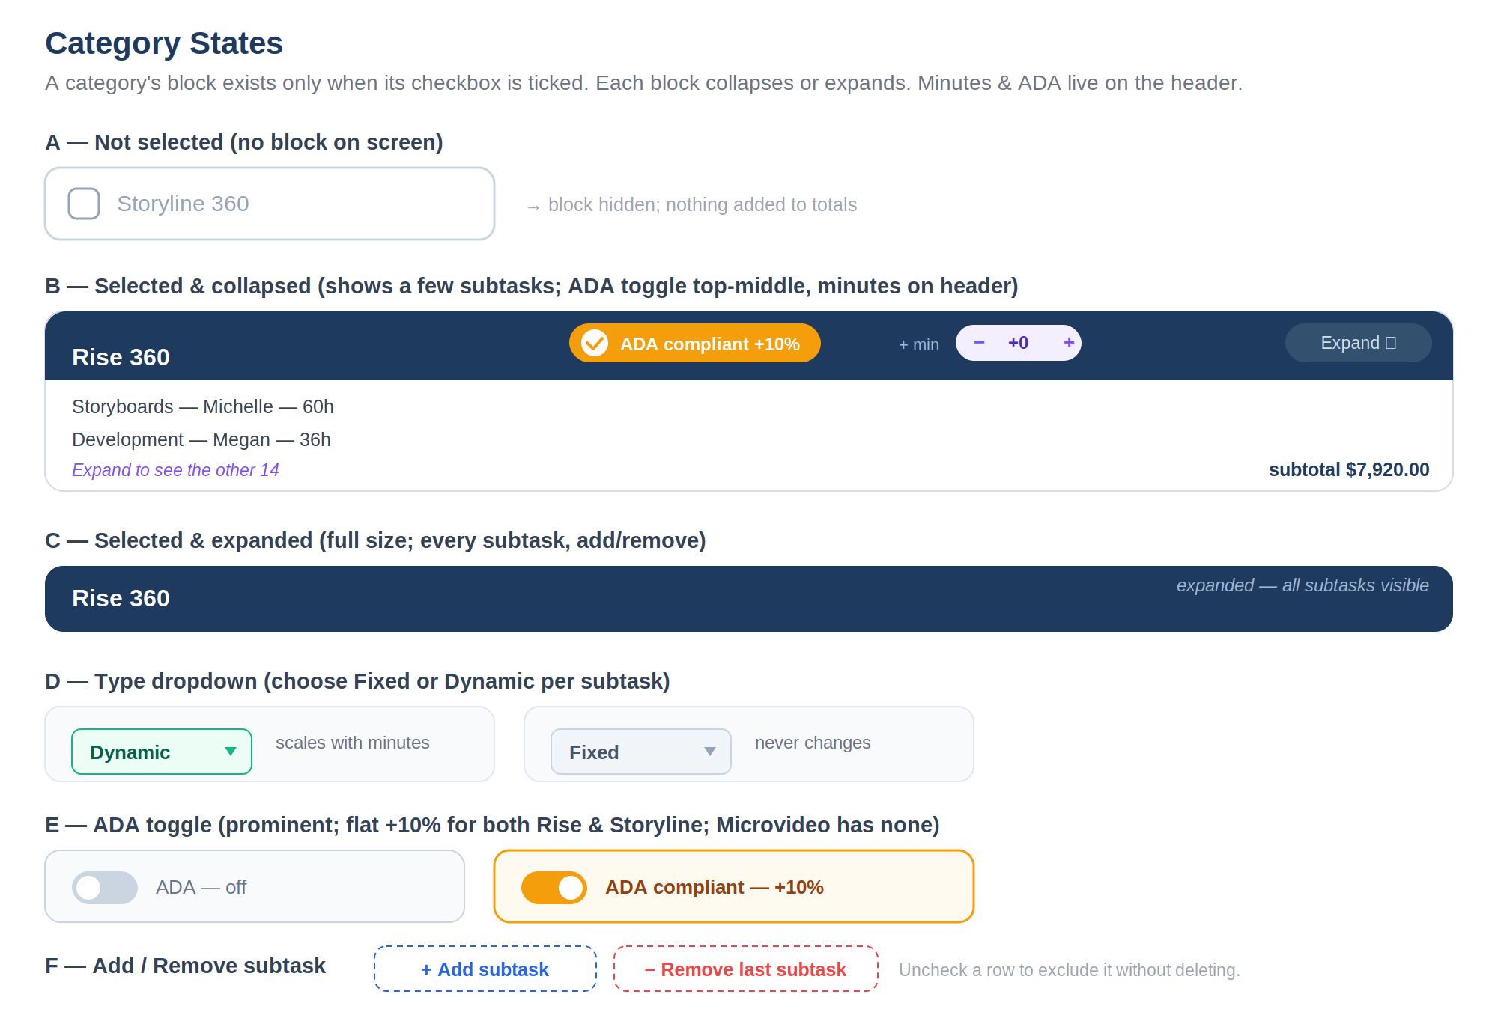
Not-selected (no block), selected & collapsed, selected & expanded, the Type dropdown (Fixed/Dynamic), the prominent ADA toggle (flat +10%), and the Add / Remove subtask controls. The additional-minutes control and ADA toggle live on the category header. Unchecking a row drops it from totals — never deletes.

6. Formulas & Calculations
Every number the tool shows comes from the formulas below. They run live as Laurie edits the form.

6.1 Hours after minute-scaling
First, each subtask's effective hours are determined by its Fixed/Dynamic flag and its category's additional minutes:
Fixed: hours = default_hours
Dynamic: hours = default_hours × (default_minutes + additional_minutes) / default_minutes
Example: a Dynamic subtask with 6 default hours in Microvideo (default 3 min) with 3 additional minutes → 6 × (3 + 3) / 3 = 12 hours. A Fixed subtask stays at its default regardless.
Open item — The scaling method is set to linear (proportional to runtime) for now, based on the default placeholder hours. Laurie to confirm the exact behaviour with Michelle; the design keeps it easy to change.

6.2 Per-subtask line cost
line_cost = hours × rate(responsible)
where rate is the constant for the responsible person: Megan $50, Michelle $65, Laurie $75. Only checked subtasks count.

6.3 Per-category subtotal
category_internal = sum of line_cost for all checked subtasks in the category
if ADA checked: category_internal = category_internal × (1 + ada_rate)
ada_rate is a flat 0.10 for both Rise 360 and Storyline 360. Microvideo has no ADA.

6.4 Hours per team member
member_hours = sum of that member's subtask hours across ALL checked categories
Hours for the same person combine across categories, so each of Megan, Michelle, and Laurie appears once in the totals.

6.5 Internal cost (grand total)
internal_cost = sum of all category_internal (including each category's ADA)
Equivalently, the sum over members of member_hours × rate, plus ADA uplifts.

6.6 Client price
client_price = internal_cost × 2 (a 50% profit margin)
Worked example: internal cost $4,000 → client price $8,000. The $4,000 difference is 50% of the client price. The margin is a constant 50%.

6.7 Worked end-to-end example
A complete estimate with Microvideo (+3 min) and Rise 360 (ADA on) selected, Storyline excluded — matching the screens above:
Item | Detail | Amount
Microvideo subtotal | Dynamic rows scaled to 6 min | $1,485.00
Rise 360 subtotal | $7,200 + 10% ADA | $7,920.00
Internal cost | sum of subtotals | $9,405.00
Client price | internal × 2 | $18,810.00

7. How Additional Minutes Work
- Each category has a single additional-minutes control (0–20) on its header. It is independent of the other categories.
- Adding minutes scales every Dynamic subtask in that category (linearly off its default hours); Fixed subtasks never change.
- Scaling is linear off the default hours: at double the total runtime, a Dynamic subtask's hours double (per the formula in 6.1).
- Because scaling changes hours, it flows automatically into line cost, the category subtotal, internal cost, and client price.

8. Export to Word
The “Export to Word” button opens the Export Preview, then downloads one combined Word document covering everything selected.

8.1 Export Preview screen
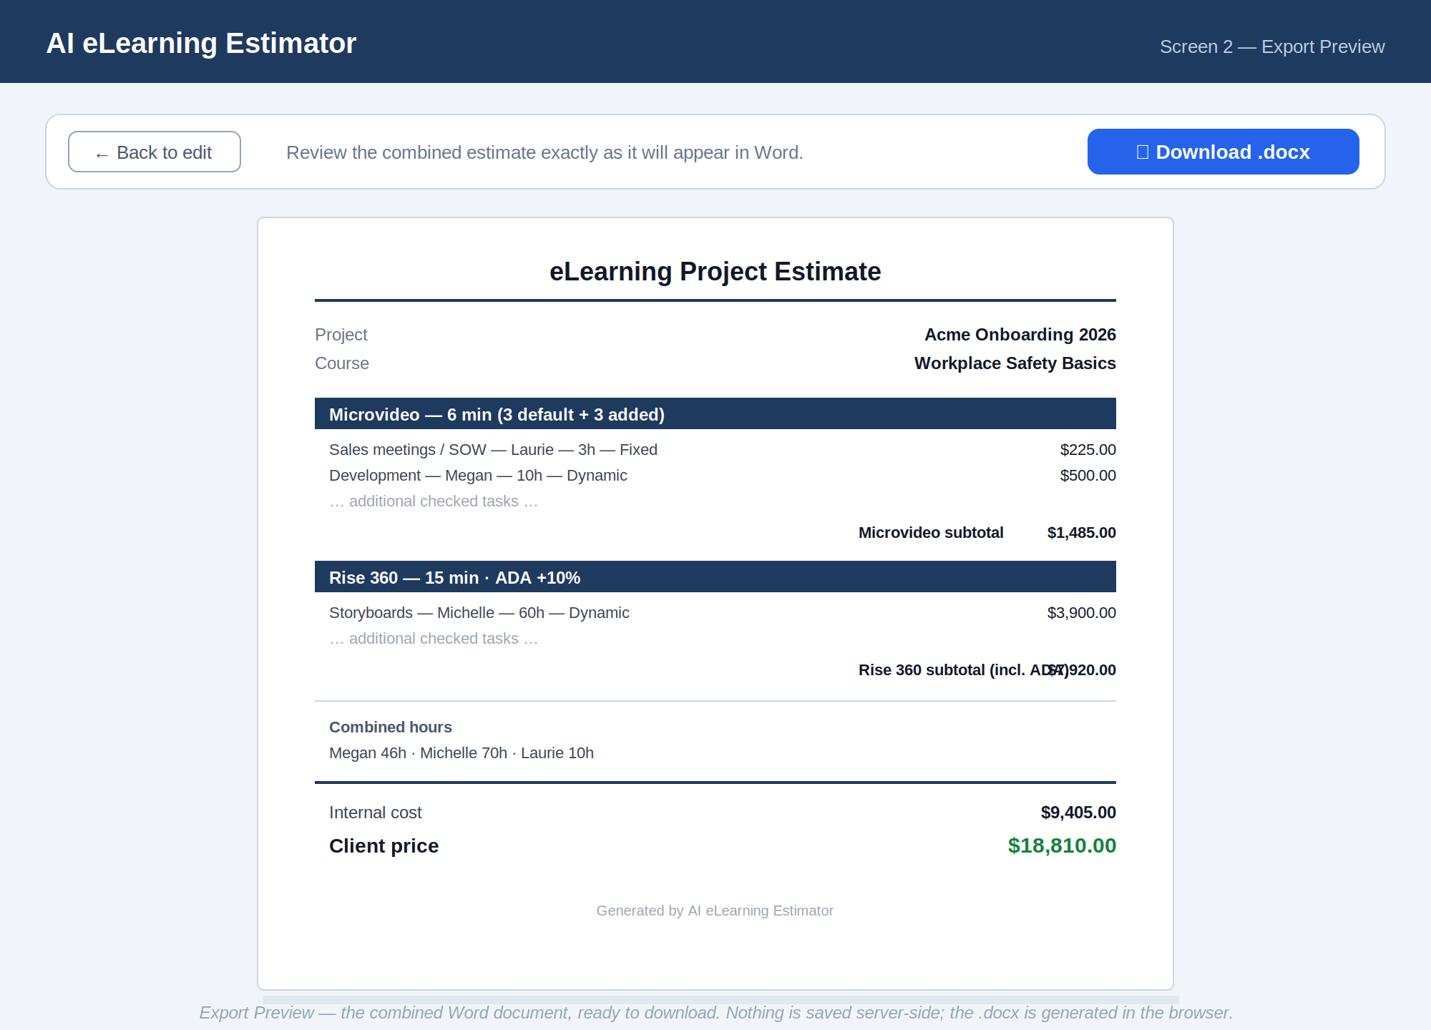
Export Preview — review the combined estimate exactly as it will appear in Word, then download. Generated in the browser; nothing is saved server-side.

8.2 The Word document
The .docx contains:
- Project name and course name.
- Each checked category with its total length (default + additional minutes).
- Per category: every checked subtask with its responsible person, hours, Fixed/Dynamic flag, and line cost; then the category subtotal (including ADA if applied).
- Combined hours for Michelle, Megan, and Laurie.
- Internal cost and client price.
Word is the only export format. The file is generated in the browser and downloaded directly.
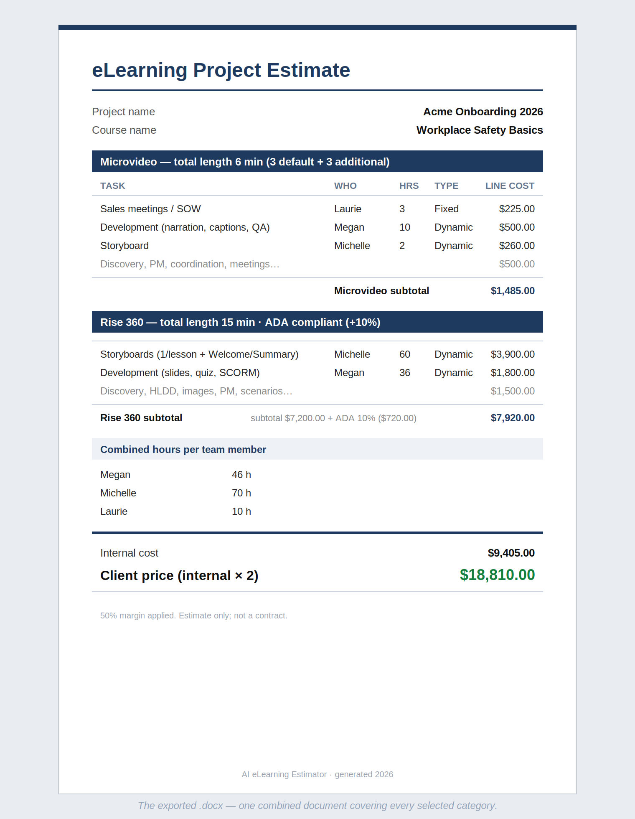
The exported .docx — one combined document covering every selected category, ready to send or keep as the record of the estimate.

9. Default Subtask Data (placeholders)
Each category loads these subtasks as the default/placeholder values, taken from the revised requirements. Format: subtask — responsible person — hours. Every subtask is now assigned to one named person (Michelle, Megan, or Laurie); the old shared “Team” rows have each been assigned to a specific owner — meetings, communication, and lessons-learned default to Laurie as PM. Adjust per row if the real owner differs.

9.1 Microvideo (default 3 min)
- Sales meetings / SOW — Laurie 3
- Discovery — Megan 1
- 1 SME meeting for storyboard — Megan 1
- Internal meetings, client kickoff and status meetings — Laurie 6
- Development: title, outro, AI narration, record screens, captions (VTT), QA/revisions, annotations, callouts, zooms — 5
- Storyboard — Michelle 2 + Megan 1
- Lessons-learned meeting — Laurie 2
- Email / Teams communication — Laurie 2
- Project management — Laurie 2
- Project coordination — Megan 2
- Logo stinger — Megan 2

9.2 Rise 360 (default 15 min, ~6 lessons)
- Sales meetings / SOW — Laurie 3
- Discovery — Michelle 2
- Internal meetings, client kickoff and status meetings — Laurie 1
- 2 SME meetings for storyboard — Michelle 2
- HLDD — Michelle 2
- Storyboards — 1 per lesson, avg. 6, plus Welcome and Summary — Michelle 60
- Modify existing templates / prototypes — Megan 1
- Development: Welcome, Summary, title screen, 3 KC and 5 interaction slides per lesson, 10 quiz questions, QA/revisions, SCORM package — Megan 36
- Lessons-learned meeting — Laurie 2
- Image procurement — Megan 2
- Email / Teams communication — Laurie 2
- Project management — Laurie 2
- Project coordination — Megan 2
- Up to 5 min of VEO3 / Vyond scenarios — Michelle 6
- Up to 5 custom images — Megan 3
- ADA compliant — toggle, flat +10% (see Section 6)

9.3 Storyline 360 (default 15 min, ~6 lessons)
- Sales meetings / SOW — Laurie 3
- Discovery — Michelle 2
- Internal meetings, client kickoff and status meetings — Laurie 6
- 2 SME meetings for storyboard — Michelle 2
- HLDD — Michelle 2
- Storyboards — 1 per lesson, avg. 6, plus Welcome and Summary — Michelle 60
- Modify existing templates / prototypes — Megan 2
- Development: 3 KC and 3 interaction slides per lesson, Welcome, Summary, title screens, 10 quiz questions, animation on 90% of slides, AI voice, captions, SCORM package, upload all sources, QA/revisions — Megan 20
- Lessons-learned meeting — Laurie 2
- Image procurement — Megan 2
- Email / Teams communication — Laurie 2
- Project management — Laurie 2
- Project coordination — Megan 2
- Up to 5 min of VEO3 / Vyond scenarios — Michelle 6
- Up to 5 min of software simulations — Michelle 6
- Up to 5 custom images — Megan 3
- ADA compliant — toggle, flat +10% (see Section 6)

10. Hosting & Deployment
Because the tool is stateless — no database, no accounts, no server-side storage, and the Word file is built in the browser — it can ship as a single static web app. No backend server is required.
Concern | Approach
Framework | React (the UI, live calculations, and .docx generation all run client-side).
Word export | Generated in the browser with a JavaScript .docx library and downloaded directly — no round-trip to a server.
Source control | GitHub repository; every change committed and pushed so versions are recoverable.
Hosting | Vercel, connected to the GitHub repo. Each push auto-deploys; the live URL updates automatically.
Backend / API | Not needed for the current scope. A server layer would only be required if saving, accounts, or integrations are added later — all currently out of scope.
Cost | A static app on Vercel's free/hobby tier is sufficient for a single internal user.

Note — Next.js with API routes is an option but unnecessary here; a plain client-side React build covers every requirement. Keep the architecture minimal until a real need (saving, multi-user, integrations) appears.

11. How to Use the Tool
A typical estimate, end to end:
- Open the tool's URL in a browser.
- Type the project name and course name at the top.
- Check the category or categories this project includes (Microvideo, Rise 360, Storyline 360).
- For each checked category, review the pre-filled subtasks. Uncheck any that don't apply; edit names, responsible people, or hours where the default isn't right.
- If the project runs longer than the default, set the category's additional-minutes control on its header — every Dynamic subtask in that category rescales automatically.
- Switch on the ADA toggle for Rise/Storyline if required (adds a flat 10% to that category).
- Add any one-off subtasks with “+ Add subtask”, or pop the last one off with “− Remove last subtask”. Collapse blocks you're done with to keep the form tidy.
- Read the live totals at the foot: hours per person, internal cost, and client price.
- Click “Export to Word,” review the preview, and download the .docx.
- Save or send the .docx — it is the only record, since the form itself isn't stored.
Remember — The tool is stateless. Closing the tab discards the form. To revise an estimate later, re-enter it (or keep the exported .docx as your source of truth).

12. Open Items
Item | Status
Exact minute-scaling behaviour and which subtasks default to Dynamic | Laurie to confirm with Michelle

Neither blocks the build. The tool can be developed and tested now with the placeholder values and the linear scaling default.

