**Scrum Retrospective**

Joshua M. Collins

SNHU

CS-250, Arthur McWain

10/27/2024

Throughout the scrum process, each role within the team contributed greatly to the advancement of the project. The tester and product owner in particular were instrumental in the completion of user stories. Utilizing scrum-agile principles, the team was able to handle interruptions to work flow and adapt to changes easily. Communication was a major key to the success of the scrum process and the project over all.

Within the project, each team member performed their role in a way that complimented the work of other team members and moved the project forward. The developer quickly created a working product with which to begin testing, and updated it when demands changed. Using this working product, the tester designed use cases and investigated their results. The product owner contributed by focusing on the value of the final product and improving communication between the team and the client. The scrum master helped to ensure that the project followed Agile frameworks and the scrum process was simple for other team members to follow.

A Scrum-Agile approach is useful in both the creation and adjustment of user stories. Given that an agile approach to development encourages iterative development through the different “sprints”, user stories can be quickly generated. Once generated, team members are able to investigate important details about these stories and further clarify the wants, needs, and likely actions of users in relation to the final product. For example, within the design of the user test cases, after the initial cases were created, an email was sent providing clarification on the needs of the client, and the test cases were updated based on this email. This created a far more targeted user story that dealt directly with the needs and wants of the client and userbase. \

The scrum-agile approach helps to deal with interruptions in many ways. Generally, scrum-agile methods are focused heavily on speed and flexibility. Given this, dealing with interruptions such as the change in focus from vacation spots to health/treatment centers was quite simple, and could be completed quite quickly. One of the main ways in which the scrum approach helped is that it is highly based on iterative development, so the majority of the building blocks were there from which the changes could be implemented. Within a normal project with a scrum team, daily scrums are a common method that allows priorities to shift quickly in alignment with a change in vision or other unexpected interruptions.

Communication is one of the most integral parts of the Scrum-Agile process. Within the module 6 discussion, we were presented with the opportunity to engage with each other as a mock scrum team. For my part in the team, I chose the role of tester. As a tester, I communicated with a “developer” and a “product owner”. In my reply to the “developer” I responded to their proposition of utilizing a sprint retrospective within the project.

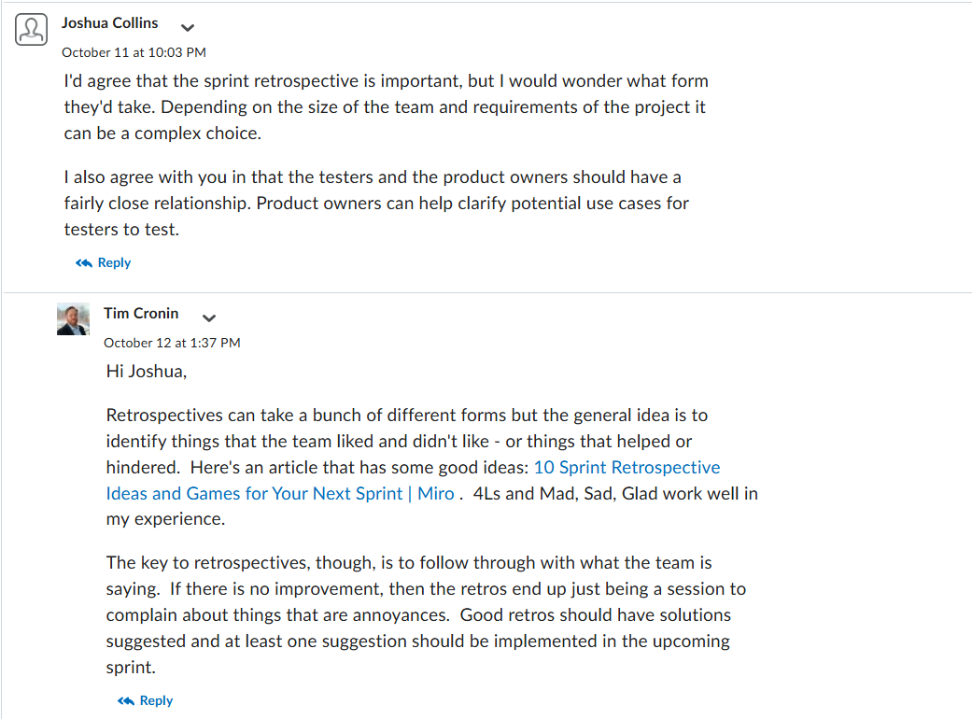

Within my reply, I concur with his proposition of a sprint retrospective as a tool we should use within the project, and then ask a clarifying question of his proposition. In asking a clarifying question, it provides an opportunity for the team member to further outline their idea, while also making them feel like their input is not only valuable but also welcomed. This is evidenced by his response in which the team member outlines their goal in advancing sprint retrospectives as an important part of this project, and goes on to describe what they DON’T want it to be. I also responded to the “product owner”.

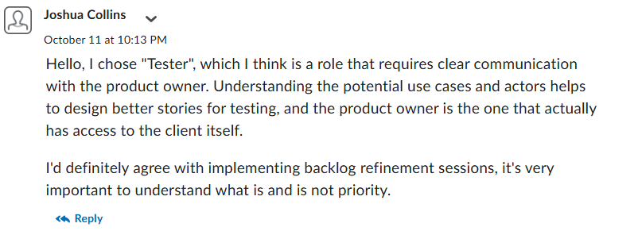

Here, I explain the role I have chosen while also expressing the extent of the relationship between us as team members. I provide my rationale for this, mentioning that the product owner has access to the client which will provide further material with which to produce accurate user stories and test cases.

Organizational tools within Scrum are important to maintaining efficient teams. One of the most important is the backlog, the backlog contains a list of different tasks and their priorities. Backlog refinement is a scrum event that helps to maintain this backlog, keeping it up to date. This increases efficiency within the scrum team and process by assuring that the tasks that have highest priority are known.

The Scrum-Agile process is quite effective for the SNHU Travel project. Despite the direction of the project changing halfway through, the agile-scrum process allowed for flexibility and the ability to build upon the foundation of previous sprints. Some aspects of Scrum-Agile would be counterproductive to the project, for example, small team sizes can limit the ability of a team to function if one falls behind or is unable to work that day. Daily meetings and planning events can also be quite time consuming.

.