**Problem statement**

This lab is about evaluating the performance of a pseudo-randomly generated graph, as an abstraction of a wireless sensor network.

**Connectivity**

Given pseudo-random WSN had three isolated clusters of nodes. Full connectivity was achieved by adding two nodes to the WSN. The location of the nodes was selected to increase coverage with robust connectivity.

Figure 1. Given WSN (left), Fully connected WSN with two added nodes highlighted with circle (middle), Nodes that will cause portions of the WSN to go dark if they were to fail are highlighted (right)

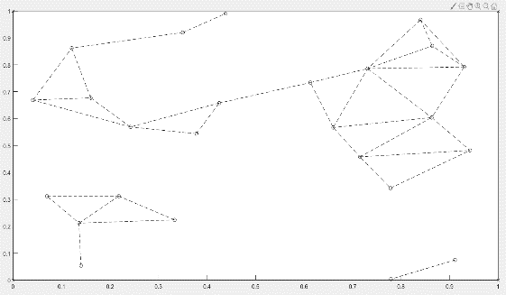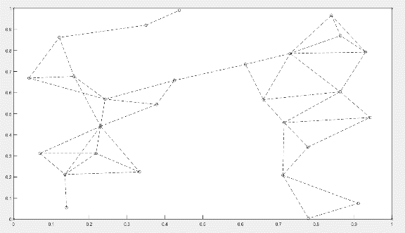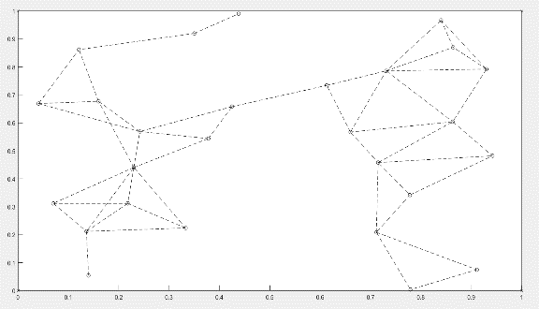

**Coverage**

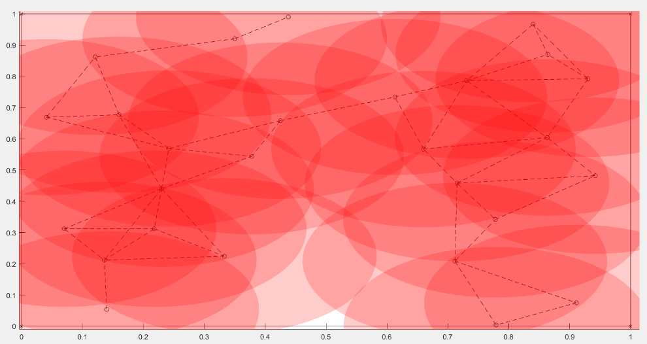The graph below shows the coverage of the WSN. The overlapping circles were given a transparent red colour in MATLAB. The darker areas represent areas with a high k-coverage, the highest of these k values if 5. The areas with only a light red colour are areas with a low k-coverage. The top right corner and bottom middle have a k value of 1 for example. The very bottom middle that is white has a k value of 0. This means there is no sensor nodes converging this area.

Figure 2. Coverage of WSN in L by L area. Each node's coverage area is model as transparent red circle.

**Maximal Breach Distance**

The maximal breach distance was calculated by using the Voronoi tessellation. Many of the calculations for the path were done by looking at the graph. A few choices were made by comparting calculations.The correct path is drawn in red with the possible decisions in purple. Along with the Voronoi tessellations a table of the option calculations is below.

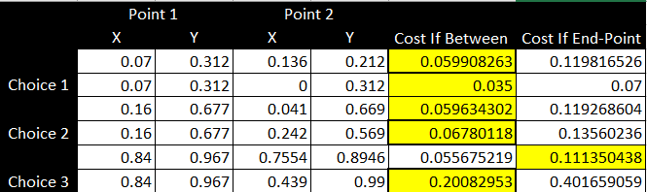

Figure 3.Voronoi tessellation (left), Maximal breach distance, red line, with the other paths considered, purple lines (right)

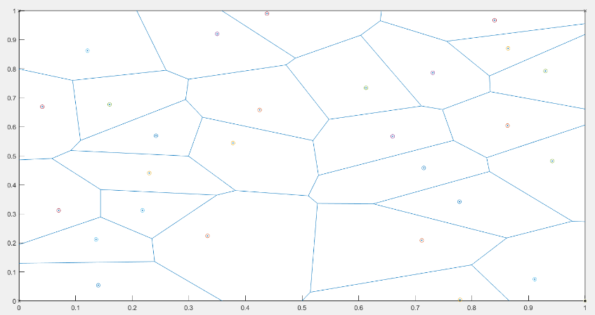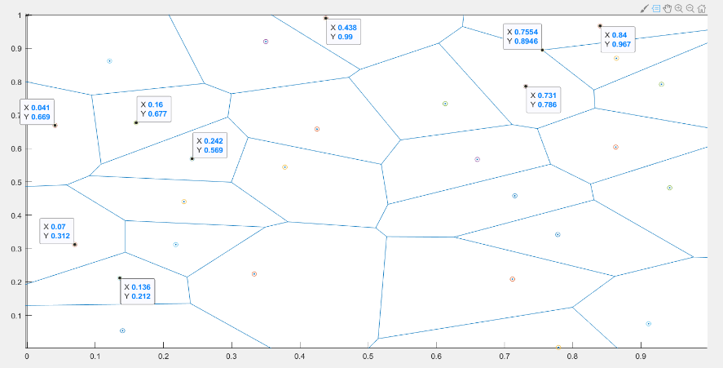

**Maximal Support Path**

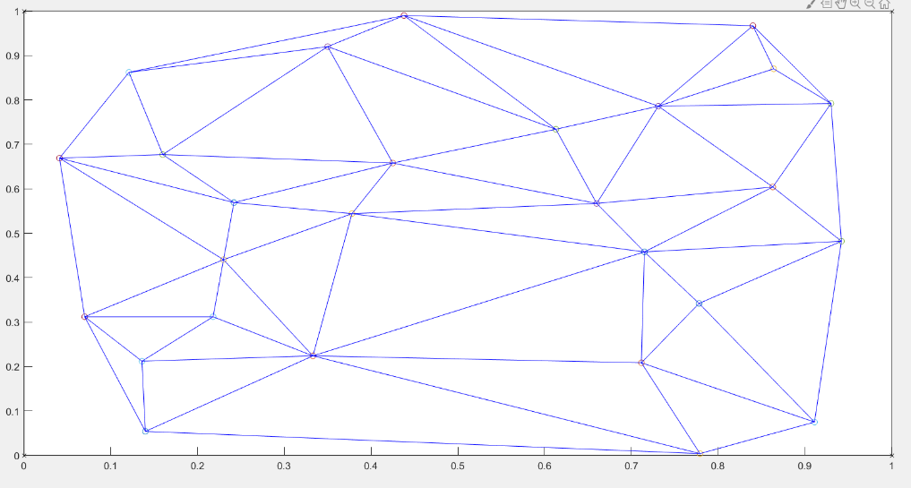

Figure 5. Maximal support path

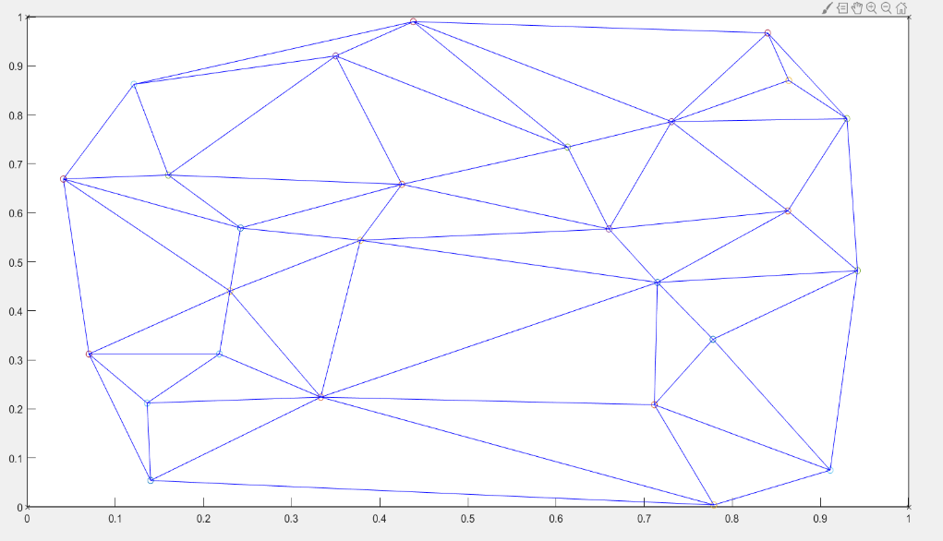

Figure 4. Delaunay triangle