Joshua Desmond - jdesmo01@rams.shepherd.edu
Nathan Healy - nhealy01@rams.shepherd.edu
Final Report
Abstract:
This report will detail the process and inner workings on the financial calculator. This calculator was developed by the teammates listed. It is a combination of web programming fundamentals which include coding experience in html, css, and javascript. The program is created using one html file that creates the skeleton and combines all of the files together. It then uses one css file to style the calculator. It concludes the calculator with a javascript file for program functionality. This calculator was developed as a team project for CIS 332 Web Programming in order to display our coding prowess and growth in these web fields.
Financial Calculator Development:
We chose this project because it was a simple yet effective way to demonstrate what we have learned in CIS 332. It allowed us to combine all three forms of scripting we did over the semester being html,css, and javascript. It solidified our understanding of how each individual language can be intertwined to create a functional web application. For instance, we learned that the html is the foundation of the program. It is what the user will be interacting with. It creates the gui and then the css styles it to make it look appealing to the user. Then the javascript gives us functionality. This project aims to achieve a goal of allowing users to quickly perform financial calculations for insurance, auto loan, and other payments such as mortgage. It is designed to be a portable application so it can be used on the go for user friendly availability. In our project we focused on the agile methodology which means we broke our project down into smaller subproblems and programmed it in a series of “sprints.”These sprints were the html, css, and javascript. We had to perform each sprint one after the other because without the html, neither the css or javascript could be programmed or tested. Once all three sprints were complete we began testing our project in our browser. As stated before, it started with this html file. 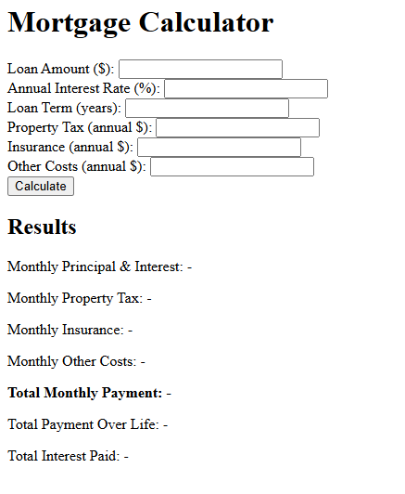
This is the foundation and it defines all our functional requirements. We needed to be able to take an input from the user,perform quick calculations, and then display them back to the user. The software requirements were obviously html, css, and javascript, but also we had to define what javascript api we wanted to use. Since we need to display and calculate data for the user it would make sense to use APIS that directly assists with that. Axios is great for calculations. Combining all of these features gives up this program.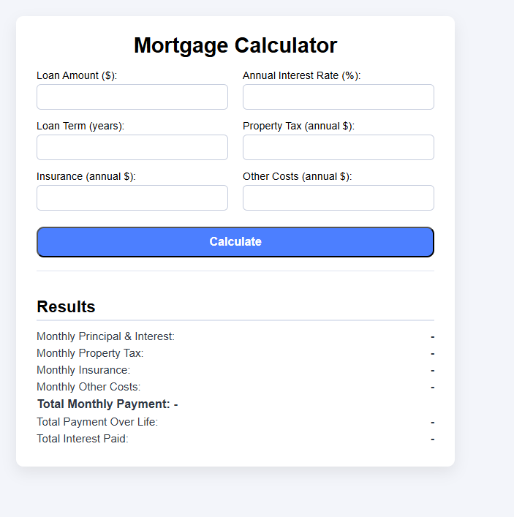
Against the timeline, this project performed well. This project was designed to be built over the course of 4 weeks and it came together nicely. Each individual part was small so they were able to be programmed rather quickly and when they were combined the final result performed well. Here are some of the final results from our demo to display how it works.
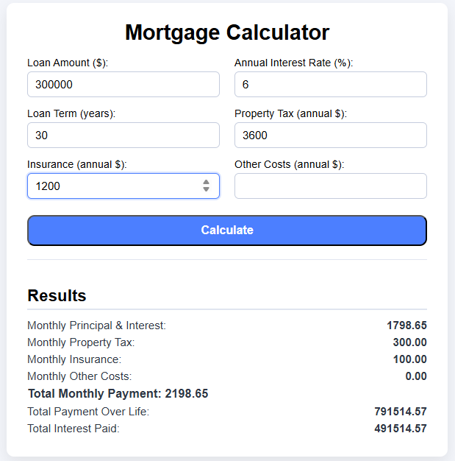
We wanted to include imagery using chart.js but it was not working for this program and due to time constraints we will have to abandon this concept. In summary, we created a calculator using html,css and javascript that is able to calculate a user's mortgage and monthly payments. It displays the calculations back to the user. The goal is for it to be a quick and efficient calculator for our users.

