Team 4 Testing Evidence
(J. Dickerson, D. Desautels, K. Smith, A. Melen)

Contents
- Introduction
- Overall System Inspection
- Server-Side Inspection
- GUI Inspection
- Game Loop Testing
- Conclusion

Introduction
Our Rat-A-Tat-Cat is a 2 player Java-based game that runs as an embedded applet in any Java-enabled web-browser. At the outset of the project, our team divided work into the several primary components, and then specified their interfaces. This process made working around developer schedules and time-constraints easier as each team member had a largely compartmentalized unit to work on. While this “modular” approach made development easier, it made testing more disjoint and without a unifying procedure. Because of this, team members were responsible for the testing procedures of their own code. No single harness was written that captured all components under a single umbrella. Once individual components were tested by their developer, the system was coupled together and tested for “top-to-bottom” functionality.
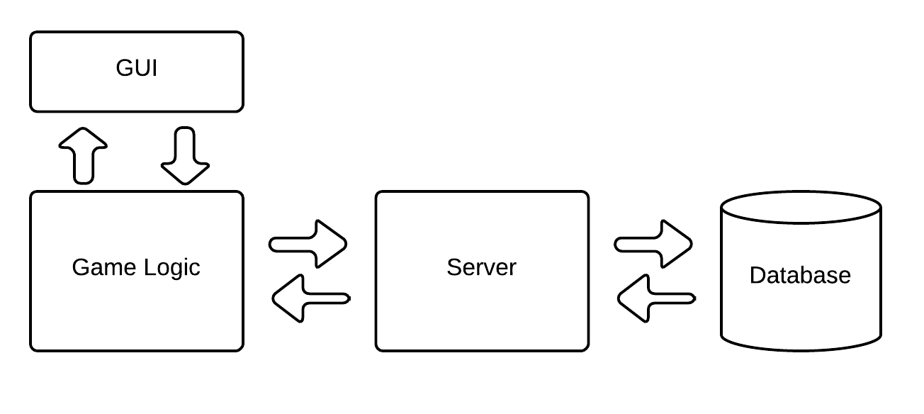
Fig 1.0 – Game System Architecture

On the client side, both GUI and game logic testing was performed, while on the server-side connectivity, database availability, and the Java-to-PHP interface were tested.
Whole system runs were performed where the applet was built, embedded, and run in the Google Chrome browser. During these runs, data was posted to the web API, and added to the database. The leader-board graphs were then inspected, and observed to be changing as gameplay was being simulated. Figure 1.1 shows live usage graphs changing over time as simulation games are played.

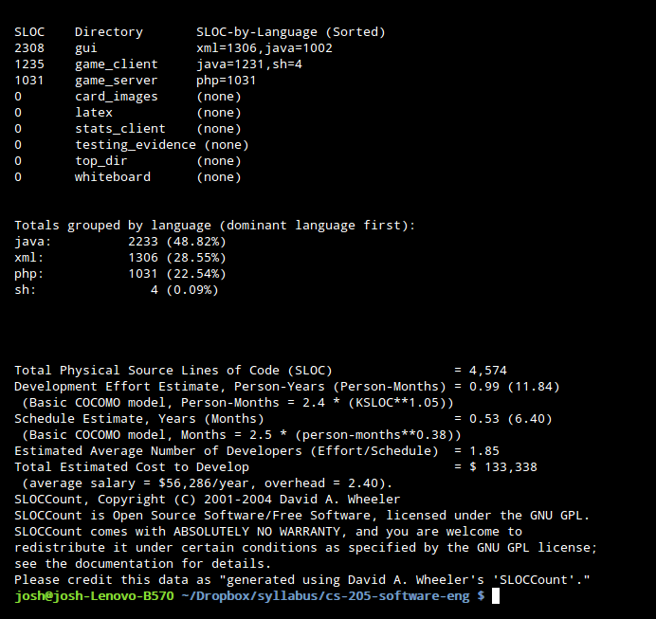
Overall System Testing
To get an overview of the system, we used the SlocCount command-line utility to record the size and composition of the codebase.

The output of the SlocCount tool shows a breakdown of the project's lines of code, estimated programmer-time employed, and estimated of labor costs. The lines of code are slightly inflated by included libraries, but nonetheless give a quick indicator of the codebase composition.

Figure 1.1 shows the change in games/time graph during and after actual game play.

Server-Side Testing
Evidence of communication during state transitions
To test the exchange of state data between the Java client and the web-server, a view was written to output the contents of a server-side log file. The log file shows the contents of each http-post to the web server, and was used to verify that the Java applet was able to communicate with the server. The data shown below is the post requests being sent during an active game, where each state transition is sent to the server as a JSON object, where it is parsed and stored in the MySQL database.

Figure 1.2 - server-log receiving JSON strings during game play

Database Testing
Figure 1.3 shows the results of database connectivity testing. The system is connected to the database, and authentication has succeeded. Active tables are listed with their names, the SQL engine that they employ, and the number of rows present in each. Below the database output, are the results of a query on the PHP Routing object, listing the client’s user-agent, IP address, device type, and requested URL.

L
Figure 1.3 - database connectivity test

Client-Side Testing

Display of GUI development
The GUI has been developed largely separate, but in concert with the game loop. Figure 1.4 shows the main game screen in the NetBeans IDE preview screen. The player cards are displayed below and the opponent’s hand is above. The deck is a button which allows the player to click it in order to draw. Next to it is the displayed discard pile. An optional peek button is above the player cards during tutorial mode.

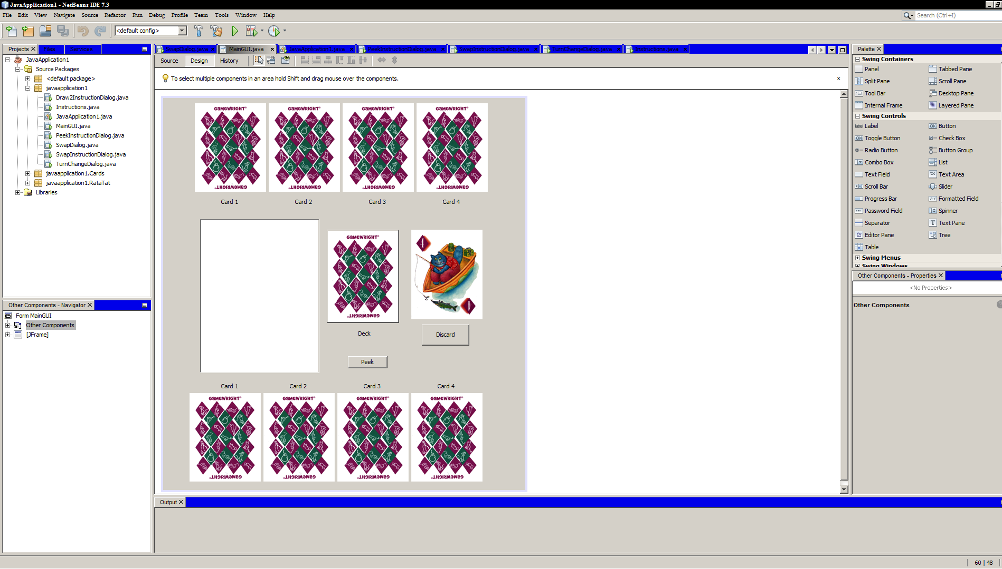
Figure 1.4 – GUI development

Figure 1.5 shows the development process of the introduction/instruction GUI component.
The GUI has not yet been coupled to the game loop, and thus was not able to be adequately tested with the rest of the system. System-wide testing was performed using the console version of the game loop.
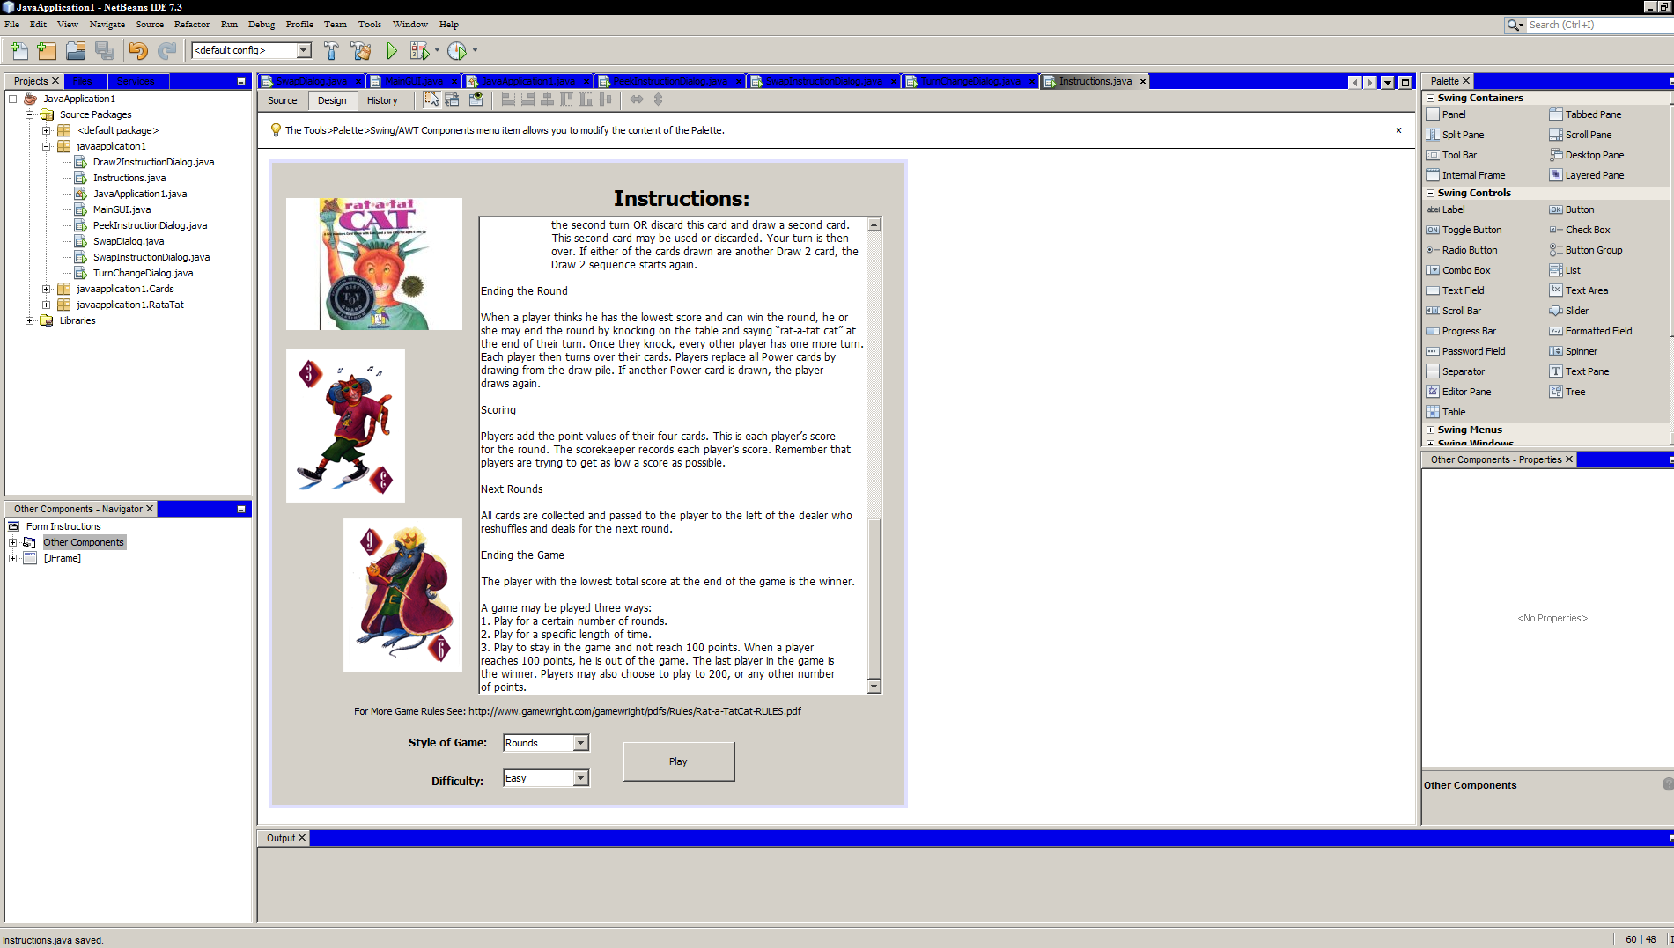
Figure 1.5 shows implementation of the different Java Swing components into the GUI.

Game Loop Testing
Overview
Game loop testing was performed on both, individual components, and together as a system as a whole. A debug switch was added to the system to provide for a single point to turn testing on or off.
Individual Component Testing
Figure 1.6 shows an un-shuffled deck object output to the console. This output was viewed to ensure that at the opening of each game, all card objects were present, and available for manipulation.
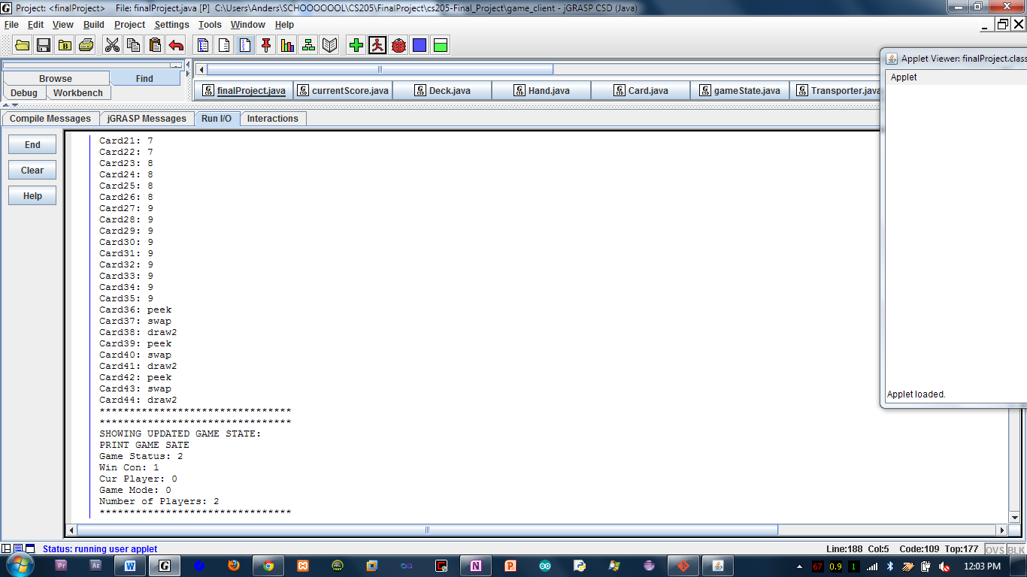
fig 1.6 – output of deck object

The deck object contains an array-list of card item, each of which is printed to the screen using their toString() method.
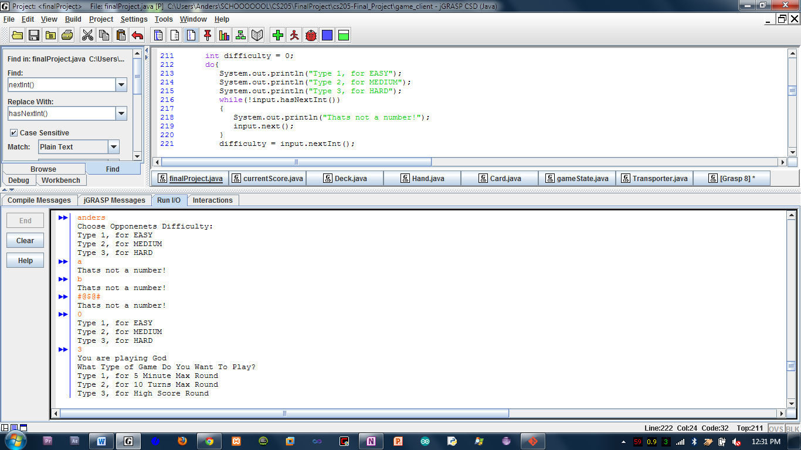
Figure 1.7 – user input validation

Overall Game Loop Testing
User input was simulated to automate input validation testing. The system would run through randomized inputs, and compare expected output to actual output. Figure 1.7 shows a portion of this process. After user inputs were tested, http-output was enabled, and the content sent to the server was logged for accuracy (figure 1.2).

Conclusion
Like the writing of documentation, our testing procedure was often an afterthought, not considered to be integral during other phases of development. Because much of our software is not written with unit-testing in mind, the harnesses we developed could easily have become as complex as the game itself. Constrained by time, our testing harness was made to test only the most integral components and interfaces of the game. If done over, we would have developed a testing strategy before any code was written, and implemented the testing-harness early in the process.

