**Data, Data Storage and Data Processing**

(Dylan Smyth)

Data, Data Storage and Data Processing

Data Gathered by Sensors

Our IoT cooking system uses a Bluetooth thermometer connected to a Raspberry Pi. The thermometer measures the internal temperature of meat during cooking and the Pi acts as a bridge between the thermometer, the Internet and the database. The system may also use a camera module for photo-based doneness detection but we will try to use the users phone if possible.

1. Bluetooth Thermometer

* Data collected:
  + Internal meat temperature
  + Battery level of the thermo
  + Timestamp of each reading
* How it works:  
  The thermometer uses a thermistor sensor inside the metal probe. A thermistor changes resistance with temperature. The onboard chip converts this change into a digital temperature reading and sends it over bluetooth to the Raspberry Pi.
* Frequency of readings:
  + Default: 1 reading every 5 seconds
  + High accuracy mode: 1 reading every 1 second
  + Low power mode: 1 reading every 30 seconds – 1 minute for slow cookers
* Sample data format:
* {
* device_id: Dylan’s Pi,
* thermometer_id: bluetooth_thermometer,
* temperature_c: 63.5,
* battery_percent: 80
* }

2. Raspberry Pi Camera Module

* Data collected: Photos of the meat’s surface during cooking to visually detect rawness of the meat.
* How it works: The users takes a picture of the meat inside and out and it gets compared to photos in the database to confirm if its cooking right or done.
* Frequency of capture:
  + Whenever the internal temperature rises by 5°C
  + User is pinged to take photo if they don’t know if meat is cooked or not
* Stored data:  
  Each photo is stored with a timestamp and associated cooking session ID.

3. Third-Party API Data

* Data collected:
  + Recommended cooking temperatures
  + Recipe details and images
* Source: Third-party cooking/food safety APIs (BBC Foods)
* Use: These are stored in the local database and used to give the user guidance on safe cooking temperatures for specific meats.

**Data Storage**

All sensor data and cooking records are stored in a MySQL relational database. MySQL is used because it provides data integrity, supports structured queries. It is also the database software we are most familiar with.

**The UI, User and Testing**

(Joshua Donnelly)

**Ui Mock-up**

**Screen 1** – The landing page. Consists of a simple straight forward, with a choice between the high-risk meats that we have decided to focus on. Its important for all of these screens to follow our usability guideline, Simple and intuitive.

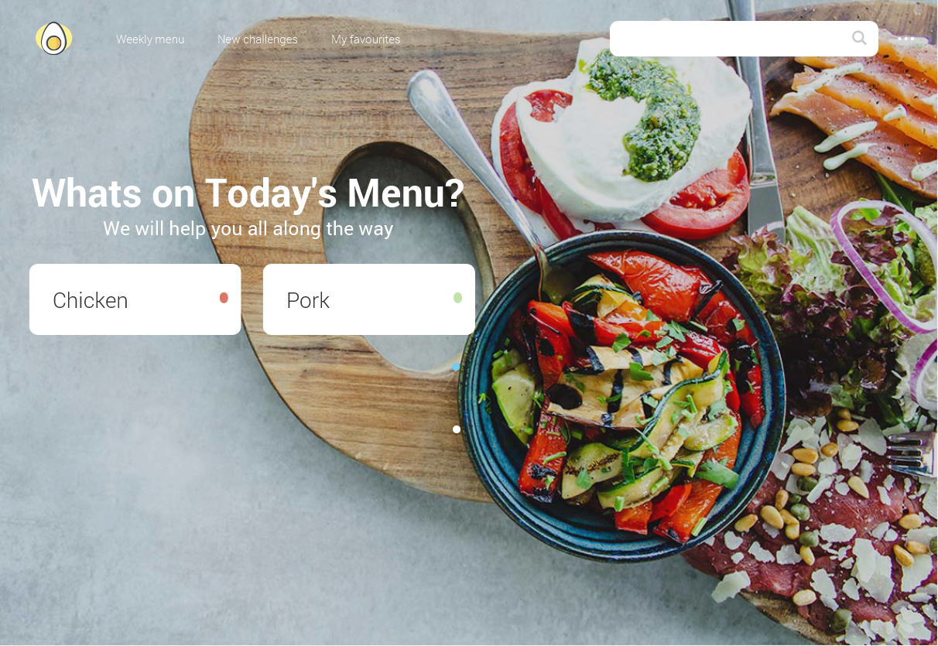

**Screen 2** – App responds with this screen once meat is selected. The user is requested to connect the necessary hardware. The design is simple and clear what is requested from the user.