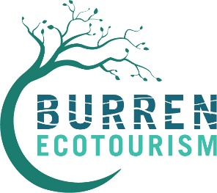**About the Burren Ecotourism Network (B.E.N.)**

The Burren Ecotourism Network (the B.E.N.) is a membership organisation embedded in a sustainable tourism ethos. It was formally established in 2011. Its purpose is to:

* connect tourism enterprises in the Burren region and enable them to work together to deliver economic, social and environmental benefits, both for themselves and for their communities;
* provide members with training, networking, marketing, business development and partnership opportunities;
* enable members to make an active contribution to the conservation of the region’s natural and cultural heritage.

The B.E.N. mission is to contribute to transforming the Burren region into a truly sustainable destination by being a thought-leader and advocate **and** by providing learning, development and business opportunities to tourism enterprises.

B.E.N. is a network of tourism businesses with the objective of establishing the Burren as a premier internationally-recognised sustainable tourism region ensuring the future economic and social growth and sustainable development of its communities, environment and heritage. It seeks to support continued training, mentoring and accreditation in sustainable tourism for its members and for businesses interested in joining the Network.

The Burren Ecotourism Network and the management organisation of the Burren and Cliffs of Moher UNESCO Global Geopark enjoy a special relationship. Both organisations are committed to the promotion of responsible tourism that conserves the environment and improves the well-being of local people. Having agreed in late 2012 to pool their resources in pursuit of their common objective, they work together to promote ‘The Burren & Cliffs of Moher UNESCO Global Geopark’ as a leading sustainable visitor destination, celebrated for high standards in visitor experience, conservation and learning,