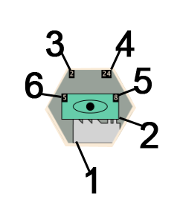
Each tile contains several pieces of information:
- The terrain type's visual representation.
- The unit type's visual representation.
- The terrain's Dig-In level, if the level is greater than zero.
- The terrain's health (HP), if the terrain doesn't have full health.
- The unit's health (HP), if the unit doesn't have full health.
- The unit's concealment (including current modifiers).

