Activities

1. Determine O(n) and O(n2)
2. O(n2)
3. O(n)
4. O(n2)
5. O(n2)
6. First Loop: [0, 1, 2, 3, 3, 3, 3, 3]

Second Loop: [0, 1, 2, 3, 3, 4, 5, 6]

1. Calculate O(n) and T(n)
2. O(n) and T(n) = n + 4
3. O(n3) and T(n) = n3 + 4
4. O(n) and T(n) = 3n + 1
5. O(n) and T(n) = n + 3
6. Binary Search = O(log N)

Merge Sort = O(n log n)

Quicksort = O(n log n)

Bubble sort = O(n2)

1. An abstract data type is a way of organizing data according with the rules of how the data can be manipulated. Example = Array, List, Queue, Stack, Sort
2. List vs ArrayList

|  |  |
| --- | --- |
| List | ArrayList |
| List is an interface | Is a class that implements the List |
| Does not have built In resizing mechanism | Can resize itself when necessary |

1. ArrayList

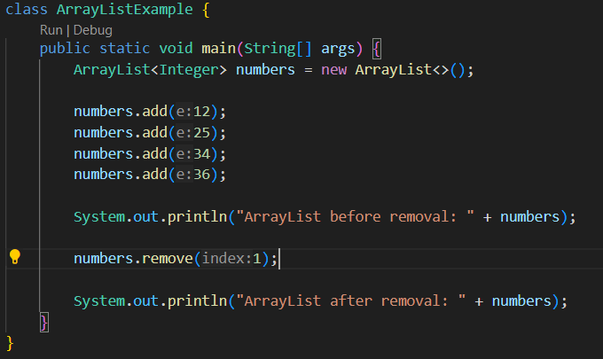

Project Task