Deploying MYSQL with AWS:

Connecting to AWS MYSQL RDS Instance:

Creating a new user:

Users_db on AWS reflecting the changes:

Two Factor Authentication Library. Secret Key will be updated before deployment. Using the current time but rounded down to the nearest 3 minutes. 2FA Codes will be unique every 3 minutes

Method that generates a unique six digit code that is valid for 3 minutes based on the username, the rounded time and a secret key:

Method that generates a hash from the username and the tfa code for comparison, if no tfa code is provided the current tfa code will be used:

Method that validates a login for a user based on their username and tfa_code

Creating a basic login form for the API, testing the API by simply sending back the login info:

Form is correctly hitting the API endpoint:

Login Process:

After many failed attempts first successful login:

User_logins table functioning:

Login attempt with incorrect password:

Failed attempt saved in db:

Lockout Feature explanation and screenshots. When a user fails a login the failed_login_count column in the database increments (starts at 0). If the user fails 3 logins the following happens:

1. locked_out column is set to 1 (default is 0)
2. locked_out_end is set to 5 minutes from now
3. failed_login_count resets to 0
4. All logins from the user will be blocked until the locked_out_end with a 403 code until time has passed

Database with an active lockout:

Successful login with redirect to 2FA page:

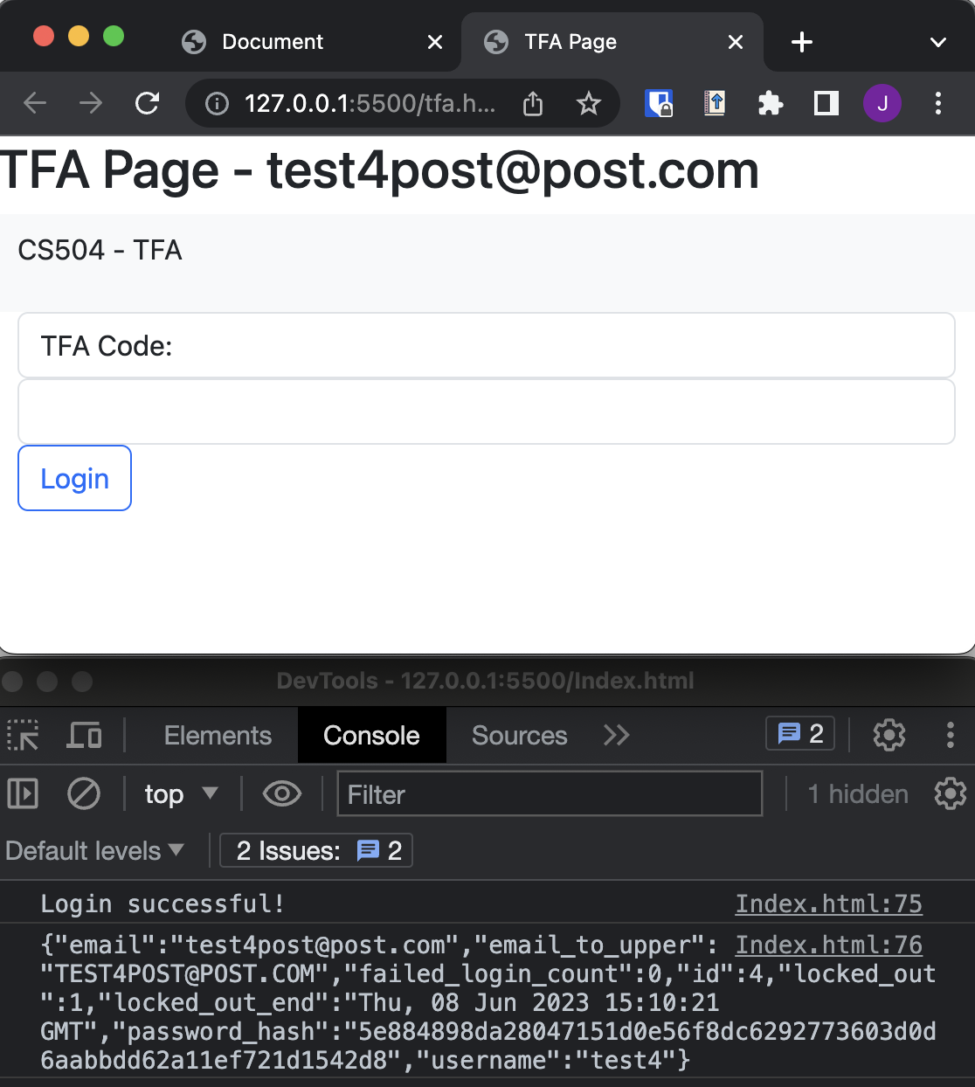

TFA_Code generation with postman:

Code updates automatically with the time:

Testing for Validation:

Code has expired:

