National Institute of Technology Karnataka [NITK], Surathkal.
NH 66, Srinivasnagar, Surathkal, Mangalore, Karnataka- 575025


Corrosion Engineering Project Report
Department of Metallurgical and Materials Engineering
Groundwater Corrosivity Assessment of Telangana Using Langelier and Larson-Skold Indices with Machine-Learning Screening
[Student Name] - [Roll Number]
Submitted to:
[Guide / Faculty Name]

Abstract
Corrosion of steel and galvanised-iron pipes is a common cause of failure in groundwater supply systems, and whether a water attacks a pipe depends on its chemistry. This project assesses the corrosivity of groundwater in Telangana, India, using a state groundwater survey of about 380 sampling locations measured before and after the monsoon in 2018, 2019 and 2020 (2,196 samples, 2,140 after quality control). For every sample the Langelier Saturation Index, the Ryznar Stability Index and the Larson-Skold index were calculated and combined into four risk classes: Scaling, Balanced, Moderate and High.
Telangana groundwater is mostly alkaline and hard. By the Langelier index 57% of samples are scale-forming and only 2.3% are corrosive, yet 42% fall in the Moderate class, almost always because chloride and sulphate are high relative to alkalinity (Larson-Skold above 1.2). Pre-monsoon water is more often at risk than post-monsoon water. In the second stage, random-forest and gradient-boosting models were trained to predict the risk class from pH, electrical conductivity, location and season, without using the ions from which the labels are computed. On districts and a year that were not used for training the macro F1 score was 0.58 to 0.63, against 0.20 for always guessing the most common class, and conductivity was the most important input. The result is a screening aid for deciding which wells to send for laboratory analysis, not a replacement for that analysis.

1. Introduction
Hand pumps, rising mains and well casings are often made of galvanised iron or mild steel. Their life depends on the water they carry. Calcium and bicarbonate decide whether a protective film of calcium carbonate forms on the metal or the water instead dissolves it, while chloride and sulphate interfere with protective films and raise the attack on iron and steel. Water utilities summarise this behaviour with saturation and aggressiveness indices calculated from a laboratory analysis.
A full analysis takes time and money, whereas pH and electrical conductivity (EC) can be read in the field with a cheap meter. This project calculates the standard indices for a large public groundwater survey, maps where the water is aggressive, and tests how well pH, EC and location can predict the result without a full analysis.

2. Problem Statement
The project addresses two questions for the groundwater of Telangana. First, what share of the water is corrosive or scale-forming according to standard indices, where are the aggressive areas, and does this change between the pre-monsoon and post-monsoon seasons? Second, can the risk class be predicted reliably from cheap field measurements, so that a laboratory analysis is needed only for wells that look risky? The prediction must be tested on districts and years that the model has not seen, because wells in the same district resemble each other.

3. Objectives
- Combine the Telangana pre-monsoon and post-monsoon groundwater files into one clean table and remove samples that fail quality checks.
- Calculate the Langelier Saturation Index, Ryznar Stability Index and Larson-Skold index for every sample and assign a risk class.
- Map and summarise corrosion risk by district and season, and test how sensitive the classes are to the assumed water temperature.
- Train machine-learning models that predict the risk class from pH, EC, location and season only, and validate them on unseen districts and an unseen year.
- Explain the predictions with SHAP and provide a simple tool that returns the indices and a pipe-material recommendation.

4. Dataset Description
The data are the Telangana State groundwater quality survey, obtained from two public Kaggle redistributions: a post-monsoon dataset (2018 to 2020) and a pre-monsoon dataset (2018 to 2020). The original source and licence of these redistributions were not verified. The national portals (data.gov.in and India-WRIS) could not be reached from the computing environment used, and the only national file found contains pH, conductivity and temperature only, which is not enough for the Langelier index. The study is therefore a single-state case study.
Table 1: Summary of the dataset used
Item | Description
Source | Telangana State groundwater survey, via two Kaggle redistributions
Period | 2018, 2019 and 2020; pre-monsoon and post-monsoon in each year
Samples loaded | 2,196 (1,090 pre-monsoon and 1,106 post-monsoon)
Locations | About 380 sampling locations in 33 districts
Parameters | pH, EC, TDS, CO3, HCO3, Cl, F, NO3, SO4, Na, K, Ca, Mg, total hardness, water level, latitude, longitude
Samples after quality control | 2,140 (1 removed for a missing input, 55 for charge-balance error above 10%)
Not available | Iron, pipe-failure records, other states

The files needed cleaning. Column headers are spelled differently in different files (for example E.C, EC, CO_-2 and Ca+2), one pH value was mistyped as 8..05, and the 2019 post-monsoon file leaves carbonate blank where the other files record zero. Blank carbonate was treated as zero. The TDS column in the files equals exactly 0.64 times EC, so it is derived from EC and not measured independently.

5. System Architecture
The work is a six-stage data pipeline written in Python. Each stage reads the output of the previous one, and every stage is covered by the scripts and tests described in Section 7.
Table 2: Pipeline stages
No. | Stage | Output
1 | Survey files (pre- and post-monsoon) | 2,196 raw samples with 22 columns
2 | Harmonise headers, parse values | One table with consistent names and numeric columns
3 | NASA POWER temperature | Mean annual air temperature for each 0.5 degree cell
4 | Quality control | 2,140 samples with charge-balance error of 10% or less
5 | Indices and risk class | LSI, RSI, Larson-Skold and the risk class for each sample
6 | Machine-learning screening | Trained models, validation results, SHAP, and the check-your-water tool

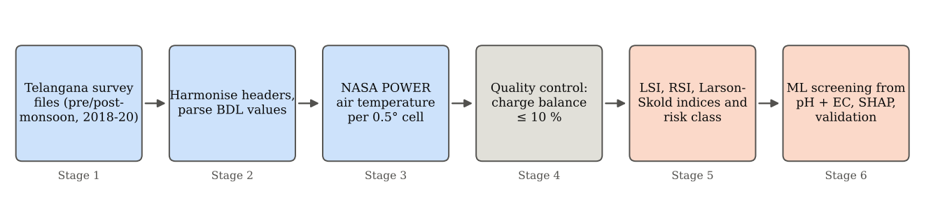
Figure 1: Data pipeline from survey files to the screening models.

6. Methodology
1) Data harmonisation: header spellings were mapped to one set of names, values such as BDL (below detection limit) and entries starting with < were converted to numbers (BDL as zero and < x as half of x), and the season label of each file was split into season and year.
2) Water temperature: the Langelier index depends on temperature, which was not recorded. The mean annual air temperature from the NASA POWER climatology was fetched for each 0.5 degree grid cell and 1 degree Celsius was added as an estimate of groundwater temperature. Section 10.4 tests how much this assumption matters.
3) Quality control: samples with a missing input, pH outside 4 to 11, coordinates outside India or a negative concentration were removed. The charge-balance error, the difference between the total cations and total anions in milliequivalents per litre as a percentage of their sum, must be 10% or less for an analysis to be internally consistent.
4) Corrosivity indices: the Langelier Saturation Index (LSI) is the pH minus the saturation pH (pHs) of calcium carbonate:
LSI = pH − pHs, pHs = (9.3 + A + B) − (C + D)
A = (log10 TDS − 1) / 10, B = −13.12 log10(T + 273) + 34.55, C = log10(Ca as CaCO3) − 0.4, D = log10(alkalinity as CaCO3)
The Ryznar Stability Index (RSI = 2 pHs − pH) was calculated as a cross-check, and the Larson-Skold index, which measures chloride and sulphate attack on steel, was calculated in milliequivalents per litre. Table 3 gives their interpretation.
Table 3: Interpretation of the indices
Index | Definition | Interpretation
LSI | pH − pHs | Below −0.5 corrosive; −0.5 to 0.5 balanced; above 0.5 scale-forming
RSI | 2 pHs − pH | Below 6.2 scaling; 6.2 to 6.8 neutral; above 6.8 corrosive (cross-check only)
Larson-Skold (LS) | (Cl + SO4) / (HCO3 + CO3), meq/L | Below 0.8 low; 0.8 to 1.2 moderate; above 1.2 high risk to mild steel

5) Risk classification: the indices were combined into four classes with the rules in Table 4, applied in the order High, Moderate, Scaling and Balanced.
Table 4: Risk class rules
Class | Rule | Practical meaning
High | LSI < −2, or (LSI < −0.5 and LS > 1.2) | Avoid GI and mild steel; use uPVC, HDPE, CPVC or lined pipe
Moderate | LSI < −0.5 or LS > 1.2, only one of the two | Steel is attacked by chloride and sulphate; prefer plastic pipe or plan early replacement
Scaling | LSI > 0.5 and LS < 0.8 | Carbonate scale and clogging; plan descaling
Balanced | All other samples | Any standard pipe material

6) Machine learning: the target has three classes, At-risk (Moderate and High together, because High has only 20 samples), Balanced and Scaling. The models were not given Ca, HCO3, CO3, Cl, SO4 or any index, because the label is computed from them and the model would only learn the formula.
7) Validation: wells in the same district have similar water, so a random split overstates accuracy. The models were tested with five-fold cross-validation grouped by district (unseen districts) and by training on 2018 and 2019 and testing on 2020 (unseen year). A model that always predicts the most common class was used as the baseline.
8) Interpretation: SHAP values of a random forest were used to show how much each input pushes a sample towards the At-risk class.

7. Implementation Details
The code is written in Python 3.13 with pandas, NumPy, scikit-learn, SHAP, matplotlib and Streamlit, in a project folder named groundwater-corrosivity-india. The main modules are indices.py (LSI, RSI, Larson-Skold, charge balance and the risk class), cleaning.py (value parsing and the quality-control filter with a per-rule removal report), data_loading.py (header harmonisation and season parsing), climate.py (NASA POWER requests with caching), pipeline.py (builds the labelled table), analysis.py (tables and figures), modeling.py (models and validation) and train_final.py (saves the final models).
There are 50 unit tests, including a check of the Langelier calculation against a hand-worked example, the Larson-Skold calculation, the charge balance, the risk rules, value parsing and header harmonisation. A Streamlit application, Check your water, returns the exact indices and the risk class from a full laboratory report, or a machine-learning estimate from pH and EC alone. The same work is also available as a single notebook that runs on Google Colab.

8. Models and Techniques Used
Table 5: Techniques used
Component | Approach
Corrosivity assessment | Langelier Saturation Index and Larson-Skold index, with the Ryznar index as a cross-check
Water temperature | NASA POWER mean annual air temperature per 0.5 degree cell plus 1 degree Celsius
Data quality | Charge-balance error of 10% or less, range checks on pH, coordinates and concentrations
Risk screening models | Logistic regression, random forest and histogram gradient boosting with class weights
Validation | Five-fold cross-validation grouped by district, and training on 2018 and 2019 with testing on 2020
Interpretation | SHAP values for the random forest
Interface | Streamlit application and a Google Colab notebook

9. Experimental Setup
The analysis was run in a cloud Linux environment with four processor cores. Three input sets were compared: A0 uses pH and EC; A uses pH, EC, latitude, longitude, season and air temperature; B uses location, season and air temperature only, with no water measurement. The random forest used 300 trees with a minimum of three samples per leaf, the gradient-boosting model used depth 4, a learning rate of 0.05 and 200 iterations, and logistic regression used standardised inputs. The class weights were balanced for all three.
Performance was measured with the macro F1 score, which averages the F1 score of the three classes so that the small classes count equally, the accuracy, and the recall of the At-risk class, since missing an aggressive well is the costly error. To test the temperature assumption, the labels were recalculated with the groundwater temperature taken as air temperature plus 0, 1 and 3 degrees Celsius and as fixed values of 20 and 30 degrees Celsius.

10. Results and Discussion
10.1 Overall risk classes
Table 6 gives the distribution of the 2,140 samples. The median LSI is 0.58, so most of the water is hard and alkaline and tends to form scale: 57% of samples have an LSI above 0.5 and only 49 samples (2.3%) have an LSI below −0.5. Even so, 42% of the samples are in the Moderate class.
Table 6: Distribution of the risk classes
Class | Samples | Share (%)
Scaling | 452 | 21.1
Balanced | 765 | 35.7
Moderate | 903 | 42.2
High | 20 | 0.9

The reason is shown in Figure 2. Of the 923 Moderate and High samples, 874 (94.7%) are flagged by the Larson-Skold index alone, 29 (3.1%) by the Langelier index alone and 20 (2.2%) by both. A total of 529 samples are scale-forming (LSI above 0.5) and also chloride and sulphate rich (LS above 1.2). For these samples the two indices disagree, and because carbonate scale can protect steel, the Moderate class probably overstates the real corrosion risk for them.
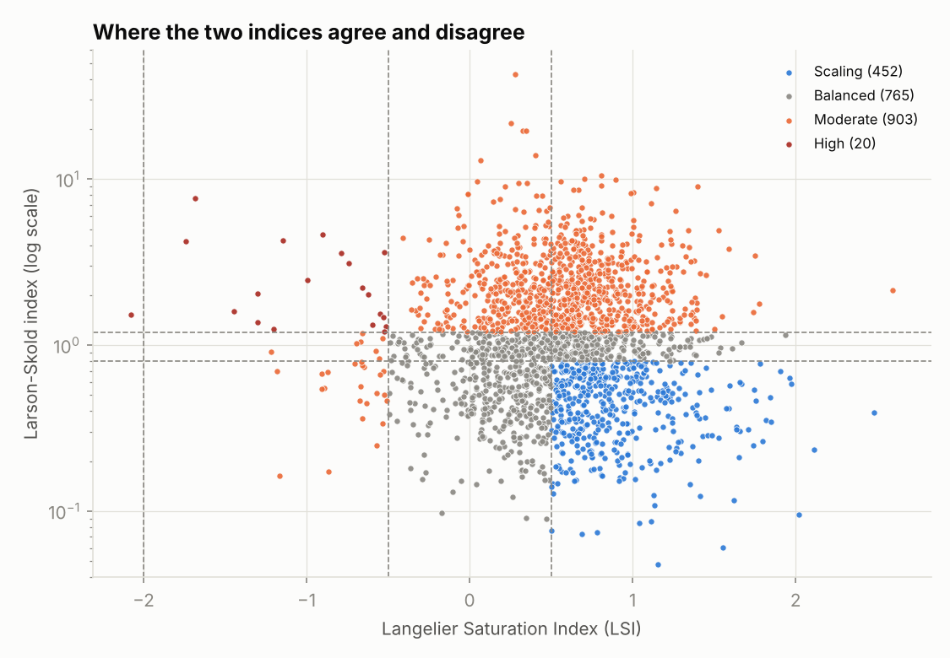
Figure 2: Langelier and Larson-Skold indices for all samples, coloured by risk class.
10.2 Districts and hotspots
The share of Moderate and High samples varies strongly between districts (Figure 3). Table 7 lists the highest and lowest districts. Several districts have only four to six sampling locations, for example Mulugu with 15 samples, so their percentages are uncertain.
Table 7: Districts with the highest and lowest share of Moderate and High samples
District | Samples | At risk (%)
Peddapalli | 29 | 75.9
Jogulamba (Gadwal) | 65 | 73.8
Mulugu | 15 | 73.3
Sircilla | 36 | 72.2
Warangal (Urban) | 39 | 69.2
Hyderabad | 47 | 14.9
Karimnagar | 30 | 13.3
Kumuram Bheem | 34 | 8.8

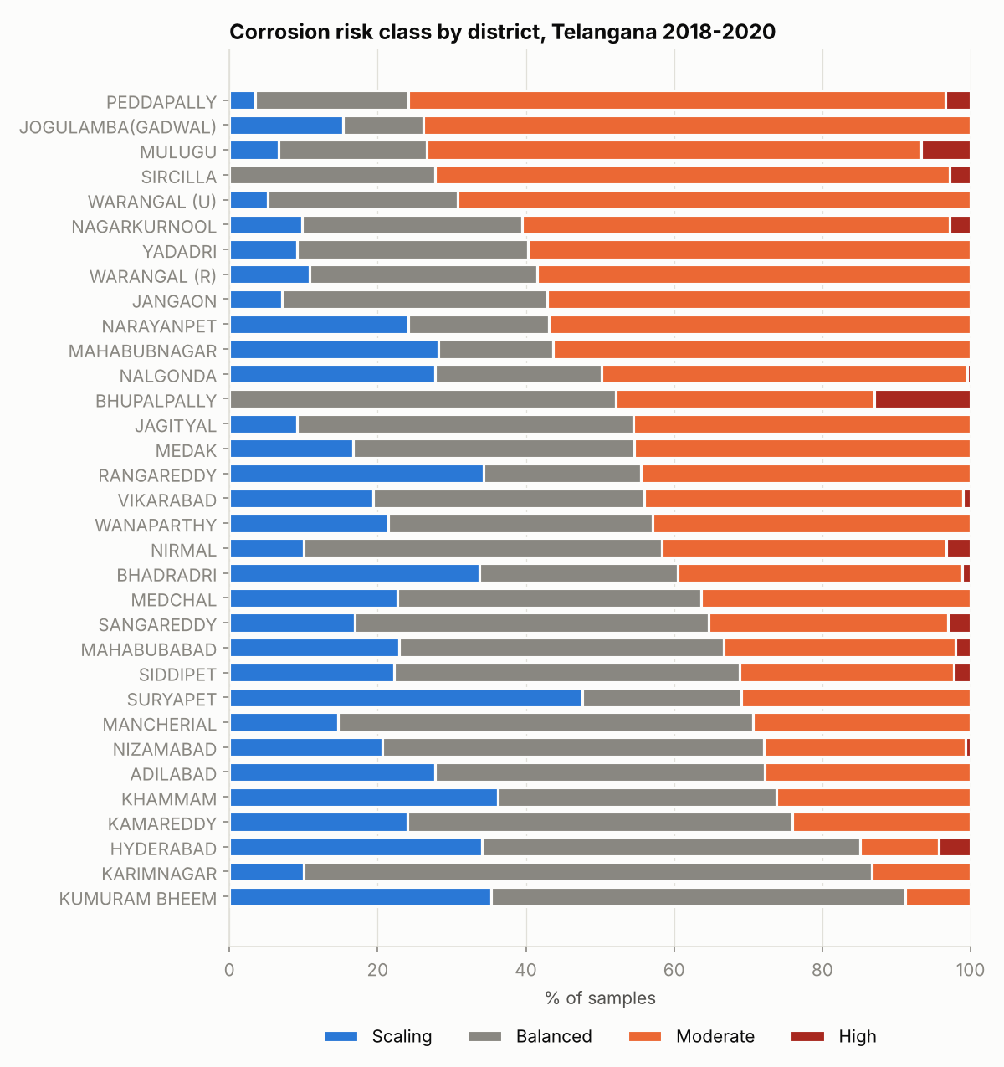
Figure 3: Share of each risk class by district.
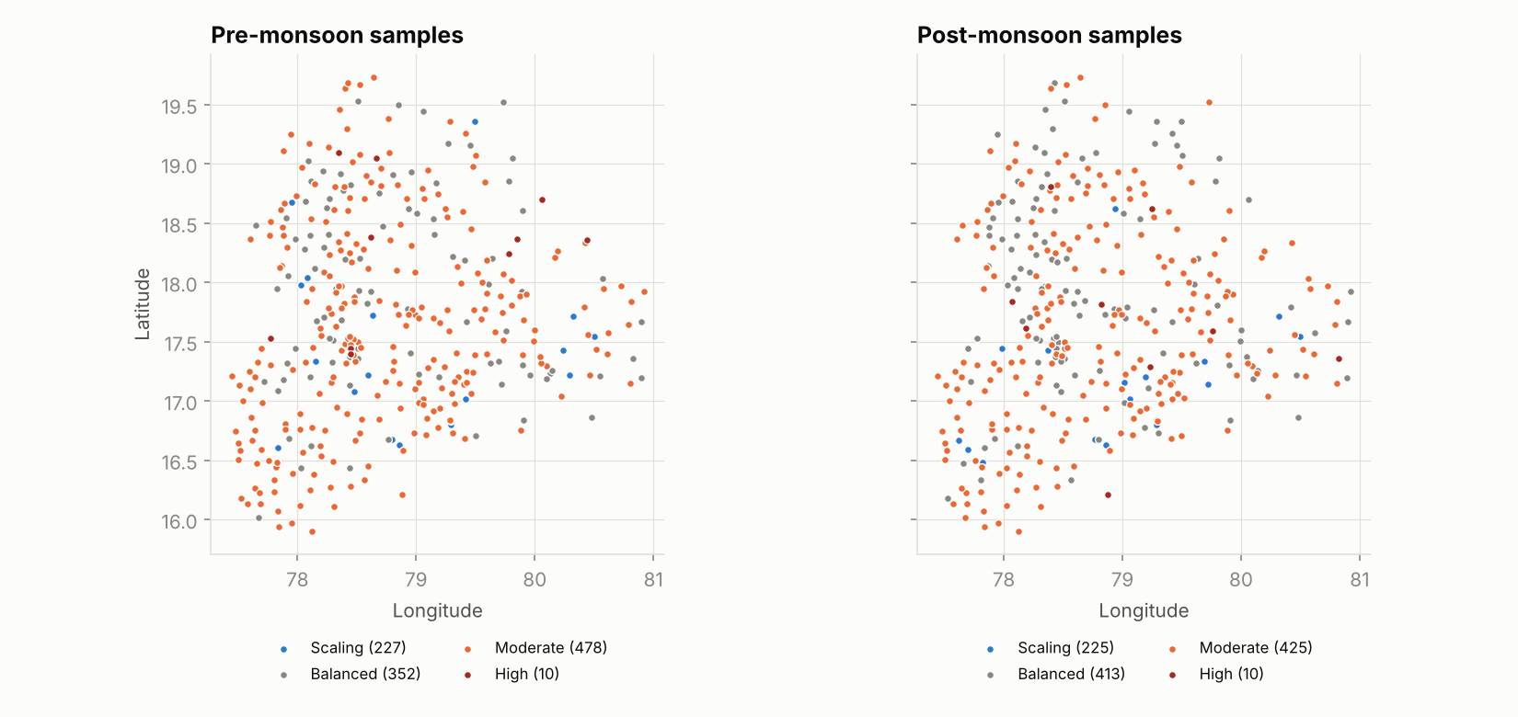
Figure 4: Sampling locations coloured by risk class, pre-monsoon and post-monsoon.
10.3 Effect of season
Pre-monsoon water is more often at risk than post-monsoon water in every year (Table 8). For the 1,025 well-year pairs in which a well was sampled in both seasons of the same year, the median LSI falls from 0.60 before the monsoon to 0.54 after it, and the post-monsoon LSI is higher in only 46% of the pairs. This agrees with concentration of dissolved salts in the dry season and dilution by monsoon recharge, but the data cannot prove the cause.
Table 8: Share of at-risk samples by year and season
Year | Season | Samples | At risk (%)
2018 | Pre-monsoon | 365 | 48.8
2018 | Post-monsoon | 365 | 42.2
2019 | Pre-monsoon | 359 | 49.0
2019 | Post-monsoon | 352 | 42.1
2020 | Pre-monsoon | 343 | 39.1
2020 | Post-monsoon | 356 | 37.4

10.4 Sensitivity to water temperature
Assuming that the water is 0 to 3 degrees Celsius warmer than the air changes only 1.0% to 1.8% of the labels, and a fixed temperature of 30 degrees Celsius changes 2.0%. Only a fixed 20 degrees Celsius, which is well below the air temperatures in the region (about 26 to 28 degrees Celsius), changes more (6.5%). The classes are therefore not sensitive to the temperature estimate.
Table 9: Labels changed by the temperature assumption
Assumption | Labels changed | Share (%)
Air temperature + 0 °C | 21 | 1.0
Air temperature + 1 °C (baseline) | 0 | 0.0
Air temperature + 3 °C | 39 | 1.8
Fixed 20 °C | 139 | 6.5
Fixed 30 °C | 42 | 2.0

10.5 Machine-learning screening
Table 10 gives the macro F1 score on unseen districts and an unseen year, and the At-risk recall on unseen districts. The majority-class baseline scores 0.20 (0.18 for the unseen year), and a random guess among the three classes would score about 0.33.
Table 10: Model performance
Inputs | Model | F1 unseen districts | F1 unseen year | At-risk recall
A0: pH, EC | Logistic regression | 0.559 | 0.574 | 0.60
 | Random forest | 0.573 | 0.580 | 0.66
 | Gradient boosting | 0.585 | 0.599 | 0.65
A: pH, EC, location, season, climate | Logistic regression | 0.568 | 0.572 | 0.61
 | Random forest | 0.610 | 0.624 | 0.70
 | Gradient boosting | 0.600 | 0.633 | 0.67
B: location, season, climate only | Random forest | 0.361 | 0.489 | 0.50
 | Gradient boosting | 0.387 | 0.480 | 0.46

Three conclusions follow. First, pH and EC alone give a macro F1 score of 0.57 to 0.60 on unseen districts, clearly better than the baseline, and adding location, season and climate raises it to about 0.61. Second, location alone is not useful on unseen districts (0.36 to 0.39, close to chance), so the risk at places that were never sampled cannot be predicted from location, and this approach should not be claimed. Third, the best model reaches about 62% accuracy and finds about 70% of the truly at-risk samples, which means about 30% are missed. The model can prioritise wells for laboratory testing but cannot replace it.
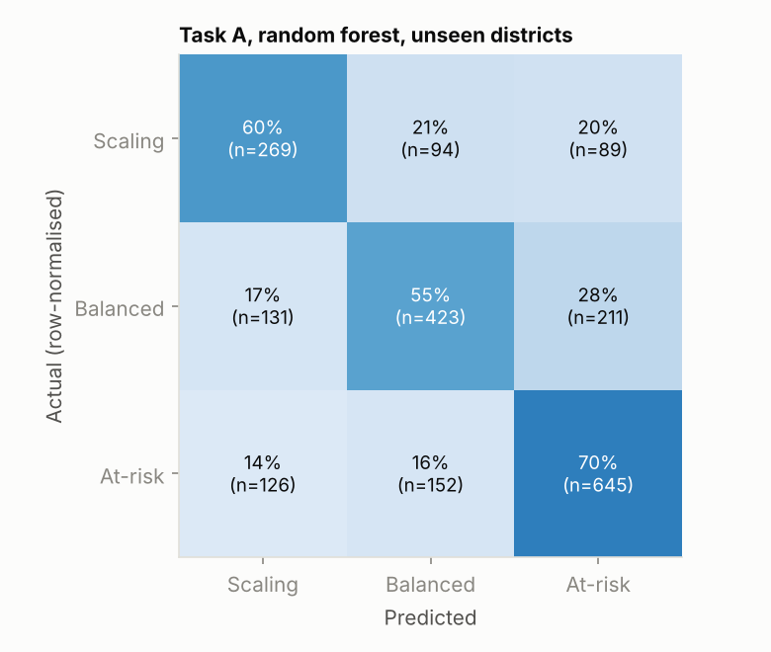
Figure 5: Confusion matrix of the random forest on unseen districts (input set A).
Figure 6 shows that electrical conductivity is by far the most important input (mean absolute SHAP value 0.196), followed by pH (0.060), while latitude, longitude, season and air temperature each contribute 0.02 to 0.04. High conductivity pushes a sample towards At-risk, which is consistent with the chemistry: salty water carries more chloride and sulphate, which raises the Larson-Skold index.
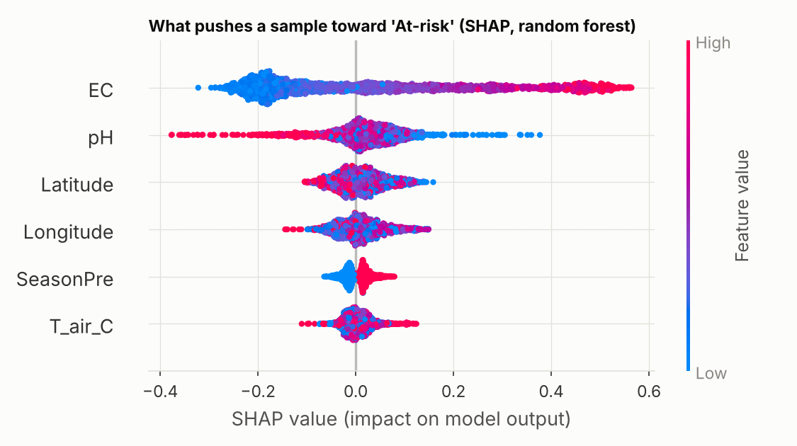
Figure 6: SHAP values showing how each input pushes a sample towards the At-risk class.

11. Limitations
- The risk classes are calculated from water chemistry, not from measured corrosion rates or pipe failures, so they indicate tendency and not actual damage.
- The study covers one state and one source of data, so the results should not be applied to other states. The Kaggle redistribution was not checked against the original source, and its licence is unknown.
- The Moderate class is driven almost entirely by the Larson-Skold index, and for the 529 samples that are also scale-forming the two indices disagree, so the 43% at-risk share is probably an overestimate.
- Groundwater temperature was estimated from air temperature. The labels are not sensitive to this, but it is still an assumption.
- The rules leave samples with LSI above 0.5 and LS between 0.8 and 1.2 in the Balanced class (246 samples), which is a choice made in the rules and was not tested.
- The data contain no iron concentrations, so the classes could not be checked against iron released from corroding pipes. Several districts have few sampling locations.

12. Conclusions
Standard saturation and aggressiveness indices were calculated for 2,140 groundwater samples from Telangana and combined into a four-class risk label. The water is mostly hard and scale-forming, but chloride and sulphate make 42% of the samples aggressive towards steel by the Larson-Skold index, with the highest shares in Peddapalli, Jogulamba (Gadwal), Mulugu, Sircilla and Warangal (Urban), and with dry-season water more often at risk. The labels are stable against the assumed water temperature.
Machine-learning models using pH and electrical conductivity alone predict the risk class with a macro F1 score of about 0.6 on districts and years they have not seen, mainly through conductivity, but they miss about 30% of the at-risk samples and location alone has no predictive value. The approach is therefore suitable for ranking wells for laboratory testing and not for choosing pipe material by itself. Future work should add data from other states, compare the classes with real pipe-failure records, and test the screening models on a second survey.

References
Langelier, W. F. (1936). The analytical control of anti-corrosion water treatment. Journal of the American Water Works Association, 28(10), 1500-1521.
Ryznar, J. W. (1944). A new index for determining amount of calcium carbonate scale formed by a water. Journal of the American Water Works Association, 36(4), 472-483.
Larson, T. E. and Skold, R. V. (1958). Laboratory studies relating mineral quality of water to corrosion of steel and cast iron. Corrosion, 14(6), 285t-288t.
Breiman, L. (2001). Random forests. Machine Learning, 45, 5-32.
Lundberg, S. M. and Lee, S.-I. (2017). A unified approach to interpreting model predictions. Advances in Neural Information Processing Systems 30.

