# Links used

## Python Reference

<https://microsoft.github.io/AirSim/apis/>

Build AirSim + Install Unreal

<https://microsoft.github.io/AirSim/build_windows/>

Link to binaries for maps

<https://microsoft.github.io/AirSim/>

---------

From this link: <https://microsoft.github.io/AirSim/>

Go into those two links, the binaries is just the map, pick any map you want.

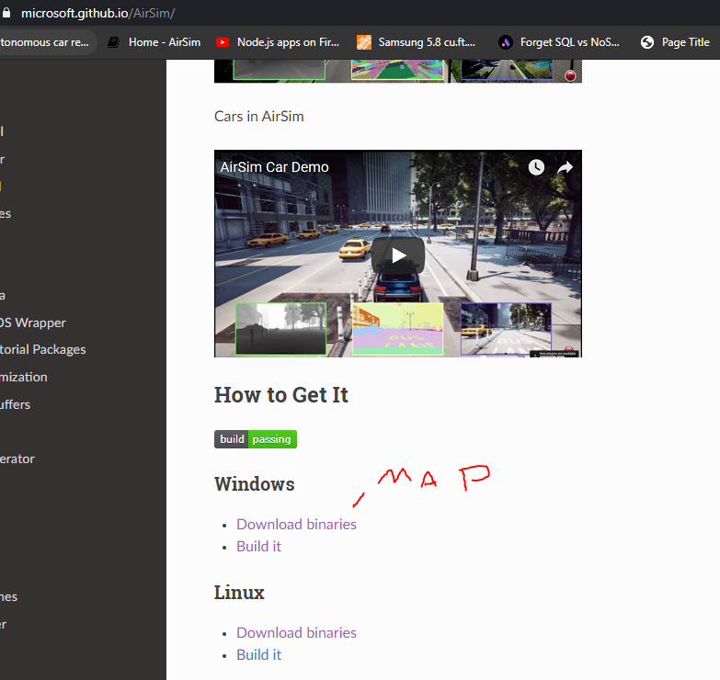

Now click on the second link, build it, follow the instructions to install unreal

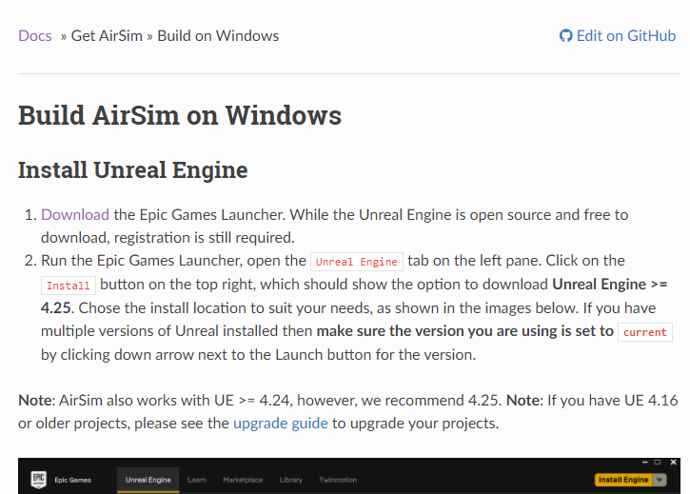

Since we are going to use python literally ignore everything written there, you only want the repository link

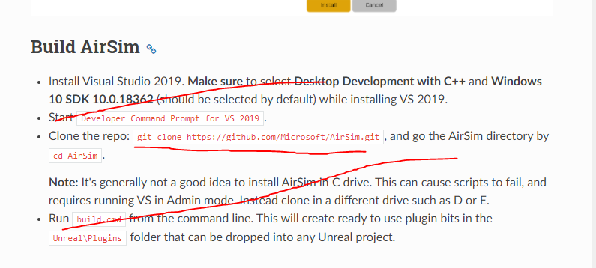

Now that you have cloned the repo link to whatever folder, follow instructions below