# **25 year old male - 2B sick person**

Case details:

**2B sick person (14:00 hrs).** Mt Druitt apartment. notes state: 25 year old male C & B. Caller statement: Pain all over body. Nil other significant details. Call had been sent to Health direct, although sent back to Ambulance.

**On Arrival**

Greeted by pts mother outside small 2 story apartment in a set of units in Mt Druitt. Paramedics led upstairs to a warm room where we were greeted by the pt lying supine on his bed. We quickly learn the job is not quite as stated. The pt states he is unable to move from the position he is in, and is effectively paralysed from the neck down.

Timeline:

* Pt states 3/12 Hx of generalised weakness in bilateral quadriceps, most notable when walking up stairs.
* Pt states had this investigated with medical imagine and blood test by GP which all returned NAD.
* Pt denies recent trauma or illness, and denies previous history of same.
* Pt states he went to bed at 11pm the night prior and awoke at 0200hrs to use the bathroom, barely able to move.
* Pt states he then returned to bed and awoke at 0600hrs and was completely paralysed.

**Observations**

Neuro:

* GCS15, PEARL, Bilateral grips weak but equal.
* Maintaining flexion of bilateral biceps and minimal rotator cuff movement.
* Flexion of bilateral feet remained normal. Unable to flex or extend at knees.
* Pt complaining of paresthesia in bilateral feet.

Resp:

* L = R lung fields clear and equal.
* Nil recent cough, colds or flus.
* RR: 16, good T/V, Sats: 99%(RA)

Cardiovascular:

* Warm, dry, CR <2.
* HR: 60-70 bpm - Regular, strong radial pulses.
* BP: 140/70

Other:

* Temp: 37.0C
* BGL: 5.5 mmols/L
* Nil gastrointestinal or urinary symptoms. Nil FAST, or other significant neuro symptoms present.

**Secondary Survey**

**Allergies**

* NKDA

**Medications:**

* Serotide
* Ventolin

**PmHx:**

* HTN
* Asthma

**Social Hx**

* Lives at home with mother
* Nil drug or alcohol use
* Non-smoker
* Slightly overweight although attends gym 2/7
* NIL family Hx of similar.

As apart of our assessment we do a 12 lead ECG:

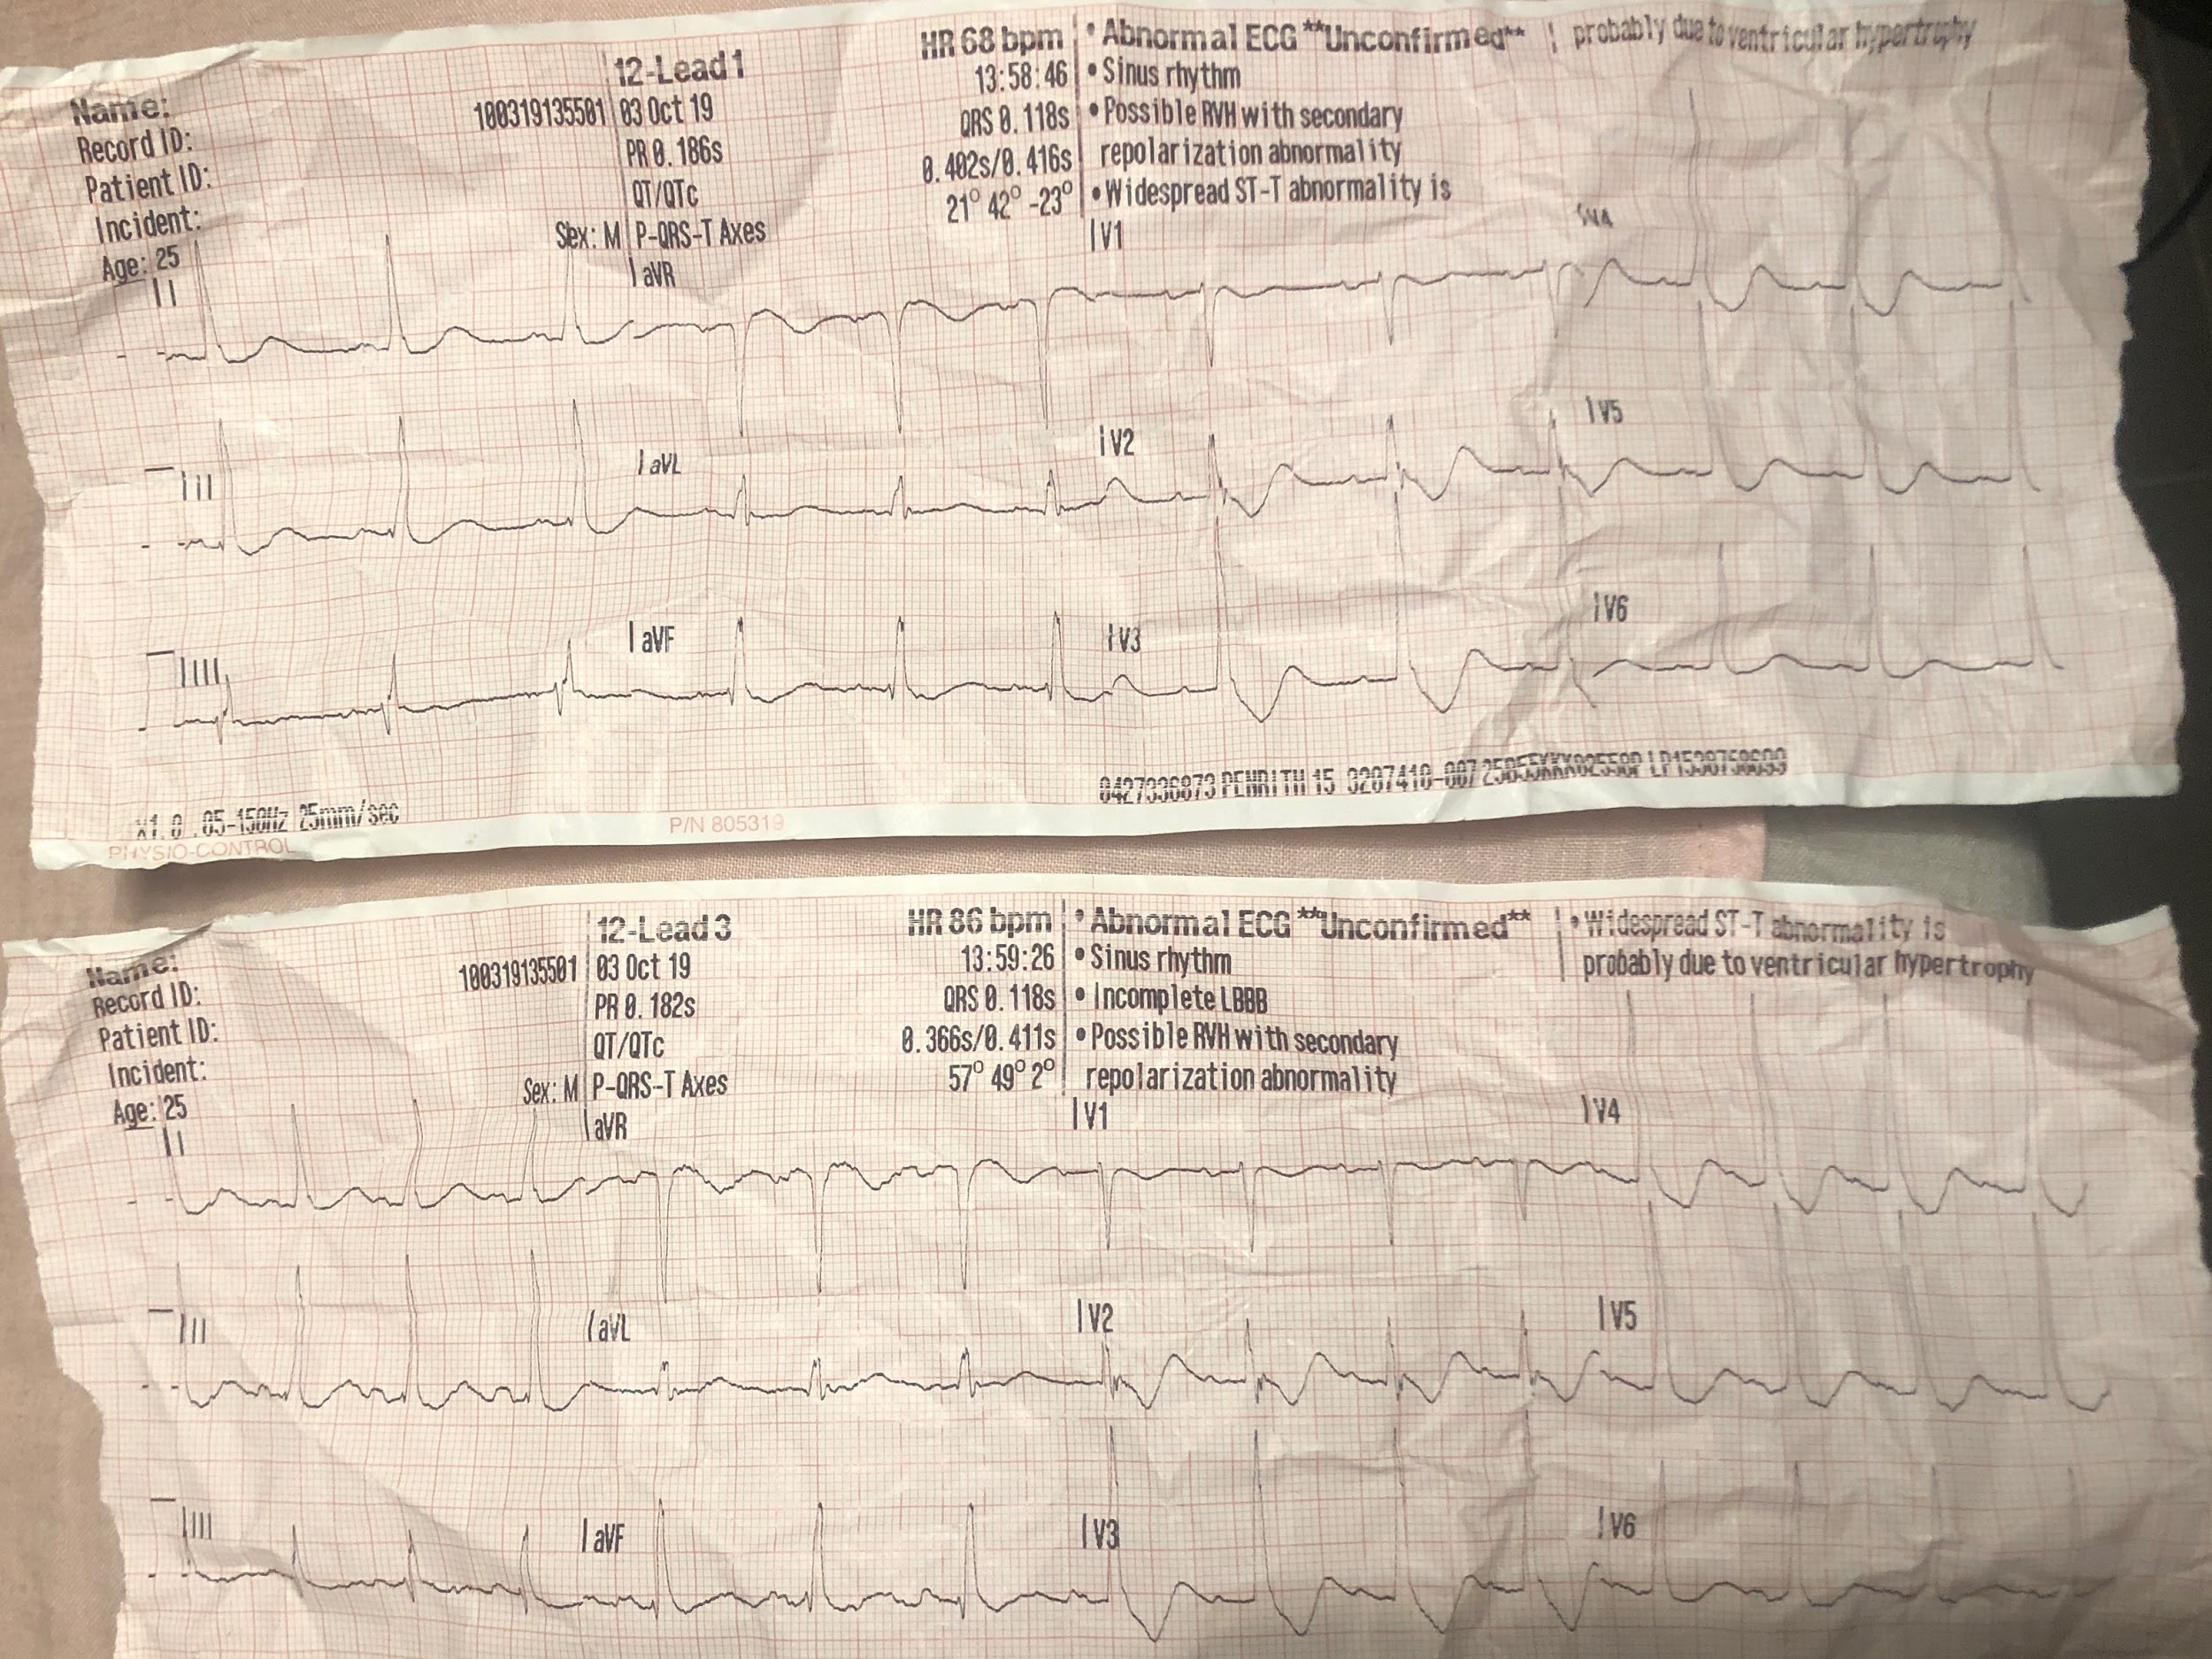

What is the interpritation of this ECG?

**Management:**

* IVC 18g RACF
* 4mg of ondansetron IV.

**Nil change in pt condition during care.**

**Some challenges during job:**

* Pt weight was approx 110kg.
* Pt was upstairs in a small apartment with a narrow staircase similar to the one pictured below although carpeted...
* Obviously, pt was unable to assist with extrication at all.

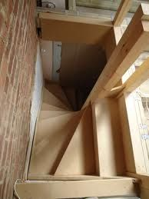

# 

# 

# 

# **What is your Provisional Diagnosis?**