Gear Rental – Resource Booking & Management App
Assignment Report
Jetpack Compose · Two-Activity Architecture · Navigation Compose · Parcelable + Activity Result API

Development Plan & Time Log
The app was built in a fixed sequence so the scoring/business rules existed and were correct before any UI was written on top of them. The plan, in order:
- Choose the domain (outdoor/climbing gear rental) and define the data model — fields, zones, and the fixed in-memory catalog.
- Build the model + ViewModel layer in isolation (GearItem, BasketItem, Booking, the Parcelable booking models, and BookingViewModel's validation rules) before any screen existed.
- Set up the Gradle project for Compose (BOM, Material3, Navigation Compose, Parcelize plugin) and get an empty Activity building.
- Build the Browse screen (search, sort, pager) and wire it to the ViewModel.
- Build the Basket screen, including the Activity Result launcher and the Intent construction for BookingActivity.
- Build BookingActivity and its confirmation screen (name field, terms checkbox, Confirm/Cancel).
- Build the History screen and the cancel/refund/restore flow.
- Add the reusable UI components (SectionHeading, PriceTag, StatusBadge, QuantityStepper) and the light/dark theme.
- Test end-to-end in Android Studio, fix build errors found only once a real Gradle sync/compile ran, and verify against the assignment's validation rules.

Time log (fill in actual hours spent per session):
Date | Task | Hours
 | Domain choice, data model, SampleGearData catalog
 | BookingViewModel: basket, validation rules, credit/availability logic
 | Gradle/Compose project setup (BOM, Material3, Navigation, Parcelize)
 | Browse screen: SearchBar, sort DropdownMenu, HorizontalPager
 | Basket screen: QuantityStepper, Activity Result launcher, Intent
 | BookingActivity + confirmation screen (name/terms validation)
 | History screen: cancel / refund / restore availability
 | Reusable components + light/dark theme
 | Testing in Android Studio, fixing build/runtime errors
 | Report writing (diagrams, user stories, sketches)

App Design & UI/UX Decisions

Domain and concept
The app models rentals for an outdoor/climbing gear shop (tents, ropes, harnesses, crampons, approach shoes, an avalanche beacon), deliberately in the same thematic space as the gym scoring app this project grew out of. Each catalog entry (GearItem) carries ten properties — id, name, category, year, rating, availableUnits, costPerNight, description, location and condition — well past the assignment's five-property minimum.

Screen layout decisions
The app is organised around three Navigation Compose destinations reachable from a bottom navigation bar, plus a separate confirmation Activity:
- Browse — the primary screen. Shows one resource at a time via a HorizontalPager (rather than a long scrolling list) so the user's attention is on a single decision at a time, with a Material3 SearchBar and a sort DropdownMenu above it.
- Basket — a LazyColumn of selected resources, each with a QuantityStepper for nights, a remove action, and a running total; validation errors are shown inline and the Book Now button is disabled until they clear.
- History — a LazyColumn of past bookings with a status badge and a Cancel action on active rows.
- BookingActivity — a dedicated, full-screen confirmation step reached only from Basket's Book Now button.
The credit balance is shown persistently in the TopAppBar (as “482 / 1000 cr”) so the user never has to navigate away to check whether they can afford another booking.

Two user stories and use cases
User Story 1 — Browsing and comparing gear
“As a gym member preparing for a weekend trip, I want to search and sort the gear catalog so that I can quickly find well-reviewed equipment that fits my trip.”
Use case:
- Actor: a member with the app open on the Browse screen.
- Precondition: the catalog has at least one resource with availableUnits > 0.
- Main flow: types “climbing” into the SearchBar → the pager narrows to matching resources → opens the sort menu and chooses “Rating (high to low)” → swipes through the top-rated matches → taps Add to Basket on a harness.
- Postcondition: exactly one entry for that resource exists in the basket (re-tapping Add to Basket on the same item is a no-op, enforced by BookingViewModel.isInBasket).
See Fig. A for the corresponding low-fidelity layout.
User Story 2 — Confirming a booking safely
“As a gym member finalising a rental, I want the booking to be blocked until I've entered my name and accepted the terms, so that no booking is ever recorded without clear accountability.”
Use case:
- Actor: a member with a valid basket (within the 400-credit cap, within their balance, 1–7 nights, available stock).
- Main flow: taps Book Now → BookingActivity opens with a summary of items and total cost → taps Confirm & Save with the name field empty → an inline error appears and nothing happens → enters a name and ticks the terms checkbox → taps Confirm & Save again → the booking is recorded, credits are deducted, and a Snackbar confirms it back on the Basket screen.
- Alternate flow: at any point before confirming, the user presses Cancel or the system back button → the Activity returns immediately with no state changes and a distinct “Booking cancelled” Snackbar.
See Fig. B for the corresponding low-fidelity layout.
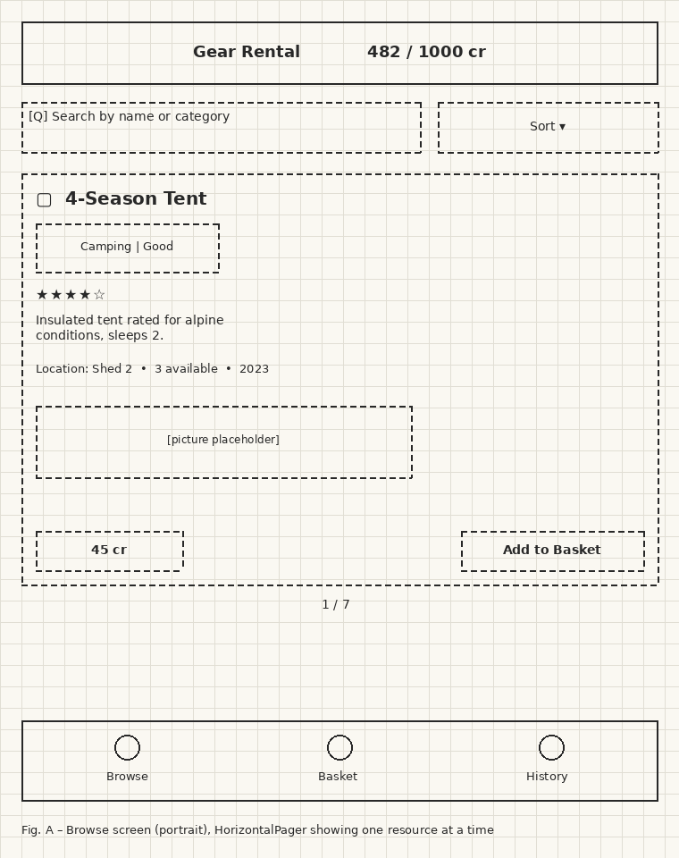
Fig. A – Browse screen sketch (portrait): search, sort, pager card, bottom navigation
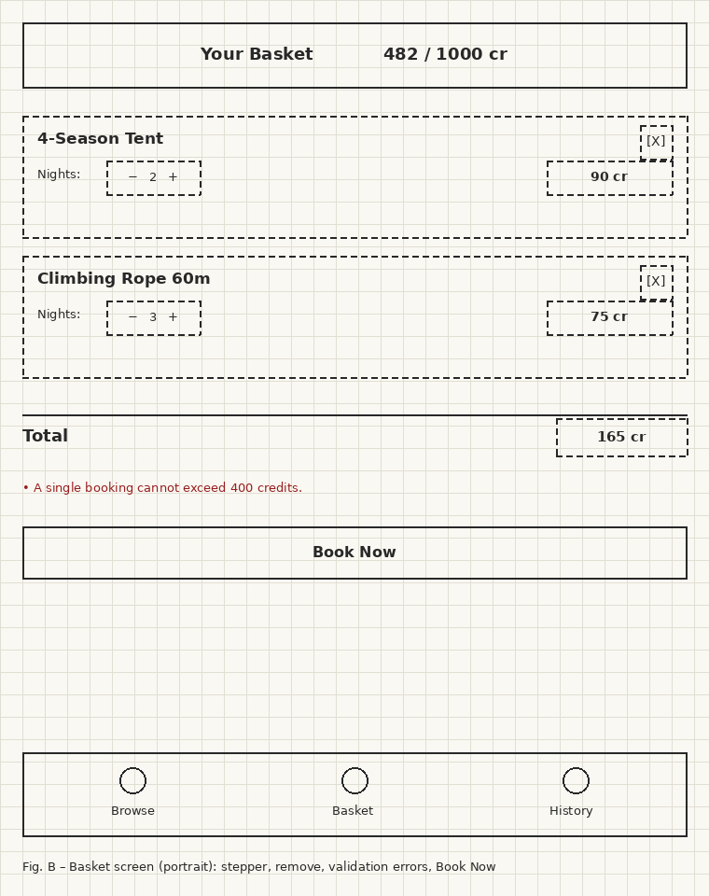
Fig. B – Basket screen sketch (portrait): stepper, remove, validation errors, Book Now
Both sketches deliberately use different widget emphasis: Browse leans on a single large interactive card plus a search/sort header (discovery-oriented), while Basket leans on a repeating list row pattern plus an always-visible total and error area (confirmation-oriented) — reflecting the different task each screen supports.

Reusable styles and the light/dark theme
Two (of four) reusable components are discussed here in detail, per the assignment's styling requirement:
- PriceTag — a small coloured pill rendering “N cr”. It is used on the Browse card, every Basket row, the basket total, every History row, and the BookingActivity summary — five distinct call sites sharing one definition.
- StatusBadge — a coloured pill with three tones (POSITIVE/NEGATIVE/NEUTRAL). It is used for a resource's category and condition on the Browse card, and for a booking's Active/Cancelled status in History.
Both components read their colours from MaterialTheme.colorScheme.* tokens (e.g. primaryContainer, tertiaryContainer, errorContainer) rather than hardcoded values. ui/theme/Theme.kt defines two separate ColorScheme objects — LightColors and DarkColors — and GearRentalTheme picks between them using isSystemInDarkTheme(). Because the components never reference a literal colour, switching the system theme re-themes every instance of PriceTag and StatusBadge across all three screens and BookingActivity automatically, with no per-screen theme-handling code.

Functionality & Implementation

Architecture overview
The app follows a small MVVM structure: GameState-equivalent data classes (GearItem, BasketItem, Booking) and pure rule constants live in model/; BookingViewModel is the single place state is mutated and validated; the ui/ package contains only rendering code — no screen computes a business rule itself, it only calls a ViewModel method and reads the result back.

How Navigation Compose is used in MainActivity
MainActivity hosts a single NavHost with three composable destinations — “browse”, “basket” and “history” — wrapped in a Scaffold with a persistent TopAppBar (credit balance) and a bottom NavigationBar. All three destinations receive the same BookingViewModel instance, created once in MainActivity via by viewModels() and passed down as a parameter, so a change made on one screen (e.g. cancelling a booking in History) is immediately visible on the others without any extra plumbing.
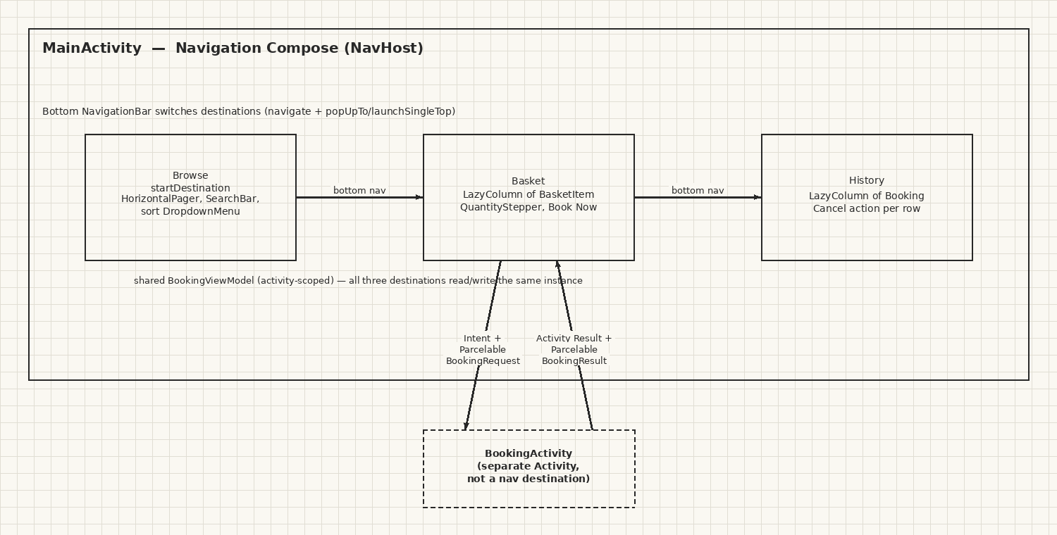
Fig. C – Navigation Compose graph inside MainActivity, and where BookingActivity sits outside it

Activity communication: why a second Activity, and how data crosses the boundary
Why a second Activity: the assignment specifically requires demonstrating cross-Activity data flow, which a Navigation Compose destination cannot provide — a destination lives in the same Activity and shares its ViewModel directly, with no Intent, no Parcelable boundary, and no Activity Result contract. BookingActivity is also a natural seam for a workflow with its own local, throwaway state (a name field, a terms checkbox) that should not leak into the shared BookingViewModel unless the user actually confirms.
How the Intent is constructed: BasketScreen builds a BookingRequest from the current basket (resource name/category, nights, cost per night and line total for each item, plus the total cost and the credit balance at the time), and starts BookingActivity with:
Intent(context, BookingActivity::class.java).putExtra(EXTRA_REQUEST, request)
How Parcelable is used: BookingLineItem, BookingRequest and BookingResult are declared as @Parcelize data classes (model/BookingModels.kt), which lets the Kotlin Parcelize compiler plugin generate the Parcelable boilerplate (writeToParcel/CREATOR) automatically from the constructor properties. BookingRequest travels MainActivity → BookingActivity as an Intent extra; BookingResult travels the other way as the Activity Result payload.
How the Activity Result API returns information: BasketScreen registers a launcher with rememberLauncherForActivityResult(ActivityResultContracts.StartActivityForResult()). BookingActivity never mutates BookingViewModel directly — it only calls setResult(RESULT_OK, Intent().putExtra(EXTRA_RESULT, result)) then finish(). Back in BasketScreen, the launcher's callback reads the BookingResult via IntentCompat.getParcelableExtra(...) and calls viewModel.confirmBooking(result) when result.confirmed is true, or viewModel.onBookingCancelled() otherwise — so the only way application state changes is through that one return path, confirmed or not.
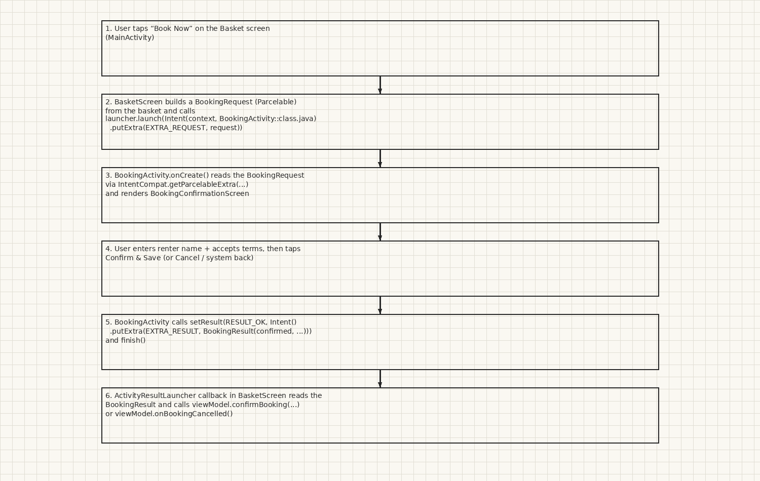
Fig. D – Full round trip: Basket → Intent + BookingRequest → BookingActivity → Activity Result + BookingResult → Basket

Navigation Compose vs. a separate Activity
 | Navigation Compose destination | Separate Activity
State sharing | Free — same composition, same ViewModel instance | Must be explicitly serialised (Parcelable) across a process boundary
Lifecycle | Tied to the host Activity; no separate back stack entry in the OS task sense | Own lifecycle, own entry in the back stack, can be launched by other apps
Best for | Browse/Basket/History — views over one continuous session of shared state | A bounded, self-contained workflow (booking confirmation) with its own local state and a clear “done/cancelled” outcome
Return value | None needed — state is just read back from the shared ViewModel | Explicit via the Activity Result API, so the caller only reacts when the workflow actually finishes
Navigation Compose is the right fit for Browse/Basket/History because they are different views over the same live session — a resource added in Browse must be visible in Basket a frame later, with no serialization in between. BookingActivity is the right fit for the booking workflow because it is a bounded transaction with its own input (name, terms) that should be discarded entirely on cancel, and because the assignment specifically wants that boundary to be crossed with an Intent/Parcelable/Activity Result, not shared mutable state.

Error checking and blocking confirmation (Technical Instruction C.1)
Two independent validation layers exist, one per Activity:
- In MainActivity: BookingViewModel.basketValidationErrors() checks, in order, that the basket is non-empty, the total does not exceed 400 credits, the total does not exceed the current balance, every item's nights fall within 1–7, and every item is still available. The list of returned messages is rendered directly under the basket total, and the Book Now button's enabled state is bound to canBook() (errors.isEmpty()) — so an invalid basket cannot even launch BookingActivity.
- In BookingActivity: BookingConfirmationScreen tracks attemptedConfirm, and only shows “Name is required” / “You must accept the terms” once the user has tried to confirm with either field incomplete. Confirm & Save only calls onConfirm(...) when both checks pass. Cancel (the button) and the system back button (via BackHandler) are always enabled and always call the same cancel path — so the user is never trapped: they either fix the two fields or leave via Cancel, exactly as the assignment requires.

Testing & Debugging
Testing was manual, performed in Android Studio against the running app, covering:
- Search/sort: typing partial names and categories narrows the pager; each sort option (rating desc, year desc, price asc) was checked against the known catalog order.
- Basket rules: adding the same resource twice is a no-op; nights cannot go below 1 or above 7 (the QuantityStepper's +/− buttons disable at the range edges); a basket whose total exceeds 400 credits, or exceeds the current balance, shows the matching error and disables Book Now.
- Booking flow: confirming deducts the exact total from the balance, removes the booked unit from availableUnits (hiding the resource from Browse once its stock reaches zero), and adds an Active row to History; cancelling returns to Basket unchanged with a distinct Snackbar.
- History cancel flow: cancelling an Active booking flips its status to Cancelled, refunds its exact cost back to the balance, and restores one unit of availableUnits per line item — verified by re-opening Browse and seeing the resource reappear.
- Light/dark theme: toggled the system theme from device Settings and confirmed every PriceTag/StatusBadge instance and both Activities re-themed without a restart.
Logging: Log.d and Log.w calls are placed on every ViewModel mutation (addToBasket, updateNights, confirmBooking, cancelBooking, etc., tagged “BookingViewModel”) and on BookingActivity's lifecycle/decision points (reading the request, confirming, cancelling, tagged “BookingActivity”), so Logcat shows a clear trace of what the user did and what the app decided — including rejected actions, e.g. the “Add to basket ignored: already present” warning when the same resource is added twice.
Two real build/runtime errors were only caught once the project was actually opened and synced in Android Studio, not by static review alone:
- Unresolved reference 'dp' in two files — Dp literals (16.dp) were used without importing androidx.compose.ui.unit.dp. Fixed, and every other file was swept for the same missing-import pattern (dp, sp, Modifier, Alignment, Arrangement, MaterialTheme, FontWeight, and every specific Material icon) to rule out further instances.
- “Activity class {com.example.boulderwallapp/com.example.gearrental.MainActivity} does not exist” — not a code defect but a stale Android Studio Run Configuration left over from before the applicationId changed; resolved by uninstalling the old APK and resetting the Run Configuration's launch target to Default Activity.
This underlines a limitation worth stating plainly: a sandboxed development pass without access to the Android SDK or Android Studio's full indexer can verify structure, naming and logic, but genuine compilation and on-device behaviour can only be confirmed by actually building and running the project — which is what eventually surfaced both issues above.

Code Quality & Project Structure
Package layout (app/src/main/java/com/example/gearrental/):
Package / file | Responsibility
model/ | GearItem, BasketItem, Booking, SortOption, and the Parcelable BookingLineItem / BookingRequest / BookingResult
data/SampleGearData.kt | The fixed, in-memory catalog (7 resources)
viewmodel/BookingViewModel.kt | Single source of truth: catalog, basket, bookings, credit balance, all validation rules
ui/theme/Theme.kt | Light/dark ColorScheme definitions and the GearRentalTheme wrapper
ui/components/Components.kt | SectionHeading, PriceTag, StatusBadge, QuantityStepper — reused across every screen
ui/screens/ | BrowseScreen, BasketScreen, HistoryScreen, BookingConfirmationScreen — rendering only
ui/App.kt | Scaffold, bottom navigation, NavHost wiring
MainActivity.kt / BookingActivity.kt | The two Activities; thin, delegate everything to the ViewModel or screen composables
This separation means every business rule (the 400-credit cap, the 1–7 night range, the uniqueness constraint, the refund-on-cancel logic) exists in exactly one place — BookingViewModel — and every screen is a straightforward function of its current state, which made both manual testing and this report's “where is X implemented” explanations far simpler to write accurately.

Challenges, Solutions & Reflection
- Keeping two Activities on one Gradle module while changing applicationId mid-project caused a stale Run Configuration in Android Studio (see Testing & Debugging). Solution: reset the launch target and uninstall the previous APK — a reminder that IDE/device state can lag behind a renamed package even when the manifest and build script are already correct.
- Deciding exactly where the Navigation Compose / Activity boundary should sit took some thought: it would have been possible to make booking confirmation just another NavHost destination, but that would not satisfy the assignment's explicit requirement to demonstrate Intent/Parcelable/Activity Result communication, and would also let BookingActivity's local draft state (name, terms) leak into the shared ViewModel before the user had actually committed to anything.
- Getting the combo of “commit nothing until the Activity Result returns” right required resisting the temptation to update the ViewModel optimistically when the user taps Book Now; instead BookingViewModel only ever changes state inside confirmBooking(result) or onBookingCancelled(), both called strictly from the launcher's callback, so a process death or back-press mid-flow can never leave the basket or credit balance in an inconsistent state.
- Writing most of the implementation without being able to run a full Android Gradle build directly (no local Android SDK in that environment) meant relying on careful manual review of imports and API shapes; this caught most issues but, as noted above, two still only surfaced once the project was opened in real Android Studio — a useful reminder that static review and an actual compiler/runtime check are complementary, not substitutes for each other.
- Reflection / takeaways: structuring all business rules as plain functions and a single ViewModel (rather than spreading validation checks across screens) made the cancel → refund → restore-availability flow straightforward to implement correctly in one place and easy to re-verify by reading just BookingViewModel.kt, rather than hunting across every screen that touches bookings.

Repository Link
https://github.com/JoshuaGwinnett/Assignment1/tree/claude/resource-booking-app
(Branch: claude/resource-booking-app — merge into main before submitting if the unit expects the default branch.)

GenAI Acknowledgement & References
The following section uses the Gen AI Reflection Template provided for this assignment. Draft content is included as a starting point — personalise the Learning Reflection answers and insert the requested prompt/answer screenshots before submitting, since those must reflect your own genuine experience and usage.

Permitted GenAI Tools Used
Claude (Claude Code, Sonnet model family): used to architect and implement the two-Activity Compose app end-to-end (data model, ViewModel, screens, Parcelable models, Gradle configuration), to debug build/runtime errors found during testing, to generate the diagrams and sketches in this report, and to draft this report's text.

Specific Tasks & Prompts
[Insert screenshots of your key prompts and Claude's responses here, per the template's instruction, rather than retyping them. Suggested tasks to capture:]
- Task 1: Initial scaffold of the two-Activity Compose app from the assignment brief.
- Task 2: Debugging the “Unresolved reference 'dp'” and stale Activity/Run-Configuration errors.
- Task 3: Generating this report's content and diagrams.

Code Attribution
app/src/main/java/com/example/gearrental/** (all files): AI-assisted — implementation (architecture, Kotlin/Compose code, Gradle configuration) produced with Claude based on the assignment brief, then iteratively reviewed, built, and tested by the student in Android Studio; two import/configuration errors found during that testing were fixed with further AI assistance (see Testing & Debugging).

Learning Reflection
How did GenAI help me learn?
[Your answer — e.g. seeing a complete, working MVVM/Compose/Parcelable implementation end-to-end made it easier to understand how the pieces (ViewModel, Navigation Compose, Intent/Parcelable, Activity Result) fit together than reading about each in isolation.]
What challenges did it create?
[Your answer — e.g. needing to verify generated code actually compiles and behaves correctly rather than assuming it does, since some errors (missing imports, stale IDE state) only appeared once the project was built for real.]
What specific skills did I develop?
[Your answer — e.g. reading and verifying someone else's (or an AI's) Kotlin/Compose code against a spec, diagnosing Gradle/IDE sync issues, and reasoning about Activity-boundary data flow with Intents and Parcelables.]

References
- Android Developers, “Jetpack Compose,” https://developer.android.com/jetpack/compose
- Android Developers, “Navigate with Navigation Compose,” https://developer.android.com/jetpack/compose/navigation
- Android Developers, “Material Design 3 in Compose,” https://developer.android.com/jetpack/compose/designsystems/material3
- Android Developers, “Get a result from an activity,” https://developer.android.com/training/basics/intents/result
- Android Developers, “Intents and intent filters,” https://developer.android.com/guide/components/intents-filters
- Android Developers, “Send simple data to other apps” / Parcelable overview, https://developer.android.com/guide/components/activities/parcelables-and-bundles
- Android Developers, “Parcelize,” https://developer.android.com/kotlin/parcelize
- Android Developers, “ViewModel overview,” https://developer.android.com/topic/libraries/architecture/viewmodel
- Android Developers, “Support dark theme,” https://developer.android.com/develop/ui/compose/designsystems/darktheme

