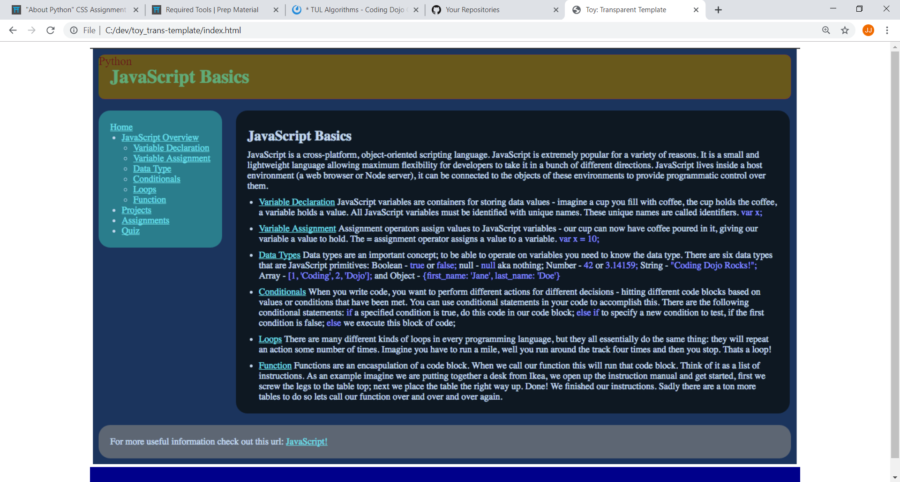

**Local**: C:\dev\toy_trans-template

**Repo**: toy_trans-template

**Branch**: Master

**Commit**: The heading is perfectly overlayed on top of the original heading. New heading is green with opacity 0.5 and old heading is red from the original Javascript image.

**TODO**: ...

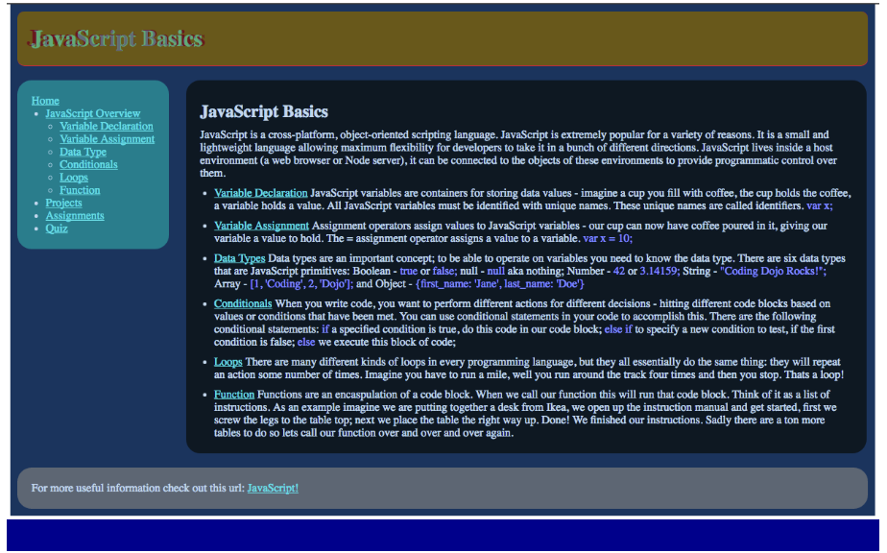

**Local**: C:\dev\toy_trans-template

**Repo**: toy_trans-template

**Branch**: Master

**Commit**: Changed heading title to match template.

**TODO**: ...

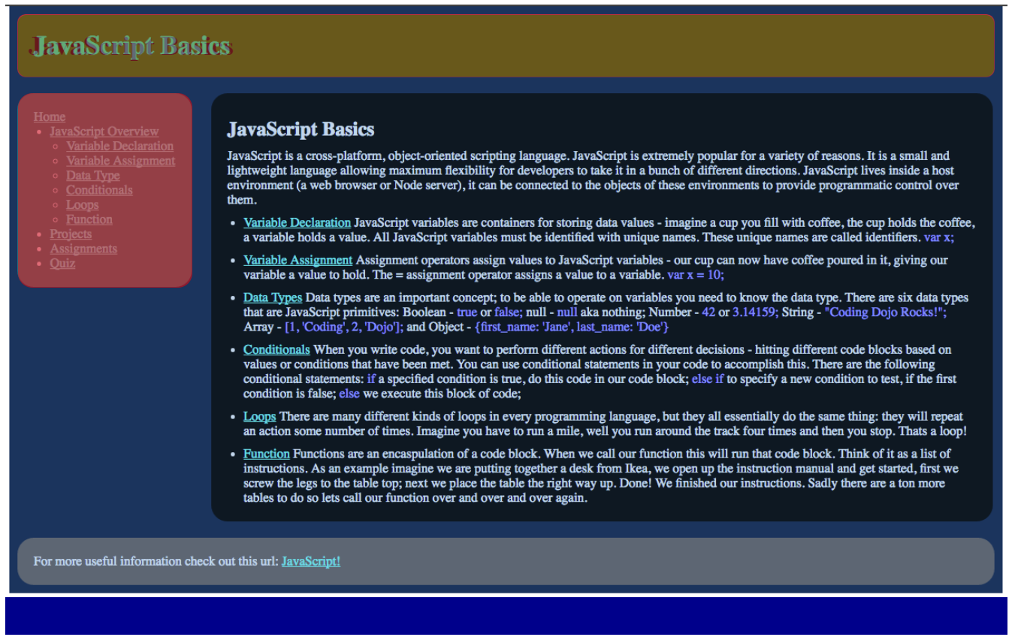

**Local**: C:\dev\toy_trans-template

**Repo**: toy_trans-template

**Branch**: Master

**Commit**: Added the navigation bar and modified it to match the template.

**TODO**: Delete the current CSS-A2 repo and then rename this one