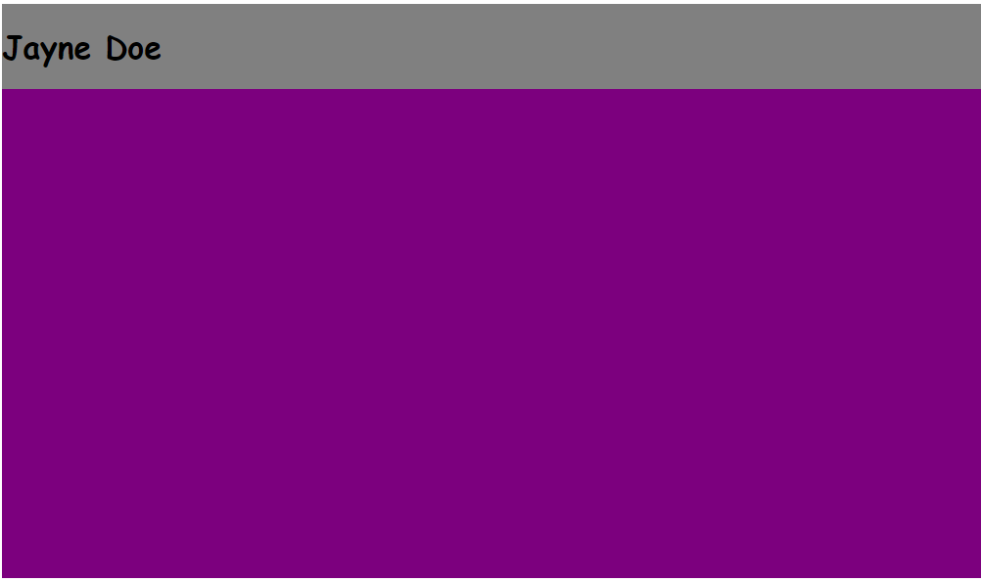

Commit: Main containers: Gray and purple (without gradients)

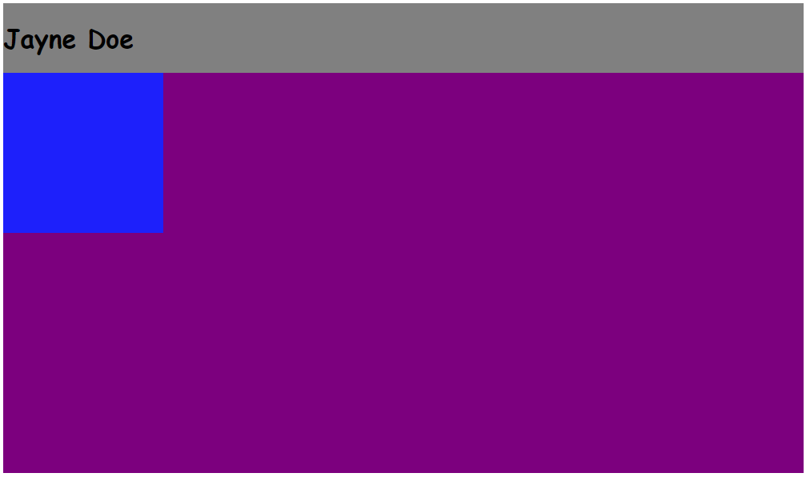

Commit: Floating box (upper left corner)

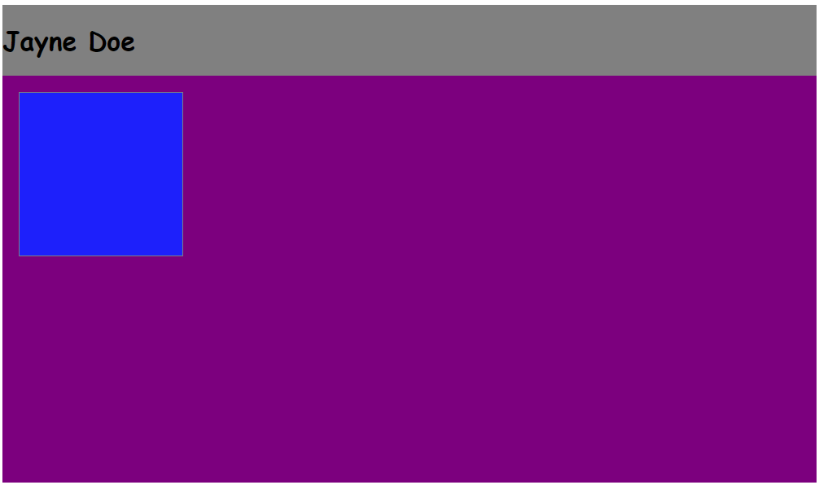

**Local**: D:\dev\bootcamp\01_Web-Fundamentals\02_CSS\02_portfolio

**Repo**: bootcamp

**Branch**: Master

**Commit**: Border and margin of upper left floating block.

**Note**:

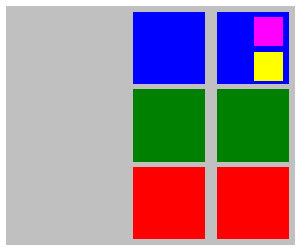

**Local**: D:/dev/full_stack/1_CSS/box-model/nested_box-model/box_matrix-nested.html

**Repo**: full-stack

**Branch**: Master

**Commit**: Border and margin of upper left floating block.

**Note**:Could not figure out how to place the two nested cols next to

each other so I only left in the code for the one working nested col (which contains the two nested boxes [pink and yellow])