**CSS Assignment-4**

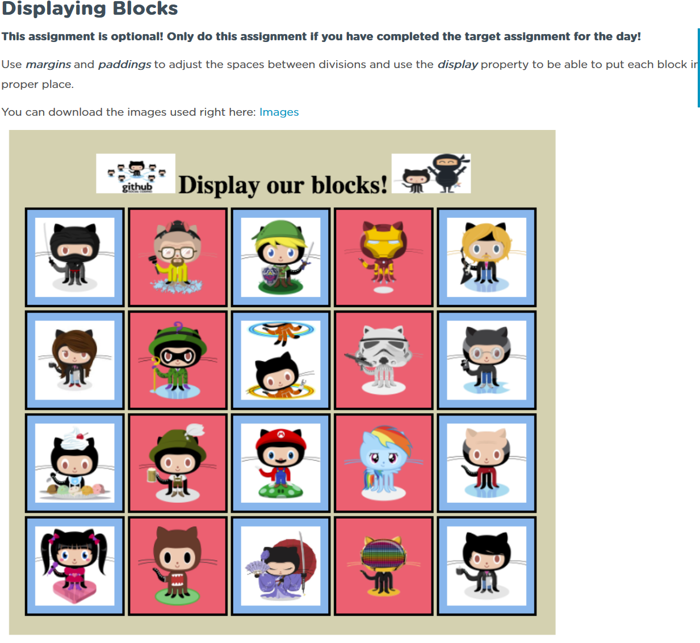

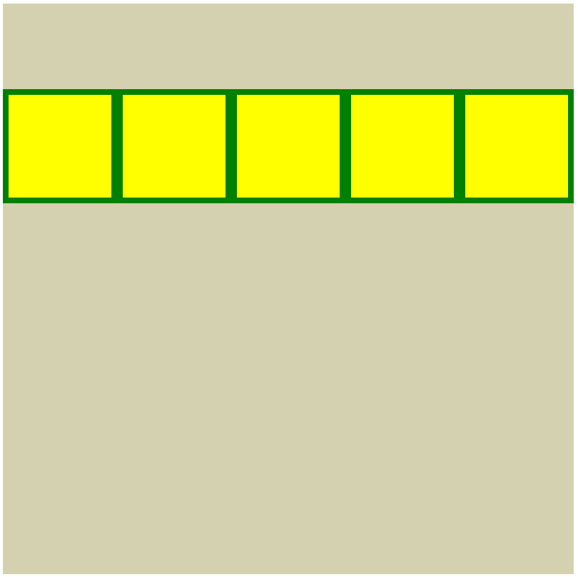

**Local**: C:\dev\CSS-4_displaying-blocks

**Repo**: CSS-4_displaying-blocks

**Branch**: Master

**Commit**: Set up base project. Created matrix structure.

**Note**:

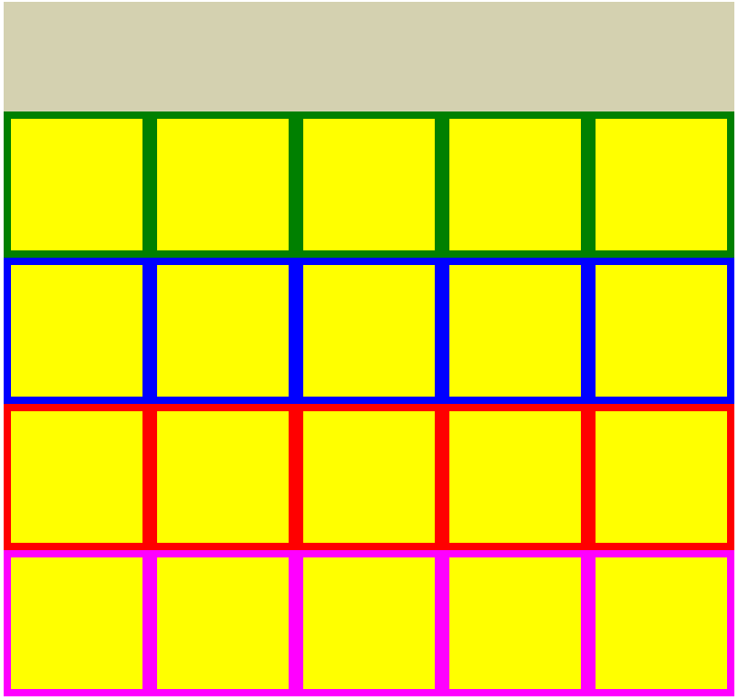

**Local**: C:\dev\CSS-4_displaying-blocks

**Repo**: CSS-4_displaying-blocks

**Branch**: Master

**Commit**: Completed matrix structure.

**Note**:

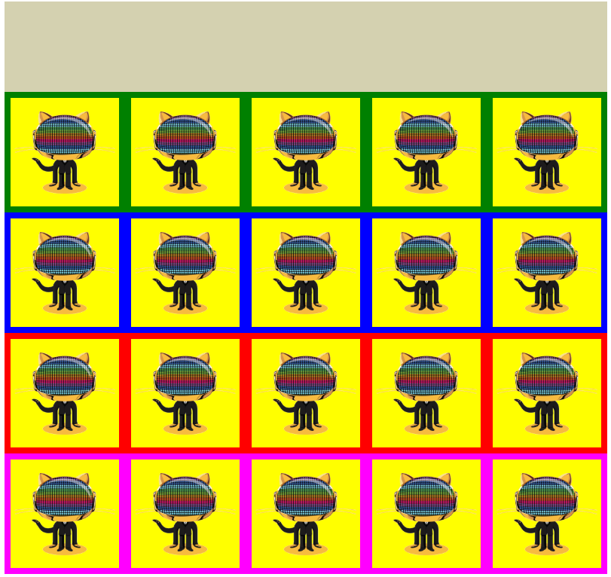

**Local**: C:\dev\CSS-4_displaying-blocks

**Repo**: CSS-4_displaying-blocks

**Branch**: Master

**Commit**: Added in images. [currently replicating same image]

**Note**:

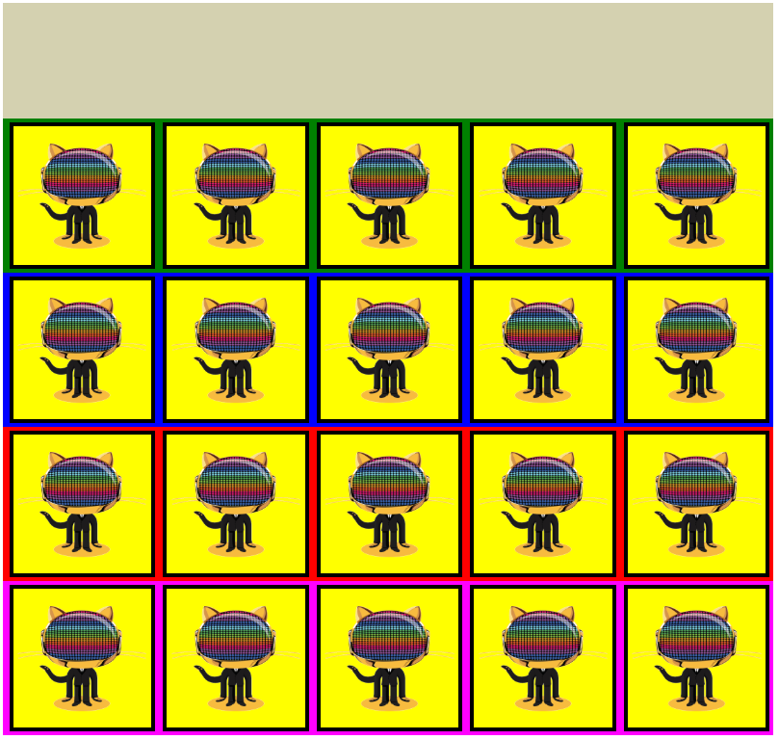

**Local**: C:\dev\CSS-4_displaying-blocks

**Repo**: CSS-4_displaying-blocks

**Branch**: Master

**Commit**: Added borders.

**Note**:

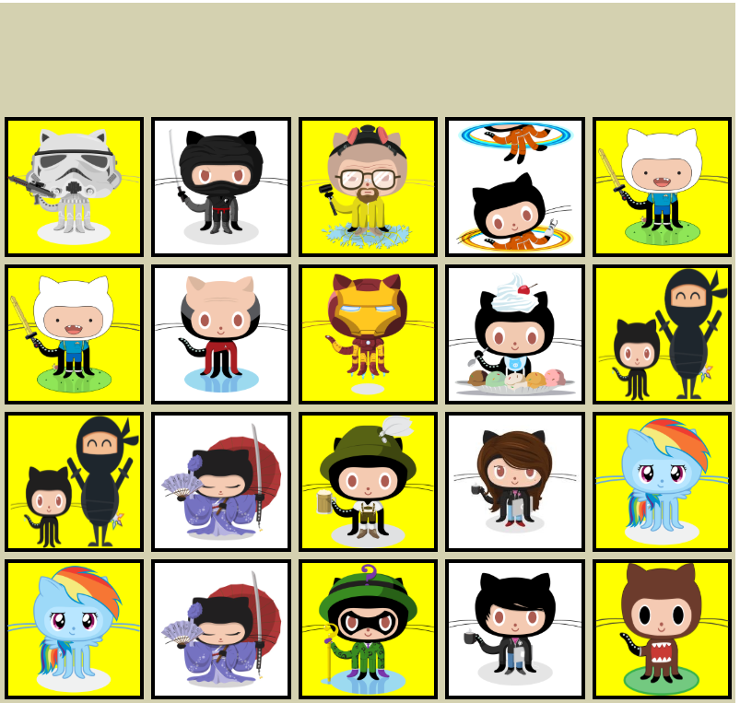

**Local**: C:\dev\CSS-4_displaying-blocks

**Repo**: CSS-4_displaying-blocks

**Branch**: Master

**Commit**: Added all images such that their transparencies are grouped into columns is similar to the spec.

**2019-05-22 TODO:**

* Add top text (“Displaying our blocks!”)
* Add top images
* Add background colors
  + For png’s make background yellow
  + For jpg’s make background blue and add in border
    - Probably need to put a nested box inside all the boxes to match the blue border effect.