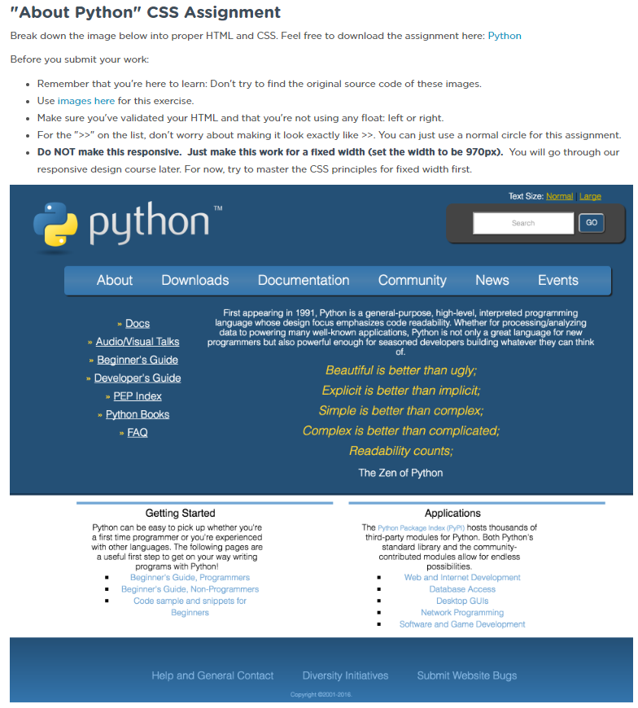

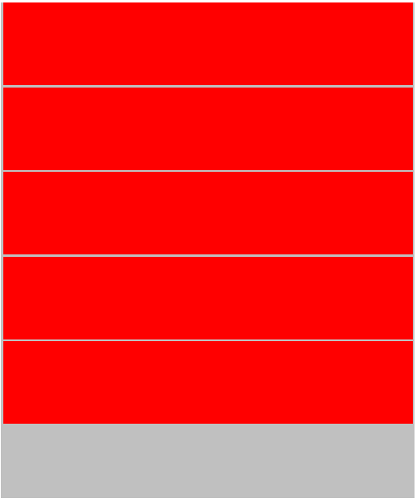

**Local**: C:\dev\C:\dev\CSS-5_about-python

**Repo**: CSS-5_about-python

**Branch**: Master

**Commit**: Set up base projects and created 5 rows.

**TODO**: Measure the actual ratios of the row heights and their corresponding columns widths;

Accurate measurements:

* All measurements are with screen zoomed in to 100% to the file:
  + C:\dev\CSS-5_about-python\spec.png
* Using program “**Simple Screen Ruler**” with measurements units **big** and **small**
* Overall page:
  + 16.75 wide
    - Measured this value
  + 13.75 tall
    - Measured each of the heights of the five rows and then added up the values
      * Row 1: 2
      * Row 2: 1.25
      * Row 3: 5.25
      * Row 4: 3.75
      * Row 5: 1.75
        + => Total measured width = 14
  + See hand notes for ratio calculations
  + Results of heights (keeping all widths held at 1k):
    - Row1: 120px
    - Row2: 75px
    - Row3: 315px
    - Row4: 225px
    - Row5: 100px

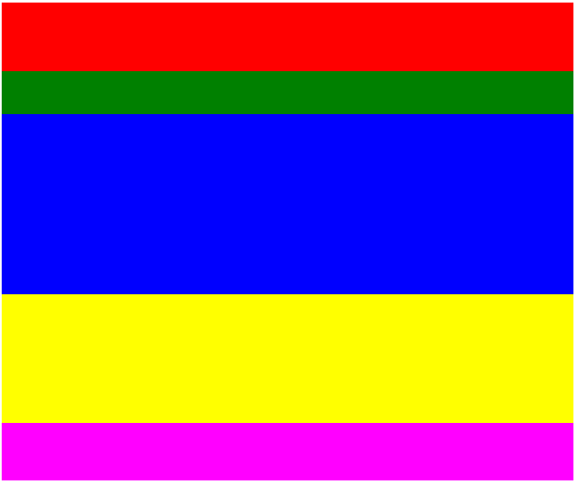

**Local**: C:\dev\C:\dev\CSS-5_about-python

**Repo**: CSS-5_about-python

**Branch**: Master

**Commit**: Measure the actual ratios of the row heights and their corresponding columns widths;

**TODO**:

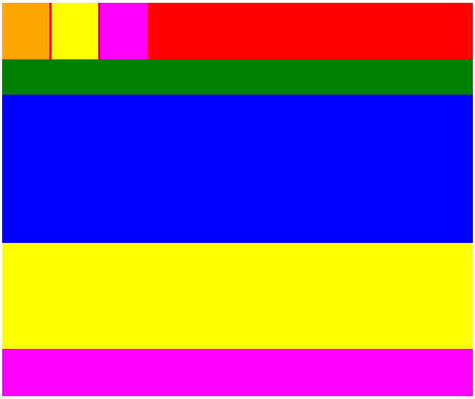

**Local**: C:\dev\C:\dev\CSS-5_about-python

**Repo**: CSS-5_about-python

**Branch**: Master

**Commit**: Added three boxes in top row. The dimensions are not correct yet. NOTE: Why are there margins between the blocks horizontally? See work-log for details.

**TODO**:

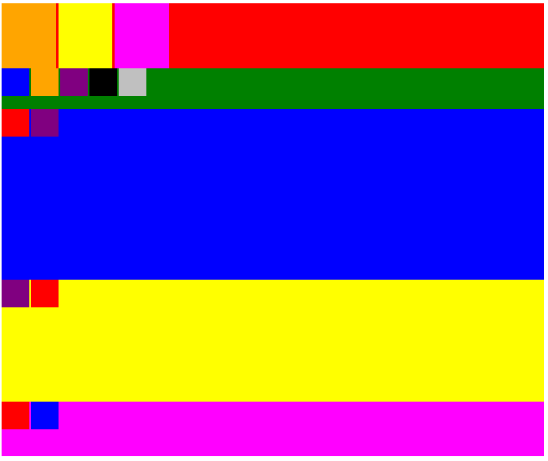

**Local**: C:\dev\C:\dev\CSS-5_about-python

**Repo**: CSS-5_about-python

**Branch**: Master

**Commit**: Added all the columns for each row.

**TODO**: Add in transparencies

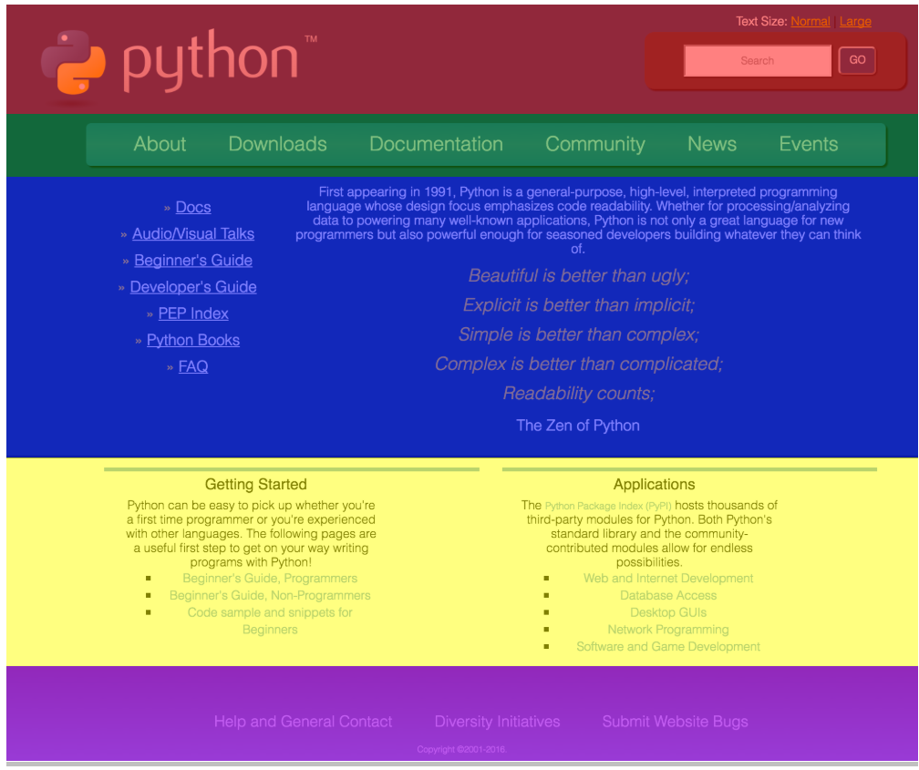

**Local**: C:\dev\C:\dev\CSS-5_about-python

**Repo**: CSS-5_about-python

**Branch**: Master

**Commit**: **Started over.** Fixed the size of each of the rows. Added transparent template.

**TODO**:

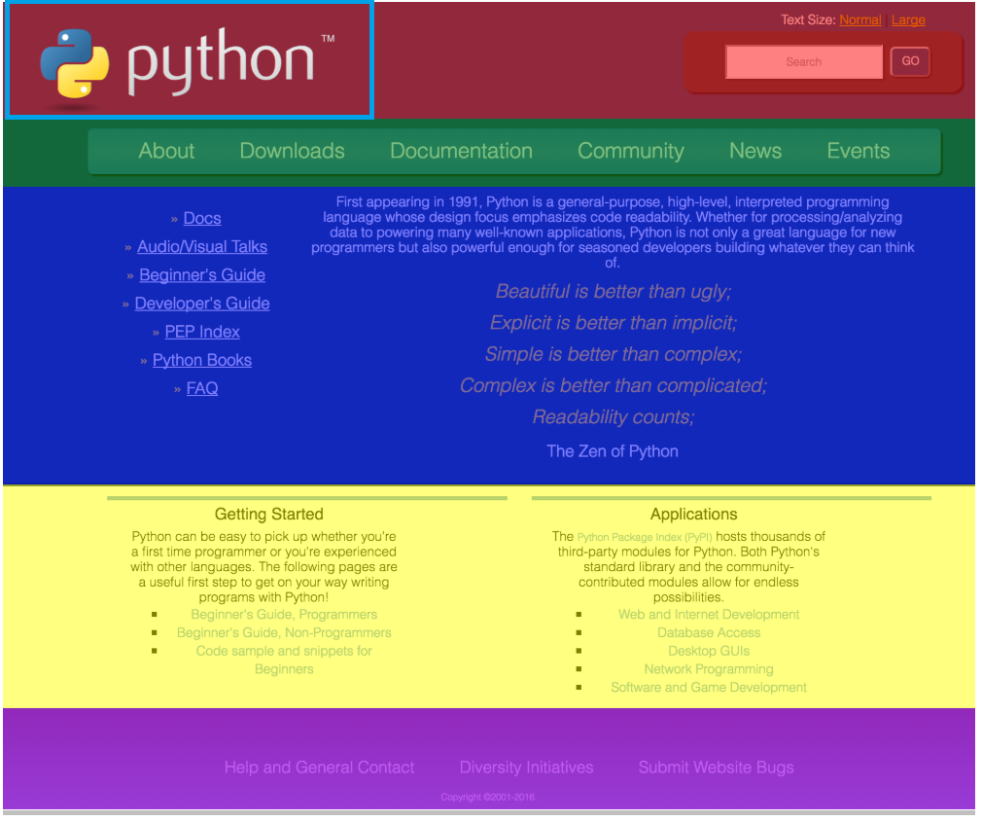

**Local**: C:\dev\C:\dev\CSS-5_about-python

**Repo**: CSS-5_about-python

**Branch**: Master

**Commit**: Added upper left Python image.

**TODO**:

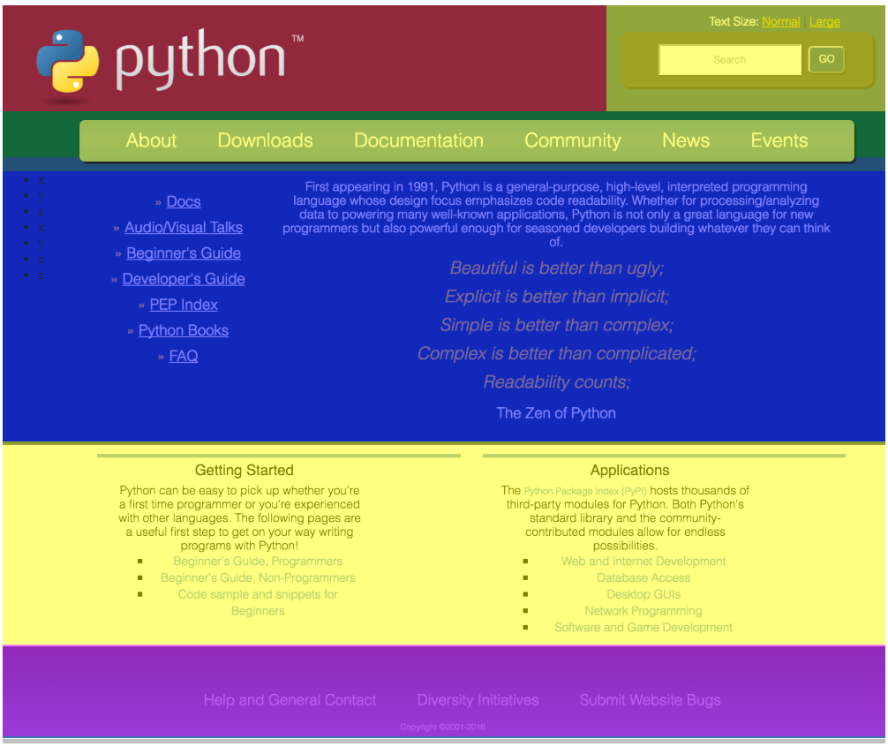

**Local**: C:\dev\C:\dev\CSS-5_about-python

**Repo**: CSS-5_about-python

**Branch**: Master

**Commit**: Added middle rounded row.

**TODO**:

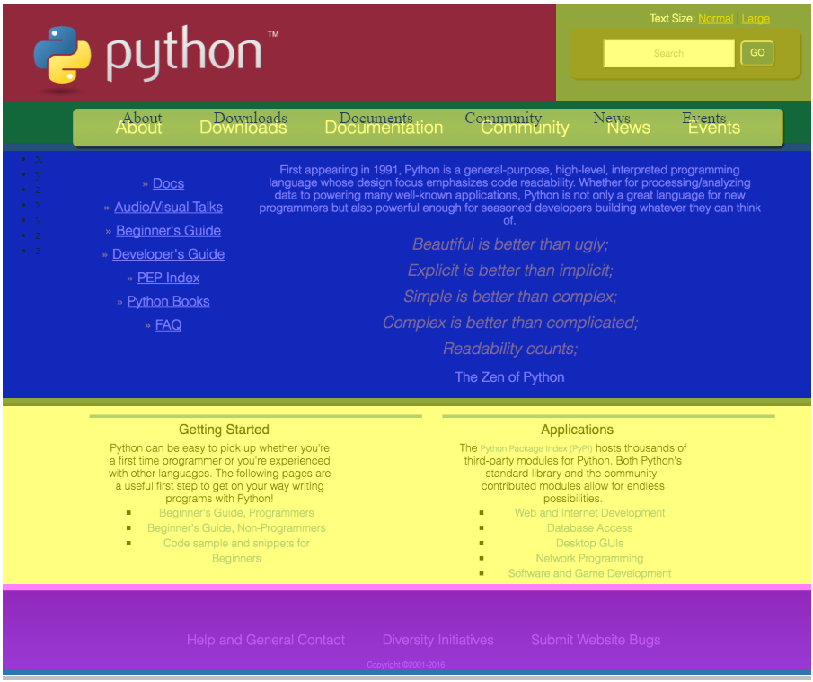

**Local**: C:\dev\C:\dev\CSS-5_about-python

**Repo**: CSS-5_about-python

**Branch**: Master

**Commit**: Added text second row.

**TODO**:

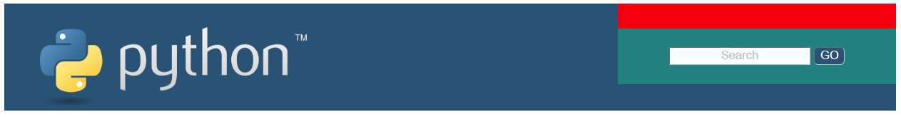

**Local**: C:\dev\C:\dev\CSS-5_about-python

**Repo**: CSS-5_about-python

**Branch**: Master

**Commit**: started from scratch. Added header and fully functioning search bar.

**TODO**:

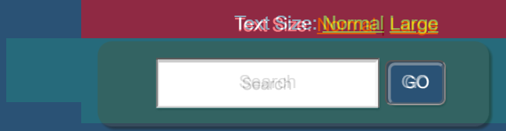

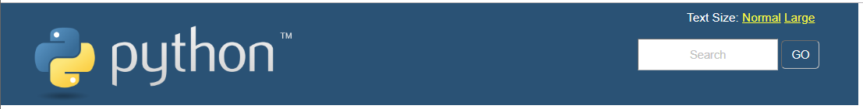

**Local**: C:\dev\C:\dev\CSS-5_about-python

**Repo**: CSS-5_about-python

**Branch**: Master

**Commit**: Finished header

**TODO**: Create structure of second row