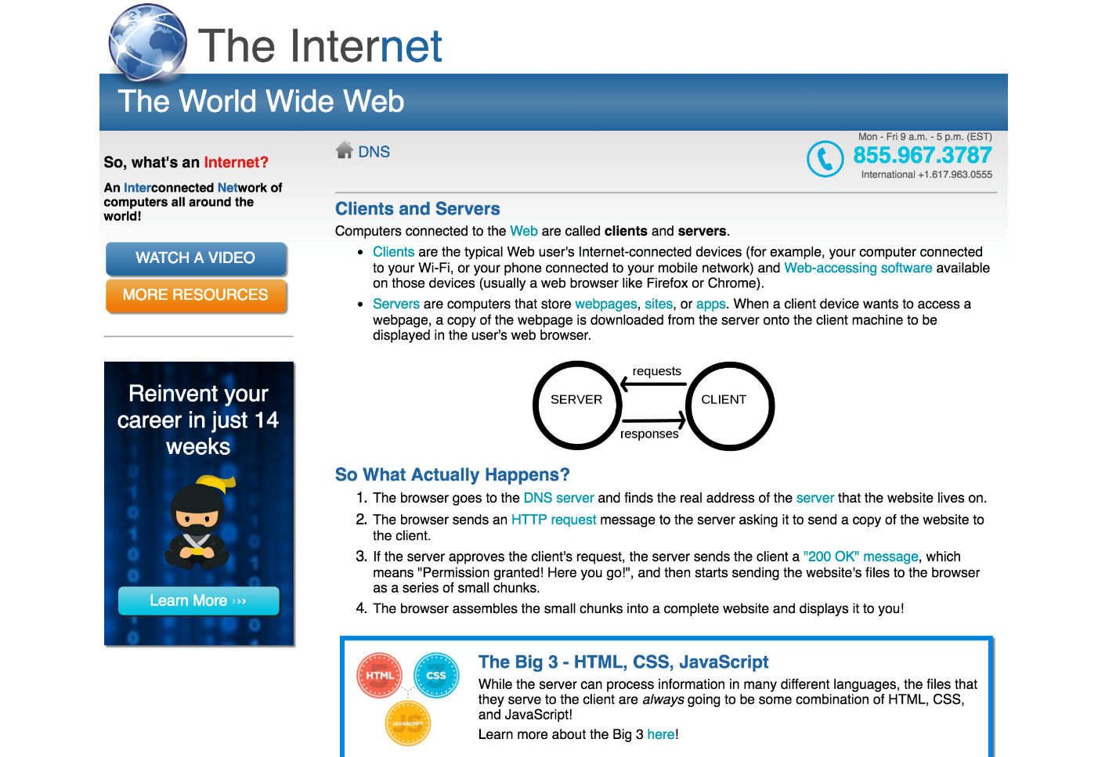

**Local**: D:\dev\CSS-6_Internet

**Repo**: CSS-6_Internet

**Branch**: Master

**Commit**: Created base project.

**TODO**:



**Local**: D:\dev\CSS-6_Internet

**Repo**: CSS-6_Internet

**Branch**: Master

**Commit**: Overlay globe over header.

**TODO**:

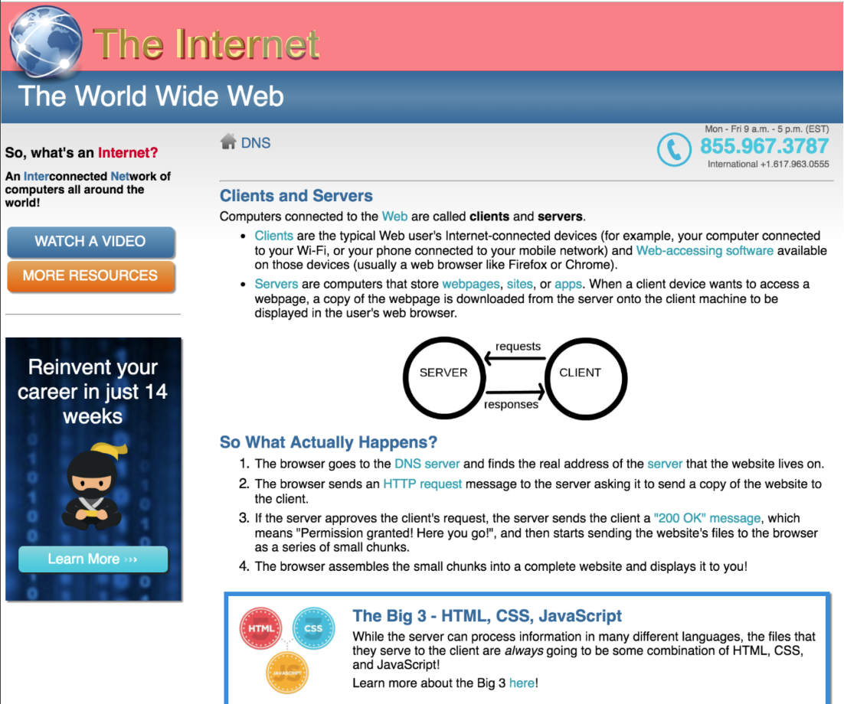

**Local**: D:\dev\CSS-6_Internet

**Repo**: CSS-6_Internet

**Branch**: Master

**Commit**: Title

**TODO**:



**Local**: D:\dev\CSS-6_Internet

**Repo**: CSS-6_Internet

**Branch**: Master

**Commit**: Changed color of second part of title

**TODO**:

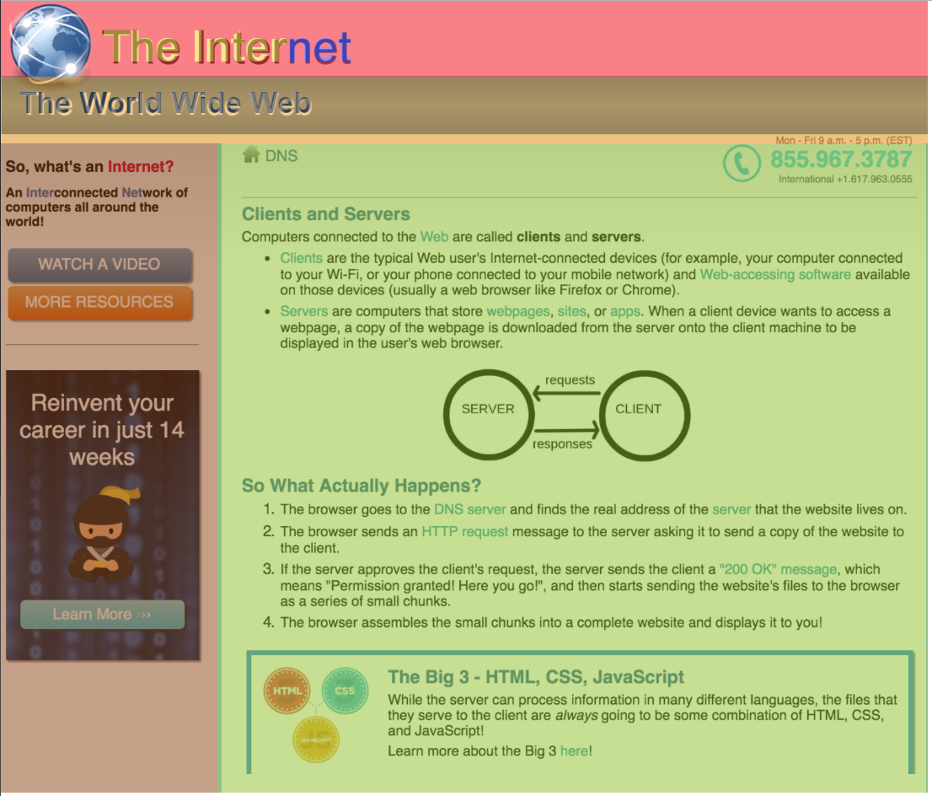

**Local**: D:\dev\CSS-6_Internet

**Repo**: CSS-6_Internet

**Branch**: Master

**Commit**: Added two cols in main section.

**TODO**: