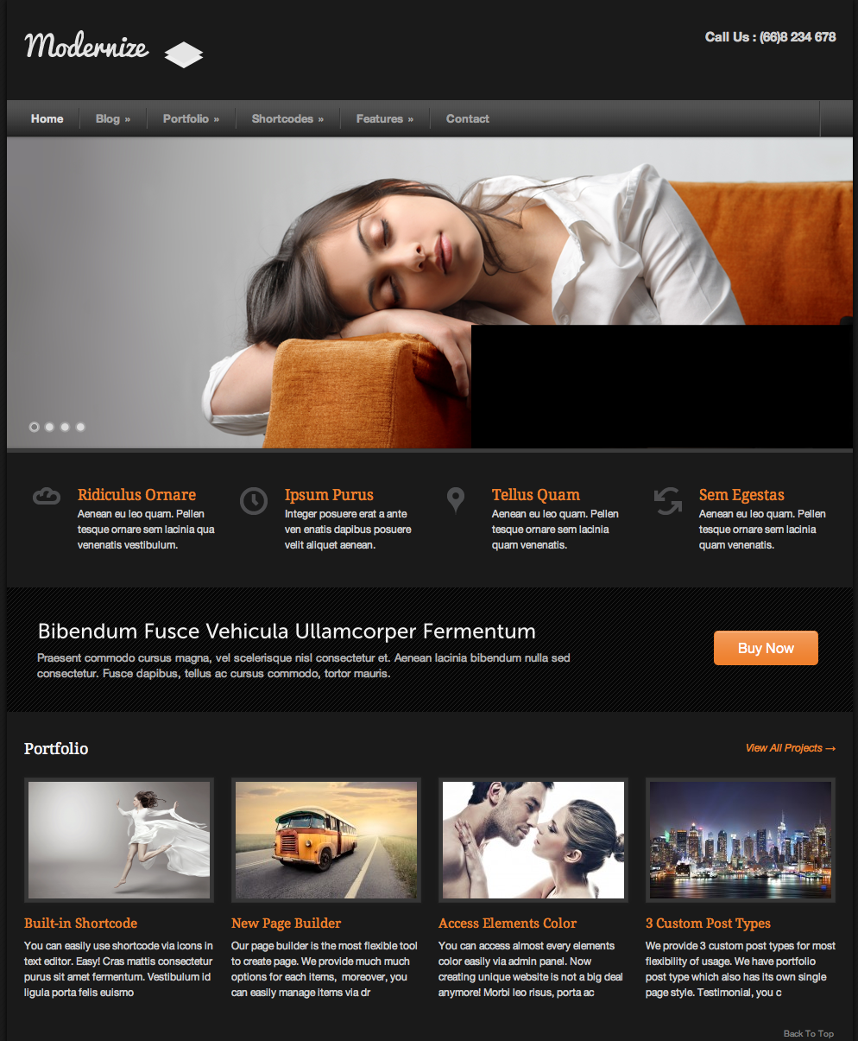

**Local**: C:\dev\CSS-exam

**Repo**: CSS-exam

**Branch**: Master

**Commit**: Created base project

**TODO**: ..

**Repo**: CSS-exam

**Branch**: Master

**Commit**: added background image and sized container appropriately

**TODO**: Add image log in upper left corner

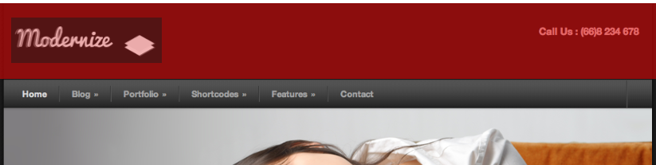

**Local**: C:\dev\CSS-exam

**Repo**: CSS-exam

**Branch**: Master

**Commit**: Added image log in upper left corner

**TODO**: Phone number in upper right corner

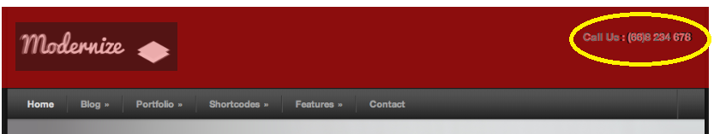

**Local**: C:\dev\CSS-exam

**Repo**: CSS-exam

**Branch**: Master

**Commit**: Phone number in upper right corner

**TODO**: Navigation bar

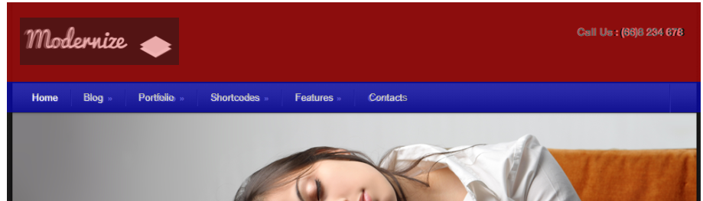

**Local**: C:\dev\CSS-exam

**Repo**: CSS-exam

**Branch**: Master

**Commit**: Added nav-bar with links

**TODO**: Add photo below nav-bar

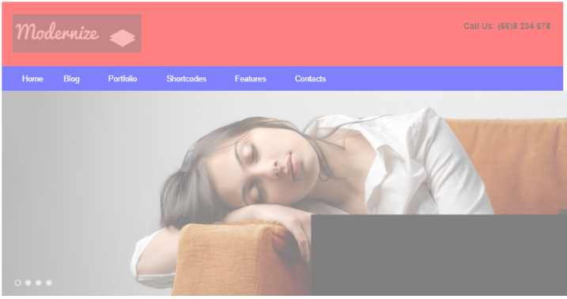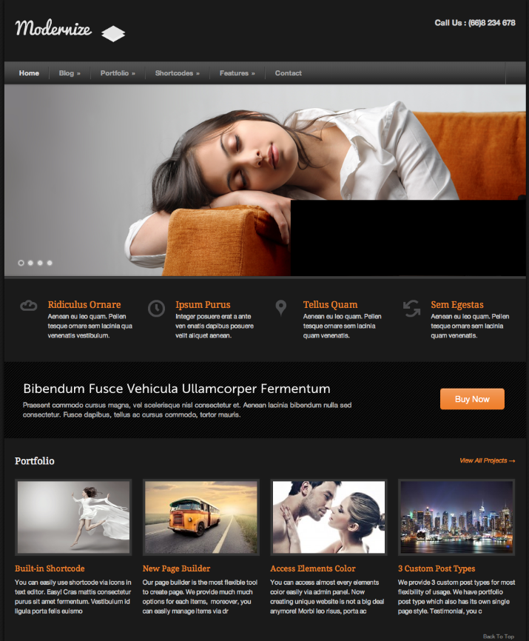

**Local**: C:\dev\CSS-exam

**Repo**: CSS-exam

**Branch**: Master

**Commit**: Added photo below nav-bar

**TODO**: Add links below nav bar