**Second-Django-Project Log**

Run local web-server

D:\dev\Django-00_First-Django-Project **> cd first_project**

D:\dev\Django-00_First-Django-Project\first_project **>** **python manage.py runserver**

* Copy URL into browser
  + <http://127.0.0.1:8000/>

Terminology

* Migrations
  + A migration allows you to move databases from one desing to another.
    - This is also reversible.
  + So you can “migrate” your database.
* Django Project
  + 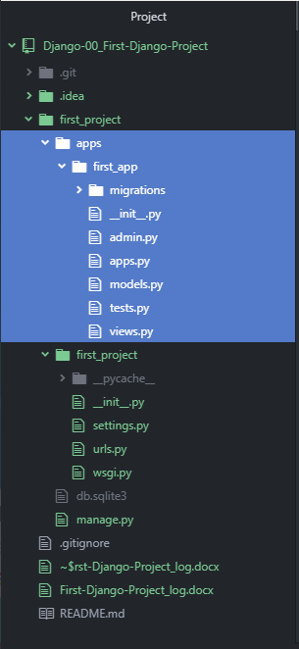A Django project is a collection of applications and configurations that when combined-together will make up the full web-application (i.e. your complete website running with Django)

**Step 2: Manually create a folder for projects apps**

D:\dev\Django-00_First-Django-Project\first_project **>** **mkdir apps**

D:\dev\Django-00_First-Django-Project\first_project **>** **cd apps**

D:\dev\Django-00_First-Django-Project\first_project\apps **>** **python ..\manage.py startapp second_app**

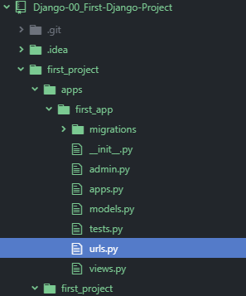D:\dev\Django-00_First-Django-Project\first_project\apps **>** **cd first_app**

D:\dev\Django-00_First-Django-Project\first_project\apps\first_app **>** **touch urls.py**

* Modify first_project/settings.py

INSTALLED_APPS = [  
 'apps.first_app', # JOSH: added  
 'django.contrib.admin',  
 'django.contrib.auth',  
 'django.contrib.contenttypes',  
 'django.contrib.sessions',  
 'django.contrib.messages',  
 'django.contrib.staticfiles',  
]

* + Add apps/first_app to list of INSTALLED_APPS
* Add code snippet to **project**-level urls.py file

from django.conf.urls import url, include  
urlpatterns = [  
 url(r'^', include('apps.first_app.urls')),  
 # url(r'^admin/', admin.sites.urls)  
]

* + Place in app-name in the include function
* Add code snipped to **app**-level urls.py file

from django.conf.urls import url  
from . import views  
  
urlpatterns = [  
 url(r'^$', views.index),  
]

* Add code snipped to **app**-level views.py file

# Create your views here.  
from django.shortcuts import render, HttpResponse  
def index(request):  
 return HttpResponse("this is the equivalent

of @app.route('/')!")

* Re-run server:

