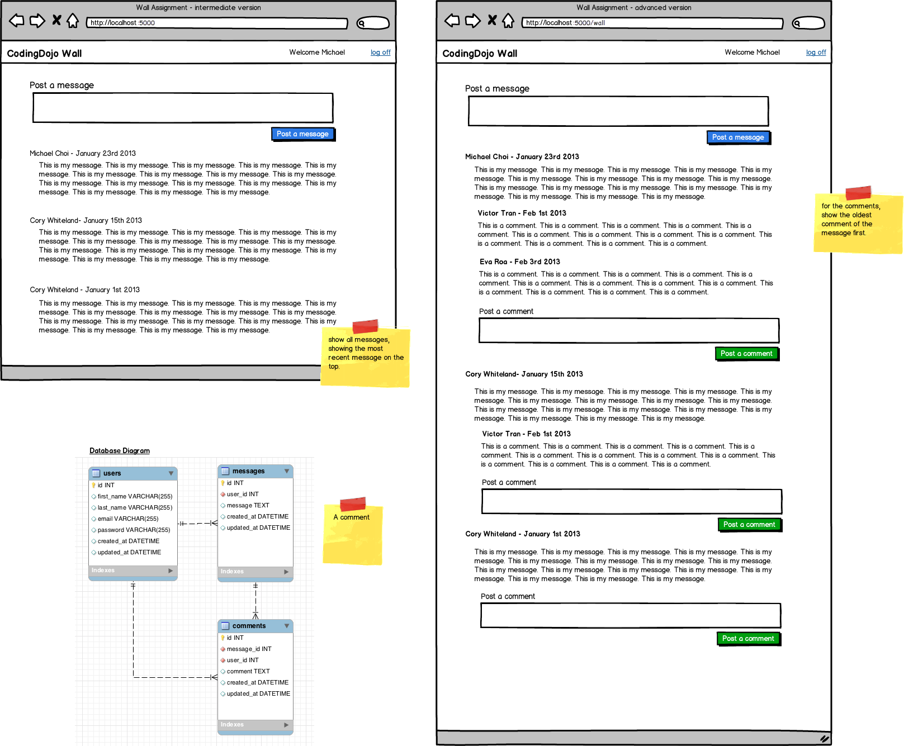

* Users $→$ Messages [**One-to-Many**]:
  + One **user** can leave many **messages**
* Users $→$ Comments [**One-to-Many**]:
  + One **user** can leave many **comments**
* Messages $→$ Comments [**One-to-Many**]:
  + Each **message** can have many **comments**

