**Josh Holloway**

**mySQL Install**: <https://youtu.be/0cNOD1KMJ40>

# **Assignment-1: MySQL Countries**

**Queries**

1. What query would you run to get all the **countries** that **speak Slovene**?

* Your query should return:
  + Name of the country
  + Language
  + Language percentage
* Your query should arrange the result by language percentage in descending order. (1)

SELECT language, country_code, percentage FROM languages

WHERE languages.language = "Slovene"

ORDER BY percentage DESC;

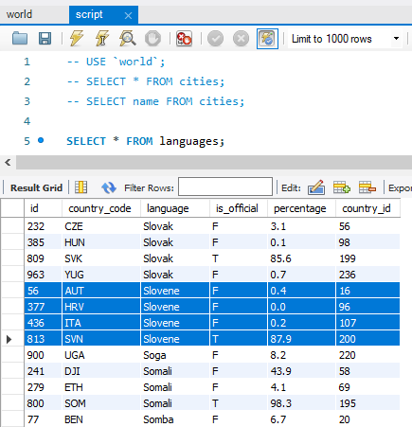 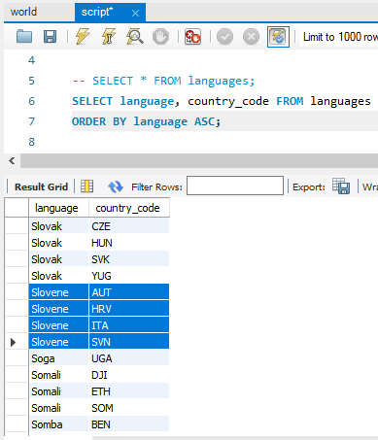 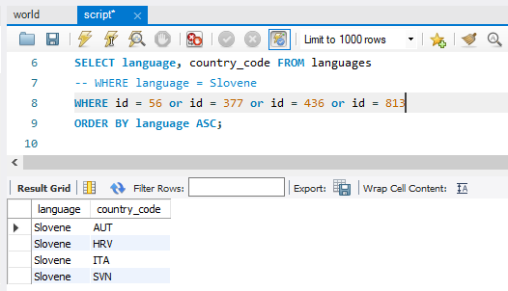 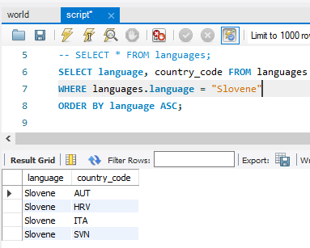

Steps taken to arrive at solution

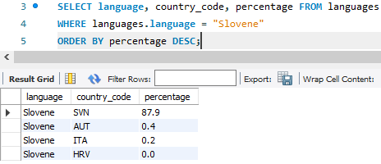

2. What query would you run to display:

* **The total number of cities for each country**?
* Your query should return the **name of the country** and the **total number of cities**.
* Your query should arrange the result by the **number of cities** in **descending order**. (3)

SELECT cities.country_id as Country_ID, countries.name AS Country_Name, COUNT(*) AS Number_of_Cities FROM cities

JOIN countries ON countries.id = cities.country_id

GROUP BY countries.name

ORDER BY Number_of_Cities DESC;

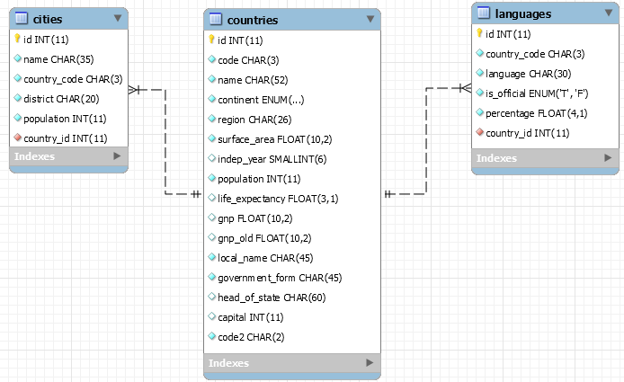

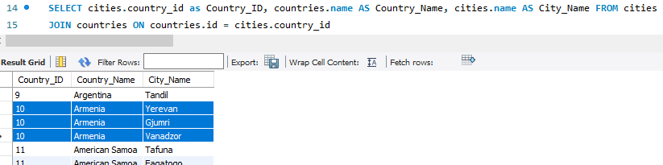

- - - - - - - - - - - - - - - - - - - - - - - - - -

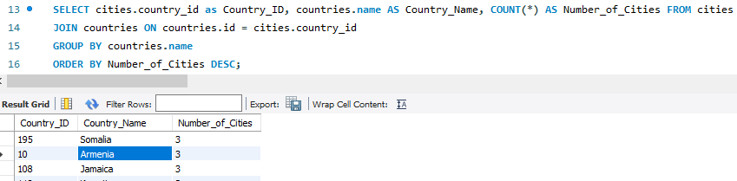

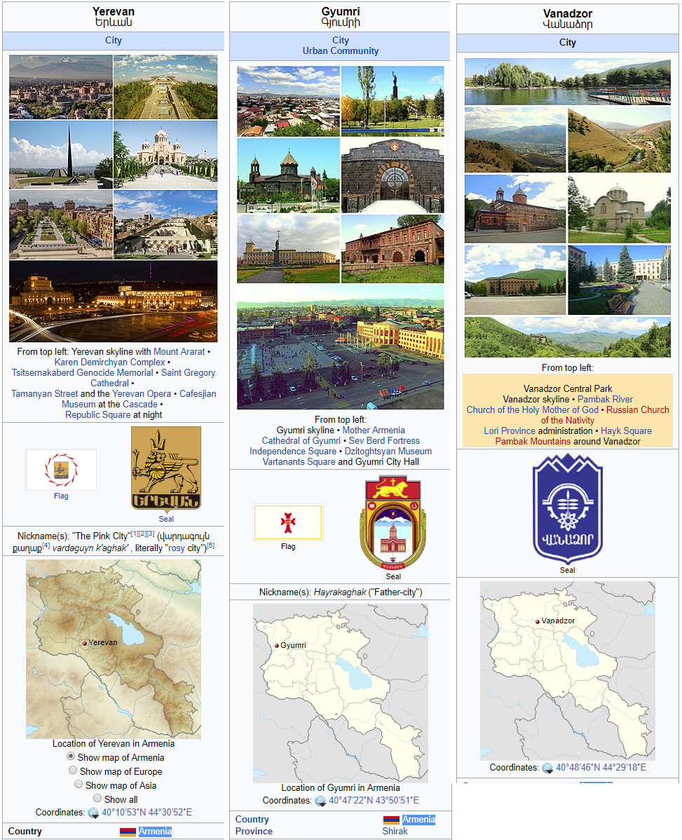

Cities used as a sanity check. [They are the 3 cities listed for Armenia]

3. What query would you run to get

* **all the cities**
* **in Mexico**
* **with a population of greater than 500,000**?
* Your query should arrange the result by population in descending order.

SELECT **cities**.name as City_Name, **cities**.population, **cities**.country_id, countries.name as Country_Name FROM **cities**

JOIN **countries** ON **countries**.id = **cities**.country_id

WHERE **cities**.population > 500e3 AND **countries**.name = 'Mexico'

ORDER BY population DESC;



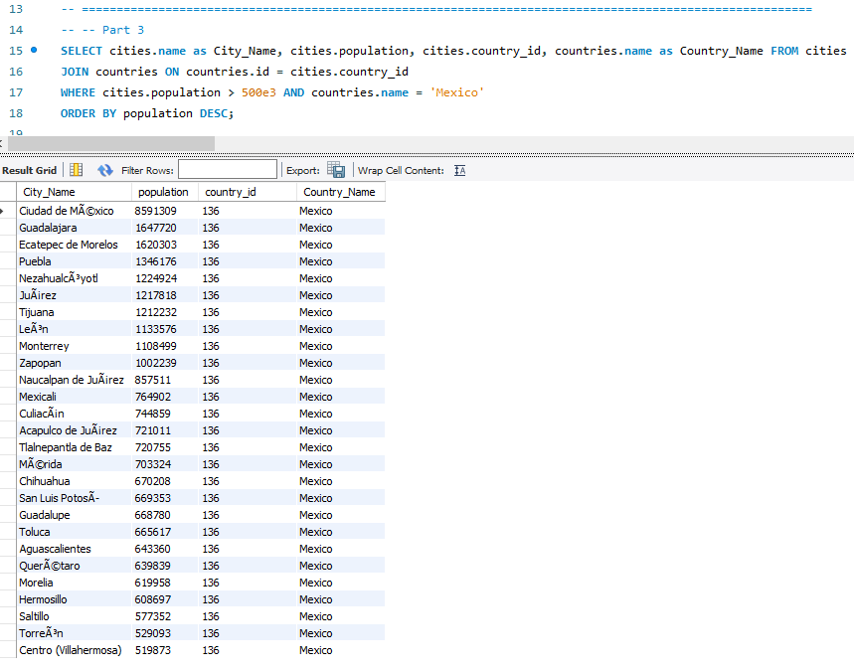

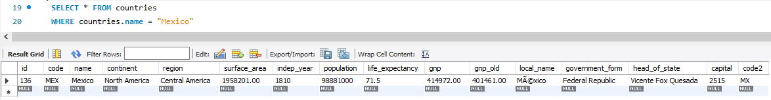

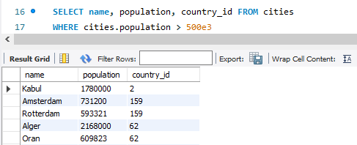 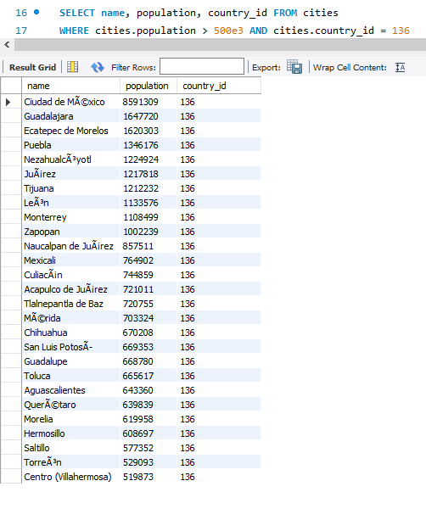

Steps taken to work toward final solution.

4. What query would you run to get **all languages in each country with a percentage greater than 89%**?

* Your query should arrange the result by percentage in descending order. (1)

SELECT countries.name AS Country_Name, language, percentage FROM languages

JOIN countries ON countries.id = languages.country_id

WHERE languages.percentage > 89

ORDER BY percentage DESC;

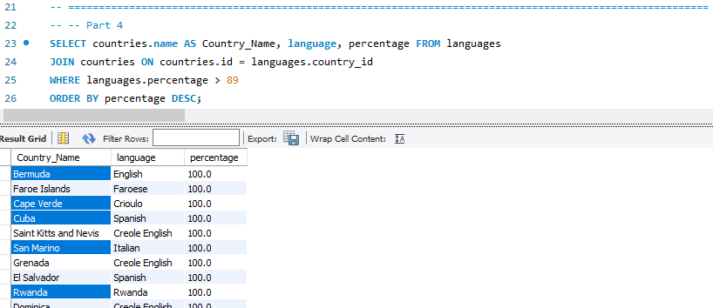

5. What query would you run to get:

* All the countries
* With Surface Area below 501
* And population greater than 100,000?

SELECT name, surface_area, population FROM countries

WHERE surface_area < 501 AND population > 100e3

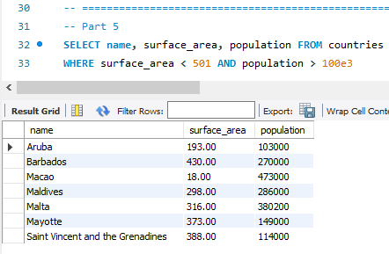

6. What query would you run to get:

* Countries
* With only Constitutional Monarchy
* With a capital greater than 200
* And a life expectancy greater than 75 years?

SELECT name, government_form, capital, life_expectancy FROM countries

WHERE capital > 200 AND government_form = 'Constitutional Monarchy' AND life_expectancy > 75

order by life_expectancy DESC

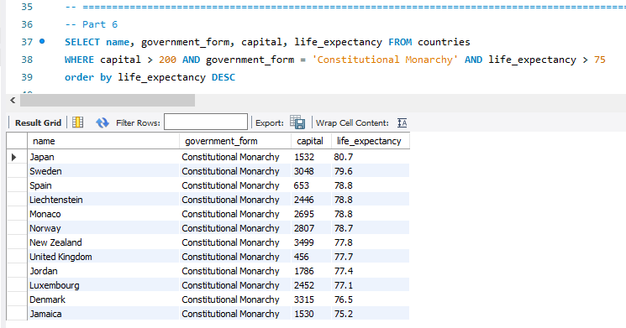

7. What query would you run to get:

* All the cities of Argentina
* Inside the Buenos Aires district
* And have the population greater than 500, 000?
* The query should return the Country Name, City Name, District and Population.

SELECT countries.name AS Country_Name, cities.name AS City_Name, district as District, cities.population as Country_Population FROM cities

JOIN countries ON countries.id = cities.country_id

WHERE cities.population > 500e3 AND cities.district = 'Buenos Aires' AND countries.name = 'Argentina'

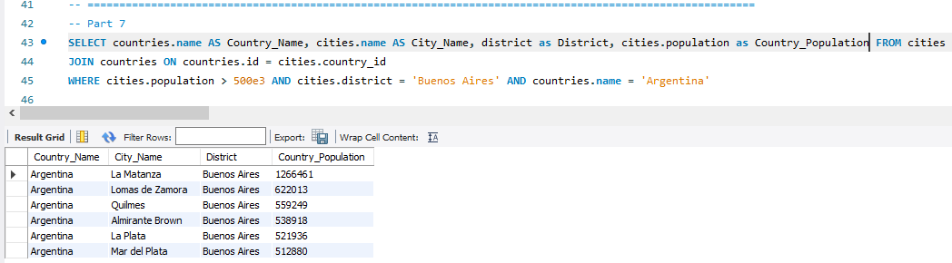

8. What query would you run to:

* Summarize the number of countries in each region?
* The query should display the name of the region and the number of countries.
* Also, the query should arrange the result by the number of countries in descending order. (2)



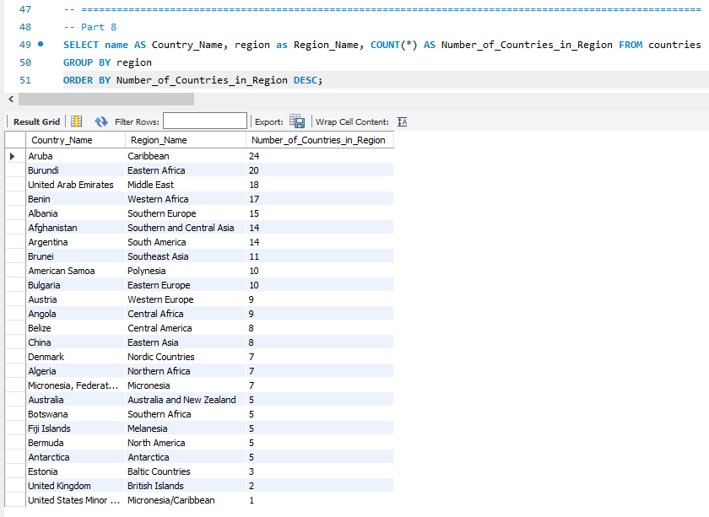

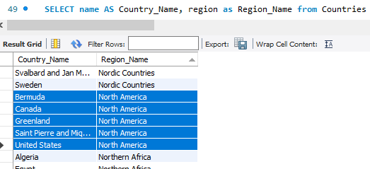

* **Showing that there are 5-countries in North-America region**
* **A few other regions were tested also**

# Assignment-2: ***Sakila***

1. What query :

* All the customers
* Inside city_id = 312
* Your query should return customer
  + first name
  + last name
  + email
  + address.

SELECT city_id, first_name, last_name, email, address.address FROM customer

JOIN address ON address.address_id = customer.address_id

WHERE city_id = 312;

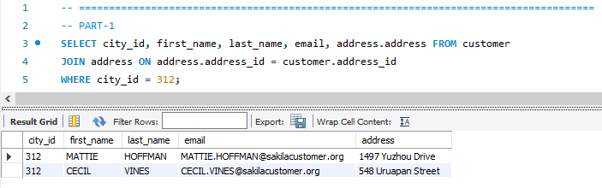

2. What query would you run to get

* All comedy films
* Your query should return:
  + - film title
    - description
    - release year
    - rating
    - special features
    - genre (category)

SELECT film.film_id, title AS Film_Title, description, release_year, rating, special_features, name AS Genre FROM film_category

JOIN film ON film.film_id = film_category.film_id

JOIN category ON category.category_id = film_category.category_id

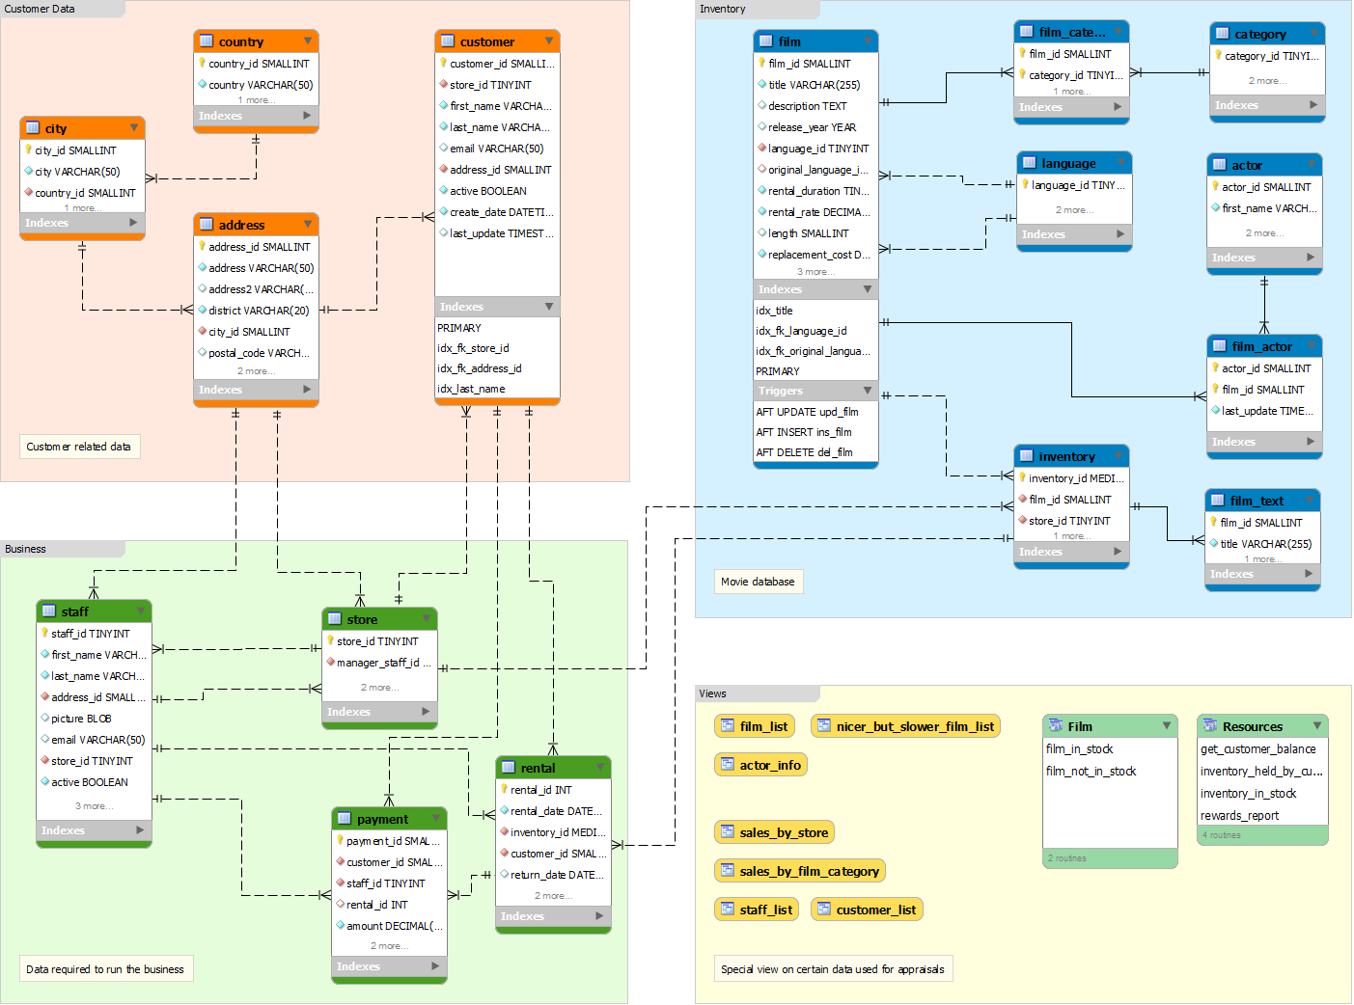

3. What query would you run to get

* + All the films joined by actor_id=5
* Your query should return
  + Actor id
  + Actor name
  + Film title
  + Description
  + Release year.

SELECT film_actor.actor_id, first_name, last_name, film.film_id, title, film.description, film.release_year FROM film_actor

JOIN film ON film.film_id = film_actor.film_id

JOIN actor ON actor.actor_id = film_actor.actor_id

WHERE actor.actor_id = 5



4. What query would you run to get:

* + All the customers in store_id = 1
  + and inside these cities (1, 42, 312 and 459)
* Your query should return
  + first name
  + last name
  + email
  + address

SELECT * FROM customer

JOIN address ON address.address_id = customer.address_id

JOIN city ON city.city_id = address.city_id

WHERE store_id = 1 and city.city_id = 1 or city.city_id = 42 or city.city_id = 312 or city.city_id = 459



5. What query would you run to get

* + **all the films**
  + **with a "rating = G"**
  + and **"special feature = behind the scenes"**,
  + **joined by actor_id = 15**
* Your query should return the film title
  + Description
  + Release Year
  + Rating
  + Special Feature.
* Hint: You may use LIKE function in getting the 'behind the scenes' part.

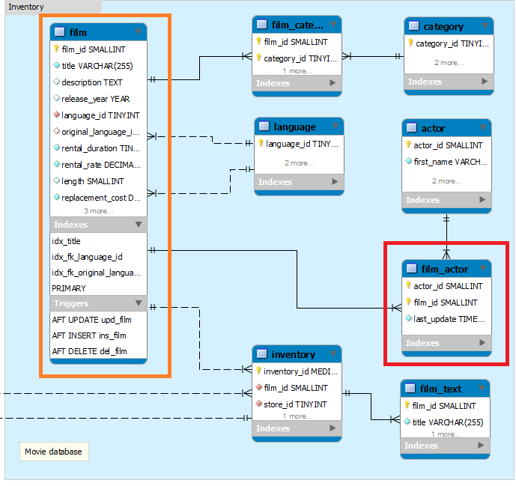

6. What query would you run to get

* + all the actors
  + that joined in the film_id = 369
* Your query should return the
  + film_id
  + title
  + actor_id
  + actor_name

SELECT film_actor.film_id, film.title, actor.actor_id, actor.first_name, actor.last_name FROM film

JOIN film_actor ON film_actor.film_id = film.film_id

JOIN actor ON film_actor.actor_id = actor.actor_id

WHERE film.film_id = 369

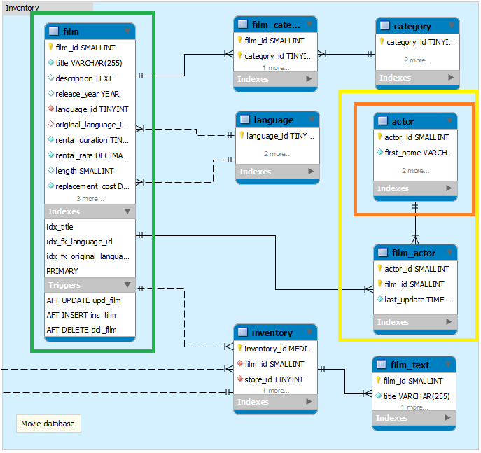

7. What query would you run to get

* + all drama films
  + with a rental rate of 2.99
* Your query should return
  + film title
  + description
  + release year
  + rating
  + special features
  + genre



8. What query would you run to get

* + all the action films
  + which are joined by SANDRA KILMER
* Your query should return
  + film title
  + description
  + release year
  + rating
  + special features
  + genre (category)
  + actor's first name
  + last name

