**<https://youtu.be/OSvAeb99YcM?t=614>**

**CMake Projects in VS**

<https://docs.microsoft.com/en-us/cpp/build/cmake-projects-in-visual-studio?view=vs-2019>

**VS-2019 CMake Project Settings UI**

<https://devblogs.microsoft.com/cppblog/introducing-the-new-cmake-project-settings-ui/>

* Check CMake Version

C:\> **cmake --version**

cmake version 3.14.2

* Local directory-path :
  + D:\dev\build\2_cmake\00_hello\3_VS2019

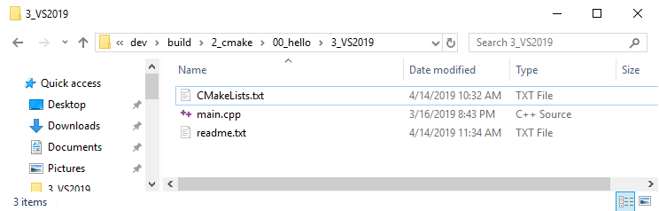

* Contents of CMakeLists.txt:

cmake_minimum_required(VERSION 3.10)

project(MyProject VERSION 1.0.0)

add_executable(josh main.cpp)

* Contents of main.cpp

#include <iostream>

auto main() -> int

{

std::cout << "Hello!\n";

return(0);

}

* Open folder containing the CMakeList.txt file.

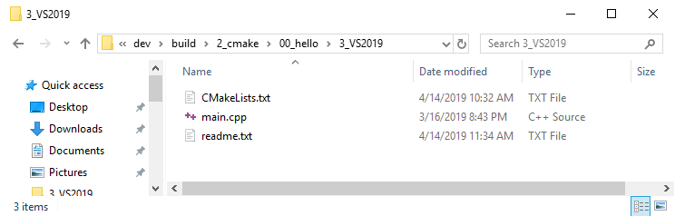

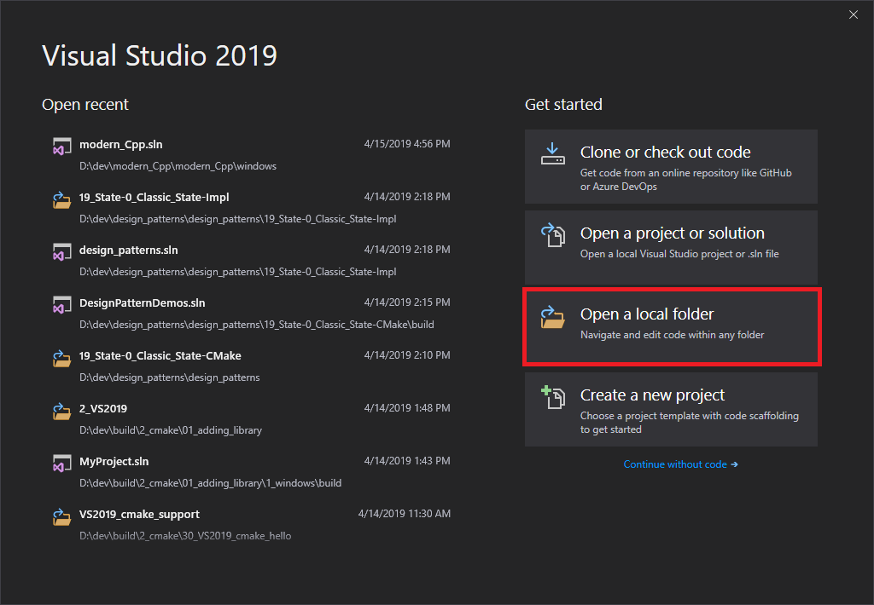

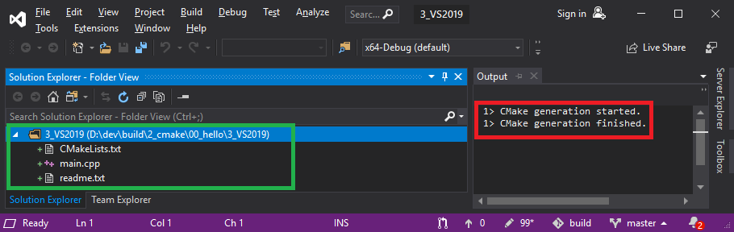

**Change to x86-debug:** 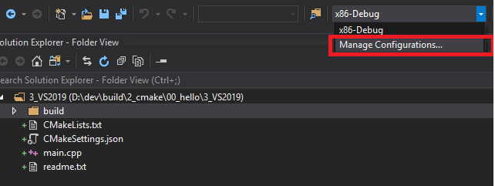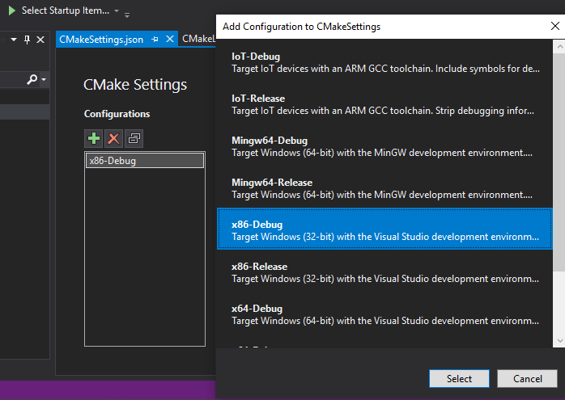

**Edit the JSON** file:

[https://docs.microsoft.com/en-us/cpp/build/**configure-cmake-debugging-sessions**?view=vs-2019](https://docs.microsoft.com/en-us/cpp/build/configure-cmake-debugging-sessions?view=vs-2019)

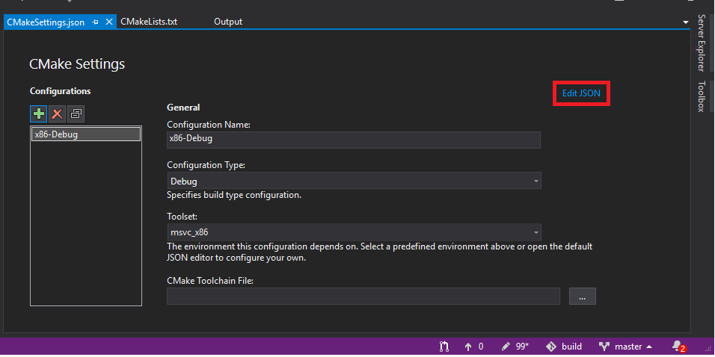

Change the **buildRoot** and **installRoot**:

{

"configurations": [

{

"name": "x86-Debug",

"generator": "Ninja",

"configurationType": "Debug",

"buildRoot": **"${workspaceRoot}**\\build\\${name}",

"installRoot": "**${workspaceRoot}**\\install\\${name}",

"cmakeCommandArgs": "",

"buildCommandArgs": "-v",

"ctestCommandArgs": "",

"inheritEnvironments": [ "msvc_x86" ],

"variables": []

}

]

}

**Go into CMake view:**

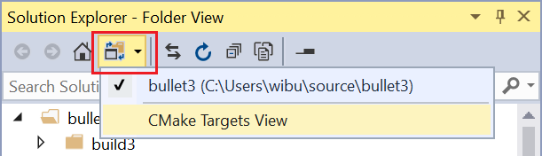

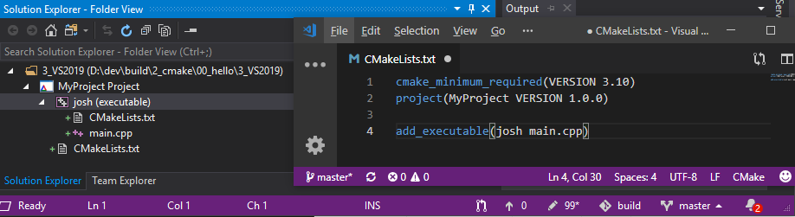

Go back into non-CMake Target view, and **right-click** the CMakeLists.txt file and select **build**.

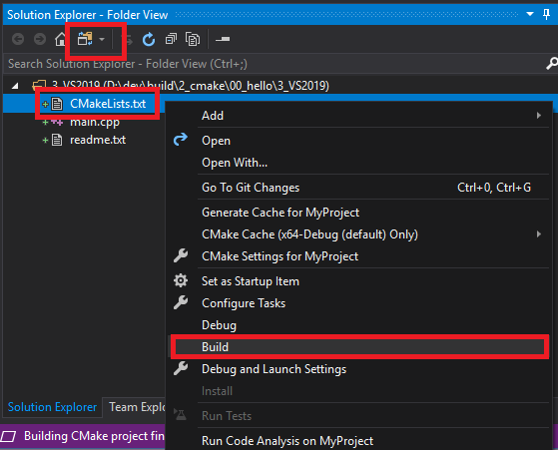

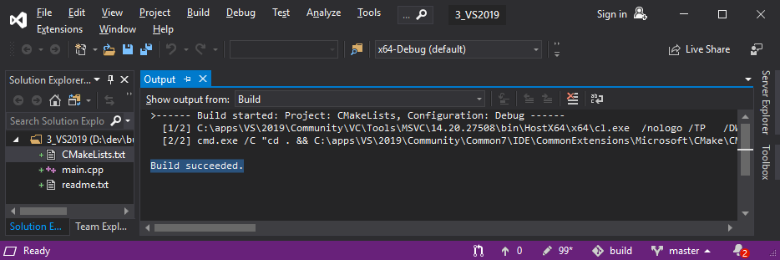

>------ Build started: Project: CMakeLists, Configuration: Debug ------

[1/2] C:\apps\VS\2019\Community\VC\Tools\MSVC\14.20.27508\bin\HostX64\x64\**cl.exe** /nologo /TP /DWIN32 /D_WINDOWS /W3 /GR /EHsc /MDd /Zi /Ob0 /Od /RTC1 /JMC /showIncludes

/FoCMakeFiles\josh.dir\main.cpp.obj /FdCMakeFiles\josh.dir\ /FS **-c** D:\dev\build\2_cmake\00_hello\3_VS2019**\main.cpp**

[2/2] **cmd.exe** /C "cd . && C:\apps\VS\2019\Community\Common7\IDE\CommonExtensions\Microsoft\CMake\CMake\bin\cmake.exe -E vs_link_exe --intdir=CMakeFiles\josh.dir --manifests --

C:\apps\VS\2019\Community\VC\Tools\MSVC\14.20.27508\bin\Hostx64\x64**\link.exe** /nologo CMakeFiles\josh.dir**\main.cpp.obj** /out:**josh.exe** /implib:**josh.lib** /pdb:**josh.pdb** /version:0.0 /machine:x64

/debug /INCREMENTAL /subsystem:console kernel32.lib user32.lib gdi32.lib winspool.lib shell32.lib ole32.lib oleaut32.lib uuid.lib comdlg32.lib advapi32.lib && cd ."

**Build succeeded.**

This will build the executable in the following directory:

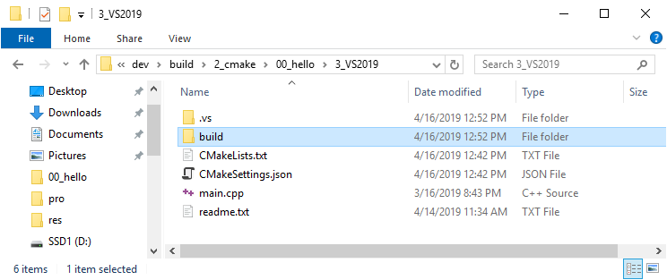

Change the startup item to the generated executable:

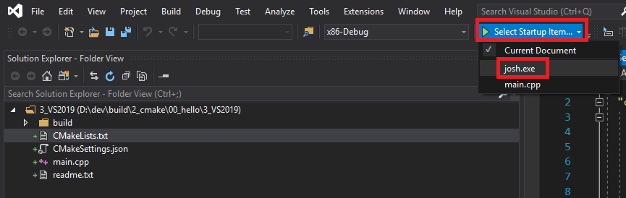And run it.



