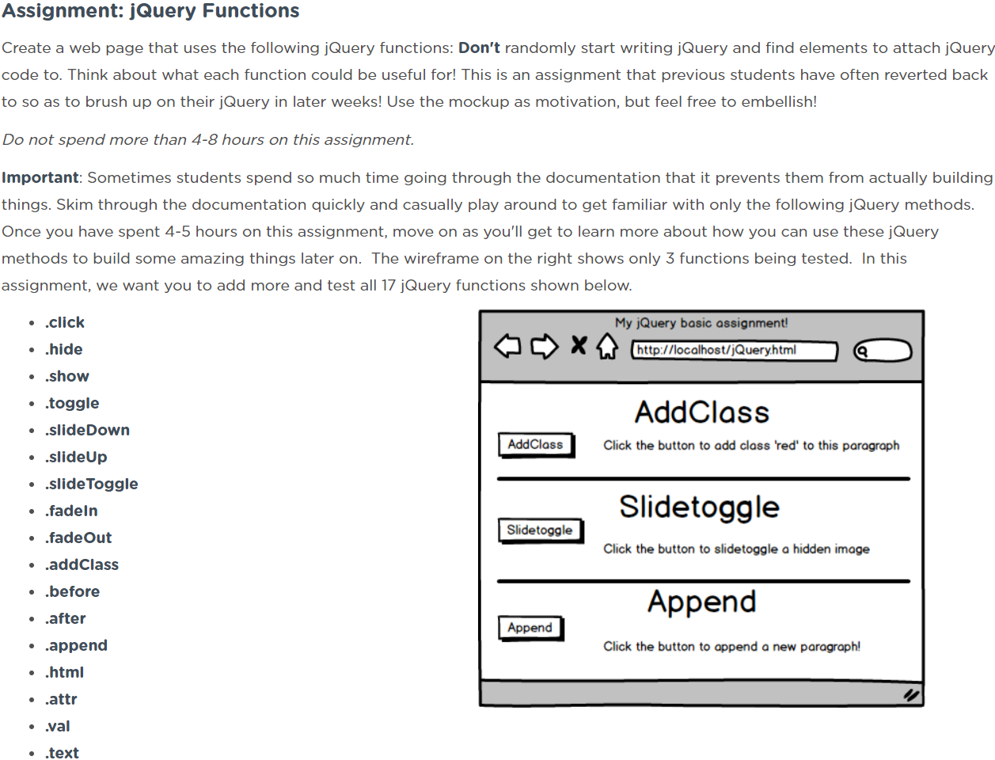

**jQuery Basics:**

<https://www.coursera.org/learn/javascript-jquery-json/lecture/VkM0I/jquery-basics>

**Strategy**:

* Create button in HTML
* Use following in <style> tag in <head> section of HTML file:

$('.josh').on('click',

function()

{

// Do stuff

$(this).toggleClass('turnRed');  
 }

); // end **on**()

display: inline-block;

vertical-align: top;

**List of jQuery methods to investigate:**

* ~~.click()~~
* ~~.hide()~~
* ~~.show()~~
* ~~.toggle()~~
* .slideDown()
* .slideUp()
* .fadeIn()
* .fadeOut()
* .addClass()
* .before()
* .after()
* .append()
* .html()
* .attr()
* .val()
* .text()

**.on()**

**Description:***Attach an event handler function for one or more events to the selected elements.*

* The **.on()** method is used to handle all events.

$('button').on('click',

function() {

alert('you clicked the button!');

}

);

1. The jQuery selection contains all the <button> elements.
2. The .on() method is used to handle events.
3. The 1st -parameter to .on() is the event you want to respond to.
4. The 2nd-parameter to .on() is the code you want to run when that event occurs on any element in the matched set.

* Can be named function or anonymous functions.

.on(events[$∙$][$∙$], handler)

* **events[$∙$][$∙$]**
  + One or more space-separated event types and optional namespaces (e.g. ‘click’)
* **handler**
  + A function to execute when the event is triggered.

**- - - - - - - - - - - - - - - - - - - - - - - - - - - - - - - - - - - - - - -**

**.click()**

**Description:***Bind an event handler to the "click" JavaScript event, or trigger that event on an element.*

* This method is a shortcut for .on( "click", handler ) in the first two variations, and .trigger( "click" ) in the third.
* The click event is sent to an element when the mouse pointer is over the element, and the mouse button is pressed and released.

**.hide()**

**Description:***Hide the matched elements.*

.hide([duration], [,complete])

* **duration**
  + A string or number determining how long the animation will run.
* **complete**
  + A function to call once the animation is complete, called once per matched element.

**- - - - - - - - - - - - - - - - - - - - - - - - - - - - - - - - - - - - - - -**

**.show()**

**Description:***Display the matched elements*

.show([duration], [,complete])

* **duration**
  + A string or number determining how long the animation will run.
* **complete**

**- - - - - - - - - - - - - - - - - - - - - - - - - - - - - - - - - - - - - - -**

**.toggle()**

**Description:***Bind two or more handlers to the matched elements, to be executed on alternate clicks.*

.show([duration], [,complete])

* **duration**
  + A string or number determining how long the animation will run.
* **complete**

**- - - - - - - - - - - - - - - - - - - - - - - - - - - - - - - - - - - - - - -**

**- - - - - - - - - - - - - - - - - - - - - - - - - - - - - - - - - - - - - - -**

**- - - - - - - - - - - - - - - - - - - - - - - - - - - - - - - - - - - - - - -**

**- - - - - - - - - - - - - - - - - - - - - - - - - - - - - - - - - - - - - - -**