Module 3 Microbial Species Concepts

Evidence worksheet_05 “Extensive mosaic structure”

Part 1: **Learning objectives:**

* Evaluate the concept of microbial species based on environmental surveys and cultivation studies.
* Explain the relationship between microdiversity, genomic diversity and metabolic potential
* Comment on the forces mediating divergence and cohesion in natural microbial communities

**General Questions:**

• *What were the main questions being asked?*

To understand the genetic bases for pathogenicity and the evolutionary diversity of E. coli by analyzing the genome sequence of E. coli CFT073, a pathogenic strain isolated from the blood of a woman with acute pyelonephritis and comparing it with the genome sequences of enterohemorrhagic E. coli strain EDL933 and the nonpathogenic laboratory strain MG1655

• *What were the primary methodological approaches used?*

They cloned and sequenced an isolated strain of E. coli by using dye-terminator chemistry (Sanger Sequencing). Finishing used sequencing of opposite ends of linking clones, PCR-techniques, and primer walking.

Sequence analysis and annotation was done with MAGPIE, GLIMMER (to define ORFs), and BLAST.

• *Summarize the main results or findings.*

*ABSTRACT*

They generated the complete genome sequence of the uropathogenic E. coli strain CFT073 and compared it to the EDL933 and MG1655 strains, and they found that only 39.2% of their combined set of proteins are common to all three strains.

The disease potential of CFT073 is reflected in the absence of genes for type 3 secretion system or phage- and plasmid-encoded toxins that is found in some diarrheagenic E. coli. CFT073 is rich in genes for fimbrial adhesins, autotransporters, iron-sequestration systems, and phage-switch recombinases.

The common core of the backbone has been preserved for generations. Genes within the islands of the backbones are more likely to be horizontally transferred. Overall, survival is preserved vertically but pathogenicity is transferred horizontally.

• *Do new questions arise from the results?*

“black holes” – genes that are detrimental to a uropathogenic lifestyle that are lost are a challenge to assess due to a lack of sequences to compare to.

What is a species in a microbial world? Should the large differences in overall genome content be part of the definition, or should the definition focus on the backbones which are common?

What is the meaning of the

• *Were there any specific challenges or advantages in understanding the paper (e.g. did the authors provide sufficient background information to understand experimental logic, were methods explained adequately, were any specific assumptions made, were conclusions justified based on the evidence, were the figures or tables useful and easy to understand)?*

It would have been nice if they had presented more data about the other strains they had used (Table 1)

One of the limitations of their analysis is that they only used three strains of e. coli when there are many more strains. With more strains, the overall variance may be less (sampling bias)

Part 2: **Learning objectives:**

* Comment on the creative tension between gene loss, duplication and acquisition as it relates to microbial genome evolution
* Identify common molecular signatures used to infer genomic identity and cohesion
* Differentiate between mobile elements and different modes of gene transfer

Based on your reading and discussion notes, explain the meaning and content of the following figure derived from the comparative genomic analysis of three *E. coli* genomes by Welch et al. Remember that CFT073 is a uropathogenic strain and that EDL933 is an enterohemorrhagic strain. Explain how this study relates to your understanding of ecotype diversity. Provide a definition of ecotype in the context of the human body. Explain why certain subsets of genes in CFT073 provide adaptive traits under your ecological model and speculate on their mode of vertical descent or gene transfer.

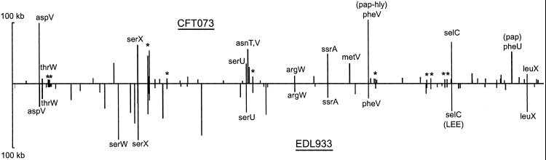

The top half refers to CFT073 and the bottom half refers to EDL933. Each line relates to a gene island, with the size of the line indicating the size of the island and the position along the long representing the position in their genomes. The labels refer to islands that are located at tRNAs. * indicates islands at the same backbone position between

The different strains reside in different environments, which is why there is ecotype diversity.

The common core of the backbone has been preserved for generations. Genes within the islands of the backbone are more likely to be horizontally transferred. Overall, survival is preserved vertically but pathogenicity is transferred horizontally.