Class 4 R Intro
Joshua Khalil
January 15th, 2026
x <- 1:50
plot(x, sin(x))
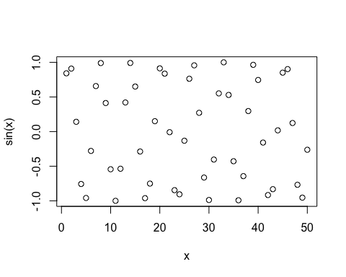
plot (x, sin(x), typ="l", col="blue", lwd=2)
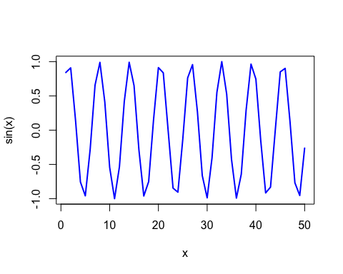
log(10, base =10 )
## [1] 1

