ICT2101/2201 Introduction to Software Engineering

Software Requirements Specifications (SRS)

Milestone 1

AY2021/2022, Trimester 1

Code A Car

Lab group P3-8

P3-8

Team Leader: Leong Jin Kuan, Joshua (2002133)

Product Developer: Loh Hui Qi (2001718)

Web Developer: Muhammad Alam Sah Bin Syed Hamzah (2001776)

Web Developer: Tse Kin Ping (2001568)

# 1. Introduction

## 1.1 Product Scope

This project aims to teach users of ages 6-16 computational thinking through gamification and subsequently, block-based programming. Through the use of a web portal, users will be able to implement functionalities and guide the way the car should go. Details such as movement speed, IR sensors functionality and direction will be shown on the web portal. These details are meant to better create a link between the webpage information and the actions reflected by the vehicle.

In learning to manipulate the robot car, users will be taught to think and plan in a logical manner. It will enable users to be better problem solvers as they navigate a set of challenges.

## 1.2 Intended Audience and Document Overview

This document is intended to inform the following users on the development of the robotic car prototype and the web portal. The document contains various information regarding the background of its creation, various functionalities, and guidance on how they can be used.

### 1.2.1 Client:

To provide the client with further information on the market research of the product and the various developmental considerations behind the creation of the robotic car, Section 2.1 can be read first. Following which, section 2.2 will provide an overview of the robotic car and its interaction with the web portal. These include the sequences on how instructions are being inputted and sent to the robotic car for execution. Sections 3 and 4 would provide an in-depth look into the various requirements set forth and their subsequent implementations. Section 4.2 would set forth the security and safety aspects of the project and products. Lastly, an overview of the project timeline can be found in section 6.

Should there be a need for clarification on terminologies, Sections 1.3 and Appendix A can be consulted.

Appendix B would provide insight into the types of challenges set forth and the considerations on their implementation to teach computational thinking to the end-users.

### 1.2.2 Users:

Before operating the car, Section 4.2 is to be consulted. This will provide the user with understanding of the hidden safeguards of the robotic car and the restrictions placed upon the user’s scope of interactivity.

The following sections 3.1.1 and 3.1.2 will provide users with an overview of the web portal and an understanding of the modules on the robotic car respectively. Should any clarifications regarding terminology be required, sections 1.3 and appendix A should be referenced.

Appendix B provides specifications for the modules found on the robotic car, to be used during hardware diagnosis.

## 1.3 Definitions, Acronyms and Abbreviations

|  |  |
| --- | --- |
| Term | Definition |
| IR | Infrared |
| MAC | Media Access Control |
| SPI | Serial Peripheral Interface |
| SSID | Service Set Identifier |

## 1.4 Document Conventions

### 1.4.1 Formatting Conventions

1. General Text: Calibri, Font Size 11, Alignment: Justified, Single Spaced
   1. Lists or pointers should include a spacing after the last paragraph
2. Headers: Arial, Font Size 20, Bolded
3. Sub-Headers: Arial, Font Size 16, Bolded
4. Image or Figure Titles: Arial, Font Size 9, Italicised
5. Page Margins: 1”
6. Comments are to be italicised

### 1.4.2 Citations

All citations, both in-text, and that within the “References” section shall adhere to IEEE formatting convention [1].

# 2. Overall Description

## 2.1 Background and Research

In order to get a better understanding of teaching our target audience how to code, an examination of current market offerings was done:

### 2.1.1 Cozmo Robot by Anki

The first research is regarding Cozmo Robot by Anki [2]. The target audience of this product ranges from children to adults. The product consists of over 300 individual parts which allow for a multitude of functionalities. The Cozmo robot provides users with various functionalities such as a built-in camera, sensors, gyroscopes and a cliff detector. Additionally, included within the mobile application is the ability for facial recognition.

Anki has provided inexperienced users with a simplified coding experience called Code Lab. It allows users to program the Cozmo Robot through the combination of code-blocks. To cater to experienced users, a software development kit is provided, with the programming language being Python. This simplifies the learning curve for newer users while experienced users are given the ability for in-depth customisation.

Additional features provided by Anki include a series of games which increase in complexity, as well as a tuning functionality. By having a pre-set series of challenges, Anki teaches its users to think in different, more complex ways whilst providing an engaging experience for its users. The provided tuning function allows for easy diagnostics, to quickly identify faults. We aim to provide users with challenges of scaling difficulties, in addition, we aim to provide users with a small page to quickly identify faults and tune wheel functionalities.

### 2.1.2 Code A Pillar Twist by Fisher-Price

Our second research is on Code A Pillar Twist by Fisher Price [3]. The target audience of this product are pre-schoolers ages 3-6 years old. The product consists of 1 motorised head and 5 permanently attached segments. To allow easy programming, each segment has a dial. Through multiple dial configurations, the users would be able to program the robot functionality, which include volume controls, lighting and sound effects.

By implementing physical programming, Fisher-Price has enabled instantaneous feedback on learning. This is achieved when users are able to see the code a pillar react upon the press of a button. We aim to create a similar situation via the use of images which depict movement and reactions of the toy.

### 2.1.3 Ultimate 2.0 10-in-1 Programmable Robot Kit by Makeblock

Our final research is on the Ultimate 2.0 10-in-1 Programmable Robot Kit by Makeblock [4]. This product is an advanced programming kit that consists of over 550 mechanical parts and electronic modules. The kit is compatible with the maker platform and Arduino, making it a better option for people learning robotics, electronics, graphical programming, Arduino programming, and Python programming. It uses Bluetooth connection which can be changed to a 2.4G WiFi Module to control the robots wirelessly.

The kit allows users to learn and apply programming skills to create many different projects, such as a Robotic Bartender, Camera Dolly, and more. These are all made possible with the large number of parts and a megaPi main control board that it provides. However, with the many features, sensors, and industry-standard parts that it provides, the cost of the kit is much higher than many other robot kits available in the market.

## 2.2 Product Overview

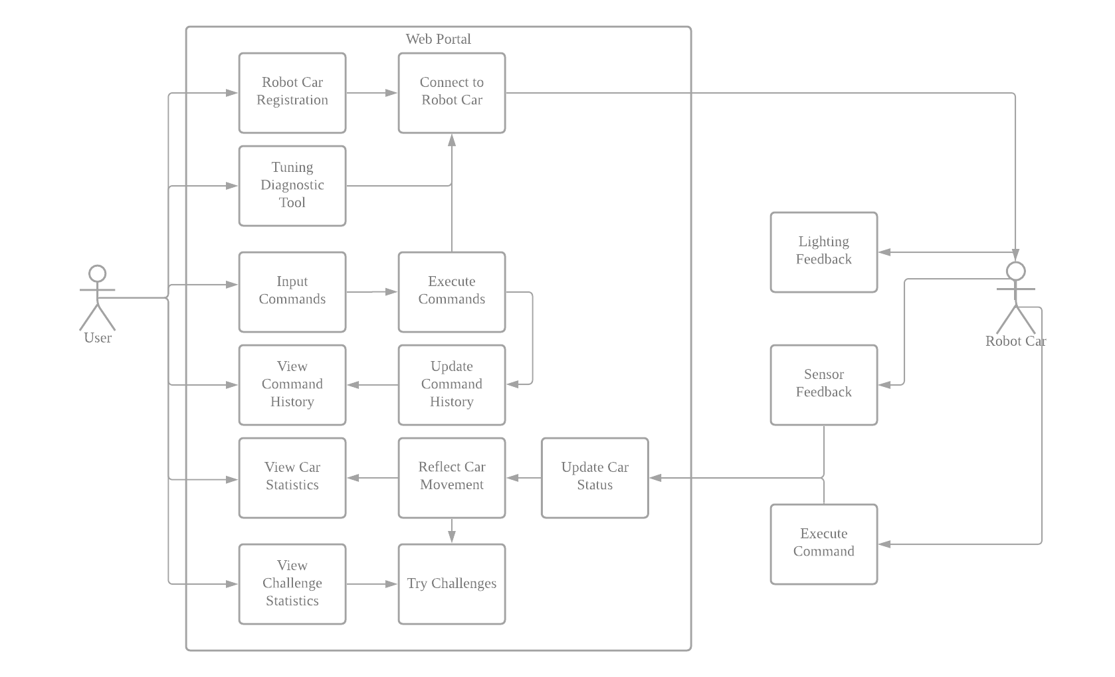

Figure 1 shows the high-level diagram of our product

This product is a stand-alone and consists of a web portal and a robotic car, as shown in figure 1 above. The product aims to allow users to explore the ideas of computational thinking by allowing free play or using challenges which will be solved by manoeuvring of the toy car.

As the target users range from age 6-16, the web portal is designed to be accessible and minimalistic. Users accessing the web portal will be requested to input the mac address of the WiFi card on the robot car. Pressing a “Connect” button will initiate a connection and validation between the portal and the robot car. This will help our portal to filter out unrelated devices in the network and identify the desired robot car if there are multiple connected to the same network.

Upon establishing connection, the user may then access various challenges. After selecting a challenge, users will be able to create a list of commands for execution by pressing directional buttons (up, down, left, right) on the web portal. The “Run” button will then be used to send the list of commands through an API towards the robot car. The robot car will move according to the list of commands given by the user and will concurrently send the car's current status back to the web portal. The web portal will then reflect the car’s current status, such as speed, distance travelled, the wheels’ direction and connectivity status. Additionally, the executed list of commands will be added to a command history such that user may refer back to the directions the car took. A pop-up text will update the user on the car’s current actions, as well as informing them of current objectives or if the car has failed in doing so.

A tuning or diagnostic tool would be included in the web portal. This would allow users to easily diagnose the various functionalities of the car should any issues occur.

## 2.3 Product Functionality

Web Portal:

1. Attempt and solve challenges, robot car to reflect decisions made.
2. Interact and manoeuvre the robot car through commands.
3. View the car’s current status information and command history.
4. Allow tuning and diagnostic of robot car hardware.

Robot Car:

1. Execute the command list given by the web portal.
2. Send multiple updates back to the web portal regarding the car’s current status.
3. Interact with provided materials for extended learning.

# Specific Requirements

## 3.1 External Interface Requirements

### 3.1.1 User Interfaces

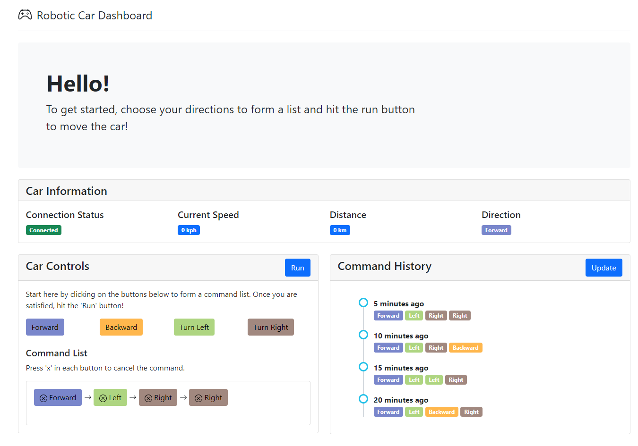 *Figure 1.1 Dashboard*

Figure 1.1 above shows the main dashboard, which will provide the user with an overview of the controls and various statistics from the car.

1. Hello

In this section, we greet the user and display basic instructions on how to operate the website and the robotic car

1. Car Information

In this section, the user will be able to view the robotic car’s information and statistics. It mainly consists of the connection status between the web portal and the robotic car, the current speed which will be updated as the car is moving, the total distance travelled by the car since the first command list execution and lastly, the direction of where the car is currently facing, which gets updated as the car is executing the command list.

1. Car Controls

In this section, the user will be able to create the command list by clicking on the directional buttons. For every click, the direction chosen will be added into the end of the list in the “Command List” box. This is so that the user is able to follow through the list and make amendments, when necessary, by pressing "x” in each button. Once satisfied, the user may click on the “Run” button to execute the command list and move the robotic car.

1. Command History

In this section, it shows all of the user’s previous executed command list in a timeline manner. The list is sorted by the most recent command list first for the ease of user to refer.

1. Challenges

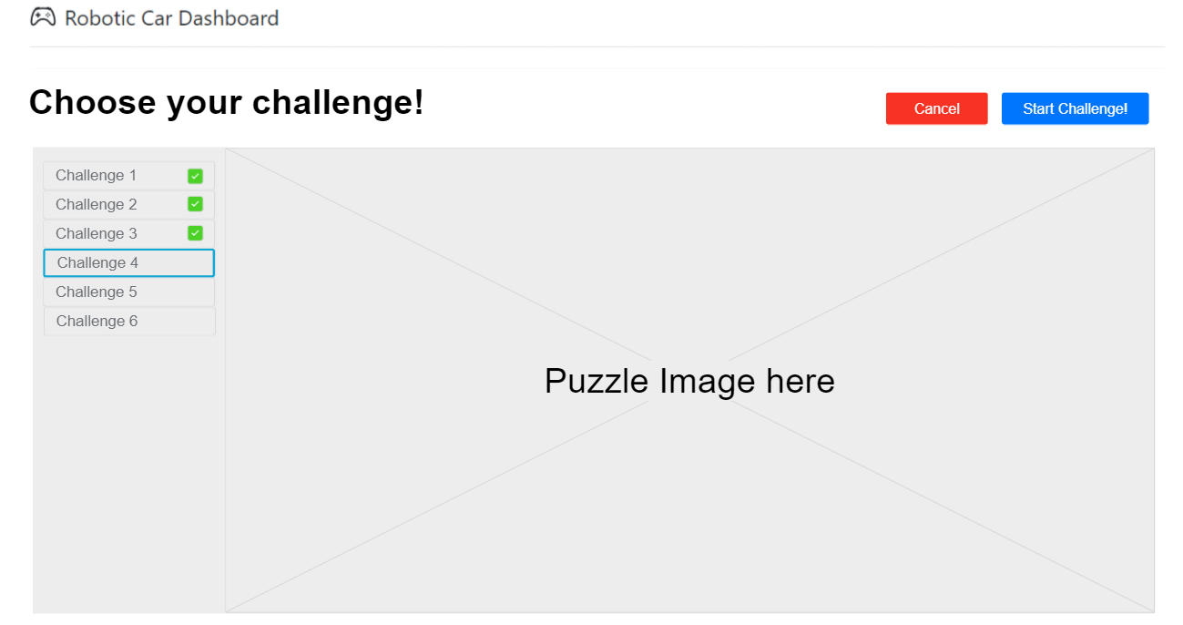

*Figure 1.2 shows the Challenge Screen in our web portal*

Figure 1.2 above shows the challenge page where users will be able to select their desired challenges.

In this challenge screen, the user is able to view all the available challenges as well as see the challenge that he/she has completed which is reflected by the green tick mark beside the challenge. Once a challenge has been selected, the user may then click on the “Start Challenge” button to be redirected back to the dashboard with the new challenge in progress.

*The figures are a work in progress and may not reflect the final product.*

### 3.1.2 Hardware Interfaces

1. MSP432 Board

This will provide the computing and main functionalities of the robot car. It interacts with the following devices and provides data to be sent back to the web portal via the WiFi Serial Transceiver Module. There is a RGB LED on-board which will be used to send real time feedback to the user, its functionalities can be customised.

1. WiFi Serial Transceiver Module

To allow communication with the web portal. This will allow receive the MSP432 to receive input commands from the web portal via SPI.

1. Motor Driver

The MSP432 board will interact with this module to initiate movement for the robot car. This will be used to provide and coordinate directional movement. To be used in conjunction with the IR Optical Speed Sensor.

1. IR Optical Speed Sensor

This device will provide users with movement information on the car. It will be used in conjunction with the black slotted discs on the robot car to evaluate the directional position of the robot car as well as current speed. The output will be formatted to meters per second.

1. Ultrasonic Ranging Module

To provide users with the ability to evaluate distances of objects or boundaries from the front of the car. Output will be reading from the interface to get current distance. The output will be formatted into meters.

1. IR Line Tracking Module

This will be used to provide the robot car with line tracking functionalities.

1. IR Strips

These will be used in conjunction with the IR line tracking module to provide added interactivity between the robot car and the environment.

### 3.1.3 Software Interfaces

*In Progress: To be filled up once the WiFi Configuration and communication between car and web portal is established*

## 3.2 Functional Requirements

Evaluate based on **who, input, output, alt scenarios, exceptions**

Web portal in-depth functional requirements:

1. The system shall allow the user to register their robotic car using the MAC address of the robotic car
2. The system shall be able to connect to the robotic car via local WiFi using the indicated MAC address
3. The system shall be able to maintain a consistent connection while the robot car is turned on
4. The system will prompt user if the car is unable to be reached
5. Users shall be able to initiate a diagnostic procedure on robot car hardware
6. Users shall be able to create a list of commands using the directional buttons
7. Users shall be able to initiate execution of the command list by clicking the run button
8. The system shall be able to send the command list to the robotic car via local WiFi
9. Users shall be able to view connectivity status with the car on demand
10. Users shall be able to view the current sensor data from the robot car
11. Users shall be able to view live updates of the car’s current manoeuvring action
12. Users shall be able to view a history of commands that has been executed
13. Users shall be able to view challenges
14. Users shall be able to attempt and complete challenges
15. The system shall be able to check if a challenge is completed
16. Users shall be able to create custom challenges

Robotic car in-depth functional requirements:

1. The system shall be able to receive and send information from the web portal via the local WiFi
2. The system shall be able to maintain a stable connection to the web portal
3. The system shall be able to receive a list of commands given by the web portal
4. The system shall be able to execute the commands listed
5. The system shall be able to send updates to the web portal regarding its current status and various sensors
6. The system shall be able to detect obstacles such as IR strips using the ultrasonic sensor and IR tracker
7. The system shall be able to determine if the user successfully reached the objective or failed to do so and send subsequent information to the web portal
8. Users shall be able to interact with the robotic car outside the web portal via the onboard switches

## 3.3 Use Case Model

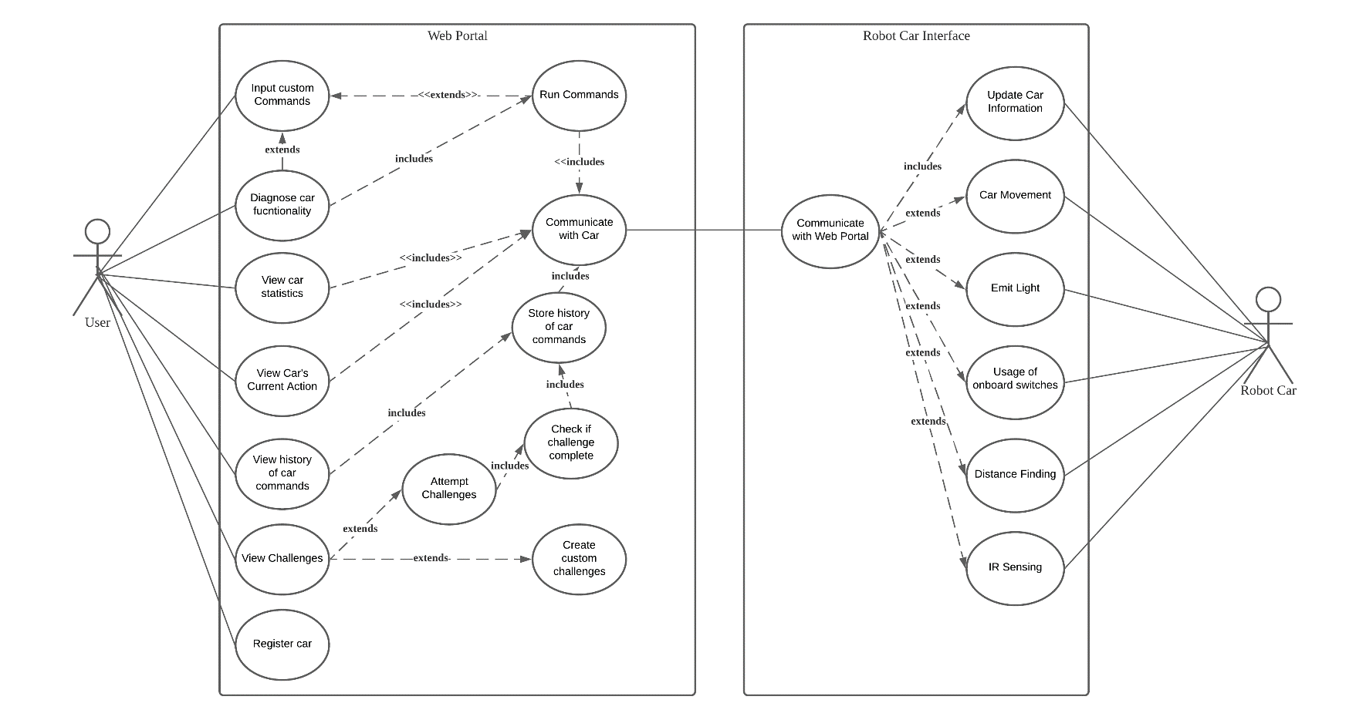

Figure 3 shows the Use Case Diagram

### 3.3.1 UC1 - Register Car

|  |
| --- |
| **Author: Md Alam Sah** |
| **Purpose:** To register and connect the car with the web portal |
| **Requirements Traceability:**  F1: The system shall allow the user to register their robotic car using the MAC address of the robotic car  F2: The system shall be able to connect to the robotic car via local WiFi using the indicated MAC address  F3: The system shall be able to maintain a consistent connection while the robot car is turned on  F4: The system will prompt user if the car is unable to be reached within 3 tries, or after 10 seconds |
| **Priority:** High |
| **Preconditions:**   1. The user must have a robotic car 2. Both web portal and robotic car must be connected to the same WiFi 3. User should know the MAC address of the robotic car |
| **Post conditions:** The robotic car will successfully be connected to the web portal. |
| **Actors:** User, Robot Car |
| **Flow of Events**  Basic Flow:   1. User enters the mac-address of his/her robotic car in the web portal 2. User clicks submit button 3. System will find for the robotic car with the mac-address 4. Once found, the system will initialize a connection to the robotic car interface 5. System will then reflect a “Connected” status to the portal dashboard   Alternative Flow:   1. System fails to initialize a connection to the robotic car    1. System will reflect an error message saying that it is unable to find a robotic car with the mac-address given 2. System is unable to find robotic car due to invalid mac address    1. System will reflect an error message saying the mac-address is invalid   Exceptions:   1. System loses the WiFi connection    1. Once reconnected, the system will repeat steps 1-5 |
| **Total Number of Transactions:** 6 |
| **Use Case Complexity:** Average |

### 3.3.2 UC2 – Input Custom Commands

|  |
| --- |
| **Author: Md Alam Sah** |
| **Purpose:** Allows the user to choose their own directional commands for the robotic car |
| **Requirements Traceability:**  F6: Users shall be able to create a list of commands using the directional buttons |
| **Priority:** High |
| **Preconditions:**   1. The robotic car must be connected to the web portal |
| **Post conditions:** The user will have formed a command list for the toy car to run |
| **Actors:** User |
| **Extends:** UC3 – Run Commands, UC5 – Diagnose Car Functionality |
| **Flow of Events**  Basic Flow:   1. The user clicks on the directional buttons sequentially according to how he/she will like the car to move 2. System will display the directional buttons clicked so user can view the command list   Alternative Flow: -  Exceptions:   1. System is unable to capture the buttons clicked to display them in the list    1. System will inform the user saying that there is an error in capturing the directions and prompt user to refresh the portal |
| **Total Number of Transactions:** 3 |
| **Use Case Complexity:** Simple |

### 3.3.3 UC3 – Run Commands

|  |
| --- |
| **Author: Md Alam Sah** |
| **Purpose:** Sends the command list to the API connected to the robotic car interface |
| **Requirements Traceability:**  F8: The system shall be able to send the command list to the robotic car via local WiFi |
| **Priority:** High |
| **Preconditions:**   1. The robotic car must be connected to the web portal 2. The user must have formed a command list according to UC2 3. The user must have clicked on the “Run” button |
| **Post conditions:** The API will have the command list created by the user |
| **Actors:** - |
| **Extends:** UC2 – Input Custom Commands |
| **Flow of Events**  Basic Flow:   1. System will validate the command list for any invalid inputs 2. System will sanitize and forward the list to the API   Alternative Flow:   1. System detects an invalid/malicious input in the command list    1. System returns an error message to the user saying that there was an error in submitting the directions and prompts the user to retry again   1.3 Exceptions: - |
| **Includes:** UC5 – Diagnose Car Functionality |
| **Total Number of Transactions:** 1 |
| **Use Case Complexity:** Simple |

### 3.3.4 UC4 – Communicate with Car

|  |
| --- |
| **Author: Md Alam Sah** |
| **Purpose:** Sends/Receives data to/from the Robotic Car Interface API |
| **Requirements Traceability:**   1. Users shall be able to initiate a diagnostic procedure on robot car hardware within 10 seconds 2. The system shall be able to send the command list to the robotic car via local WiFi 3. Users shall be able to view the current sensor data from the robot car 4. Users shall be able to view live updates of the car’s current manoeuvring action within 10 seconds 5. Users shall be able to view a history of commands that has been executed |
| **Priority:** High |
| **Preconditions:**   1. The robotic car must be connected to the web portal 2. The user must have initiated a function that requires communication with the robotic car |
| **Post conditions:** The robotic car or web portal interface will have the requested data |
| **Actors:** - |
| **Flow of Events**  Basic Flow:   1. Receives data from sender to be transferred to the receiver 2. Use the appropriate method to forward the data accordingly 3. Update sender on success   Alternative Flow:   1. System unable to forward the data    1. System returns an error message to the sender saying how it is unable to send the data and the reason for it so that sender class may update user   Exceptions:   1. Lost communication with car while sending/receiving data    1. System will reply to the sender class with the error message in which the sender class will prompt the user to retry |
| **Includes:** UC3 – Run Commands, UC5 – View Car Statistics, UC6 – View Car Statistics, UC8 – View Car’s Current Action |
| **Total Number of Transactions:** 3 |
| **Use Case Complexity:** Medium |

### 3.3.5 UC5 – View Car Statistics

|  |
| --- |
| **Author: Md Alam Sah** |
| **Purpose:** To allow the user to view the car’s statistics on the portal |
| **Requirements Traceability:**   1. F6: The system shall allow the user to view dashboard which consists of the car’s current status information |
| **Priority:** High |
| **Preconditions:**   1. The robotic car must be connected to the web portal 2. The user must have executed a command list for the robotic car to move |
| **Post conditions:** The robotic car’s statistics will be displayed |
| **Actors:** User |
| **Flow of Events**  1.1 Basic Flow:   1. Receive car statistics from the web portal API (UC4) 2. System displays the statistics on the dashboard for the user to view   1.2 Alternative Flow:   1. There are already statistics being displayed on the dashboard    1. System will update the statistics displayed with the newly received statistics   1.3 Exceptions: - |
| **Includes:** UC4 – Communicate with Car |
| **Total Number of Transactions:** 2 |
| **Use Case Complexity:** Simple |

### 3.3.6 UC6 – Store History of Car Commands

|  |
| --- |
| **Author: Md Alam Sah** |
| **Purpose:** To obtain and store information regarding the history of car commands user have executed |
| **Requirements Traceability:**   1. F8: The system shall allow the user to view a history of commands that has been executed |
| **Priority:** High |
| **Preconditions:**   1. The robotic car must be connected to the web portal 2. The user must have executed a command list for the robotic car to move |
| **Post conditions:** The command list history will be stored here to be called by UC9 – View History of Car Commands |
| **Actors:** - |
| **Flow of Events**  1.1 Basic Flow:   1. Receive executed command list from the web portal API (UC4) 2. System stores the list in the history list   1.2 Alternative Flow: -  1.3 Exceptions: - |
| **Includes:** UC9 – View History of Car Commands, UC12 – Check if Challenge Complete |
| **Total Number of Transactions:** 1 |
| **Use Case Complexity:** Simple |

### 3.3.7 UC7 – Diagnose Car Functionality

|  |
| --- |
| **Author: Joshua Leong** |
| **Purpose:** To provide users with a quick and easy tool to diagnose car functionality |
| **Requirements Traceability:**  The system shall allow the user to view dashboard which consists of the car’s current status information  The system shall allow the user to diagnose hardware sensors of the robot car |
| **Priority:** High |
| **Preconditions:**   1. The robotic car must be connected to the web portal |
| **Post conditions:** The user should be able to diagnose car functionality |
| **Actors:** - |
| **Flow of Events**   * 1. Basic Flow:  1. User initiates diagnosis process with the car 2. System presents user with list of hardware for diagnosis 3. User selects desired area for diagnosis 4. System communicates with car (UC4) 5. System indicates to user action has been performed    1. Alternative Flow:   5.1 If any error were to occur, the system would indicate that to the user via error message on the web portal  1.3 Exceptions: - |
| **Includes:** |
| **Total Number of Transactions: 3** |
| **Use Case Complexity:** Simple |

### 3.3.8 UC8 – View Car’s Current Action

|  |
| --- |
| **Author: Tse Kin Ping** |
| **Purpose:** To view current state of car |
| **Requirements Traceability:**   1. F10: Users shall be able to view current sensor data from the robot car 2. F11: Users shall be able to view live updates of the car’s current manoeuvring action within 10 seconds |
| **Priority:** High |
| **Preconditions:**   1. The robot car must be connected to the web portal |
| **Post conditions:** The current state of car should be displayed on the web portal |
| **Actors:** - |
| **Flow of Events**  1.1 Basic Flow:   1. System communicates with car (UC4) 2. System receives current car information 3. System displays current car status   1.2 Alternative Flow: -  1.3 Exceptions: - |
| **Includes:** |
| **Total Number of Transactions:** 1 |
| **Use Case Complexity:** Simple |

### 3.3.9 UC9 – View history of car commands

|  |
| --- |
| **Author: Tse Kin Ping** |
| **Purpose:** To obtain display a history of commands that user issued. |
| **Requirements Traceability:**   1. F12: The system shall allow the user to view a history of commands that has been executed |
| **Priority:** High |
| **Preconditions:**   1. The robotic car must be connected to the web portal 2. The user must have executed at list one command to the robotic car |
| **Post conditions:** The command list history will be obtained and displayed to the user. |
| **Actors:** User |
| **Flow of Events**  1.1 Basic Flow:   1. User selects to view history of car commands 2. System reads in the history of car commands stored (UC6) 3. System displays history of car commands   1.2 Alternative Flow:   1. User refreshes view history of car commands 2. System reads in the latest history of car commands stored (UC6) 3. System displays a refreshed list of car commands history   1.3 Exceptions: - |
| **Includes:** UC6 – View History of Car Commands |
| **Total Number of Transactions: 2** |
| **Use Case Complexity:** Average |

### 3.3.10 UC10 – View Challenges

|  |
| --- |
| **Author: Tse Kin Ping** |
| **Purpose:** To obtain and display the challenges available |
| **Requirements Traceability:**   1. F13: Users shall be able to view challenges |
| **Priority:** High |
| **Preconditions:**   1. The robot car must be connected to the web portal |
| **Post conditions:** The user shall be able to view challenges and select which to attempt |
| **Actors:** - |
| **Flow of Events**  1.1 Basic Flow:   1. User selects to view challenges 2. System reads in challenges 3. System displays challenges   1.2 Alternative Flow: -  1.3 Exceptions: - |
| **Includes: -** |
| **Total Number of Transactions:** 1 |
| **Use Case Complexity:** Average |

### 3.3.11 UC11 – Attempt Challenges

|  |
| --- |
| **Author: Tse Kin Ping** |
| **Purpose:** To allow user to create a list of commands to attempt and complete the challenge |
| **Requirements Traceability:**   1. F6: Users shall be able to create a list of commands using directional buttons 2. F7: Users shall be able to initiate execution of the command list by clicking the run button 3. F8: The system shall be able to send the command list to the robotic car via local WiFi 4. F11: Users shall be able to view live updates of the car’s current manoeuvring action within 10 seconds 5. F14: Users shall be able to attempt and complete challenges |
| **Priority:** High |
| **Preconditions:**   1. The robotic car must be connected to the web portal 2. The user must have selected a challenge to attempt |
| **Post conditions:** The challenge shall be attempted and system will check if challenge is completed (UC12) |
| **Actors:** - |
| **Flow of Events**  1.1 Basic Flow:   1. User create a list of commands to be executed 2. User run the commands 3. System sends the list of commands to robot car (UC4) 4. System displays current car status (UC8) 5. System checks if challenge completed (UC12)   1.2 Alternative Flow: -  1.3 Exceptions: - |
| **Includes:** UC12 – Check if Challenge Complete |
| **Total Number of Transactions:** 2 |
| **Use Case Complexity:** Complex |

### 3.3.12 UC12 – Check if challenge complete

|  |
| --- |
| **Author: Tse Kin Ping** |
| **Purpose:** To check if the challenge is completed after user executed a list of commands |
| **Requirements Traceability:**   1. F14: Users shall be able to attempt and complete challenges 2. F15: The system shall be able to check if a challenge is completed |
| **Priority:** High |
| **Preconditions:**   1. The robotic car must be connected to the web portal 2. The user must have attempted the challenge (UC11) |
| **Post conditions:** The command list history will be stored (UC6 - Store history of car commands) |
| **Actors:** - |
| **Flow of Events**  1.1 Basic Flow:   1. System checks if challenge is completed 2. System stores history of car commands (UC6)   1.2 Alternative Flow: -  1.3 Exceptions: - |
| **Includes:** UC6 – Store history of car commands |
| **Total Number of Transactions:** 2 |
| **Use Case Complexity: Simple** |

### 3.3.13 UC13 – Create custom challenges

|  |
| --- |
| **Author: Tse Kin Ping** |
| **Purpose:** User to be able to create their own custom challenges |
| **Requirements Traceability:**   1. F16: Users shall be able to create custom challenges |
| **Priority:** High |
| **Preconditions:**   1. The robotic car must be connected to the web portal |
| **Post conditions:** The custom challenge will be saved and can be view in UC10 – View Challenges |
| **Actors:** - |
| **Flow of Events**  1.1 Basic Flow:   1. User selects to create custom challenge 2. User sets custom challenge 3. User select to save custom challenge 4. System stores custom challenge   1.2 Alternative Flow: -  1.3 Exceptions: - |
| **Includes:** UC10 – View Challenges |
| **Total Number of Transactions:** 1 |
| **Use Case Complexity:** Complex |

### 3.3.14 UC14 – Communicate with Web Portal

|  |
| --- |
| **Author: Loh Hui Qi** |
| **Purpose:** Send/Receive data to/from the Web Portal |
| **Requirements Traceability:**   1. F17: The system shall be able to receive and send information from the web portal via the local WiFi 2. F18: The system shall be able to maintain a stable connection to the web portal |
| **Priority:** High |
| **Preconditions:**   1. The web portal must be connected to the robotic car 2. Both web portal and robotic car must be connected to the same WiFi |
| **Post conditions:** The robotic car will receive/send data from/to web portal |
| **Actors:** - |
| **Flow of Events**  1.1 Basic Flow:   1. Receive data from sender to be transferred to the robotic car 2. Use appropriate method to forward the data 3. Update sender on success   1.2 Alternative Flow:  2. System unable to forward the data  2.1 System prompts an error message to sender the reason why unable to read data and ask to try again  1.3 Exceptions:   1. Lost communication with web portal while sending/receiving data    1. System prompts an error message to sender to retry connection |
| **Total Number of Transactions:** 3 |
| **Use Case Complexity:** Simple |

### 3.3.15 UC15 - Update Car Information

|  |
| --- |
| **Author: Loh Hui Qi** |
| **Purpose:** Update robotic car information to web portal |
| **Requirements Traceability:**   1. F17: The system shall be able to receive and send information from the web portal via the local WiFi 2. F21: The system shall be able to send updates to the web portal regarding its current status and various sensors |
| **Priority:** High |
| **Preconditions:**   1. The web portal must be connected to the robotic car 2. Both web portal and robotic car must be connected to the same WiFi 3. The robotic car must have sensors data of UC16 to UC20 |
| **Post conditions:** The robotic car information will successfully be updated to the web portal |
| **Actors:** Robot Car |
| **Flow of Events**  1.1 Basic Flow:   1. The robotic car receives data from sensors (UC16 to UC20) 2. The system transfers receive data to the web portal 3. The system updates the robotic car information about its current status in the web portal   1.2 Alternative Flow:  2. System unable to transfer the data to web portal  2.1 System prompts an error message to the reason why unable to transfer data and ask to try again  1.3 Exceptions:  2. Lost communication with web portal while transferring data  2.1 System prompts an error message to retry connection |
| **Includes:** UC14 – Communication with Web Portal |
| **Total Number of Transactions:** 3 |
| **Use Case Complexity:** Simple |

### 3.3.16 UC16 – Car Movement

|  |
| --- |
| **Author: Loh Hui Qi** |
| **Purpose:** Detect where the robotic car is running |
| **Requirements Traceability:**   1. F19: The system shall be able to receive a list of commands given by the web portal 2. F20: The system shall be able to execute the commands listed |
| **Priority:** High |
| **Preconditions:**   1. The web portal must be connected to the robotic car 2. Both web portal and robotic car must be connected to the same WiFi |
| **Post conditions:** The robotic car will successfully run according to the command received |
| **Actors:** Robot Car |
| **Extends:** UC14 – Communication with Web Portal |
| **Flow of Events**  1.1 Basic Flow:   1. The robotic car receives a list of commands from the web portal 2. The system executes the list of commands 3. The robotic car will successfully run according to the execution   1.2 Alternative Flow:  2.The system is unable to execute the list of commands  2.1 System prompts an error message the reason why unable to execute the data and ask to try again  1.3 Exceptions:   1. Lost communication with web portal while receiving data    1. System prompts an error message to retry connection |
| **Total Number of Transactions:** 3 |
| **Use Case Complexity:** Simple |

### 3.3.17 UC17 – Emit Light

|  |
| --- |
| **Author: Joshua Leong** |
| **Purpose:** To allow the user to operate the LEDs on the robotic car |
| **Requirements Traceability:**   1. The system shall be able to execute the commands listed 2. The system shall be able to send updates to the web portal regarding its current status and various sensors |
| **Priority:** High |
| **Preconditions:**   1. The web portal must be connected to the robotic car 2. Both web portal and robotic car must be connected to the same WiFi |
| **Post conditions:** The LED on the robotic car will emit light based on the commands from the user |
| **Actors:** Robot Car |
| **Extends:** UC14 – Communication with Web Portal |
| **Flow of Events**   * 1. Basic Flow:  1. The system receives the list of commands from the web portal via the local WiFi 2. The system will interpret and execute the commands 3. The respective LED will light up according to the commands 4. The system will indicate execution of commands to the web portal via the local WiFi    1. Alternative Flow: -    2. Exceptions:    3. The system cannot detect the LED    4. The system will send the error message to the web portal |
| **Total Number of Transactions:** 2 |
| **Use Case Complexity:** Simple |

### 3.3.18 UC18 – Usage of onboard Switches

|  |
| --- |
| **Author: Joshua Leong** |
| **Purpose:** To provide the user with additional interactivity with the robotic car via the two built-in switches |
| **Requirements Traceability:**   1. Users shall be able to interact with the robotic car outside the web portal via the onboard switches |
| **Priority:** High |
| **Preconditions:**   1. The web portal must be connected to the robotic car 2. Both web portal and robotic car must be connected to the same WiFi |
| **Post conditions:** The user will be able to interact with the robotic car via switches |
| **Actors:** User, Robot Car |
| **Extends:** UC14 – Communication with Web Portal |
| **Flow of Events**   * 1. Basic Flow:  1. The system receives the list of commands from the web portal via the local WiFi 2. The system will interpret and execute the commands 3. The user will be able to interact with the onboard switches 4. The system will indicate execution of commands to the web portal via the local WiFi    1. Alternative Flow: -    2. Exceptions: - |
| **Total Number of Transactions:** 1 |
| **Use Case Complexity:** Simple |

### 3.3.19 UC19 – Distance Finding

|  |
| --- |
| **Author:** Joshua Leong |
| **Purpose:** To allow the user to gauge distances from the robotic car to its environment |
| **Requirements Traceability:**   1. The system shall be able to send updates to the web portal regarding its current status and various sensors 2. The system shall be able to detect obstacles such as IR strips using the ultrasonic sensor and IR tracker |
| **Priority:** High |
| **Preconditions:**   1. The user must have a robotic car 2. Both web portal and robotic car must be connected to the same WiFi |
| **Post conditions:** The robotic car will measure distances between the system and objects and send subsequent data to the web portal. |
| **Actors:** Robot Car |
| **Extends:** UC14 – Communication with Web Portal |
| **Flow of Events**   * 1. Basic Flow:  1. The system receives the list of commands from the web portal via the local WiFi 2. The system will interpret and execute the commands 3. The ultrasonic sensor will detect and measure distances between the robot car and objects 4. The system will indicate resulting data from the sensors to the web portal 5. The system will indicate execution of commands to the web portal    1. Alternative Flow: -    2. Exceptions: - |
| **Total Number of Transactions:** 1 |
| **Use Case Complexity:** Simple |

### 3.3.20 UC20 – IR Sensing

|  |
| --- |
| **Author:** Joshua Leong |
| **Purpose:** To allow the user more interactivity with the robotic car using IR strips |
| **Requirements Traceability:**   1. The system shall be able to send updates to the web portal regarding its current status and various sensors 2. The system shall be able to detect obstacles such as IR strips using the ultrasonic sensor and IR tracker |
| **Priority:** High |
| **Preconditions:**   1. The user must have a robotic car 2. Both web portal and robotic car must be connected to the same WiFi |
| **Post conditions:** The robotic car will be able to interact with the IR Sensing |
| **Actors:** Robot Car |
| **Extends:** UC14 – Communication with Web Portal |
| **Flow of Events**   * 1. Basic Flow:  1. The system receives the list of commands from the web portal via the local WiFi 2. The system will interpret and execute the commands 3. The ultrasonic sensor will detect and measure distances between the robot car and objects 4. The system will indicate resulting data from the sensors to the web portal 5. The system will indicate execution of commands to the web portal    1. Alternative Flow: -    2. Exceptions: - |
| **Total Number of Transactions:** 1 |
| **Use Case Complexity:** Simple |

# Other Non-functional Requirements

## 4.1 Performance Requirements

### 4.1.1 Web Portal Non-Functional

* The website’s load time should not be more than one second for users
* The connection time with the robotic car should not exceed 3 minutes
* Users should be able to access and use the web portal 100% of the time without failure
* Web portal shall complete the sending of the command list to robotic car in 10 seconds
* Should any updates be implemented, the user shall be informed 3 days in advance
* If any crashes occur, the website should be able to be restarted within 1 hour of downtime
* The website’s interface has to be user-friendly and easy to understand

### 4.1.2 Robotic Car Non-Functional

* Robotic car shall communicate with web portal via WIFI
* Upon receiving the command list, the robotic car shall execute command list in 5 seconds
* Robotic car shall send/receive command list in 10 seconds
* Robotic car IR line tracking module sensor shall detect range between 0 to 3 cm
* Robotic car ultrasonic ranging module sensor shall measure the distance of a target object between 2 cm to 4 metres

## 4.2 Safety and Security Requirements

### 4.2.1 User Safety and Operability

As this product is expected to be used by young users, it is important to ensure that the product will not compromise the safety of the users. To achieve this, it is important to allow users the ability to control the car’s speed, provide users with clear lightings on the car to indicate the actual state of the car, as well as collision detection functions to prevent the car from colliding into any objects.

The car’s collision detection function should enable the car to detect any objects that is obstructing its projected path and if the object is not removed from the path, the car should stop at a small distance away from the object. This distance is set in the program, and it will override any user commands and will remain stationary until the obstructing object is removed or the car’s path is changed to avoid the object. With this function, damages to the car and any surrounding objects can be prevented. Furthermore, this will also prevent any injuries that could be caused if the obstruction was caused by the user or anyone around.

### 4.2.2 Security

As the product is required to work wirelessly using WiFi connection, it is therefore important to ensure that the connection between the remote-controlled device and the control device is secured. An insecure connection between both devices may result in connection being intercepted by others intentionally or unintentionally [5]. To create a secure connection, a mutual trust must be achieved by both devices, and this can be done by setting a strong password which can be reset by the user. Furthermore, setting a trusted MAC address for connection will ensure that the connection will only be successful if both devices’ MAC addresses are trusted.

# Work Distribution & Plan

The AGILE model is employed for this project as it suits small to medium-sized projects with new requirements. In addition, as the technology is new for the team members working on the robot car, the breaking down of the system into smaller modules to be tackled in sprints would ease the number of uncertainties. As the team members function in pairs, communication between the sub-teams would facilitate better communication and cooperation.

In addition, as the project is time-critical, rapid prototyping will be crucial for testing of the final product. The subsequent feedback will drive team discussion to allow for early corrections on the design and its subsequent implementation.

We decided to use Gantt Chart, as shown in figure 4 below, to monitor our progress. This helped us to schedule, manage and monitor the tasks for our project at the same time, prevents us from missing out on any unassigned task.

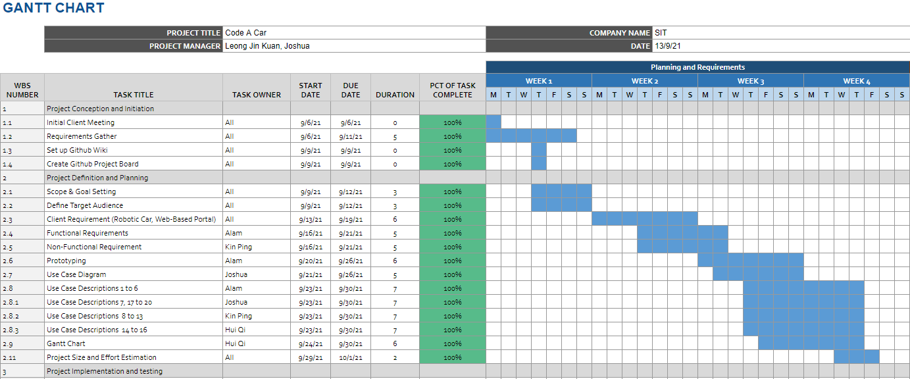

Figure 4 shows the Gantt Chart of Milestone 1

# Conclusion

Requirements Estimation:  
For our project’s requirement estimation, we decided to implement the use case points technique. According to our use case descriptions and the calculations done, we came up with the following summarised table.

|  |  |
| --- | --- |
| Title | Results |
| Use Case & Actors | Unadjusted Use Case Weight: 105  Actors Weight: 46  Total Unadjusted Weight: 151 |
| Complexity Factors | Total Weight: 38  TCF: 0.98 |
| Environmental Factors | Total Weight: 24  EF: 0.68 |
| Total UCP | 151*0.98*0.68 = 100.63 |

The table for each factor of this use case point can be found in Appendix A.

# Individual Reflections

**Muhammad Alam Sah Bin Syed Hamzah**

This assignment has taught me how to implement what I have learned from week 1 to week 3. It has been a fruitful milestone as I was able to gain more insight into the topics taught. For the first week, I was able to discuss with my team members and pick a suitable software development life cycle (SDLC) framework for our project. While discussing, we reiterated the pros and cons of each framework and tried to relate them to our project. As a result, this helped me to further understand the different frameworks. For our project, we decided to stick with the AGILE Scrum framework as we concluded that our project is small-sized and since we are not fully sure of the functionalities yet, with this framework we will be able to make changes and add new functionalities to the product as we develop it.

In addition, I had the chance to code the beta version of our user interface’s main screen. At first, it was a challenge as I did not properly understand the requirements of the project as such, I did not know what to include on the dashboard. However, thanks to a few meetings with my project team, we confirmed what the requirements were and even drew on paper what the portal should resemble together. I was then able to refer to the drawings to come up with the first draft of the user interface.

Lastly, I had the chance to learn how to create use case descriptions and calculate the requirements estimation by using the use case we created as a team. This gave us an insight on how to gather factors and estimate how long the project will take to complete. There were some challenges that I faced as it is my first few times writing a use case description, I did take some time to write the flow for each use case. However, I believe I did successfully write a detailed description for each of my use cases.

Overall, I am happy that I am able to synergise well with my teammates and contribute my part to this milestone.

**Leong Jin Kuan, Joshua**

This project is beneficial in enhancing my learning of both software engineering and embedded systems programming. The hands-on experience of understanding clientele requirements and refining the identified needs have reinforced the importance of clear goals. This certainly allowed us to have a more defined path for creation and feature crafting. Due to the theoretical nature of the lessons, I am grateful for the project allowing me to apply my understanding of project estimation and the process by which we proceed. In envisioning the workflow, we can identify topics and clarify our understanding of what was taught. The crafting of use case descriptions highlighted the importance of proper planning the use case before executions, as it requires one to consider the interactions between the actors on a system-wide scale.

Regarding embedded systems programming, it has further developed my resourcefulness in finding the relevant material to expedite the communications between the web page and the robotic car. I look forward to experimenting and bring out the most of the car’s abilities.

**Loh Hui Qi**

During this project development milestone, I was able to implement what I had learnt in software engineering for the first three weeks and able to work with my team members. I remember that during the first week we had a client meeting to understand the client’s needs, such as who the intended audience is and what functionality the client requires. Then me and my group members discuss and find a suitable software development life cycle for the project and eventually, we decide to use the AGILE methodology. This methodology allows us to break down the project into several phases and, we can make frequent requirement changes.

After breaking down the project, my group members and I are assigned different tasks. I learnt how to create the use case description which explains what will happen in each use case. Additionally, determine the complexity of the use case by counting the number of transactions in each use case description. Lastly, developing a detailed task schedule allows us to estimate the duration of each task, adjust and monitor the progress so the work can be finished within a set amount of time.

**Tse Kin Ping**

This project allowed me to learn, as well as refresh my memories of SCRUM as well as project planning. Although I have done SCRUM before in my polytechnic, I have well forgotten most of it after serving two years of National Service. After attending the lessons, I can say that my memories on SCRUM have been refreshed and I have learnt more about it. Furthermore, new skills and knowledge were taught too. The AGILE methodology, which my team decided to adopt for our project is a new thing that I first learnt in this module. With the adoption of the methodology, our team is clearer of what we are supposed to do now and what will be done in future stages. Compared to my past projects which were done without the methodology, everything was cramped together, and it seemed like I must rush through everything to complete the project, which makes the whole project a stressful one.

As we complete our first Milestone, we are now clear of what we have planned for the project, and we are ready to step into the next stage. To add one, being clear of what is coming up next helps us set a clearer goal and most importantly, an achievable one. This will allow us to help monitor each other’s progress and offer our help so that the whole team can progress together along the stages and eventually delivering a satisfactory result within the timeline.

# References

[1] Monash University. “Citing and referencing: IEEE”. IEEE – Citing and referencing – Subject guides at Monash University. <https://guides.lib.monash.edu/citing-referencing/ieee> (Accessed Sept. 12, 2021)

[2] Anki. “Meet Cozmo”. Cozmo – The Little Robot with a Big Personality – Anki Cozmo Robot. <https://ankicozmorobot.com/>(Accessed Sept. 14, 2021)

[3] Fisher-Price. " Think & Learn Code-a-pillar Twist." Think & Learn Code-a-pillar Twist. <https://www.fisher-price.com/en-us/product/think-learn-code-a-pillar-twist-gfp25> (Accessed Sept. 16, 2021)

[4] Makeblock. “Ultimate 2.0”. Ultimate 2.0 | Makeblock – Global STEAM Education Solution Provider. <https://www.makeblock.com/steam-kits/mbot-ultimate> (Accessed Sept. 20, 2021)

[5] T. Reguly, “Hacking Christmas gifts: Remote Control Cars,” *The State of Security*, 29-Dec-2020. [Online].

Available: <https://www.tripwire.com/state-of-security/featured/hacking-christmas-gifts-remote-control-cars/>

[Accessed: 02-Oct-2021].

# Appendix A – Data Dictionary

## A.1 Unadjusted Use Case Weight

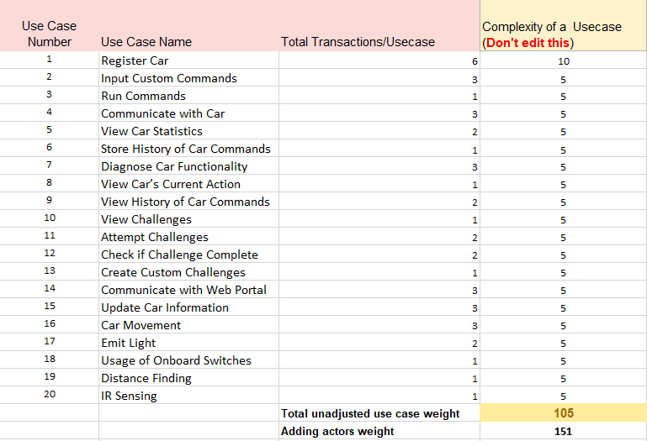

## A.2 Actors Weight

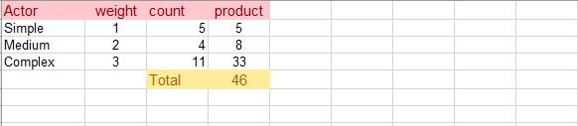

## A.3 Complexity Factors

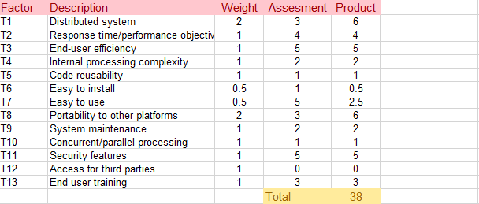

## A.4 Environmental Factors

