**Exam Assessment Questions for Math 2417**

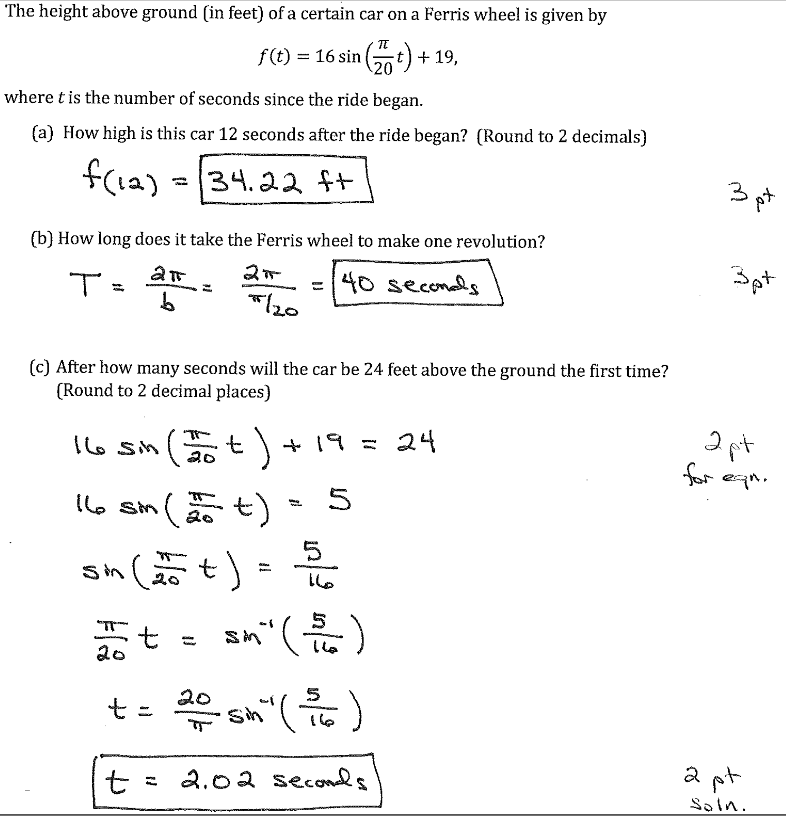

1. Suppose that $\sin\left(θ\right)= \frac{9}{10}$ and $\tan\left(θ\right)<0$. Find the following: *(2 points each)*

|  |  |
| --- | --- |
| 1. = | 1. = |
|  |  |
|  |  |
|  |  |
|  |  |
|  |  |
|  |  |
|  |  |
|  |  |
|  |  |
|  |  |
|  |  |

1. Suppose we have tank of bacteria growing in ideal conditions. In the beginning, we had 16 grams of bacteria in the tank and after 5 days there was 25 grams. Assume the amount of bacteria after t days is given by the formula $A\left(t\right)=A_{0}e^{kt}$ where $A_{0}=A(0)$ is the amount of bacteria (in grams) at time t = 0.

Questions:

1. What is the value of k?
2. Approximately how much bacteria was in the tank at the end of 3 days?
3. When will there be 50 grams of bacteria in the tank?
4. How many days does it take for the bacteria to double its weight?

Method of solution:

1. Solve the equation $A\left(5\right)=25=16e^{k5}$ to get . ***(3 points)***
2. Compute A(3) by $A(3)≅16e^{\left(.08926\right)\left(3\right)}≅20.913$ grams of bacteria.

***(2 points)***

1. Solve the equation $50=16e^{\left(.08926\right)t}$ for t to get days. ***(3 points)***
2. Solve the equation $2A\left(0\right)=32=16e^{\left(.08926\right)t}$ for t to get days. ***(2 points)***
3. Show that $\frac{1-\tan^{2}{x}}{1+\tan^{2}{x}}=2\cos^{2}{x}-1$

Solution: Note: many correct derivations exist. One is shown here.

$\frac{1-\tan^{2}{x}}{1+\tan^{2}{x}}=\frac{1-\frac{\sin^{2}{x}}{\cos^{2}{x}}}{1+\frac{\sin^{2}{x}}{\cos^{2}{x}}}=\frac{\cos^{2}{x}-\sin^{2}{x}}{\cos^{2}{x}+\sin^{2}{x}}=\cos^{2}{x}-\sin^{2}{x}=\cos^{2}{x}-\left(1-\cos^{2}{x}\right)=2\cos^{2}{x}-1$***(each step is worth 2 points)***