Tasks 1: Calculate values of the following performance metrics

|  |  |  |  |  |  |  |  |  |
| --- | --- | --- | --- | --- | --- | --- | --- | --- |
| JobID | Server | Submission  Time | Waiting  Time | Start Time | End Time | Turnaround Time | Rental Cost | Resource Utilisation |
| 0 | Tiny 0 | 32 | 40 | 72 | 1902 | 1870 | $0.20 | 100% |
| 1 | Small 0 | 54 | 50 | 94 | 2287 | 2233 | $0.24 | 100% |
| 2 | Medium 0 | 55 | 60 | 115 | 292 | 237 |  |  |
| 3 | Medium 0 | 108 | 7 | 115 | 252 | 144 |  |  |
| 4 | Medium 0 | 287 | 5 | 292 | 2833 | 2546 | $0.60 | 100% |

Task 2: Draw a schedule generated by WF. Show and explain how it matches the simulation log.

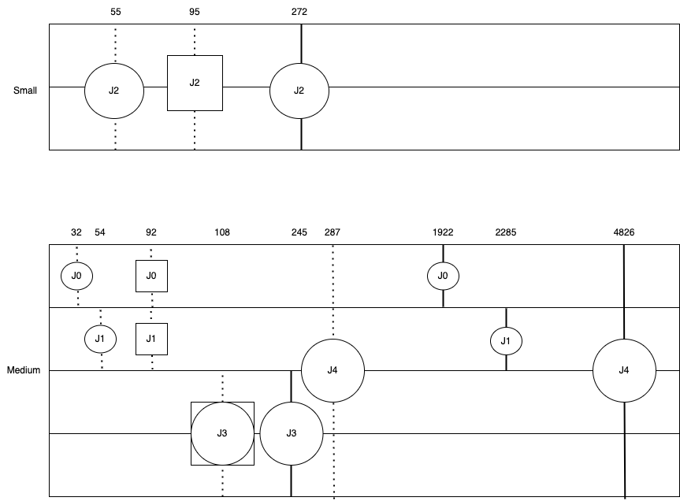

|  |  |  |  |  |  |  |  |  |
| --- | --- | --- | --- | --- | --- | --- | --- | --- |
| JobID | Server | Submission  Time | Waiting  Time | Start Time | End Time | Turnaround Time | Rental Cost | Resource Utilisation |
| 0 | Medium 0 | 32 | 60 | 92 | 1922 | 1890 |  |  |
| 1 | Medium 0 | 54 | 38 | 92 | 2285 | 2231 |  |  |
| 2 | Small 0 | 55 | 40 | 95 | 272 | 217 | $0.02 | 100% |
| 3 | Medium 0 | 108 | 0 | 108 | 245 | 137 |  |  |
| 4 | Medium 0 | 287 | 1998 | 2285 | 4826 | 4539 | $1.05 | 100% |