User Design Manual

*Furniture & Co*

Unregistered User:

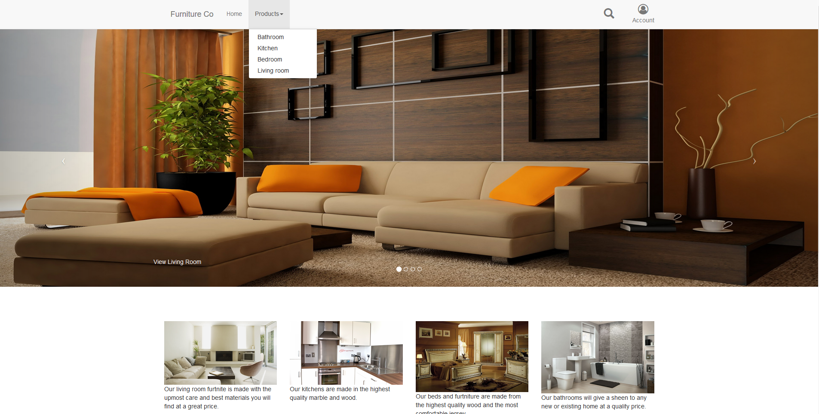

**Landing Page**

This is the landing page for the website which allows the user to go to the following pages: Any category page from the image carousel and any category from the dropdown navbar.

The arrow going towards the navbar to Products brings the unregistered user to the drop down nav bar which allows the user to access each category page.

The arrow going to the magnifying glass brings the user to the search page

The arrow going to the magnifying glass brings the user to the account drop down, the account drop down will allow the user to log in or register as shown here.

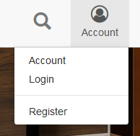

Product Category(For example, bedroom is selected)

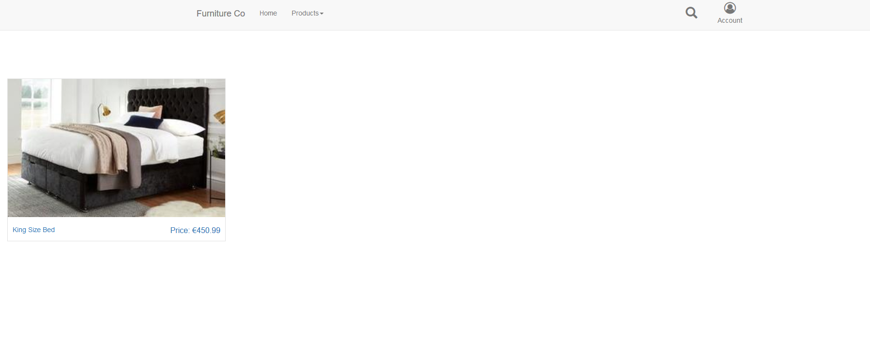

The user can select a product and it will bring the user to a product listing page for that specific product

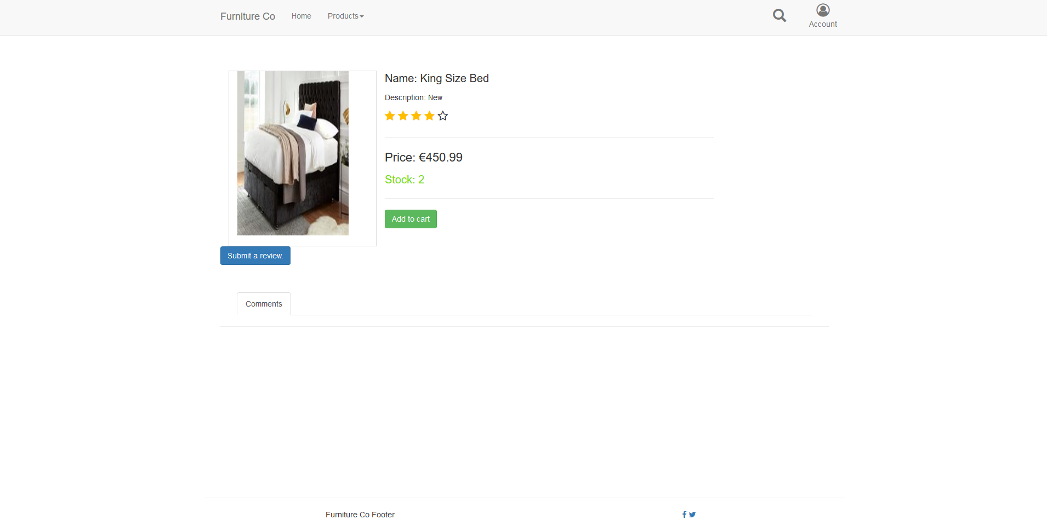

The unregistered user can just view this page they cannot do anything as they are not logged in. The user can be brought back to the home page or they can select search and be brought to that page.

**Search**

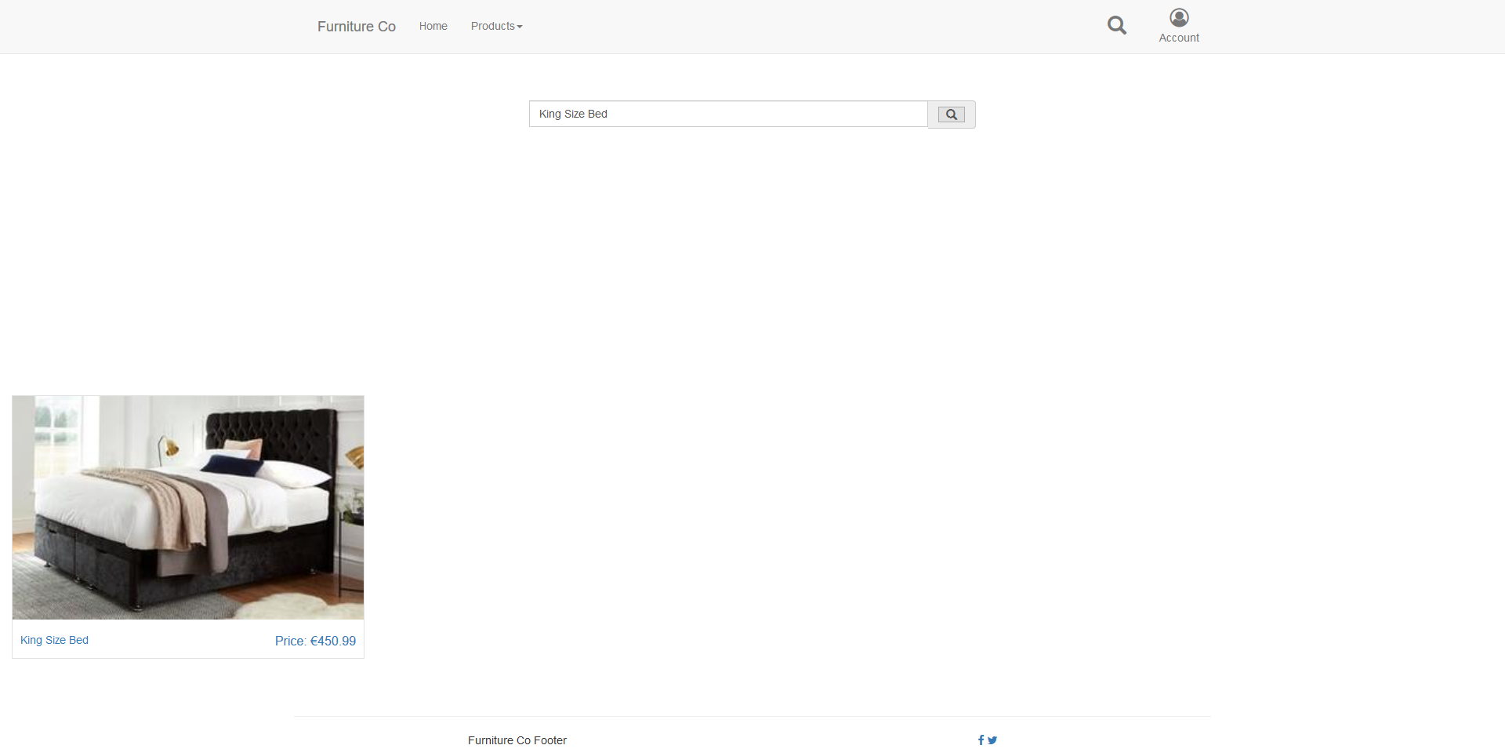

The search page displays a search bar and whatever the unregistered user has searched for, once text is inputted in that search box it searches based off the text inputted and displays the outcome. The results once clicked will bring the unregistered user to the product listing page.

Registered User

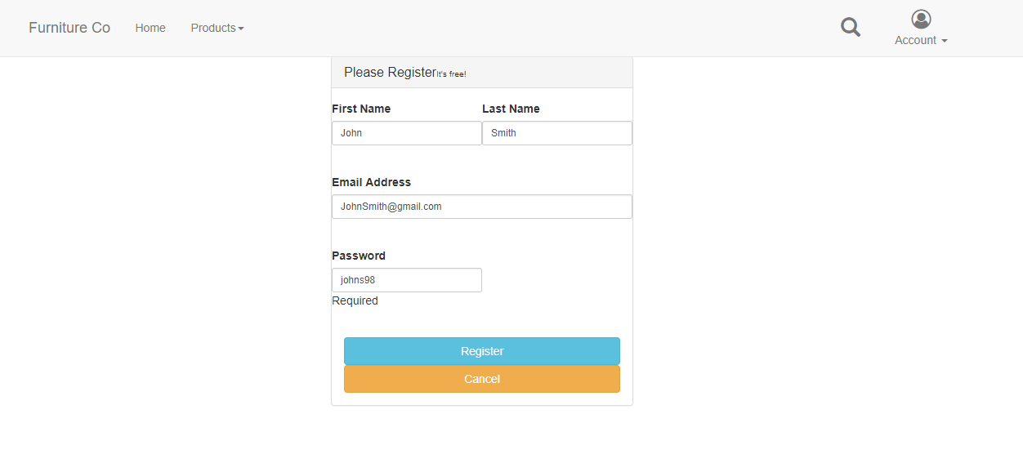

The user will first register the name, email address and a password for access. An unregistered will have to use this page before making any purchases or adding to cart.

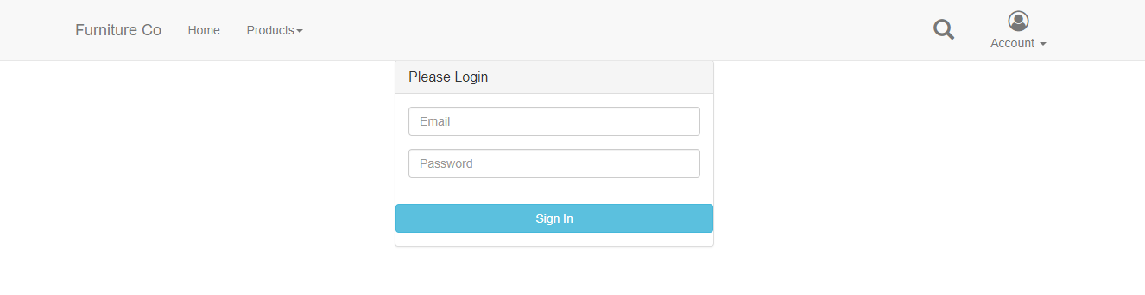

The unregistered user if already registered or if is trying to add to cart for the first time will be redirected to this login page. Sample email and password to use is [johnsmith@gmail.com](mailto:johnsmith@gmail.com) and password is johns98.



As you can see once the user is logged in the cart is then displayed to the user in the navbar.

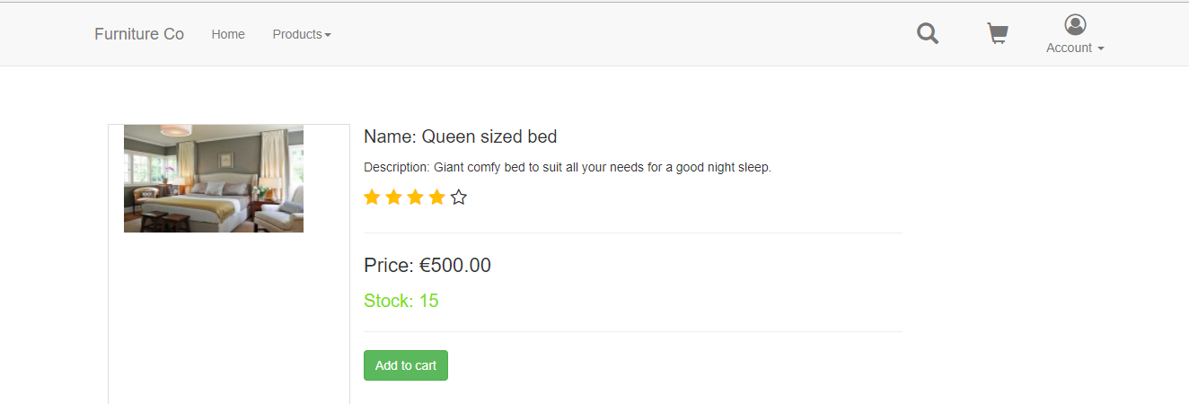

A user can then add a product to the cart such as the sample above. The user is then displayed the cart with the item added to it.

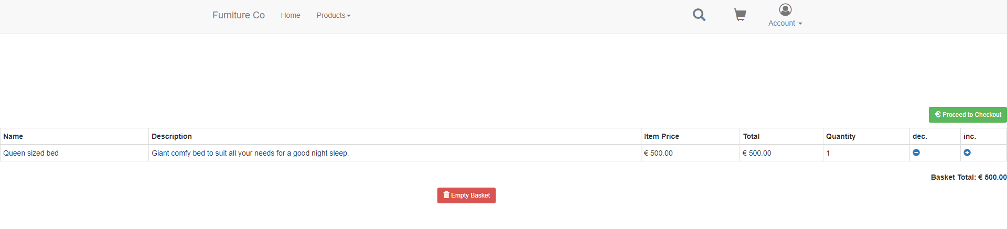

The user can then increment or decrement the amount of the item they want once there is enough in stock. If there isn’t enough in stock a user is displayed this message on the cart page.

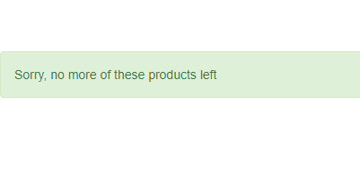

The user can then proceed to payment once they are happy with what is in their cart.

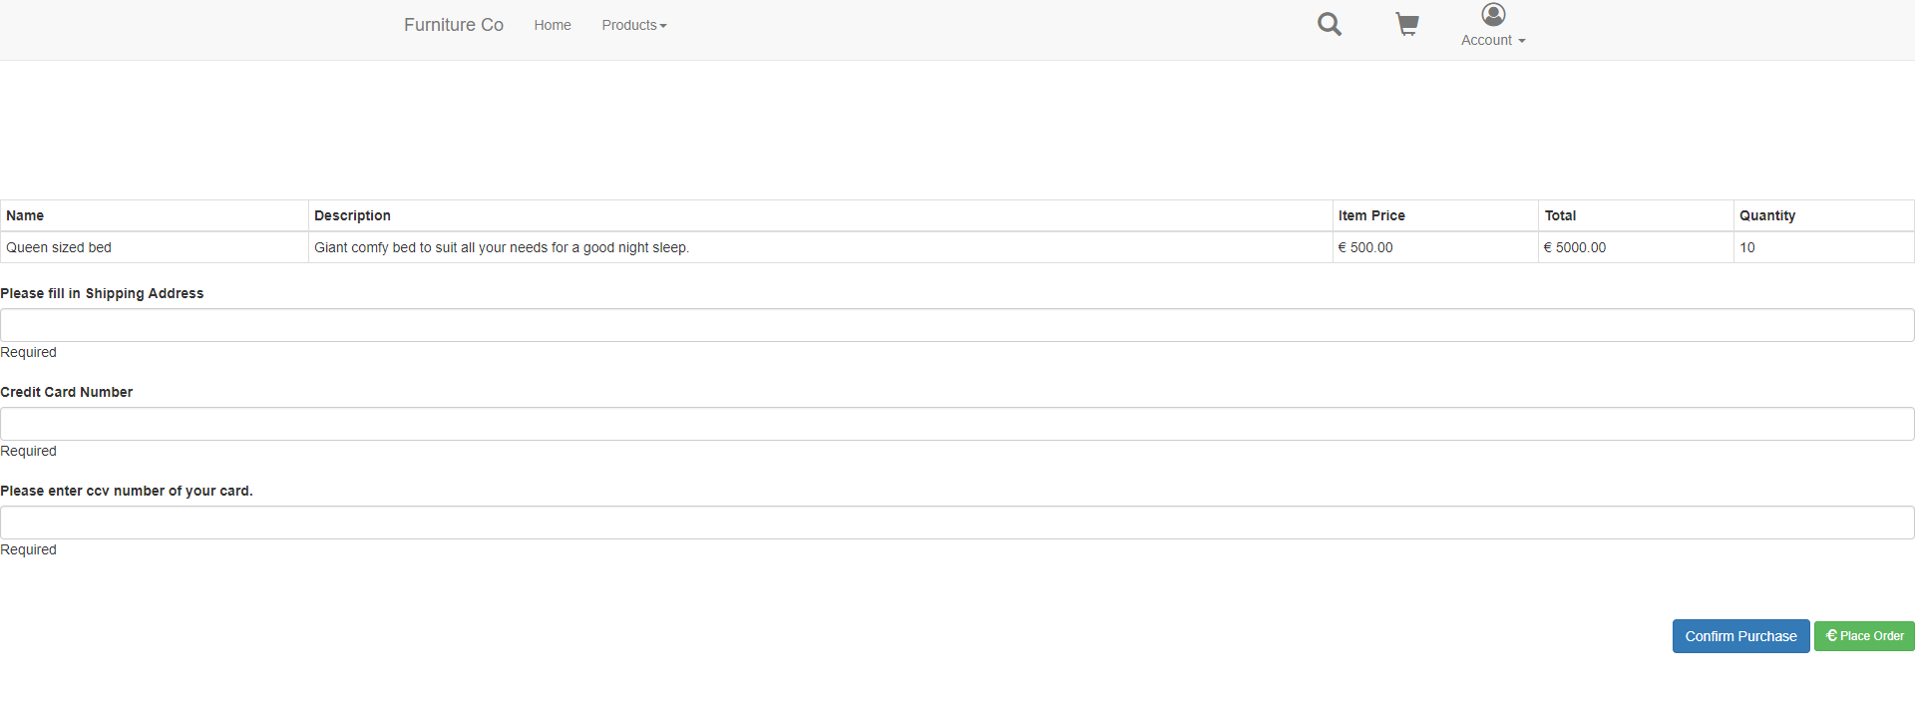

The user must then fill in their shipping address, credit card number and ccv number.

The user can then confirm their purchase. Once the purchase is completed the stock count is decremented by the amount purchased.

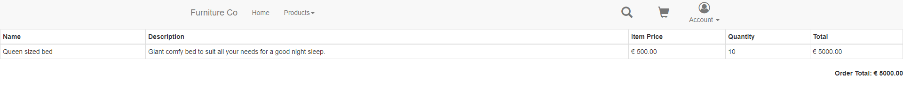

The user is then displayed a reciept for their purchase.

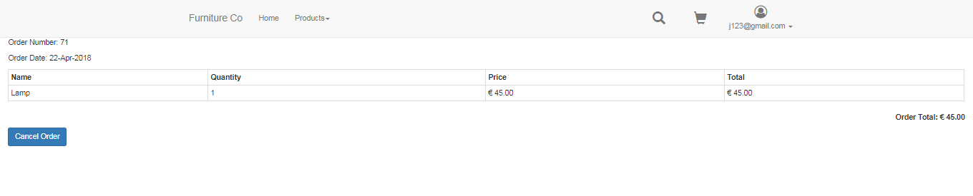

As you can see above the user can then click on the account drop down and view their recent purchases and can cancel their order up until it is delivered. If cancelled the stock is then incremented by the amount they ordered then cancelled.

Administrator

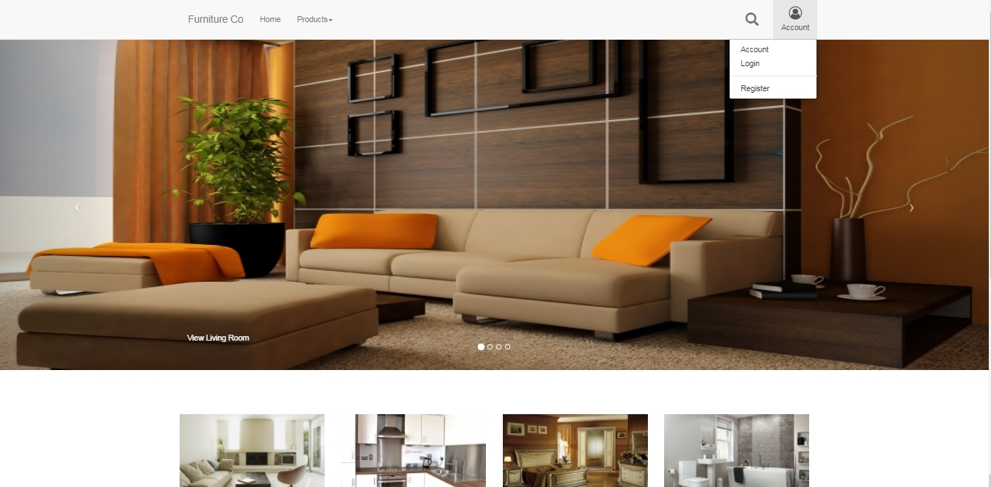

Welcome to Furniture & Co. You are currently the Administrator of this website. To use the functionalities of this website please press Account, a drop down will appear then press Login.

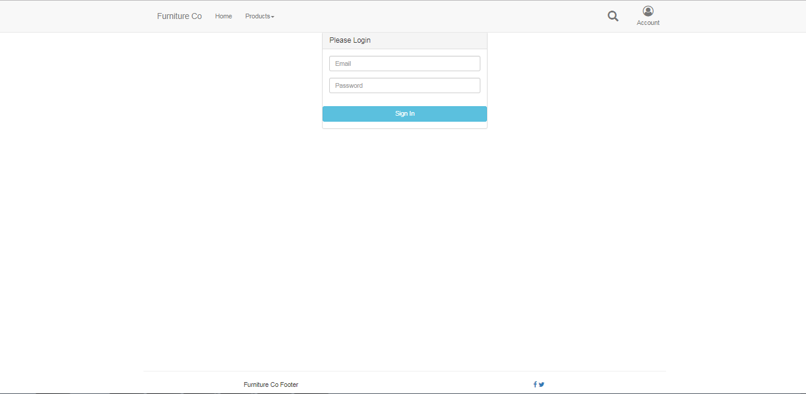

To login as a user with full functionality of this website please put in the following details:

* Email: [administrator@website.com](mailto:administrator@website.com)
* Password: admin

You are now logged in as and have ‘admin’ privileges.

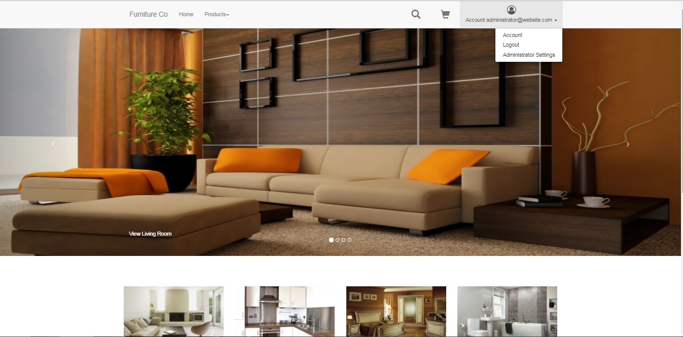

Please press Administrator Settings.

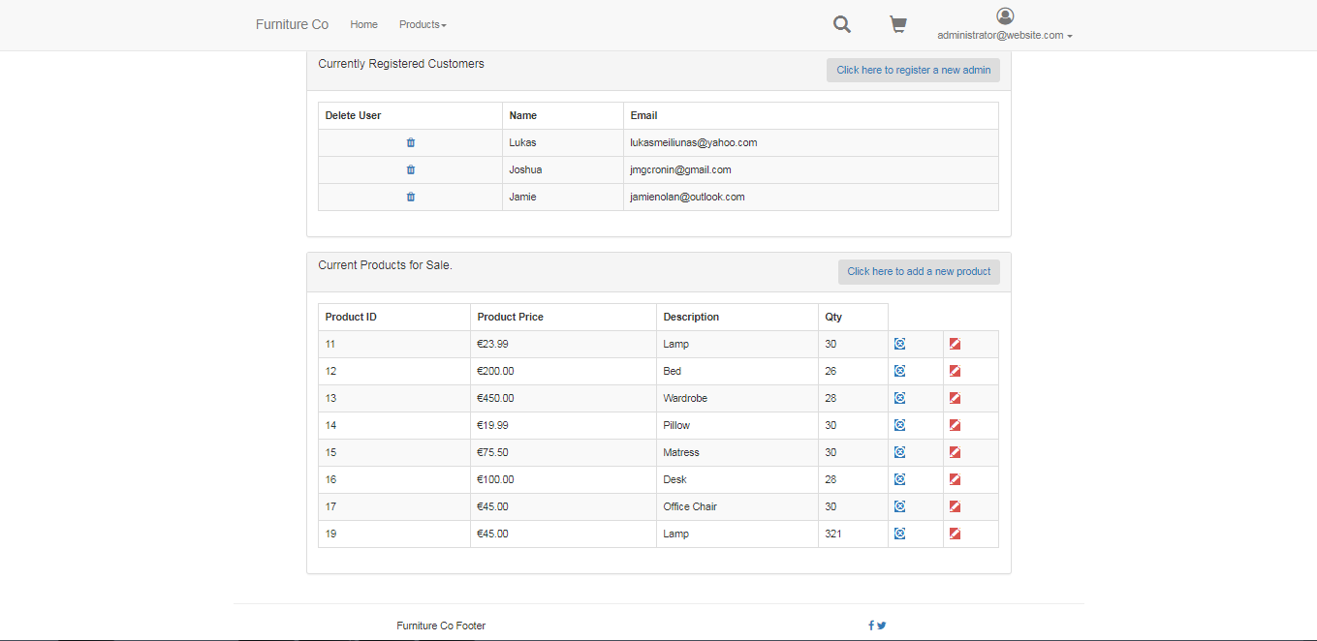

This is the Admin Control page. In this page you can delete current Users which are registered, view all products for sale in a list and Add, Update or Delete them. An admin can only be registered on this website by an already existing admin, one needs to press ‘Click here to register a new Admin.

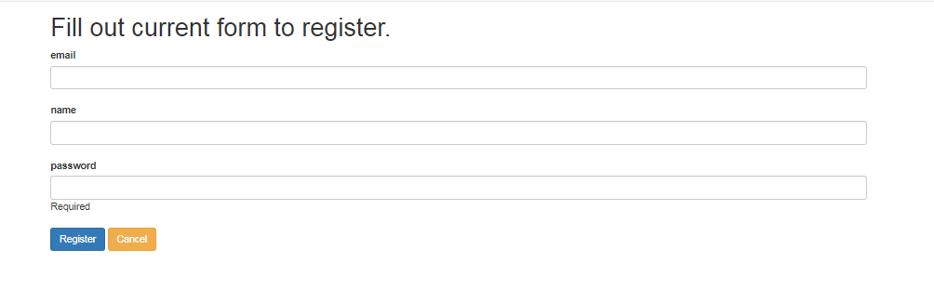

When this form is filled out an admin is registered successfully.

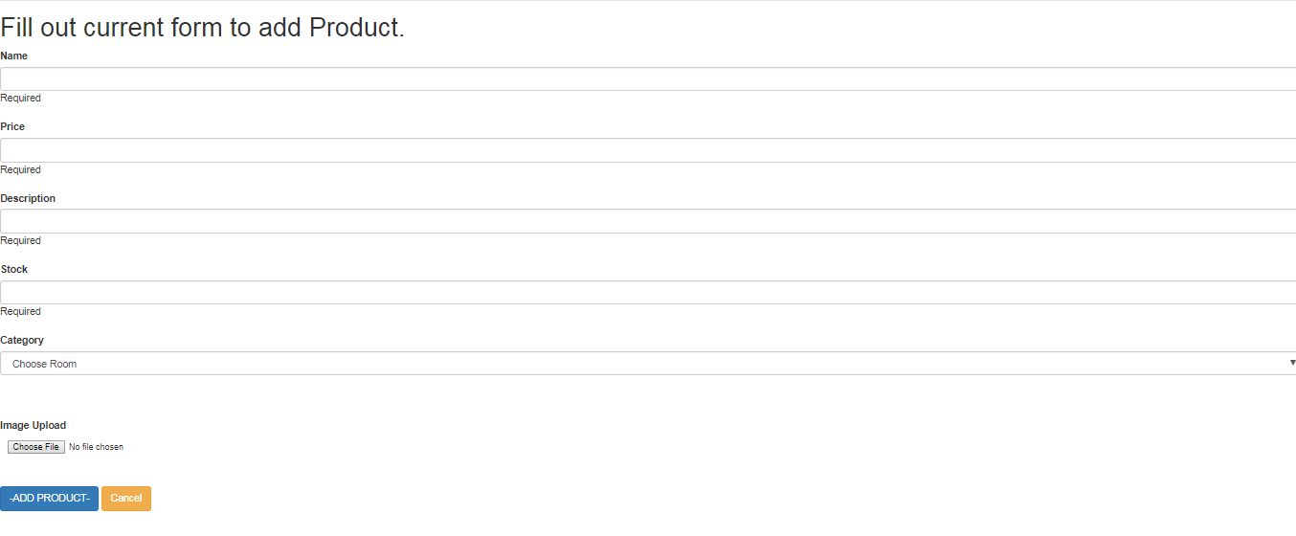

The form above needs to be completed to successfully add a new Product to the website and display it for sale.