Joshua Osborne
Version: Python 2.7

This code takes input from a file named LinkStates.csv, which is a table of the link costs from node to node in a network, then outputs the source tree and shortest path costs for a specified node. The program defines a class named “Node” for each node specified in the file. “Node” contains its name, the cost for its links to the other nodes (default 1000 if there is no direct connection), and the shortest path to it from the source node (blank to start). Once the input is formatted properly, the program asks for the user to input the node to start the algorithm from. Finally, using a function to find the minimum cost node that hasn’t been visited yet, the function iterates through the unvisited nodes. If a shorter path is found, the function updates the “costMap” to reflect this and updates the node’s “shortestPath” string. Finally, once all nodes are visited, the program formats the output, removes redundant paths in the source tree, and prints the output.

To run the code, simply type “python2 Dijkstra.py”. The program will prompt you for one of the node names. This is case sensitive; enter the name of the node to be searched and press Enter.

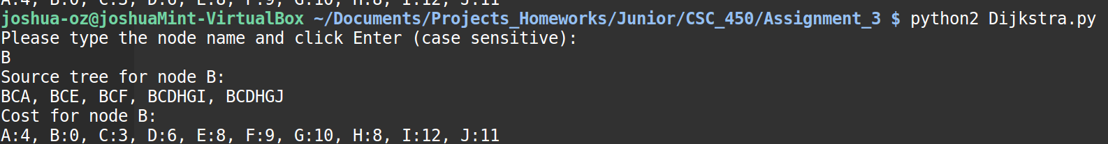
Alternatively, the code can be executed like a file using “./Dijkstra.py” as long as it is made executable (“chmod 744 Dijkstra.py”) first:

