CHAPTER 1

INTRODUCTION

Project Context
Monitoring and predicting student academic performance has become an essential aspect of modern education. Accurate and timely insights into student progress allow educators to identify learning gaps, tailor interventions, and support struggling learners before poor outcomes occur. Traditional grading systems and manual monitoring methods often fail to capture a complete picture of student performance. They tend to be subjective, time-consuming, and prone to human error, which can delay necessary interventions (Cain et al., 2021). Many institutions still rely on fragmented data collection processes, making it difficult to consolidate information, conduct efficient analysis, or generate meaningful insights. These issues are especially prevalent in online and blended learning environments, where student engagement metrics are dispersed across multiple platforms and formats (Pham Xuan Lam et al., 2024). The absence of automated performance analytics hinders educators’ ability to make data-driven decisions that enhance learning outcomes.
To address these challenges, this study proposes the development of a Prediction of Student Performance in the Entrance Examination using Classification Technique. Decision trees provide clear, interpretable classification of performance levels, allowing educators to understand how different variables influence outcomes. Together, these technologies will support educators in forecasting student outcomes, identifying at-risk learners, and improving overall academic monitoring.

Purpose and Description
The primary purpose of this project is to design and develop a prediction system capable of analyzing student performance using a Decision Tree Algorithm. The system aims to streamline the organization of applicant records and provide predictive insights based on historical data. The system automates the organization of applicant records, while the Decision Tree Algorithm identifies performance patterns based on academic indicators. Through the system interface, authorized users can enter applicant information and request a prediction. The algorithm then processes these data to generate predictions that inform educators of students’ potential performance levels. By presenting clear and interpretable results, the system supports educators in monitoring student progress, identifying those who may require additional support, and improving decision-making related to instructional strategies.

Objectives
The general objective of the study is to develop a student academic performance prediction system using a Classification Technique specifically:
- To collect a comprehensive dataset of the student performance in the entrance examination.
- To extract a predictive model using a classification technique to determine the student performance in the entrance examination.
- To evaluate the effectiveness of the model using the following:
  - Accuracy
  - F1 Score (Precision & Recall)
  - Confusion Matrix
- To provide a UI/UX for determining the performance probability.

Scope and Limitations

This study focuses on the development and application of a predictive model to categorize the performance of applicants in the Northwest Samar State University (NWSSU) Entrance Examination using the Decision Tree algorithm. The scope is specifically confined to the incoming freshmen, utilizing historical data such as Gender, Socio economic status, Junior High School General average (GA), Senior High School General Weighted Average (GWA), SHS strand, Parents occupation, Coaching support, Weekly Study hours and School type (Public or Private) provided by the NWSSU Admissions Office. Technically, the research is delimited to the use of supervised machine learning algorithms specifically Decision Tree, Random Forest, and Gradient Boosting to classify results into predefined categories such as "Qualified," "Waiting List," or "Not Qualified".
However, the study is limited by its inability to account for external qualitative factors such as the examinee’s mental well-being, socio-economic background, or test-day anxiety. Furthermore, the findings are exclusive to the unique admission criteria of NWSSU and do not extend to predicting the students' long-term academic success or retention rates once enrolled in their respective degree programs.

CHAPTER 2

REVIEW OF RELATED LITERATURES

This chapter presents findings from scholarly articles, journals, and published studies directly aligned with the development of a predictive system that uses decision tree algorithms and SQL database integration. These studies provide the foundational concepts essential for establishing automated student performance prediction and efficient academic data management.
According to the study conducted by Adnan et al. (2021), continuous predictive monitoring throughout a course significantly enhances the early identification of students who may be struggling academically. By providing timely insights into student performance, such monitoring allows educators to implement targeted interventions before challenges escalate. This finding aligns with the present study’s objective to support early detection through SQL-integrated prediction tools, ensuring that students at risk receive appropriate academic support promptly.
Zhou and Agarwal (2024) examine the application of decision-tree algorithms for categorizing student outcomes. Their analysis reveals that decision trees accurately classify performance levels while providing clear explanations for each decision path. The researchers note that transparency in predictive output fosters trust among educators relying on algorithmic guidance. Additionally, their findings indicate that predictive models help in planning academic interventions before final examinations. They conclude that decision trees are ideal for educational institutions seeking interpretable and actionable predictions. This study supports the present research by validating the decision-tree algorithm as a tool for forecasting student academic success using SQL-integrated data, underscoring the value of combining algorithmic accuracy with transparency.
The research conducted by Hasan et al. (2018) explores decision-tree methods for analyzing multidimensional student datasets. Their findings show that decision trees effectively identify patterns affecting performance, including attendance, assignment scores, and class participation. The study emphasizes that predictive models integrated into school systems allow early identification of students at risk of underperformance. The researchers also highlight the importance of structured datasets for improving algorithmic reliability. They conclude that automated prediction tools enhance institutional monitoring and academic planning. This study supports the present research by demonstrating the practical application of decision-tree forecasting using SQL-stored student data, reinforcing the importance of accuracy and interpretability in academic prediction systems.
Similarly, Hoque et al. (2020) develop a system to forecast student results by analyzing various academic factors. Their research shows that decision trees efficiently process student attributes to classify outcomes while reducing the manual workload for educators. The study emphasizes the importance of structured historical data for reliable predictions. Findings indicate that automated decision-tree models improve institutional monitoring of student performance. The researchers conclude that predictive algorithms provide both accuracy and interpretability for higher education contexts. This aligns with the present study’s approach, which integrates SQL-managed datasets and decision-tree classification for academic prediction, highlighting the significance of combining structured data with transparent algorithms.
Hamoud et al. (2018) demonstrate that decision-tree models effectively highlight predictors such as study habits, participation, and prior grades. Their research emphasizes that these algorithms outperform several traditional methods in both accuracy and interpretability. The study further recommends adopting decision trees to improve academic planning and early interventions. The authors find that integration with school information systems enhances predictive reliability. Their conclusions support the present research, which employs SQL-integrated decision-tree models to forecast student performance. The study underscores the value of transparent and actionable predictions for educators.
Kolo and Adepoju (2015) examine the efficiency of decision-tree algorithms in forecasting academic outcomes. Their findings indicate that decision trees categorize students effectively by identifying key academic variables. The researchers highlight that the clarity of the model allows educators to make informed decisions based on algorithmic insights. The study also emphasizes the role of predictive modeling in supporting academic planning strategies. The authors recommend integrating these models with institutional databases for continuous monitoring. This supports the present research by illustrating the benefits of SQL-based decision-tree prediction for structured and reliable student performance analysis.
Cheewaprakobkit (2015) explores decision trees in comparison to neural networks for academic prediction. The research highlights that decision trees offer superior interpretability, enabling educators to understand the rationale behind predictions. Findings reveal that structured datasets further enhance the accuracy of algorithmic outputs. The study concludes that decision trees are highly suitable for school-based predictive systems. This aligns with the present study’s focus on using transparent decision-tree models integrated with SQL databases, underscoring the importance of combining clarity with accuracy in academic performance prediction.
Shovon and Haque (2015) introduce a hybrid prediction system combining clustering and decision-tree techniques. The study shows that clustering students into groups before applying decision trees improves classification precision. Their research highlights that integrating unsupervised and supervised learning methods yields more refined and accurate predictions. The findings emphasize that early identification of academic challenges is possible through automated analysis. Structured datasets enhance algorithmic efficiency. This supports the present study’s methodology, which integrates SQL-managed data with decision-tree analysis for reliable forecasting.
Wang et al. (2018) examine decision-tree applications for digital learning environments. Their findings reveal that behavioral metrics such as login frequency, participation, and assignment completion strongly predict student success. The study emphasizes that decision trees effectively classify students based on engagement patterns, enabling real-time monitoring. Researchers note that automated prediction systems provide actionable insights for instructors to guide interventions. The study concludes that combining structured data with predictive algorithms enhances the quality of academic support. These insights support the present research by validating SQL-based data input for decision-tree forecasting in educational contexts.
Rose et al. (2019) develop a predictive model integrating multiple academic indicators for more precise outcomes. Their research emphasizes that combining diverse performance metrics increases the accuracy and reliability of predictions. The study also highlights the necessity of complete and structured datasets to support automated analysis. Researchers conclude that predictive analytics facilitate continuous performance monitoring and institutional planning. Their findings confirm that algorithmic systems enhance data-driven academic decision-making. This supports the present research, which integrates SQL-stored student records with decision-tree models for comprehensive performance forecasting.
The literature reviewed above shares common objectives with the present study, emphasizing the importance of structured data and interpretable prediction models in academic performance monitoring. These studies highlight how decision trees, when combined with well-organized datasets, provide reliable and actionable insights for educators. They also demonstrate that centralized data storage, such as SQL databases, enhances accuracy, reduces errors, and supports automated prediction systems. The present study aligns with these findings by maintaining structured student records, implementing a decision-tree algorithm, and delivering clear outputs to assist in academic interventions. This approach ensures that predictive models are both transparent and practical, helping educators identify at-risk students while improving the efficiency of school performance tracking.
Kumar (2011) examines the effectiveness of decision-tree algorithms in classifying student outcomes. The study applies decision trees to historical academic datasets and demonstrates that these models accurately predict performance while identifying key influencing factors such as attendance and prior grades. The research emphasizes the interpretability of decision-tree outputs, which allows educators to understand the rationale behind each prediction. Additionally, the study highlights the efficiency of decision trees in handling large datasets for automated prediction systems. The findings indicate that decision trees provide a reliable foundation for performance forecasting. This aligns with the present study, which uses a decision-tree algorithm integrated with SQL-stored student data to ensure both accuracy and transparency. By combining structured databases with predictive modeling, the system supports informed academic decisions.
Pandey and Sharma (2015) apply decision trees to multiple academic performance indicators. Their findings reveal that the algorithm accurately classifies students according to risk and achievement levels while uncovering relationships among various academic factors. The researchers emphasize that decision trees enable clear interpretation of results, aiding educators in understanding patterns of success and areas needing intervention. They also highlight that transparent predictive models are critical for adoption in educational settings. The study concludes that decision-tree-based analytics enhance monitoring and early intervention processes. This supports the present research by reinforcing the algorithm’s suitability for analyzing SQL-integrated datasets. It demonstrates that predictive clarity is essential for guiding academic support strategies.
Muraina et al. (2022) investigate the performance of decision-tree models on complex subject-specific datasets. Their research finds that decision trees accurately forecast student outcomes and facilitate early identification of those at risk of failing. The study emphasizes that structured and comprehensive data improves the reliability of algorithmic predictions. Additionally, decision trees enable educators to make informed interventions. The researchers conclude that combining predictive analytics with organized academic records enhances educational decision-making. This aligns with the present study, which integrates SQL-managed student data with decision-tree algorithms to deliver actionable insights. The findings illustrate the importance of combining automated analytics with accessible database structures.
Olaniyi et al. (2017) explore how decision trees categorize students into performance groups. The research shows that the model identifies key predictors of academic outcomes, including exam scores and assignment completion. The authors highlight that clear, interpretable outputs assist educators in understanding students’ progress and potential risks. Their findings confirm that decision-tree-based prediction models outperform traditional statistical approaches in both accuracy and usability. They conclude that structured, automated prediction systems support effective academic planning. This supports the present research, which employs decision trees on SQL-stored datasets to generate accurate, understandable performance predictions.
Hamoud (2016) compares several decision-tree variants, including ID3, C4.5, and CART. The study demonstrates that algorithm selection affects both prediction accuracy and interpretability. The researchers emphasize that the appropriate choice of decision-tree model is crucial for ensuring reliable academic forecasts. Additionally, they highlight the importance of structured datasets in improving algorithmic performance. Their conclusions indicate that decision trees are suitable for real-time, automated academic prediction systems. This aligns with the present study, which evaluates and implements the most effective decision-tree variant for predicting student performance from SQL-managed data. The findings stress the importance of model selection for optimized predictive outcomes.
Mesarić and Šebalj (2016) demonstrate that decision-tree algorithms identify significant predictors of student performance, such as attendance and prior assessments. Their research highlights that predictive models enable early intervention for at-risk students, improving academic outcomes. The study also emphasizes that decision trees provide interpretable outputs, facilitating educator understanding and informed decision-making. Researchers conclude that integrating automated prediction systems into educational institutions enhances monitoring and academic planning. This supports the present research by showing that SQL-integrated decision-tree models can reliably analyze student performance. The study illustrates the value of structured data and transparent algorithms in guiding interventions.
Acharya (2023) demonstrates that intuitive interfaces significantly enhance the efficiency and accuracy of academic data management. Well-designed layouts and clear navigation reduce user errors while improving speed in handling student records. The research highlights that usability directly impacts system adoption and staff productivity. Additionally, the study shows that structured input forms and dashboards facilitate easy access to large datasets. Findings indicate that a user-centered approach supports both administrative efficiency and reliable data entry. This supports the present study by guiding the design of an accessible interface for managing SQL-stored student records. It reinforces the importance of usability for educators interacting with automated prediction systems.
Likewise, Ugalingan and Antonio (2025) find that web-based interfaces improve usability for staff handling academic records. Their study emphasizes that simplified workflows and responsive designs reduce errors and increase efficiency in daily operations. The researchers demonstrate that user-friendly dashboards allow quick data retrieval and minimize training requirements. Additionally, their findings highlight that system efficiency improves when design aligns with the staff’s workflow needs. This aligns with the present study, which aims to create a functional and easy-to-use interface for educators managing student performance data in an SQL database. The results underscore the value of usability in enhancing the adoption of automated systems.
Salama and Aly (2024) explore how intuitive interface design improves accessibility and communication between teachers and students. Their research reveals that structured navigation and consistent layout reduce input errors and streamline data access. Additionally, the study emphasizes that responsive design supports quick adaptation by educators and enhances overall system usability. The authors conclude that user-centered interfaces facilitate smoother administrative processes while supporting predictive analysis. This supports the present study by demonstrating the importance of interface design in systems that combine SQL databases with decision-tree prediction. It also reinforces that usability is critical for educators to effectively use automated tools for student performance monitoring.
Nimy et al. (2023) demonstrate that predictive models can classify students according to risk levels using historical academic data. Their findings reveal that probabilistic techniques improve the early identification of students who may underperform. The researchers emphasize that timely intervention, guided by algorithmic predictions, can prevent academic failure. Additionally, the study highlights that structured datasets enhance the accuracy and reliability of prediction models. Their conclusions support the present research by demonstrating the benefits of integrating predictive algorithms with educational data stored in SQL. These insights provide a foundation for developing decision-tree outputs that guide interventions effectively.
Likewise, Cao and Mai (2025) develop an AI-based system to identify students at risk of failing. Their research confirms that predictive insights allow educators to implement timely interventions and adjust instructional strategies. The study highlights the importance of interpretable outputs for practical application in schools. Findings emphasize that accurate predictions depend on clean, structured datasets. This aligns with the present study, which uses SQL-integrated decision-tree models to generate actionable predictions. Both studies underscore the critical role of predictive analytics in supporting early academic interventions.
Adnan et al. (2021) show that continuous predictive monitoring improves the identification of struggling students throughout a course. Their research emphasizes that early predictions allow targeted interventions, enhancing student success rates. Additionally, the study indicates that structured and reliable datasets are essential for improving model accuracy. Findings demonstrate that predictive systems help institutions allocate resources effectively for at-risk students. This supports the present research, which integrates SQL-managed student records with decision-tree outputs for early detection and intervention planning.
Hung et al. (2015) apply predictive analytics to monitor student performance over time. The study finds that observing trends enables educators to identify students likely to face academic difficulties early. The researchers emphasize that continuous analysis and structured data improve intervention effectiveness. Additionally, their findings indicate that integrating predictive tools with institutional data enhances decision-making. This supports the present study, which combines SQL-stored datasets with decision-tree algorithms to deliver timely and actionable predictions for educators.
Al-Shabandar et al. (2019) highlight that predictive models enhance the accuracy of identifying students in need of support. Their findings confirm that automated algorithms allow educators to intervene promptly, preventing potential academic decline. The study also emphasizes that interpretable outputs are essential for guiding effective decision-making. Additionally, structured datasets improve model reliability and actionable insight generation. This aligns with the present research, which employs SQL-integrated decision-tree models to support early intervention strategies. Both studies demonstrate the value of predictive analytics in education.
Overall, the reviewed literature underscores the critical role of decision-tree algorithms and structured SQL-based data in accurately predicting student performance and supporting early interventions. Collectively, these studies demonstrate that combining algorithmic precision with transparent, user-friendly systems enhances both academic planning and administrative efficiency. By integrating insights from previous research, the present study aims to develop a predictive system that is not only accurate and interpretable but also practical and accessible for educators. This synthesis of predictive analytics, structured data management, and intuitive interface design ensures a comprehensive approach to supporting student success and optimizing institutional performance.

CHAPTER 3

TECHNICAL BACKGROUND

This chapter presents the software, hardware, and human resources involved in developing the Prediction System for Student Academic Performance using a Decision Tree Algorithm. It explains the tools, technologies, and methods used to build the system, as well as how each component contributes to achieving accurate predictions and organized data management.

Software Requirements
The development of the Prediction System for Student Academic Performance requires specific software tools that are essential for the researchers to build a functional and reliable system. Establishing clear software requirements provides a foundation for the design, development, and testing phases, ensuring that the system operates efficiently and meets its intended purpose. Understanding the system’s objectives and needs allows the researchers to implement features such as student record management, data processing, and performance prediction, while creating a user-friendly interface for educators. Proper software selection ensures that the application is effective, organized, and capable of supporting informed decision-making in monitoring student academic performance.

Table 1
Software Requirements of Prediction of Student Performance in the Entrance Examination using Classification Technique

Software | Specification | Description
Operating System | Windows 10 | Provides the environment for system development and testing.
IDE | Visual Studio Code | Used for coding the system interface and algorithm interactions.
Programming Language | Typescript | The programming or scripting language used to develop the user interface.
Framework | react.js, TypeScript | Backend framework for system interface and routing.
Python | 3.12 | Primary language for machine learning model training, data preprocessing, and the FastAPI prediction service.
Node.js | v18 or higher | JavaScript runtime environment used to run the Express.js backend server.
FastAPI | Latest stable | Python web framework used to serve the trained machine learning model as a REST API endpoint.
Express.js | v4 or higher | Node.js backend framework that handles API routing and proxies prediction requests to the ML service.
scikit-learn | Latest stable | Python machine learning library used to implement and train the Random Forest Classifier.
imbalanced-learn | Latest stable | Python library providing the SMOTE implementation used to address class imbalance in the training set.
pandas / NumPy | Latest stable | Python libraries used for data loading, preprocessing, feature engineering, and numerical computation.
Vite | Latest stable | Frontend build tool used to bundle and serve the React application during development and production.
joblib | Latest stable | Python serialization library used to save and load the trained Random Forest model artifact (.pkl).
GitHub | — | Version control platform used by the team for source code management and collaborative development.

Hardware Requirements
The development of the Prediction System for Student Academic Performance requires certain hardware components to ensure the system operates efficiently and reliably. Hardware requirements are necessary to support the software tools and machine learning algorithms used in the project.
Proper hardware ensures smooth data processing, quick computation of predictions, and stable operation of the application, especially when handling large datasets of student records. Selecting the appropriate hardware also helps maintain performance during testing and use, providing educators with a system that is both responsive and dependable.

Table 2
Software Requirements of Prediction of Student Performance in the Entrance Examination using Classification Technique

Hardware | Specification | Description
Laptop | Processor: at least 2.4 GHz, RAM: 8GB or higher, Storage: 500 Gb | A hardware device used by the researchers to develop and run the student performance prediction system.

Table 2 displays the hardware requirements to outline the essential physical components and specifications needed to support the proper functioning of the system. This includes devices that provide the foundation for reliable and efficient operation, ensuring that the system can handle workload and user demands effectively. The researchers used the laptop with a minimum of 8GB RAM and at least a 2.4GHz processor, since it should be able to run the IDE and other resources used during the development smoothly.

Human Resources Requirements
The development of the Prediction System for Student Academic Performance requires specific human resources to ensure the project is completed efficiently and effectively. Human resources include researchers, developers, and other personnel involved in planning, designing, implementing, and testing the system. Each member plays a vital role in handling tasks such as coding, algorithm implementation, and system evaluation. Proper allocation of human resources ensures that the project is developed according to plan, operates reliably, and meets the needs of educators and students.

Table 3
Human Resources Requirements of Prediction of Student Performance in the Entrance Examination using Classification Technique

Roles | Responsibilities
Project Manager | Responsible for planning, organizing, and overseeing the development of the project to ensure timely completion.
System Developer / Researcher | Handles the coding, implementation of the Decision Tree Algorithm, and overall system development.
UI/UX Designer | Designs a user-friendly interface for teachers to input, view, and manage student data, ensuring smooth navigation.
Tester / QA Analyst | Tests the system for errors, bugs, and functionality issues to ensure accurate predictions and stable performance.
Users | Provides input on system requirements, participates in testing, and uses the system to monitor and analyze student performance.

Table 3 shows the roles and responsibilities of human resources involved in the development of the Prediction System for Student Academic Performance, ensuring the smooth and efficient implementation of the study. The Project Manager is responsible for planning, organizing, and overseeing the entire project. The System Developer / Researcher handles the coding, implementation of the Decision Tree Algorithm, and overall system development. The UI/UX Designer is responsible for creating a user-friendly interface that allows teachers to input, view, and manage data easily. The Tester / QA Analyst ensures the system functions correctly, is free of errors, and provides accurate predictions. Finally, the end users, including teachers and school staff, provide feedback and insights during testing and actual use, helping improve the system’s usability and effectiveness. This collaboration highlights the importance of each role in the successful development and implementation of the project.

Gantt Chart
This section outlines the schedule followed in the proposed study. A Gantt chart was used to organize tasks and set deadlines throughout the project timeline.
This scheduling method helped the researchers allocate time and resources efficiently during each development phase.
Activities | 2025 |  |  |  |  |  |  |  |  |  |  |  |  |  |  |  | 2026
 | SEPT |  |  |  | OCT |  |  |  | NOV |  |  |  | DEC |  |  |  | JAN |  |  |  | FEB |  |  |  | MAR |  |  |  | APR
Requirements Gathering
Model Development
Web App Development
Testing
Implementation and
Maintenance

Figure 1. Gantt Chart for the Development of the Student Academic Performance Prediction System

Figure 1 illustrates the Gantt chart based on a Hybrid Agile–Waterfall methodology, which combines structured planning with iterative development. This approach is selected to ensure systematic progress while allowing flexibility during algorithm development, interface design, and system refinement. The project is planned over an eight-month period, beginning in September 2025 and concluding in April 2026.
The project begins with the Requirements Analysis and Planning phase, which runs from September to October 2025. During this phase, the researchers define the project scope, identify system requirements, gather academic data requirements, and prepare Chapter 1 of the manuscript. Initial consultations and approval processes are also conducted to ensure alignment with institutional guidelines.
The project begins with the Requirements Analysis and Planning phase, which runs from September to October 2025. During this phase, the researchers define the project scope, identify system requirements, gather academic data requirements, and prepare Chapter 1 of the manuscript. Initial consultations and approval processes are also conducted to ensure alignment with institutional guidelines.
The Algorithm Implementation and Model Development phase occurs from January to February 2026. The Decision Tree Algorithm is implemented using Python and relevant libraries. Data preprocessing, model training, and validation are performed to ensure accurate prediction of student academic performance.
The System Development and Integration phase runs from February to March 2026. In this phase, the user interface is developed, the data input structure is validated, and the prediction model is connected to the system. Iterative testing and refinement are conducted to improve usability and functionality.
The Testing and Evaluation phase is carried out in March 2026. The system undergoes functional testing, accuracy evaluation, and error correction. Test cases are defined to ensure that predictions are reliable and that the system meets its objectives.
The final phase, Documentation, Final Defense, and Revisions, takes place from April 2026. The researchers finalize Chapters 3 to 5, prepare for the final defense, and apply revisions based on panel recommendations.

CHAPTER 4

DESIGN AND METHODOLOGY

This chapter presents the design and methodology used in the development of the Web-Based Student Academic Performance Prediction System Using Classification Techniques. It covers the development framework adopted, the data strategy used to fulfill Objective 1, the classification models built for Objective 2, the model evaluation approach for Objective 3, and the system design for Objective 4.
The researchers adopted the Rapid Application Development (RAD) model under the System Development Life Cycle (SDLC) framework. RAD is an iterative and adaptive approach that enables rapid prototyping and continuous refinement based on ongoing feedback. This methodology was selected because it allowed the research team to progressively develop and adjust the prediction models and system interface within the available timeframe.

REQUIREMENTS ANALYSIS
The requirements analysis phase began by reviewing the study's objectives and identifying the data needed to train and evaluate the student performance prediction model. The original plan, as stated in the approved proceedings paper, was to gather entrance examination records directly from students of the university to serve as the primary training dataset. However, this approach could not be carried out within the study period due to three key constraints: (1) time limitations, as the data collection period was insufficient to accumulate a dataset large enough to train a reliable classification model; (2) lack of institutional access, as no formal clearance was obtained to collect or access student examination records from the university; and (3) student privacy considerations, as academic and socioeconomic records are sensitive personal information subject to data privacy regulations.
In response to these constraints, the researchers adopted a publicly available secondary dataset as the primary data source for training the classification model. The dataset titled Student Performance on an Entrance Examination, obtained from Kaggle (Shamim, 2023), was selected because its features—academic background, socioeconomic indicators, language of instruction, and study preparation habits—closely correspond to the factors that are commonly associated with entrance examination performance in the Philippine educational context. The use of publicly available secondary datasets when primary data collection is infeasible is a recognized and acceptable research practice in educational data mining and machine learning literature (Romero & Ventura, 2010; Kabakchieva, 2013). The dataset was contextually adapted through feature mapping to align its variables with equivalent local educational indicators, ensuring that the model remains applicable to the study's intended campus context.

Requirements Documentation
Following the requirements analysis, the researchers documented the functional and non-functional requirements of the system. These requirements guided the design and development of all system components.
Functional Requirements
Functional requirements define the specific capabilities the system must perform. The table below presents the functional requirements of the Web-Based Student Performance Prediction System.

Table 4
Functional Requirements of the Prediction of Student Academic Performance Using Decision Tree Algorithm
Functions | Descriptions
Student Profile Input Form | Allows users to input their demographic, academic background, and socioeconomic information—including gender, socioeconomic background, review program participation, institution types, academic grade bands, parental occupations, primary language of instruction, and daily study time—which are then processed by the prediction model.
Performance Prediction | Uses the trained Random Forest classification model to classify the student's submitted profile into one of two performance bands: Excellent/Very Good (Higher-Performance Band) or Good/Average (Support-Needed Band).
Prediction Confidence Display | Presents the model's confidence score alongside the predicted performance band using an animated gauge visualization, enabling users to understand the certainty of the prediction.
Model Performance Dashboard | Displays the evaluation metrics of the trained model—accuracy, precision, recall, F1 score, and confusion matrix—in a structured format so users can assess the reliability of the prediction results.
Contextual Guidance | Provides actionable academic guidance and recommendations based on the predicted performance band to encourage academic improvement and preparation.

Table 4 shows the functional requirements of the system. The system enables users to input their student profile, receive a performance band prediction with a confidence score, and view the model's evaluation metrics. Contextual academic guidance is generated based on the predicted performance band.
Non-Functional Requirements
The non-functional requirements define the quality standards that the system must meet in order to be dependable and easy to use. These requirements do not describe a single function; instead, they describe how well the system should operate in real use.
Table 5
Non-Functional Requirements of the Prediction of Student Academic Performance Using Decision Tree Algorithm
Quality Attribute | Description
Reliability | The system operates consistently with minimal downtime, and prediction results are reproducible given the same input data.
Performance | The system loads and returns prediction results within an acceptable response time to ensure a smooth user experience.
Usability | The interface is designed to be intuitive and accessible, requiring minimal technical knowledge from student users.
Portability | The system is accessible via any modern web browser on desktop or mobile devices without requiring software installation.
Security | User inputs are validated at both the backend API layer and the machine learning service layer before processing, preventing invalid or malformed data from reaching the prediction model.
Reliability | The system operates consistently with minimal downtime, and prediction results are reproducible given the same input data.

Table 5 outlines the non-functional requirements of the system. The system is designed to be reliable, performant, usable, portable, and secure, ensuring that students can access the performance prediction system conveniently and safely from any device.
System Architecture
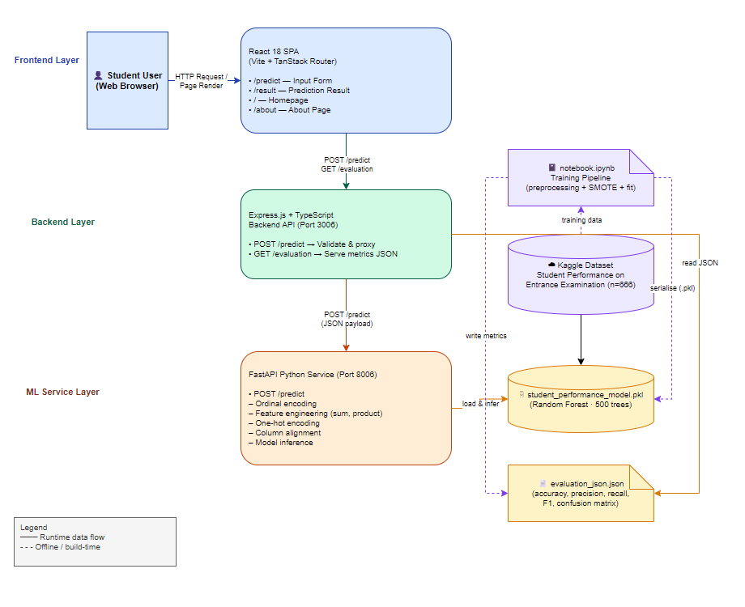
Figure 1 System Architecture Web-Based Student Performance Prediction System Using Classification Technique
Figure 1 illustrates the system architecture of the Web-Based Student Performance Prediction System. The diagram is organized into four horizontal swim-lane layers, each representing a distinct tier of the system. The topmost layer, the Frontend Layer (highlighted in blue), contains the Student User and the React 18 Single-Page Application built with Vite and the TanStack Router library, which serves four routes: the homepage (/), the student profile input form (/predict), the prediction result page (/result), and the about page (/about). The second layer, the Backend Layer (highlighted in green), contains the Express.js and TypeScript backend server running on Port 3006. This layer exposes two RESTful endpoints: POST /predict, which validates and proxies prediction requests to the machine learning service, and GET /evaluation, which serves the precomputed model performance metrics from a static JSON file. The third layer, the ML Service Layer (highlighted in orange), contains the FastAPI Python service running on Port 8006. This service receives the validated student profile, applies the full preprocessing pipeline—ordinal encoding, feature engineering, one-hot encoding, and feature column alignment—and performs inference using the loaded Random Forest model. The fourth and bottommost layer, the Offline / Training layer (highlighted in purple with a dashed border), contains the Kaggle Dataset (666 records) and the training notebook (notebook.ipynb), representing the offline model development phase. The diagram uses solid arrows to indicate runtime data flows and dashed arrows to indicate offline, training-time flows. Bidirectional flows are shown explicitly: the predicted performance band and confidence score travel back from the ML service to the backend, and from the backend to the frontend. The trained model artifact (student_performance_model.pkl) and the evaluation metrics file (evaluation_json.json) are produced during the offline phase and consumed at runtime.
Process Model
This section describes the system's process model and illustrates the flow of data and interactions within the Web-Based Student Performance Prediction System.
Context Diagram

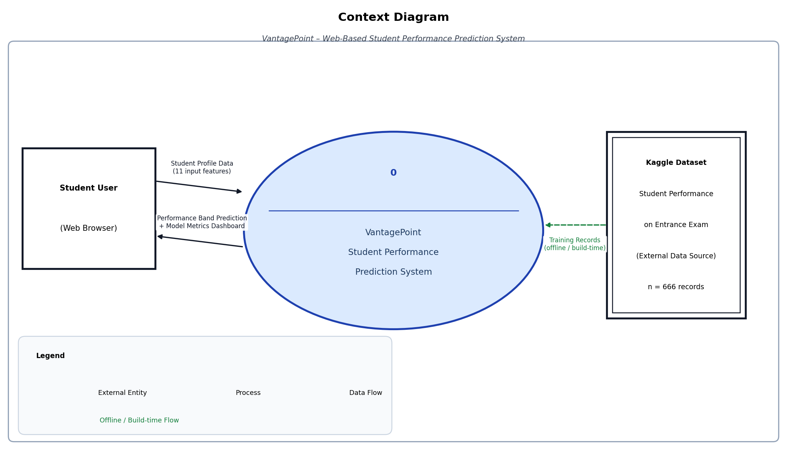
Figure 2. Context Diagram of the Web-Based Student Performance Prediction System

Figure 2 presents the Context Diagram of the Web-Based Student Performance Prediction System. It depicts the system as a single process (Process 0), showing the Student User as the primary external entity who provides eleven input features through the web browser. The Kaggle Dataset is represented as an external data source that supplies training records during the offline build phase. The system processes the student profile and returns the predicted performance band along with model evaluation metrics to the user.
Data Flow Diagram
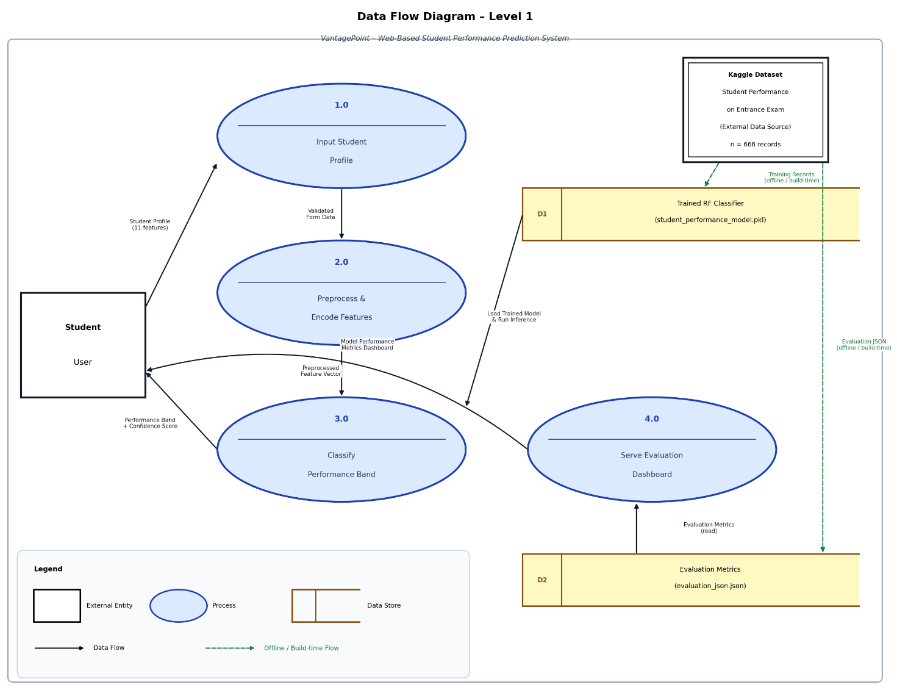
Figure 3. Data Flow Diagram (Level 1) of the Web-Based Student Performance Prediction System
Figure 3 presents the Data Flow Diagram (Level 1) of the Web-Based Student Performance Prediction System. The diagram is divided into two sections. The upper section depicts the runtime flow, while the lower section depicts the offline training-time flow. In the runtime section, the Student User external entity submits student profile input data to Process 1.0 (React Frontend – Collect & Display). The React Frontend sends the data as a POST /predict JSON payload to Process 2.0 (Express.js Backend – Validate & Route). The Express.js Backend validates the payload against the defined schema and forwards the schema-validated student data to Process 3.0 (FastAPI ML Service – Preprocess & Predict). The FastAPI ML Service loads the trained model from Data Store D1 (student_performance_model.pkl) and returns the Predicted Performance Band and Confidence Score back to the Express.js Backend. The Express.js Backend also reads model evaluation metrics from Data Store D2 (evaluation_json.json) and combines them with the prediction result before returning the full response to the React Frontend, which displays the result to the Student User. In the offline section, the Kaggle Dataset external entity supplies the raw CSV training data to Process 4.0 (Training Pipeline – notebook.ipynb). The training pipeline serializes the trained Random Forest model as a .pkl artifact to Data Store D1 and writes the computed evaluation metrics to Data Store D2, making both artifacts available for runtime consumption.
Functional Decomposition Diagram

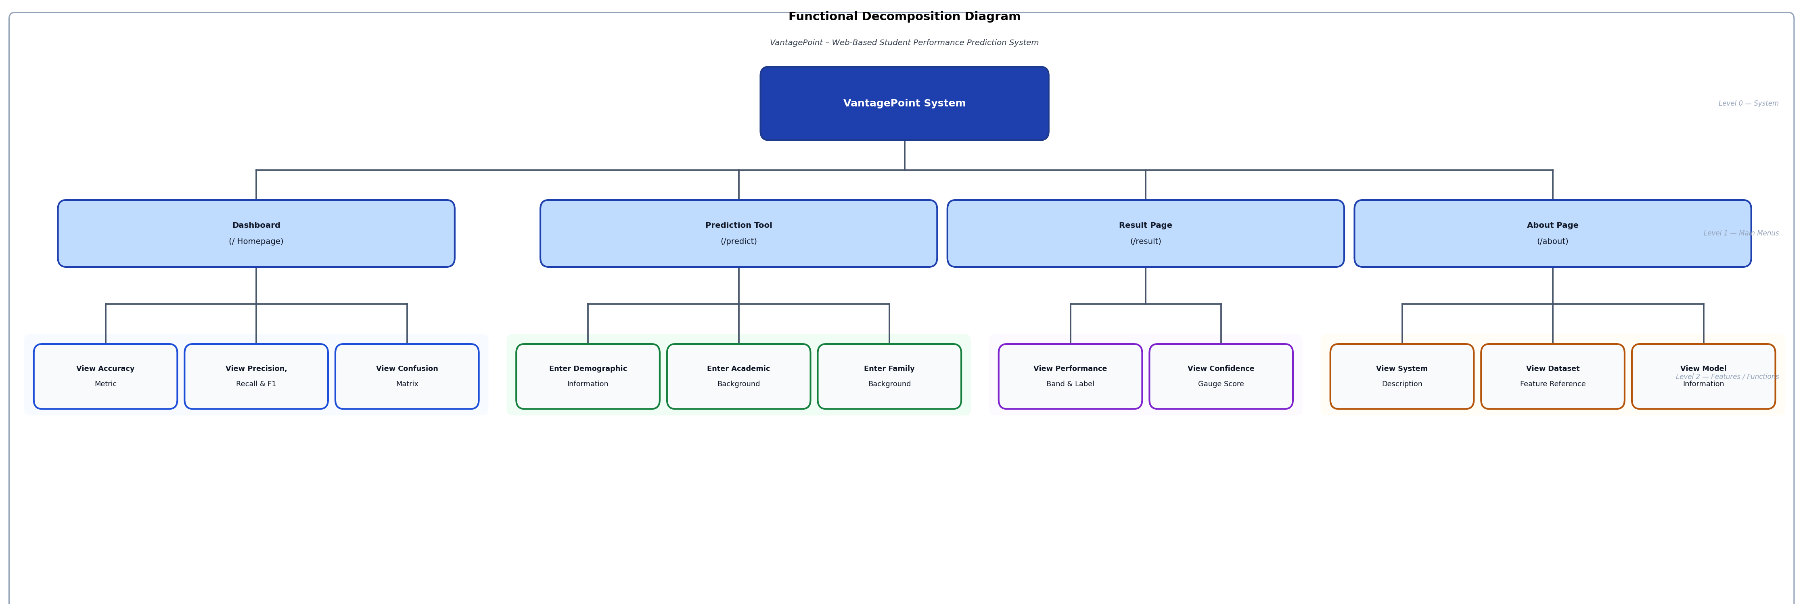
Figure 4. Functional Decomposition Diagram of the Web-Based Student Performance Prediction System
Figure 4 presents the Functional Decomposition Diagram of the Web-Based Student Performance Prediction System. The diagram is organized as a three-level tree. At the root level sits the top-level system function: Student Performance Prediction System. This decomposes into three Level-1 sub-functions arranged in columns: 1.0 User Interface, 2.0 Data Processing, and 3.0 Prediction Engine. Sub-function 1.0 (User Interface) further decomposes into five Level-2 functions: 1.1 Submit Student Profile Form, which handles the collection of student demographic, academic, and socioeconomic inputs; 1.2 View Predicted Performance Band, which displays the classification result to the user; 1.3 View Confidence Score Gauge, which presents the model's prediction certainty as a visual indicator; 1.4 Explore Model Performance Metrics, which shows accuracy, precision, recall, F1 score, and confusion matrix; and 1.5 Read Academic Guidance, which provides informational content on the About page. Sub-function 2.0 (Data Processing) decomposes into five Level-2 functions: 2.1 Validate Input Fields using the Zod schema; 2.2 Apply Ordinal Encoding to grade band features; 2.3 Engineer Academic Features by computing the academic_sum and academic_product derived features; 2.4 Apply One-Hot Encoding to nominal categorical features; and 2.5 Align Feature Columns to the trained model's expected input schema. Sub-function 3.0 (Prediction Engine) decomposes into five Level-2 functions: 3.1 Load Trained Random Forest Model from the serialized .pkl artifact; 3.2 Generate Performance Band Prediction by running model inference; 3.3 Compute Prediction Confidence Score using predicted class probabilities; 3.4 Return Prediction Response as a JSON payload to the backend; and 3.5 Serve Model Evaluation Metrics via the GET /evaluation endpoint.

CHAPTER 5
RESULT AND DISCUSSION

This chapter presents the results and discussions of the study based on the four specific objectives: (1) to gather a comprehensive dataset for analysis, (2) to extract a predictive model using a classification technique, (3) to evaluate the performance of the model using accuracy, F1 score, precision, recall, and confusion matrix, and (4) to implement and deploy a UI/UX dashboard to predict student performance. Each objective is discussed in sequence with supporting tables, metrics, and analysis.
Gathering a Comprehensive Dataset for Analysis
The first objective was to gather a comprehensive dataset for analysis. As discussed in Chapter 4, the researchers were unable to collect the full primary dataset from the university within the study period due to time constraints, the absence of institutional data access clearance, and student data privacy restrictions. To fulfill this objective, the researchers adopted a publicly available secondary dataset as the training data source.

The Student Performance on an Entrance Examination dataset from Kaggle (Shamim, 2023) was used as the primary dataset. This dataset contains 666 records and 11 input features covering student demographic profiles, academic background from Junior and Senior High School, socioeconomic indicators, language of instruction, and study preparation habits. It is a structured, validated dataset that has been used in educational prediction research, making it appropriate as a substitute for locally collected entrance examination data.

Table 7
Summary of the Dataset Used in the Study
Attribute | Details
Dataset | Student Performance on an Entrance Examination (Kaggle, 2023)
Records | 666 student records
Features | 11 input features + 1 target variable (Performance)
Target | Binary: Excellent/Vg → Higher-Performance Band (1); Good/Average → Support-Needed Band (0)
Role | Primary training and evaluation dataset
Class Distribution (original) | Higher-Performance Band: 299 (44.9%); Support-Needed Band: 367 (55.1%)
Preprocessing applied | Ordinal encoding, feature engineering, one-hot encoding, SMOTE resampling

Table 7 summarizes the dataset used in the study. The dataset provided the statistical volume and feature diversity required to train the Random Forest classification model reliably, fulfilling the first objective of establishing a comprehensive analytical foundation for the student performance prediction system.
Dataset Description
Primary Dataset: Kaggle Student Performance on an Entrance Examination
The dataset used for training the classification model is the Student Performance on an Entrance Examination dataset obtained from Kaggle (Shamim, 2023). The dataset contains 666 records and 12 attributes covering student demographic profiles, academic history, socioeconomic background, language of instruction, and study preparation habits. The target variable is Performance, which classifies students into four categories: Excellent, Very Good (Vg), Good, and Average. For this study, these labels were grouped into two binary performance bands: Excellent and Vg were mapped to the Higher-Performance Band (class 1), while Good and Average were mapped to the Support-Needed Band (class 0). This binary grouping was adopted to reduce class imbalance and to align the model output with the study's practical objective of identifying students who may need academic support.
The dataset was selected because its features—academic grade bands from Junior and Senior High School, coaching or review program participation, parental occupation, primary language of instruction, and daily study time—correspond to contextually relevant predictors of entrance examination performance in the Philippine educational system. Each feature was mapped to a local equivalent to ensure the model's applicability in the campus context.
Table 6
Features of the Kaggle Student Performance on an Entrance Examination Dataset
Feature | Data Type | Description
Gender | Categorical | Student's biological sex (Male or Female)
Caste | Categorical | Socioeconomic background category (mapped to Upper Class, Middle Class, Lower Class, Other)
Coaching | Categorical | Review program participation (No Review, Weekly Sessions, Occasional Sessions)
Class_ten_education | Categorical | Junior High School institution type (Public, Private, Other)
twelve_education | Categorical | Senior High School academic track or institution type (Academic, Technical-Professional, Other)
Feature | Data Type | Description
Medium | Categorical | Primary language of instruction (English, Tagalog, Other)
Class_X_Percentage | Ordinal | Junior High School general average (Excellent ≥80%, Very Good 60–79%, Good 45–59%, Average <45%)
Class_XII_Percentage | Ordinal | Senior High School general average (same scale as above)
Father_occupation | Categorical | Father's employment category (Doctor, Teacher, Engineer, Business, Farmer, Bank Officer, Other)
Mother_occupation | Categorical | Mother's employment category (same categories as Father plus Homemaker)
Time | Categorical | Daily study time allocated (1 to 7 or more hours)
Performance (Target) | Categorical | Excellent/Vg → Higher-Performance Band (1); Good/Average → Support-Needed Band (0)

Table 6 presents the eleven input features of the dataset. Each feature corresponds to a contextually relevant predictor of entrance examination performance: academic grade bands from Junior and Senior High School capture prior academic achievement; institution type and strand reflect educational background; coaching participation, daily study time, and primary language of instruction indicate preparedness and study habits; and parental occupations serve as a proxy for socioeconomic background. These features were mapped to their Philippine educational equivalents to ensure the model's applicability to the study's campus context.

Extraction of a Predictive Model Using a Classification Technique

The second objective was to extract a predictive model using a classification technique. The researchers successfully trained a Random Forest Classifier on the preprocessed Kaggle Student Performance on an Entrance Examination dataset (Shamim, 2023) following a structured six-step pipeline. The dataset of 666 records was partitioned into a training set of 532 records (80%) and a holdout test set of 134 records (20%) using stratified random sampling to preserve the binary class distribution across both splits. The Synthetic Minority Oversampling Technique (SMOTE) was then applied exclusively to the training set to address the existing class imbalance, augmenting the minority Higher-Performance Band class from 239 to 293 samples, resulting in a balanced training set of 586 records before model fitting. The complete model training procedure is summarized in Table 10.
Data Preprocessing
The dataset underwent a multi-step preprocessing pipeline before training. First, missing values were verified to be absent across all 666 records. Second, the two academic grade band features—Class_X_Percentage and Class_XII_Percentage—were converted using ordinal encoding: Average was assigned a value of 1, Good was assigned 2, Very Good (Vg) was assigned 3, and Excellent was assigned 4. This encoding preserves the natural ranking of academic performance categories.
Third, two engineered features were derived from the ordinal grade values: academic_sum, computed as the sum of the Junior High School and Senior High School ordinal grades, and academic_product, computed as their product. These engineered features capture the combined and multiplicative effect of prior academic performance as a predictor of entrance examination outcomes.
Fourth, all remaining nominal categorical features—Gender, Caste, Coaching, Class_ten_education, twelve_education, Medium, Father_occupation, Mother_occupation, and Time—were converted using one-hot encoding with no column dropped, ensuring full representation of all categories. Fifth, the dataset was split into a training set (80%, n=532) and a test set (20%, n=134) using stratified random sampling to preserve the binary class distribution across both splits. Sixth, the Synthetic Minority Oversampling Technique (SMOTE) was applied exclusively to the training set to address class imbalance between the Higher-Performance Band and the Support-Needed Band, generating synthetic samples for the minority class before model fitting.
Classification Model
One supervised machine learning classification algorithm was implemented in fulfillment of Objective 2. The model was built using Python's scikit-learn library and trained on the SMOTE-balanced training set described above.

Table 10 Model Training Procedure of the Random Forest Classifier

Step | Procedure | Details
1 | Data Loading | The Student Performance on an Entrance Examination dataset (Shamim, 2023) was loaded from Student_Performance.csv containing 666 records and 12 attributes.
2 | Ordinal Encoding | The two academic grade band columns (Class_X_Percentage and Class_XII_Percentage) were encoded as ordinal integers: Average=1, Good=2, Very Good (Vg)=3, Excellent=4. The target variable Performance was converted to binary: Excellent/Vg → 1 (Higher-Performance Band); Good/Average → 0 (Support-Needed Band).
3 | Feature Engineering | Two derived features were computed: academic_sum (sum of JHS and SHS ordinal grades) and academic_product (product of JHS and SHS ordinal grades). These capture the combined and multiplicative academic history of each student.
4 | One-Hot Encoding | All remaining nominal categorical features (Gender, Caste, Coaching, Class_ten_education, twelve_education, Medium, Father_occupation, Mother_occupation, Time) were one-hot encoded, retaining all category columns.
5 | Train-Test Split | The preprocessed dataset was split into a training set (80%, n=532) and a holdout test set (20%, n=134) using stratified random sampling (random_state=42) to preserve the binary class distribution. The test set contained 60 Higher-Performance Band records and 74 Support-Needed Band records.
6 | SMOTE Resampling | SMOTE (random_state=42) was applied exclusively to the training set to address class imbalance. Before SMOTE: Higher-Performance Band = 239, Support-Needed Band = 293. After SMOTE: both classes = 293, total balanced training set = 586 records.
7 | Model Training | A Random Forest Classifier was trained on the SMOTE-balanced training set (n=586) with the following hyperparameters: n_estimators=500, max_depth=10, min_samples_split=5, min_samples_leaf=2, class_weight='balanced', random_state=42, n_jobs=-1.
8 | Model Serialization | The trained model artifact was serialized using joblib and saved as student_performance_model.pkl for deployment in the FastAPI machine learning service, enabling live prediction via the web interface.
Table 10 presents the complete model training procedure. The pipeline begins with data loading and ordinal encoding of academic grade bands, followed by feature engineering and one-hot encoding of nominal attributes. The dataset was then split into training and test sets using stratified sampling, after which SMOTE was applied exclusively to the training split to produce a class-balanced training set. The Random Forest Classifier was then fitted on the balanced training data and serialized as a deployable model artifact.

Table 11 Dataset Partition and Class Distribution for Model Training and Evaluation

Data Partition | Records (n) | Higher-Performance Band (1) | Support-Needed Band (0)
Full Dataset (before split) | 666 | 299 (44.9%) | 367 (55.1%)
Training Set (80%) | 532 | 239 (44.9%) | 293 (55.1%)
Training Set after SMOTE | 586 | 293 (50.0%) | 293 (50.0%)
Test Set (20%) | 134 | 60 (44.8%) | 74 (55.2%)

Table 11 presents the dataset partition used for model training and evaluation. The stratified split preserved the natural class distribution across both the training and test sets. SMOTE was applied only to the training set to avoid data leakage, ensuring that the test set contains only original records for an unbiased performance estimate. The resulting balanced training set of 586 records was used for model fitting.
Random Forest Classifier
The Random Forest Classifier was selected as the classification algorithm for this study because it is an ensemble method that builds multiple decision trees and aggregates their outputs through majority voting, which reduces variance and provides robust generalization on tabular datasets with mixed feature types. Its ability to handle a combination of ordinal-encoded academic grade features and one-hot-encoded nominal categorical features without requiring further scaling makes it well-suited to the structure of the student profile dataset. Additionally, the Random Forest algorithm provides implicit feature importance rankings, which offer interpretability regarding which student profile attributes are most predictive of entrance examination performance (Breiman, 2001).
Random Forest is an ensemble learning algorithm that constructs multiple decision trees during training and outputs the class that receives the majority vote across all trees. It handles both numerical and categorical features effectively and is inherently resistant to overfitting through bagging and random feature selection at each split. The model was configured with 500 estimators, a maximum tree depth of 10, a minimum of 5 samples required to split an internal node, and a minimum of 2 samples required at each leaf node. Balanced class weights were applied to further mitigate the effect of any residual class imbalance after SMOTE resampling. Random state was fixed at 42 for reproducibility.

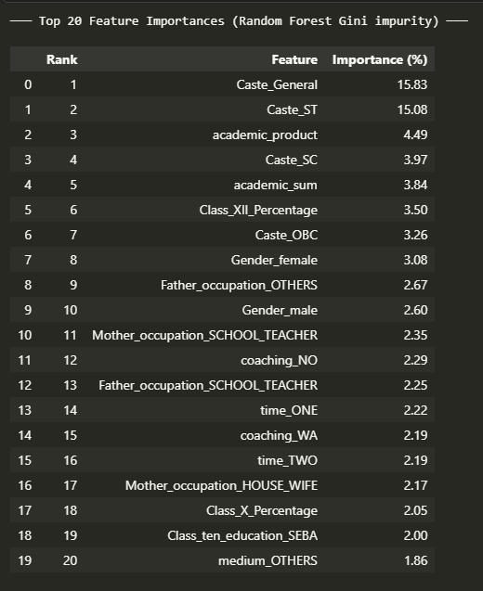

Figure 5.1. Top 20 Feature Importances of the Random Forest Classifier

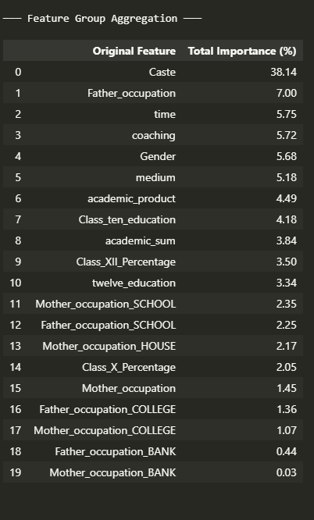

Figure 5.2. Feature Group Aggregation – Total Importance (%) per Original Feature

Evaluation of Model Performance
The third objective was to evaluate the performance of the trained model based on accuracy, F1 score (precision and recall), and confusion matrix. Model evaluation was conducted on the 20% holdout test set (n=134) that was set aside before SMOTE resampling, ensuring that the test set contains only original, unaugmented student records to provide an unbiased performance estimate.
Table 8
Performance of the Random Forest Classifier on the Test Set (n=134)
Metric | Value
Accuracy | 74.63%
Precision (Macro-Averaged) | 76.2%
Recall (Macro-Averaged) | 75.8%
F1 Score (Macro-Averaged) | 74.7%
Precision – Higher-Performance Band (Excellent/Vg) | 66.7%
Recall – Higher-Performance Band (Excellent/Vg) | 86.7%
F1 Score – Higher-Performance Band (Excellent/Vg) | 75.4%
Precision – Support-Needed Band (Good/Average) | 85.7%
Recall – Support-Needed Band (Good/Average) | 64.9%
F1 Score – Support-Needed Band (Good/Average) | 73.9%

Table 8 presents the performance of the Random Forest Classifier on the test set. The model achieved an overall accuracy of 74.63%, correctly classifying 100 of 134 test records. The macro-averaged precision, recall, and F1 score were 76.2%, 75.8%, and 74.7%, respectively, indicating balanced performance across both performance bands.

At the per-class level, the model demonstrated notably high recall of 86.7% for the Higher-Performance Band, meaning that it correctly identified 52 of 60 students belonging to the Excellent or Very Good category. This strong sensitivity is particularly valuable in the academic prediction context, as it ensures that high-performing students are correctly recognized. The Support-Needed Band achieved high precision of 85.7%, indicating that when the model classifies a student into the Good or Average band, it is correct in 85.7% of cases, which reduces the risk of incorrectly flagging higher-performing students as needing academic intervention.

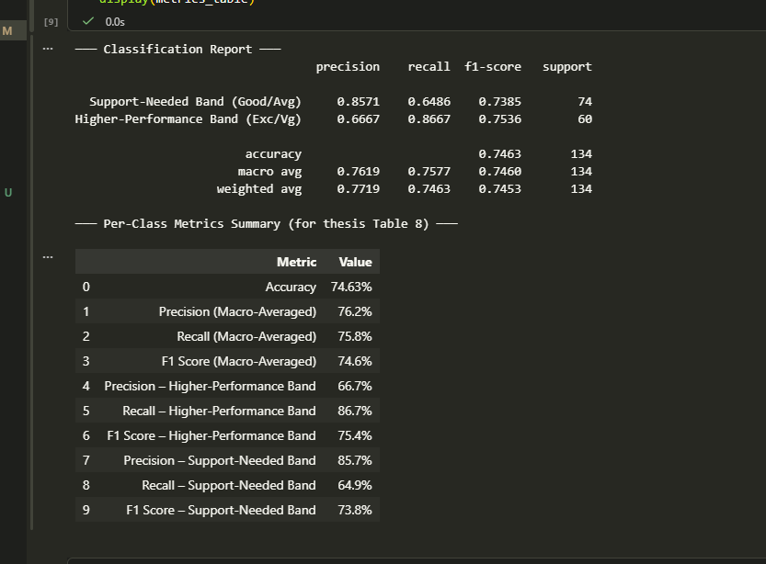

Figure 5.3. Classification Report and Per-Class Metrics Summary of the Random Forest Classifier
Table 9

Confusion Matrix of the Random Forest Classifier on the Test Set (n=134)
 | Predicted: Support-Needed Band | Predicted: Higher-Performance Band
Actual: Support-Needed Band (Good/Average) | 48 (True Negative) |  | 26 (False Positive)
Actual: Higher-Performance Band (Excellent/Vg) | 8 (False Negative) |  | 52 (True Positive)

Table 9 presents the confusion matrix of the Random Forest Classifier. Out of 134 test samples, 100 were correctly classified—48 true negatives and 52 true positives. The 34 misclassifications consisted of 26 false positives and 8 false negatives. The lower false negative count (8) relative to false positives (26) confirms the model's high sensitivity toward the Higher-Performance Band. The false positives indicate cases where students in the Support-Needed Band were incorrectly predicted as Higher-Performance, which may be attributable to the distributional overlap between the two bands—particularly among students with Vg-level Senior High School grades who ultimately performed at the Good level in the entrance examination. Overall, the model's performance at 74.63% accuracy and balanced macro-F1 of 74.7% fulfills Objective 3 and demonstrates that the Random Forest Classifier is a viable tool for entrance examination performance prediction based on student profile data.

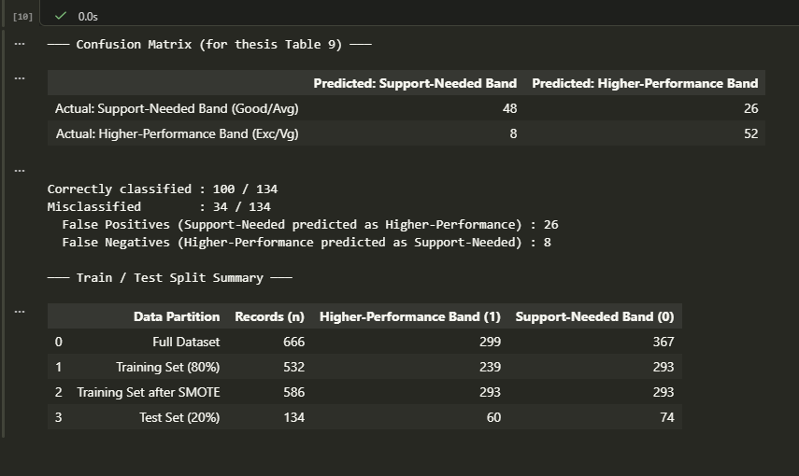

Figure 5.4. Confusion Matrix and Train/Test Split Summary of the Random Forest Classifier

UI/UX Dashboard Implementation
The fourth objective was to design a UI/UX dashboard to predict student performance. The researchers developed and deployed a web-based dashboard accessible through any modern browser. The interface is designed to be intuitive for student users and fully responsive across desktop and mobile devices.
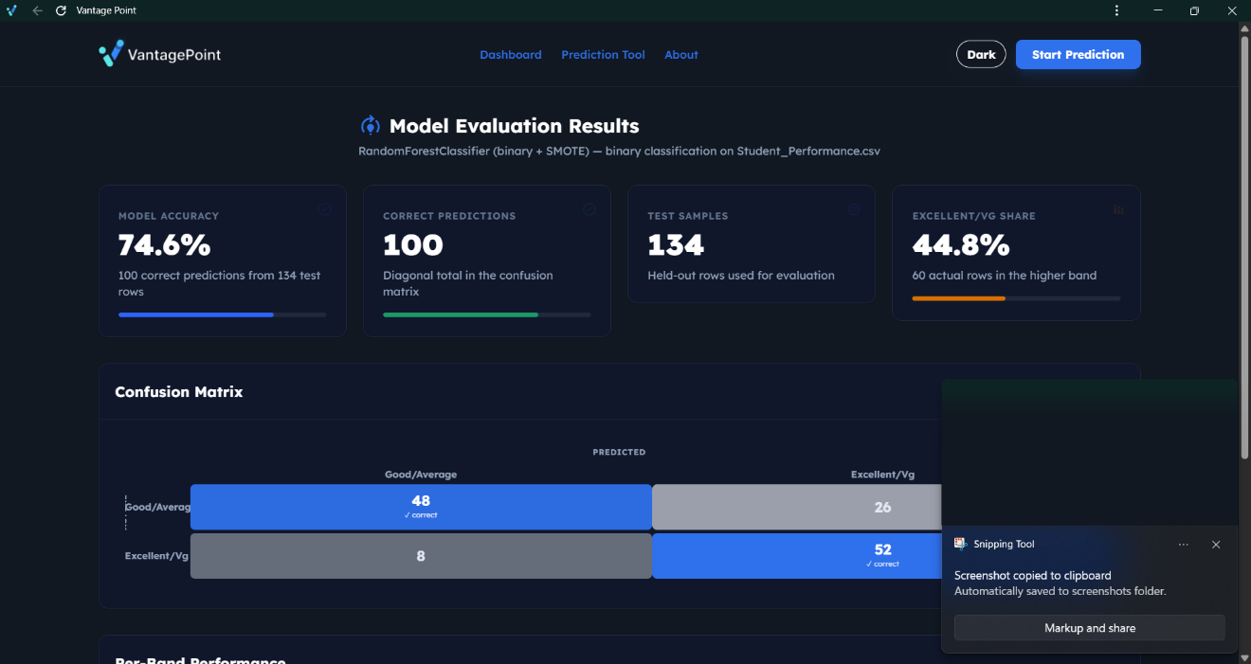
Figure 5.5. Homepage of the Web-Based Student Performance Prediction System
Figure 5.5 presents the homepage of the system. The homepage provides an overview of the system's purpose and navigates users to the prediction form. The dashboard includes several key components: a student profile input form, a prediction results panel, a model performance metrics panel, and a contextual academic guidance section.

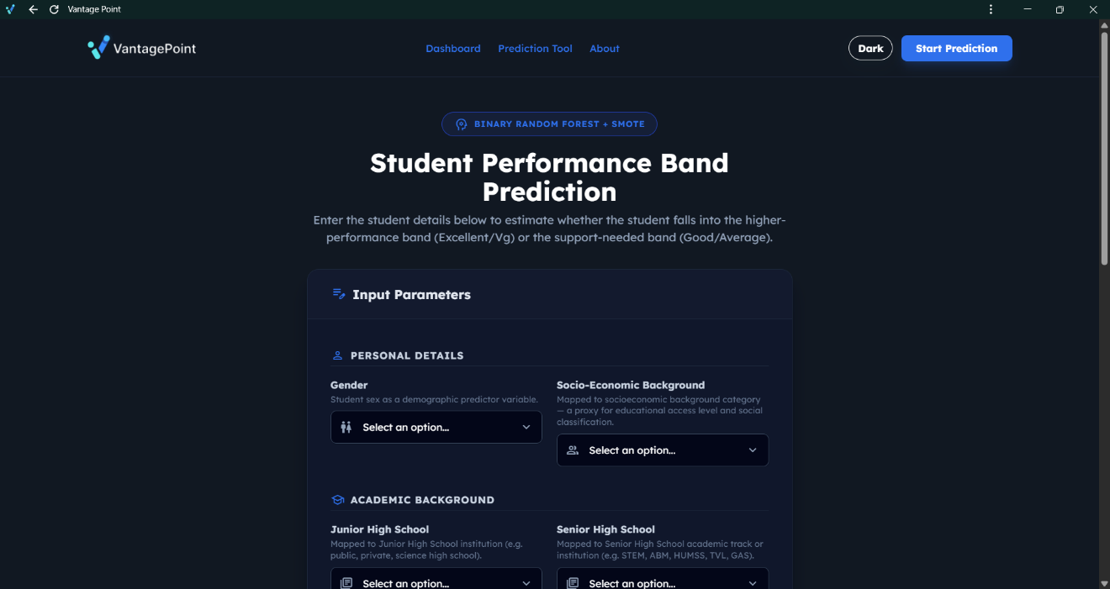
Figure 5.6. Student Profile Input Form of the Web-Based Student Performance Prediction System
Figure 5.6 presents the student profile input form. The form collects information across several sections: demographic information (gender and socioeconomic background), academic history (Junior High School and Senior High School grade bands and institution types), family background (father's and mother's occupations), and preparation profile (language of instruction, review program participation, and daily study time). Each input field includes descriptive labels and contextual hints to guide users through the form accurately. Users select their inputs from dropdown menus that present Philippine-contextualized labels corresponding to the mapped dataset categories.


Figure 5.7. Prediction Result Page of the Web-Based Student Performance Prediction System
Figure 5.7 presents the prediction result page. Upon submitting the student profile form, the system displays the predicted performance band—either Excellent/Very Good (Higher-Performance Band) or Good/Average (Support-Needed Band)—accompanied by an animated circular gauge that visualizes the model's confidence score as a percentage. A color-coded indicator distinguishes between the two bands: green for the Higher-Performance Band and amber for the Support-Needed Band. Below the prediction result, the panel presents the model's performance metrics—accuracy, precision, recall, and F1 score—alongside the confusion matrix, enabling users to contextualize the prediction within the model's known reliability. Contextual academic guidance is displayed beneath the metrics panel, providing tailored recommendations based on the predicted band.
The interface's clean, card-based layout and structured metrics presentation ensure that students can interpret both the predicted performance band and the underlying model reliability without requiring technical expertise. This design addresses the goal of producing a dashboard that promotes academic awareness and supports data-driven academic planning.

CHAPTER 6
CONCLUSION AND RECOMMENDATIONS

This study aimed to design and develop a Student Academic Performance Prediction System using classification techniques, particularly the Decision Tree Algorithm. The primary goal was to provide an efficient, reliable, and user-friendly system that can assist educators in predicting the performance of students in entrance examinations.
The findings revealed that the use of structured datasets significantly contributes to the effectiveness of predictive modeling. The collected data, which included academic performance indicators such as General Average (GA), General Weighted Average (GWA), strand, and school type, Coaching support and weekly study hours was used to train and validate the classification model. This ensured that the input features were relevant and that the model could produce meaningful predictions.
Furthermore, the implementation of classification algorithms, including Decision Tree, Random Forest, and Gradient Boosting, enabled the system to identify patterns and relationships within the dataset. These models effectively classified student performance into categories such as Qualified, Waiting List, and Not Qualified. The use of multiple algorithms also allowed comparison of model performance, leading to improved prediction reliability.
Evaluation metrics such as Accuracy, Precision, Recall, F1 Score, and Confusion Matrix were used to assess the effectiveness of the model. The results demonstrated that the system provides acceptable predictive performance, making it suitable for academic use. The Confusion Matrix, in particular, offered insights into classification errors and helped identify areas for improvement.
In addition, the development of the VantagePoint system provided a user-friendly interface that allows educators to input student data and receive predictions in real time. The interface also displays evaluation metrics, promoting transparency and trust in the system. This confirms that usability is a critical factor in the successful adoption of technology in education.
Finally, the integration of machine learning with web technologies demonstrated the practical application of predictive analytics in real-world scenarios. The system reduces manual workload, speeds up evaluation processes, and supports early identification of at-risk students, enabling timely intervention.

Conclusions
Based on the findings, the study concludes that the development of a Student Academic Performance Prediction System is both feasible and beneficial. The use of classification algorithms provides a reliable approach to analyzing and predicting student performance.
The use of Decision Tree and ensemble methods proves effective due to their ability to generate accurate and interpretable predictions. This is particularly important in educational settings, where transparency is required for decision-making. Educators can understand how predictions are made, increasing confidence in the system.
The study also highlights the importance of structured and high-quality data. The accuracy of predictions largely depends on the completeness and consistency of the dataset. Therefore, proper preparation and preprocessing of training data is essential for achieving reliable outcomes.
Moreover, the implementation of a user-friendly interface ensures that the system is accessible and practical for educators. The ability to generate real-time predictions improves efficiency and supports data-driven decision-making in the admissions process.
However, the study acknowledges certain limitations. The model does not account for external factors such as emotional, psychological, and environmental influences that may affect student performance. Additionally, the system is designed specifically for NWSSU and may require adjustments when applied to other institutions.
Overall, the study demonstrates that predictive analytics can significantly enhance academic evaluation processes when combined with proper data management and user-centered design.

Recommendations
Based on the conclusions, several recommendations are proposed to enhance the system and guide future research:
- Future studies should expand the dataset by including additional variables such as attendance, study habits, and behavioral factors to improve prediction accuracy.

- Researchers are encouraged to explore advanced machine learning models such as Neural Networks and Support Vector Machines for comparison and improvement.
- Continuous updating and retraining of the model should be implemented to ensure that predictions remain accurate over time.
- The system should be integrated with existing institutional platforms to streamline data entry and improve operational efficiency.
- Enhancements in the user interface, including dashboards and graphical visualizations, should be developed to improve user experience.
- Strong data security measures, including encryption and access control, must be implemented to protect sensitive student information.
- Future systems may incorporate real-time analytics to provide dynamic monitoring of student performance.
- The system should be tested in other educational institutions to evaluate its adaptability and generalizability.
- The prediction system should be used as a decision-support tool rather than a replacement for human judgment.
- Ethical considerations, including data privacy and algorithm bias, should be addressed in future developments.

REFERENCES
Cain, J., Medina, M., Romanelli, F., & Persky, A. (2021). Deficiencies of traditional grading systems and recommendations for the future. American Journal of Pharmaceutical Education, 85(6), 823–835. https://doi.org/10.5688/ajpeXXXX
Pham Xuan Lam, P., Phan Quoc Hung Mai, P., Quang Hung Nguyen, Q., Thao Pham, T., Thi Hong Hanh Nguyen, T., & Thi Huyen Nguyen, T. (2024). Enhancing educational evaluation through predictive student assessment modeling. Computers and Education: Artificial Intelligence, 6, 100244. https://doi.org/10.1016/j.caeai.2024.100244
Adnan, M., et al. (2021). Predicting at-risk students at different percentages of course length for early intervention using machine learning models. IEEE Access, 9,7519–7539.
Zhou, F., & Agarwal, N. (2024). Student performance prediction based on decision trees. Journal of Research in Applied Mathematics, 10(12), 114–120.
https://www.questjournals.org/jram/papers/v10-i12/1012114120.pdf
Hasan, R., Palaniappan, S., Raziff, A. R. A., Mahmood, S., & Sarker, K. U. (2018). Student academic performance prediction by using decision tree algorithm. 4th International Conference on Computer and Information Sciences (ICCOINS),1–5. https://ieeexplore.ieee.org/abstract/document/8510600
Hoque, M. I., Azad, A. K., Tuhin, M. A. H., & Salehin, Z. U. (2020). University students result analysis and prediction system by decision tree algorithm. Advances in Science, Technology and Engineering Systems Journal, 5, 115–122.
https://www.researchgate.net/publication/341128685_University_Students_Result_Analysis_and_Prediction_System_by_Decision_Tree_Algorithm
Hamoud, A., Hashim, A. S., & Awadh, W. A. (2018). Predicting student performance in higher education institutions using decision tree analysis. International Journal of Interactive Multimedia and Artificial Intelligence, 5, 26–31.
https://papers.ssrn.com/sol3/papers.cfm?abstract_id=3243704
Kolo, D. K., & Adepoju, S. A. (2015). A decision tree approach for predicting student’s academic performance.
http://irepo.futminna.edu.ng:8080/jspui/handle/123456789/5782
Cheewaprakobkit, P. (2015). Predicting student academic achievement by using the decision tree and neural network techniques. Catalyst, 12(2), 34–43.
https://www.researchgate.net/.../The-Correlation-Between-Students-Academic-Achievement...
Shovon, M. H. I., & Haque, M. (2012). An approach of improving students academic performance by using K-means clustering algorithm and decision tree. arXiv:1211.6340.
https://arxiv.org/abs/1211.6340
Wang, G. H., Zhang, J., & Fu, G. S. (2018). Predicting student behaviors and performance in online learning using decision tree. 7th International Conference of Educational Innovation through Technology (EITT), 214–219.
https://ieeexplore.ieee.org/abstract/document/8719547
Rose, J. D., Vijayakumar, K., & Sakthivel, S. (2019). Students’ performance analysis system using cumulative predictor algorithm. International Journal of Reasoning-based Intelligent Systems, 11(2), 122–133.
https://www.inderscienceonline.com/doi/abs/10.1504/IJRIS.2019.099848
Kumar, S. A. (2011). Efficiency of decision trees in predicting student’s academic performance.
https://www.csitcp.org/paper/1/12csit30.pdf
Pandey, M., & Sharma, V. K. (2013). A decision tree algorithm pertaining to the student performance analysis and prediction. IJCA, 61(13), 1–5.
https://d1wqtxts1xzle7.cloudfront.net/...Decision_Tree_Algorithm_Pertaining_to.pdf
Muraina, I. O., Aiyegbusi, E., & Abam, S. (2022). Decision tree algorithm use in predicting students’ academic performance in advanced programming course. IJHEP,3(4),13–23. https://www.diamondopen.com/journals/index.php/ijhep/article/view/274

Olaniyi, A. S., et al. (2017). Student’s performance analysis using decision tree algorithms. Annals Computer Science Series, 15(1), 55–62.
https://anale-informatica.tibiscus.ro/download/lucrari/15-1-07-Olaniyi.pdf
Hamoud, A. (2016). Selection of best decision tree algorithm for prediction and classification of students’ action. AIJRSTM, 16(1), 26–32.
https://papers.ssrn.com/sol3/papers.cfm?abstract_id=3027086
Mesarić, J., & Šebalj, D. (2016). Decision trees for predicting the academic success of students. Croat. Oper. Res. Rev., 7(2), 367–388.
https://hrcak.srce.hr/clanak/257113
Acharya, K. (2023). Teachers record management system project report.
https://journals.stecab.com/sjet/article/view/424
Ugalingan, N., & Antonio, E. (2025). SRSYS: A web-based solution for efficient school record management. Aloysian Interdisciplinary Journal, 1(5), 83–93.
https://journals.aloysianpublications.com/index.php/articles/article/view/102
Salama, W. M., & Aly, M. H. (2024). Web-based integrated school management system for enhanced student–teacher and resource accessibility. ICCTA, 115–122.
https://ieeexplore.ieee.org/abstract/document/10974894

Nimy, E., Mosia, M., & Chibaya, C. (2023). Identifying at-risk students for early intervention—a probabilistic machine learning approach. Applied Sciences, 13(6), 3869.
https://www.mdpi.com/2076-3417/13/6/3869
Cao, W., & Mai, N. (2025). Predictive analytics for student success: AI-driven early warning systems. ERHD, 2(2), 36–48.
http://www.upubscience.com/upload/20250808150514.pdf
Adnan, M., et al. (2021). Predicting at-risk students at different percentages of course length for early intervention using machine learning models. IEEE Access, 9,7519–7539.
https://ieeexplore.ieee.org/abstract/document/9314000
Hung, J. L., et al. (2015). Identifying at-risk students for early interventions—a time-series clustering approach. IEEE TETC, 5(1), 45–55.
https://ieeexplore.ieee.org/abstract/document/7339455
Al-Shabandar, R., et al. (2019). Detecting at-risk students with early interventions using machine learning techniques. IEEE Access, 7, 149464–149478.
https://ieeexplore.ieee.org/abstract/document/8847304

Appendix A
Relevant Source Code

PREDICTION

from fastapi import FastAPI
from pydantic import BaseModel
from typing import Literal
import joblib
import pandas as pd
import uvicorn

app = FastAPI()
model_artifact = joblib.load("student_performance_model.pkl")

# --- Preprocessing constants (must match the notebook exactly) ---
ORDINAL_MAPPING = {
"Average": 1,
"Good": 2,
"Vg": 3,
"Excellent": 4,
}

if isinstance(model_artifact, dict):
model = model_artifact["model"]
feature_columns = model_artifact["feature_columns"]
CLASS_LABELS = {
int(key): value
for key, value in model_artifact.get("class_labels", {}).items()
}
else:
model = model_artifact
feature_columns = list(model.feature_names_in_)
CLASS_LABELS = {1: "Excellent/Vg", 0: "Good/Average"}

CATEGORICAL_COLS = [
"Gender", "Caste", "coaching", "Class_ten_education",
"twelve_education", "medium", "Father_occupation", "Mother_occupation",
"time",
]

class StudentData(BaseModel):
Gender: Literal["male", "female"]
Caste: Literal["General", "OBC", "SC", "ST"]
coaching: Literal["NO", "WA", "OA"]
Class_ten_education: Literal["SEBA", "OTHERS", "CBSE"]
twelve_education: Literal["AHSEC", "CBSE", "OTHERS"]
medium: Literal["ENGLISH", "OTHERS", "ASSAMESE"]
Class_X_Percentage: Literal["Excellent", "Vg", "Good", "Average"]
Class_XII_Percentage: Literal["Excellent", "Vg", "Good", "Average"]
Father_occupation: Literal[
"DOCTOR", "SCHOOL_TEACHER", "BUSINESS", "COLLEGE_TEACHER",
"OTHERS", "BANK_OFFICIAL", "ENGINEER", "CULTIVATOR"
]
Mother_occupation: Literal[
"DOCTOR", "SCHOOL_TEACHER", "BUSINESS", "COLLEGE_TEACHER",
"OTHERS", "BANK_OFFICIAL", "ENGINEER", "CULTIVATOR", "HOUSE_WIFE"
]
time: Literal["ONE", "TWO", "THREE", "FOUR", "FIVE", "SIX", "SEVEN"]

@app.post("/predict")
def predict_performance(data: StudentData):
payload = data.model_dump()
print("Received data:", payload)
df = pd.DataFrame([payload])

# 1. Apply ordinal mappings (same as training notebook)
df["Class_X_Percentage"] = df["Class_X_Percentage"].astype(str).map(ORDINAL_MAPPING)
df["Class_XII_Percentage"] = df["Class_XII_Percentage"].astype(str).map(ORDINAL_MAPPING)
if df[["Class_X_Percentage", "Class_XII_Percentage"]].isnull().any().any():
raise ValueError("Unexpected grade band received by the prediction service.")

df[["Class_X_Percentage", "Class_XII_Percentage"]] = df[
["Class_X_Percentage", "Class_XII_Percentage"]
].astype(int)

# 2. Feature engineering (must mirror train.py)
df["academic_sum"] = df["Class_X_Percentage"] + df["Class_XII_Percentage"]
df["academic_product"] = (
df["Class_X_Percentage"] * df["Class_XII_Percentage"]
)

# 3. One-hot encode every categorical input with the same settings as training.
df_encoded = pd.get_dummies(
df,
columns=CATEGORICAL_COLS,
drop_first=False,
dtype=int,
)

# 4. Align columns to match exactly what the model was trained on
# (reindex adds any missing dummy columns as 0)
df_aligned = df_encoded.reindex(columns=feature_columns, fill_value=0)

# 5. Predict binary class and confidence
prediction = int(model.predict(df_aligned)[0])
proba = model.predict_proba(df_aligned)[0]
confidence = round(float(proba[prediction]) * 100, 2)

return {
"result": prediction,
"label": CLASS_LABELS[prediction],
"confidence": confidence,
}

if __name__ == "__main__":
uvicorn.run("main:app", host="0.0.0.0", port=8006, reload=True)

import pandas as pd
import json
import joblib
from imblearn.over_sampling import SMOTE
from sklearn.ensemble import RandomForestClassifier
from sklearn.metrics import accuracy_score, confusion_matrix
from sklearn.model_selection import train_test_split

df = pd.read_csv('Student_Performance.csv')

df = pd.read_csv('Student_Performance.csv').copy()

# Map ordinal grade bands for the two academic percentage columns
ordinal_mapping = {
'Average': 1,
'Good': 2,
'Vg': 3,
'Excellent': 4,
}

# Convert the target into a binary outcome
target_mapping = {
'Average': 0,
'Good': 0,
'Vg': 1,
'Excellent': 1,
}

df['Class_X_Percentage'] = df['Class_X_Percentage'].astype(str).map(ordinal_mapping)
df['Class_XII_Percentage'] = df['Class_XII_Percentage'].astype(str).map(ordinal_mapping)
df['Performance'] = df['Performance'].astype(str).map(target_mapping)

mapped_columns = ['Class_X_Percentage', 'Class_XII_Percentage', 'Performance']
if df[mapped_columns].isnull().any().any():
raise ValueError('Unexpected category found while mapping the target or ordinal features.')

df[mapped_columns] = df[mapped_columns].astype(int)

# Compact interactions between the two ordinal academic signals
df['academic_sum'] = df['Class_X_Percentage'] + df['Class_XII_Percentage']
df['academic_product'] = df['Class_X_Percentage'] * df['Class_XII_Percentage']

# One-hot encode every remaining text feature
categorical_cols = [
'Gender',
'Caste',
'coaching',
'Class_ten_education',
'twelve_education',
'medium',
'Father_occupation',
'Mother_occupation',
'time',
]
df_encoded = pd.get_dummies(df, columns=categorical_cols, drop_first=False, dtype=int)

X = df_encoded.drop('Performance', axis=1)
y = df_encoded['Performance']

X_train, X_test, y_train, y_test = train_test_split(
X,
y,
test_size=0.2,
random_state=42,
stratify=y,
)

smote = SMOTE(random_state=42)
X_train_balanced, y_train_balanced = smote.fit_resample(X_train, y_train)

print('Training class distribution before SMOTE:')
print(y_train.value_counts().sort_index())
print('Training class distribution after SMOTE:')
print(y_train_balanced.value_counts().sort_index())

model = RandomForestClassifier(
n_estimators=500,
max_depth=10,
min_samples_split=5,
min_samples_leaf=2,
class_weight='balanced',
random_state=42,
n_jobs=-1,
)

model.fit(X_train_balanced, y_train_balanced)

model_artifact = {
'model_name': 'RandomForestClassifier (binary + SMOTE)',
'model_mode': 'binary_classification',
'model': model,
'feature_columns': X_train_balanced.columns.tolist(),
'class_labels': {0: 'Good/Average', 1: 'Excellent/Vg'},
}

joblib.dump(model_artifact, 'student_performance_model.pkl')
print("Model saved as 'student_performance_model.pkl'")

y_pred = model.predict(X_test)

accuracy = accuracy_score(y_test, y_pred)
conf_matrix = confusion_matrix(y_test, y_pred)

print(f"Final accuracy: {accuracy:.4f}")

evaluation_json = {
'model_name': 'RandomForestClassifier (binary + SMOTE)',
'dataset_source': 'Student_Performance.csv',
'task_type': 'binary_classification',
'target_mapping': {
'Excellent': 1,
'Vg': 1,
'Good': 0,
'Average': 0,
},
'metrics': {
'accuracy': float(f"{accuracy:.4f}"),
},
'confusion_matrix': conf_matrix.tolist(),
'class_labels': {
'0': 'Good/Average',
'1': 'Excellent/Vg',
},
}

with open('evaluation_json.json', 'w') as f:
json.dump(evaluation_json, f, indent=4)

print("Evaluation saved to 'evaluation_json.json'")

FRONTEND

import { createFileRoute, useNavigate } from "@tanstack/react-router";
import { type FormEvent, useEffect, useState } from "react";

export const Route = createFileRoute("/predict")({
component: PredictPage,
});

type FormState = {
Gender: string;
Caste: string;
coaching: string;
Class_ten_education: string;
twelve_education: string;
medium: string;
Class_X_Percentage: string;
Class_XII_Percentage: string;
Father_occupation: string;
Mother_occupation: string;
time: string;
};

const INITIAL: FormState = {
Gender: "",
Caste: "",
coaching: "",
Class_ten_education: "",
twelve_education: "",
medium: "",
Class_X_Percentage: "",
Class_XII_Percentage: "",
Father_occupation: "",
Mother_occupation: "",
time: "",
};

const occupations = [
"CULTIVATOR",
"SCHOOL_TEACHER",
"COLLEGE_TEACHER",
"BUSINESS",
"DOCTOR",
"ENGINEER",
"BANK_OFFICIAL",
"OTHERS",
];

const casteOptions = [
{ value: "General", label: "Open / General Category" },
{ value: "OBC", label: "Community Support Category (OBC)" },
{ value: "SC", label: "Marginalized Group Category (SC)" },
{ value: "ST", label: "Indigenous Group Category (ST)" },
];

const classTenOptions = [
{ value: "SEBA", label: "Public / Regional Board (SEBA)" },
{ value: "CBSE", label: "National / Private Board (CBSE)" },
{ value: "OTHERS", label: "Other Junior High Board" },
];

const classTwelveOptions = [
{ value: "AHSEC", label: "Regional Senior High Board (AHSEC)" },
{ value: "CBSE", label: "National / Private Board (CBSE)" },
{ value: "OTHERS", label: "Other Senior High Board" },
];

const mediumOptions = [
{ value: "ENGLISH", label: "English Medium" },
{ value: "ASSAMESE", label: "Regional Language Medium" },
{ value: "OTHERS", label: "Other Language Medium" },
];

const gradeOptions = [
{ value: "Excellent", label: "Outstanding (Excellent, >= 80%)" },
{ value: "Vg", label: "Very Satisfactory (Vg, 60-79%)" },
{ value: "Good", label: "Satisfactory (Good, 45-59%)" },
{ value: "Average", label: "Needs Support (Average, < 45%)" },
];

const occupationLabels: Record<string, string> = {
CULTIVATOR: "Farmer / Cultivator",
SCHOOL_TEACHER: "Basic Education Teacher",
COLLEGE_TEACHER: "College Instructor",
BUSINESS: "Business Owner",
DOCTOR: "Doctor",
ENGINEER: "Engineer",
BANK_OFFICIAL: "Bank Officer",
OTHERS: "Other Occupation",
HOUSE_WIFE: "Homemaker",
};

const coachingOptions = [
{ value: "NO", label: "No Review Program" },
{ value: "WA", label: "Weekly Review Sessions" },
{ value: "OA", label: "Occasional Review Sessions" },
];

const studyTimeOptions = [
{ value: "ONE", label: "About 1 hour" },
{ value: "TWO", label: "About 2 hours" },
{ value: "THREE", label: "About 3 hours" },
{ value: "FOUR", label: "About 4 hours" },
{ value: "FIVE", label: "About 5 hours" },
{ value: "SIX", label: "About 6 hours" },
{ value: "SEVEN", label: "About 7 hours or more" },
];

function SelectField({
id,
label,
hint,
icon,
value,
onChange,
options,
placeholder = "Select an option...",
}: {
id: keyof FormState;
label: string;
hint?: string;
icon: string;
value: string;
onChange: (val: string) => void;
options: { value: string; label: string }[];
placeholder?: string;
}) {
return (
<div className="space-y-2">
<div>
<label
htmlFor={id}
className="block text-sm font-semibold text-slate-700 dark:text-slate-300"
>
{label}
</label>
{hint && (
<p className="text-xs text-slate-400 dark:text-slate-500 mt-0.5 m-0">
{hint}
</p>
)}
</div>
<div className="relative">
<select
id={id}
required
value={value}
onChange={(e) => onChange(e.target.value)}
className="block w-full rounded-lg border border-slate-300 dark:border-slate-700 bg-white dark:bg-slate-950 text-slate-900 dark:text-white shadow-sm focus:border-primary focus:ring-1 focus:ring-primary text-sm py-3 px-4 pl-11 appearance-none transition-shadow"
>
<option value="" disabled>
{placeholder}
</option>
{options.map((o) => (
<option key={o.value} value={o.value}>
{o.label}
</option>
))}
</select>
<div className="absolute inset-y-0 left-0 pl-3 flex items-center pointer-events-none">
<span className="material-symbols-outlined text-slate-400 text-xl">
{icon}
</span>
</div>
<div className="absolute inset-y-0 right-0 pr-3 flex items-center pointer-events-none">
<span className="material-symbols-outlined text-slate-400 text-sm">
expand_more
</span>
</div>
</div>
</div>
);
}

function SectionHeading({ icon, title }: { icon: string; title: string }) {
return (
<div className="flex items-center gap-2 pt-2 pb-1 border-b border-slate-100 dark:border-slate-800">
<span className="material-symbols-outlined text-primary text-xl">
{icon}
</span>
<h4 className="text-sm font-bold text-slate-700 dark:text-slate-300 uppercase tracking-wider m-0">
{title}
</h4>
</div>
);
}

function PredictPage() {
const navigate = useNavigate();
const [form, setForm] = useState<FormState>(INITIAL);
const [loading, setLoading] = useState(false);
const [error, setError] = useState<string | null>(null);

const set = (key: keyof FormState) => (val: string) =>
setForm((prev) => ({ ...prev, [key]: val }));

const handleSubmit = async (e: FormEvent) => {
e.preventDefault();
setLoading(true);
setError(null);

// Store form data in sessionStorage for result page sidebar
sessionStorage.setItem("arborFormData", JSON.stringify(form));

try {
const res = await fetch("/vantage-api/predict", {
method: "POST",
headers: { "Content-Type": "application/json" },
body: JSON.stringify(form),
});

if (!res.ok) {
const err = await res
.json()
.catch(() => ({ message: "Prediction failed" }));
setError(err.message ?? "Prediction failed");
return;
}

const data = await res.json();
const { result, label, confidence } = data.prediction;

navigate({
to: "/result",
search: { result, label, confidence },
});
} catch (err) {
setError(
err instanceof Error ? err.message : "Could not reach backend",
);
} finally {
setLoading(false);
}
};

useEffect(() => {
const init = async () => {
// Check if user came from result page with form data in sessionStorage
const stored = sessionStorage.getItem("arborFormData");
if (stored) {
setForm(JSON.parse(stored));
sessionStorage.removeItem("arborFormData");
}
};

init();
}, []);

return (
<main className="flex-1 flex flex-col items-center justify-center px-4 py-8 sm:py-12 rise-in">
<div className="w-full max-w-2xl">
{/* Page intro */}
<div className="mb-6 text-center sm:mb-8">
<div className="inline-flex items-center gap-2 rounded-full bg-blue-50 dark:bg-blue-900/20 px-4 py-1.5 border border-blue-100 dark:border-blue-800 mb-4">
<span className="material-symbols-outlined text-primary text-sm">
psychology
</span>
<span className="text-primary text-xs font-bold uppercase tracking-wider">
Binary Random Forest + SMOTE
</span>
</div>
<h1 className="mb-2 mt-0 text-2xl font-bold text-slate-900 dark:text-white sm:text-3xl md:text-4xl">
Student Performance Band Prediction
</h1>
<p className="text-slate-500 dark:text-slate-400 text-sm md:text-base">
Enter the student details below to estimate whether the
student falls into the higher-performance band
(Excellent/Vg) or the support-needed band
(Good/Average).
</p>
</div>

{/* Form card */}
<div className="bg-white dark:bg-slate-900 rounded-2xl shadow-xl shadow-slate-200/50 dark:shadow-slate-950/50 border border-slate-200 dark:border-slate-800 overflow-hidden">
<div className="border-b border-slate-100 bg-slate-50/50 px-5 py-4 dark:border-slate-800 dark:bg-slate-800/20 sm:px-8 sm:py-5">
<h3 className="font-bold text-slate-800 dark:text-slate-200 text-lg flex items-center gap-2 m-0">
<span className="material-symbols-outlined text-primary">
edit_note
</span>
Input Parameters
</h3>
</div>

<div className="p-5 sm:p-8">
<form
onSubmit={handleSubmit}
className="space-y-6 sm:space-y-7"
>
{/* Personal Details */}
<div className="space-y-4">
<SectionHeading
icon="person"
title="Personal Details"
/>
<div className="grid grid-cols-1 md:grid-cols-2 gap-5">
<SelectField
id="Gender"
label="Gender"
hint="Student sex as a demographic predictor variable."
icon="wc"
value={form.Gender}
onChange={set("Gender")}
options={[
{ value: "male", label: "Male" },
{
value: "female",
label: "Female",
},
]}
/>
<SelectField
id="Caste"
label="Caste / Category"
hint="Mapped to socioeconomic background category — a proxy for educational access level and social classification."
icon="group"
value={form.Caste}
onChange={set("Caste")}
options={casteOptions}
/>
</div>
</div>

{/* Academic Background */}
<div className="space-y-4">
<SectionHeading
icon="school"
title="Academic Background"
/>
<div className="grid grid-cols-1 md:grid-cols-2 gap-5">
<SelectField
id="Class_ten_education"
label="Class X Education Board"
hint="Mapped to Junior High School institution type (e.g. public, private, science high school)."
icon="library_books"
value={form.Class_ten_education}
onChange={set("Class_ten_education")}
options={classTenOptions}
/>
<SelectField
id="twelve_education"
label="Class XII Education Board"
hint="Mapped to Senior High School academic track or institution type (e.g. STEM, ABM, HUMSS, TVL, GAS)."
icon="library_books"
value={form.twelve_education}
onChange={set("twelve_education")}
options={classTwelveOptions}
/>
<SelectField
id="medium"
label="Medium of Instruction"
hint="Primary language used during previous schooling. May influence comprehension in the entrance exam."
icon="translate"
value={form.medium}
onChange={set("medium")}
options={mediumOptions}
/>
<SelectField
id="Class_X_Percentage"
label="Class X Percentage Grade"
hint="Mapped to Junior High School general average."
icon="grade"
value={form.Class_X_Percentage}
onChange={set("Class_X_Percentage")}
options={gradeOptions}
/>
<SelectField
id="Class_XII_Percentage"
label="Class XII Percentage Grade"
hint="Mapped to Senior High School general average."
icon="grade"
value={form.Class_XII_Percentage}
onChange={set("Class_XII_Percentage")}
options={gradeOptions}
/>
</div>
</div>

{/* Parents' Occupation */}
<div className="space-y-4">
<SectionHeading
icon="work"
title="Parents' Occupation"
/>
<div className="grid grid-cols-1 md:grid-cols-2 gap-5">
<SelectField
id="Father_occupation"
label="Father's Occupation"
hint="Father’s employment category — a socioeconomic indicator of access to educational resources."
icon="engineering"
value={form.Father_occupation}
onChange={set("Father_occupation")}
options={occupations.map((o) => ({
value: o,
label: occupationLabels[o] ?? o,
}))}
/>
<SelectField
id="Mother_occupation"
label="Mother's Occupation"
hint="Mother’s employment category — complements father’s occupation as an additional socioeconomic predictor."
icon="engineering"
value={form.Mother_occupation}
onChange={set("Mother_occupation")}
options={[
...occupations,
"HOUSE_WIFE",
].map((o) => ({
value: o,
label: occupationLabels[o] ?? o,
}))}
/>
</div>
</div>

{/* Study Habits */}
<div className="space-y-4">
<SectionHeading
icon="timer"
title="Study Habits"
/>
<div className="grid grid-cols-1 md:grid-cols-2 gap-5">
<SelectField
id="coaching"
label="Coaching Support"
hint="Mapped to entrance exam review participation — whether the student attended a formal review program."
icon="hub"
value={form.coaching}
onChange={set("coaching")}
options={coachingOptions}
/>
<SelectField
id="time"
label="Weekly Study Hours (approx.)"
hint="Mapped to preparation time allocation — reflects study intensity prior to the entrance examination."
icon="schedule"
value={form.time}
onChange={set("time")}
options={studyTimeOptions}
/>
</div>
</div>

{/* Error */}
{error && (
<div className="rounded-lg bg-red-50 dark:bg-red-900/20 border border-red-200 dark:border-red-800 p-4 text-sm text-red-700 dark:text-red-300 flex items-center gap-2">
<span className="material-symbols-outlined text-red-500 text-xl">
error
</span>
{error}
</div>
)}

{/* Submit */}
<div className="pt-2">
<button
type="submit"
disabled={loading}
className="group w-full flex items-center justify-center gap-2 rounded-xl bg-primary px-8 py-4 text-white shadow-lg shadow-primary/25 hover:bg-primary-dark hover:shadow-primary/40 transition-all active:scale-[0.98] disabled:opacity-60 disabled:cursor-not-allowed"
>
{loading ? (
<>
<span className="material-symbols-outlined animate-spin text-xl">
progress_activity
</span>
<span className="text-base font-bold">
Calculating...
</span>
</>
) : (
<>
<span className="text-base font-bold">
Predict Performance Band
</span>
<span className="material-symbols-outlined group-hover:translate-x-1 transition-transform">
arrow_forward
</span>
</>
)}
</button>
</div>
</form>
</div>

{/* Footer note */}
<div className="flex items-start gap-3 border-t border-slate-100 bg-slate-50 px-5 py-4 dark:border-slate-800 dark:bg-slate-800/40 sm:px-8">
<span className="material-symbols-outlined text-slate-400 text-sm mt-0.5">
info
</span>
<p className="text-xs text-slate-500 dark:text-slate-400 leading-relaxed m-0">
Predictions are estimates from the binary Random
Forest model. Each result groups the original target
classes into either Excellent/Vg or Good/Average and
should be used as academic guidance rather than a
final judgment.
</p>
</div>
</div>
</div>
</main>
);
}

import { createFileRoute, Link, useNavigate } from "@tanstack/react-router";
import { useEffect, useRef } from "react";
import { z } from "zod";

const predictionBandSchema = z.enum(["Good/Average", "Excellent/Vg"]);
type PredictionBand = z.infer<typeof predictionBandSchema>;

const searchSchema = z.object({
result: z.union([z.literal(0), z.literal(1)]),
label: predictionBandSchema,
confidence: z.number(),
});

export const Route = createFileRoute("/result")({
validateSearch: searchSchema,
component: ResultPage,
});

const labelConfig: Record<
PredictionBand,
{ bg: string; text: string; icon: string; iconColor: string; desc: string }
> = {
"Excellent/Vg": {
bg: "bg-green-100 dark:bg-green-900/30",
text: "text-green-700 dark:text-green-400",
icon: "emoji_events",
iconColor: "text-green-600 dark:text-green-400",
desc: "Higher-performance band predicted. This grouped class combines Excellent and Very Good outcomes.",
},
"Good/Average": {
bg: "bg-amber-100 dark:bg-amber-900/30",
text: "text-amber-700 dark:text-amber-400",
icon: "flag",
iconColor: "text-amber-600 dark:text-amber-400",
desc: "Support-needed band predicted. This grouped class combines Good and Average outcomes.",
},
};

const labelDisplayName: Record<PredictionBand, string> = {
"Excellent/Vg": "Excellent / Very Good",
"Good/Average": "Good / Average",
};

const resultToLabel: Record<0 | 1, PredictionBand> = {
0: "Good/Average",
1: "Excellent/Vg",
};

function GaugeCircle({ confidence }: { confidence: number }) {
const radius = 70;
const circumference = 2 * Math.PI * radius;
const offset = circumference * (1 - confidence / 100);
const circleRef = useRef<SVGCircleElement>(null);

useEffect(() => {
const el = circleRef.current;
if (!el) return;
// Animate from full offset to actual offset
el.style.strokeDashoffset = String(circumference);
requestAnimationFrame(() => {
requestAnimationFrame(() => {
el.style.transition =
"stroke-dashoffset 1.2s cubic-bezier(0.4,0,0.2,1)";
el.style.strokeDashoffset = String(offset);
});
});
}, [circumference, offset]);

return (
<div className="relative flex flex-col items-center justify-center shrink-0">
<svg
className="w-40 h-40 transform -rotate-90"
viewBox="0 0 160 160"
>
<circle
cx="80"
cy="80"
r={radius}
fill="transparent"
stroke="currentColor"
strokeWidth="12"
className="text-slate-100 dark:text-slate-800"
/>
<circle
ref={circleRef}
cx="80"
cy="80"
r={radius}
fill="transparent"
stroke="#136dec"
strokeWidth="12"
strokeLinecap="round"
strokeDasharray={circumference}
strokeDashoffset={circumference}
/>
</svg>
<div className="absolute inset-0 flex flex-col items-center justify-center">
<span className="text-3xl font-bold text-slate-900 dark:text-white leading-none">
{confidence.toFixed(1)}%
</span>
<span className="text-xs text-slate-500 dark:text-slate-400 font-medium uppercase tracking-wide mt-0.5">
Confidence
</span>
</div>
</div>
);
}

function ResultPage() {
const navigate = useNavigate();
const { result, confidence } = Route.useSearch();

// Read form inputs back from sessionStorage
const storedForm = (() => {
try {
const raw = sessionStorage.getItem("arborFormData");
return raw ? JSON.parse(raw) : null;
} catch {
return null;
}
})();

const normalizedLabel = resultToLabel[result];
const config = labelConfig[normalizedLabel];
const displayName = labelDisplayName[normalizedLabel];

// Recommendations based on label
const recommendations: Record<PredictionBand, string[]> = {
"Excellent/Vg": [
"Maintain the current study rhythm and use mock tests to sharpen exam execution.",
"Focus on consistency and revision quality rather than broad remediation.",
],
"Good/Average": [
"Prioritize structured coaching and a fixed weekly study schedule.",
"Rebuild core Class X and Class XII topics before moving to harder material.",
],
};

const tips = recommendations[normalizedLabel];

return (
<main className="flex-1 px-4 py-6 sm:py-10 rise-in">
<div className="page-wrap">
{/* Breadcrumb */}
<div className="mb-5 flex flex-wrap items-center gap-2 text-sm text-slate-500 dark:text-slate-400 sm:mb-6">
<button
onClick={() => navigate({ to: "/predict" })}
className="flex items-center gap-1 bg-transparent border-0 cursor-pointer p-0 text-slate-500 dark:text-slate-400 hover:text-primary dark:hover:text-primary text-sm transition-colors"
>
<span className="material-symbols-outlined text-lg">
arrow_back
</span>
Back to Inputs
</button>
<span>/</span>
<span className="text-slate-900 dark:text-white font-medium">
Prediction Result
</span>
</div>

<div className="grid grid-cols-1 gap-6 lg:grid-cols-3">
{/* Main result panel */}
<div className="lg:col-span-2 flex flex-col gap-6">
{/* Primary outcome card */}
<div className="relative overflow-hidden rounded-2xl border border-slate-200 bg-white p-5 shadow-sm dark:border-slate-800 dark:bg-slate-900 sm:p-8">
<div className="absolute top-0 left-0 w-full h-1.5 bg-linear-to-r from-primary to-blue-400" />
<div className="mb-6 flex flex-col items-start justify-between gap-4 sm:mb-8 sm:flex-row sm:items-center sm:gap-6">
<div>
<h3 className="text-slate-500 dark:text-slate-400 text-sm font-semibold uppercase tracking-wider mb-2">
Prediction Outcome
</h3>
<div className="flex items-center gap-3">
<div
className={`flex h-12 w-12 items-center justify-center rounded-full ${config.bg} ${config.iconColor}`}
>
<span className="material-symbols-outlined text-2xl">
{config.icon}
</span>
</div>
<h1 className="text-3xl md:text-4xl font-black text-slate-900 dark:text-white m-0">
{displayName}
</h1>
</div>
<p className="text-slate-500 dark:text-slate-400 mt-2 text-sm">
{config.desc}
</p>
</div>
<div className="flex items-center gap-2 px-4 py-2 bg-blue-50 dark:bg-blue-900/20 rounded-lg border border-blue-100 dark:border-blue-800 self-start">
<span className="material-symbols-outlined text-primary text-lg">
psychology
</span>
<span className="text-primary font-medium text-sm">
Binary Random Forest Model
</span>
</div>
</div>

<div className="flex flex-col items-center gap-6 md:flex-row md:items-start md:gap-8">
{/* Gauge */}
<GaugeCircle confidence={confidence} />

{/* Analysis */}
<div className="flex-1 space-y-4">
<div>
<h4 className="text-base font-bold text-slate-900 dark:text-white mb-2">
Analysis Summary
</h4>
<p className="text-slate-600 dark:text-slate-300 leading-relaxed text-sm">
Based on the provided student
parameters, the binary Random Forest
classifier predicts that the student
falls in the{" "}
<strong>{displayName}</strong> with{" "}
{confidence.toFixed(1)}% model
confidence (class {result} on a 0–1
scale). The two output bands
collapse the original four
categories into a simpler screening
decision.
</p>
</div>
{/* Confidence band */}
<div className="p-4 bg-slate-50 dark:bg-slate-800/50 rounded-xl border border-slate-100 dark:border-slate-800">
<h5 className="text-xs font-bold text-slate-500 uppercase tracking-wide mb-3">
Confidence Level
</h5>
<div className="space-y-2">
<div className="flex items-center justify-between text-sm">
<span className="text-slate-700 dark:text-slate-300">
Model Confidence
</span>
<span
className={`font-bold ${
confidence >= 60
? "text-green-600"
: confidence >= 40
? "text-amber-600"
: "text-orange-600"
}`}
>
{confidence >= 60
? "+ High"
: confidence >= 40
? "~ Moderate"
: "! Low"}
</span>
</div>
<div className="metric-bar rounded-full">
<div
className="bg-primary h-full rounded-full transition-all duration-700"
style={{
width: `${confidence}%`,
}}
/>
</div>
</div>
</div>
</div>
</div>

{/* Action buttons */}
<div className="mt-8 flex flex-col gap-3 border-t border-slate-100 pt-6 dark:border-slate-800 sm:flex-row sm:gap-4">
<Link
to="/predict"
className="flex-1 bg-white hover:bg-slate-50 text-slate-700 dark:bg-slate-800 dark:text-white dark:hover:bg-slate-700 border border-slate-200 dark:border-slate-700 font-bold py-3 px-6 rounded-xl transition-colors flex items-center justify-center gap-2 no-underline"
>
<span className="material-symbols-outlined">
restart_alt
</span>
Test Another Student
</Link>
<Link
to="/"
className="flex-1 bg-white hover:bg-slate-50 text-slate-700 dark:bg-slate-800 dark:text-white dark:hover:bg-slate-700 border border-slate-200 dark:border-slate-700 font-bold py-3 px-6 rounded-xl transition-colors flex items-center justify-center gap-2 no-underline"
>
<span className="material-symbols-outlined">
dashboard
</span>
View Dashboard
</Link>
</div>
</div>

{/* Recommendations */}
<div className="bg-white dark:bg-slate-900 rounded-2xl border border-slate-200 dark:border-slate-800 p-6 shadow-sm">
<div className="flex items-center gap-2 mb-4">
<span className="material-symbols-outlined text-amber-500">
lightbulb
</span>
<h3 className="font-bold text-slate-900 dark:text-white text-lg m-0">
Recommendations
</h3>
</div>
<ul className="space-y-3 list-none p-0 m-0">
{tips.map((tip, i) => (
<li
key={i}
className="flex gap-3 text-sm text-slate-600 dark:text-slate-300"
>
<span className="block w-1.5 h-1.5 mt-2 rounded-full bg-amber-500 shrink-0" />
{tip}
</li>
))}
</ul>
</div>
</div>

{/* Sidebar: input parameters */}
<div className="lg:col-span-1">
<div className="rounded-2xl border border-slate-200 bg-slate-50 p-5 dark:border-slate-800 dark:bg-slate-800/50 sm:p-6 lg:sticky lg:top-24">
<h3 className="font-bold text-slate-900 dark:text-white text-base mb-4 pb-4 border-b border-slate-200 dark:border-slate-700 m-0">
Input Parameters
</h3>

{storedForm ? (
<div className="space-y-4 text-sm">
{[
{
section: "Personal",
fields: ["Gender", "Caste"],
},
{
section: "Academic",
fields: [
"Class_ten_education",
"twelve_education",
"medium",
"Class_X_Percentage",
"Class_XII_Percentage",
],
},
{
section: "Parents",
fields: [
"Father_occupation",
"Mother_occupation",
],
},
{
section: "Study Habits",
fields: ["coaching", "time"],
},
].map(({ section, fields }) => (
<div key={section}>
<p className="text-xs font-semibold text-slate-500 dark:text-slate-400 uppercase mb-2">
{section}
</p>
{fields.map((f) => (
<div
key={f}
className="mb-1.5 flex items-start justify-between gap-3"
>
<span className="min-w-0 text-slate-600 dark:text-slate-400 capitalize">
{f.replace(/_/g, " ")}
</span>
<span className="ml-2 text-right font-semibold text-slate-900 dark:text-white wrap-break-word">
{storedForm[f] || "—"}
</span>
</div>
))}
</div>
))}
</div>
) : (
<p className="text-sm text-slate-500">
No input data available.
</p>
)}

<div className="mt-6 pt-4 border-t border-slate-200 dark:border-slate-700">
<Link
to="/predict"
className="text-primary text-sm font-semibold hover:underline flex items-center gap-1 justify-center"
>
<span className="material-symbols-outlined text-base">
edit
</span>
Edit Inputs
</Link>
</div>
</div>
</div>
</div>
</div>
</main>
);
}

BACKEND

import type { Request, Response } from "express";
import { readFileSync } from "fs";
import { join } from "path";

const EVAL_JSON_PATH =
process.env.EVAL_JSON_PATH ??
join(process.cwd(), "../prediction/evaluation_json.json");

export const getEvaluation = (_req: Request, res: Response): void => {
try {
const raw = readFileSync(EVAL_JSON_PATH, "utf-8");
res.status(200).json(JSON.parse(raw));
} catch {
res.status(500).json({ message: "Could not read evaluation data" });
}
};

import type { Request, Response } from "express";
import {
predictionDto,
predictionResultDto,
} from "../dto.ts/prediction.dto.js";

const ML_SERVICE_URL =
process.env.ML_SERVICE_URL ?? "http://localhost:8006/predict";

export const predict = async (req: Request, res: Response): Promise<void> => {
// 1. Validate incoming request body against the DTO schema
const parseResult = predictionDto.safeParse(req.body);

if (!parseResult.success) {
res.status(400).json({
message: "Validation failed",
errors: parseResult.error.flatten().fieldErrors,
});
return;
}

const validatedInput = parseResult.data;

try {
// 2. Forward validated data to the ML model service
const mlResponse = await fetch(ML_SERVICE_URL, {
method: "POST",
headers: { "Content-Type": "application/json" },
body: JSON.stringify(validatedInput),
});

if (!mlResponse.ok) {
const errorBody = await mlResponse.text();
res.status(502).json({
message: "ML service returned an error",
details: errorBody,
});
return;
}

// 3. Return the prediction result to the client
const prediction = await mlResponse.json();
const parsedPrediction = predictionResultDto.safeParse(prediction);

if (!parsedPrediction.success) {
res.status(502).json({
message: "ML service returned an unexpected response",
details: parsedPrediction.error.issues,
});
return;
}

res.status(200).json({ prediction: parsedPrediction.data });
} catch (error) {
const message =
error instanceof Error ? error.message : "Unknown error";
res.status(503).json({
message: "Could not reach ML service",
details: message,
});
}
};

Appendix B
User’s Guide

User’s Guide
The primary gateway of the Student Performance Band Prediction System is the Foundational Initialization Module. This stage is architected to perform the critical task of capturing a student’s "Feature Baseline." In machine learning, the foundational profile acts as the primary contextual layer, providing the Random Forest classifier with the demographic and institutional environment in which the student's academic performance exists.
By establishing these variables at the outset, the system anchors the subsequent academic and behavioral data within a specific socio-educational framework, allowing the algorithm to account for systemic influences on performance outcomes.

Dashboard
The VantagePoint system features a centralized graphical user interface (GUI) designed to provide a comprehensive visualization of the model's predictive performance and classification reliability. The dashboard is structured into three primary functional layers: high-level metrics, error analysis, and granular class performance.
Core Performance Indicators
The top tier of the interface (see Figure 1) presents a series of quantitative metric cards that summarize the effectiveness of the Random Forest Classifier
Model Accuracy: A cumulative percentage (e.g., 74.6%) representing the ratio of correct predictions to the total number of test instances.
- Correct Predictions: An absolute count of total diagonal values within the confusion matrix, representing the instances where the predicted label aligns with the actual student performance.
- Test Samples: The size of the held-out dataset (e.g., 134 rows) utilized for the evaluation phase to ensure the model's generalizability.
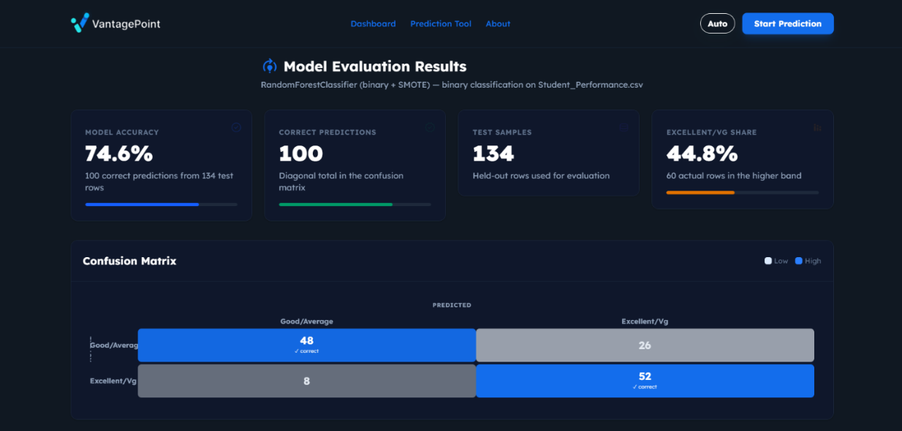
- Class Distribution Share: A specialized metric identifying the percentage of the population categorized within the higher performance bands (Excellent/Very Good), providing insight into the dataset’s skew and academic density.

Figure 6: Website Dashboard

Confusion Matrix Visualization
The central component of the dashboard is a Confusion Matrix, which facilitates a heuristic evaluation of the model's classification errors. The matrix maps the Predicted Class against the Actual Class, utilizing a color-coded heatmap approach:
- True Positives (Diagonal): Highlighted in blue to indicate successful classifications (e.g., 48 for Good/Average and 52 for Excellent/Vg).
- Off-Diagonal Elements: Represent Type I (False Positive) and Type II (False Negative) errors. For instance, 26 instances were incorrectly predicted as "Excellent/Vg" despite belonging to the "Good/Average" band, allowing researchers to identify specific performance tiers where the model exhibit bias.
Per-Band Performance Analysis
To ensure a robust evaluation beyond global accuracy, the dashboard includes a tabular Per-Band Performance breakdown (see Figure 2). This section categorizes the results into specific performance tiers:
- Class-Specific Accuracy: Individual accuracy rates are calculated for each tier (e.g., 64.9% for Good/Average vs. 86.7% for Excellent/Vg). This allows for a granular determination of the model’s reliability across different student demographics.
- Statistical Totals: A summary of True Positives versus Total Actual samples per category, providing the empirical basis for the final classification report.
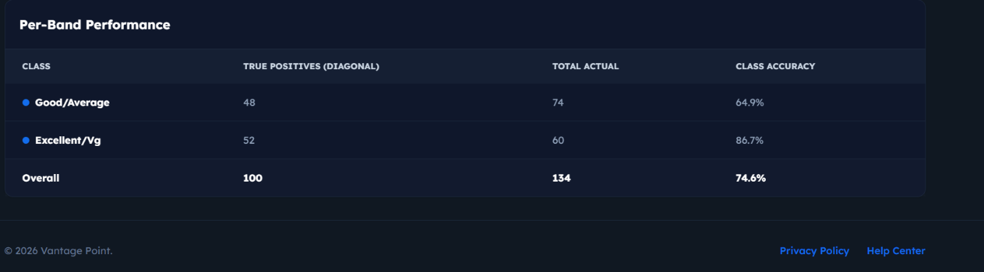

Figure 7: Per Band Performance

Operational Controls
The interface provides high-level control mechanisms for the prediction pipeline, including an Auto-Toggle for automated feature selection and a Start Prediction execution trigger. These tools allow for iterative testing and real-time model evaluation within the web-based environment, ensuring a streamlined workflow for academic researchers.
To facilitate user interaction with the Random Forest model, a web-based interface was designed. The interface requires users to input specific predictor variables, which are categorized logically to ensure a smooth user experience. The prediction tool is divided into distinct sections capturing demographics, academic history, and behavioral study habits.

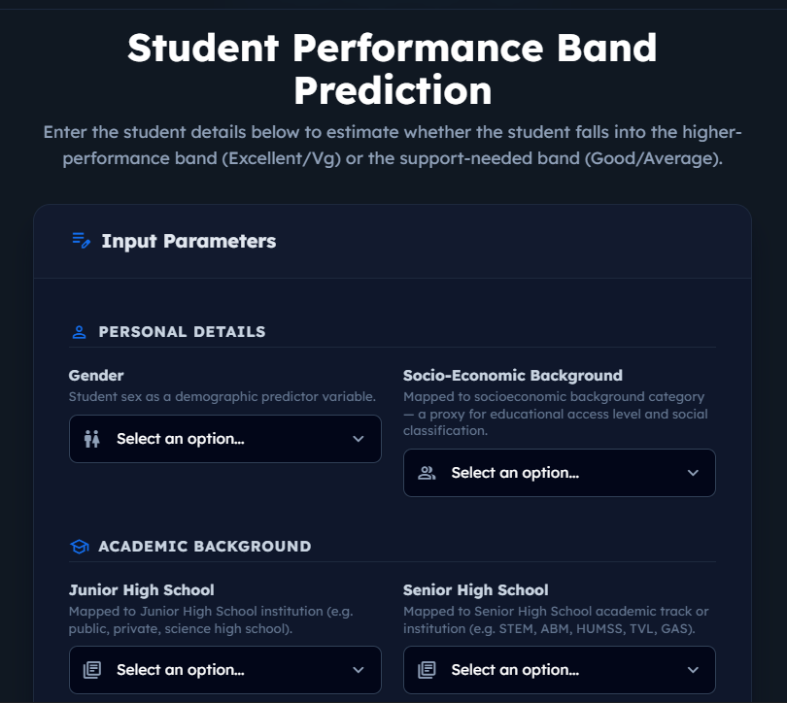

Figure 8: The top section of the prediction tool interface, capturing demographic and early academic predictor variables.
As illustrated in Figure 14, the initial phase of data entry focuses on the student's background. The user selects the student's Gender and Socio-Economic Background from dropdown menus, which serve as demographic proxies for the model. Following this, the user inputs the type of Junior High School and the specific academic track taken during Senior High School.

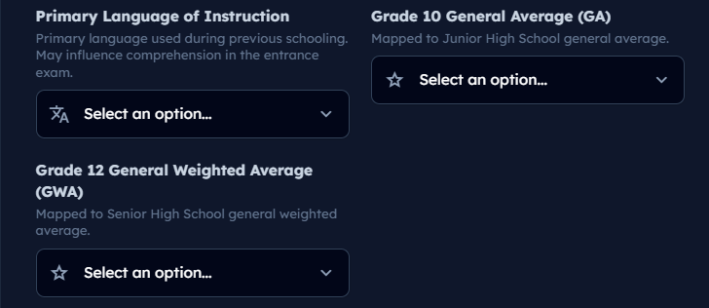

Figure 9: The middle section of the interface for inputting language of instruction and historical academic performance.
The subsequent section of the form, shown in Figure 15, gathers data regarding the student's academic performance metrics prior to college. Users are required to input the primary language used during previous schooling, alongside their Grade 10 General Average (GA) and Grade 12 General Weighted Average (GWA). These historical grades act as heavy weights in the model's predictive accuracy.

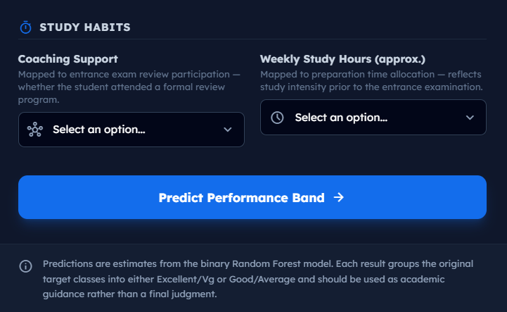

Figure 10: The final section of the interface capturing study habits and the execution button for the prediction model.
Finally, Figure 16 displays the behavioral inputs required by the system. The user indicates whether the student received formal Coaching Support and estimates their Weekly Study Hours. Once all parameters are complete, the user clicks the "Predict Performance Band" button. This action triggers the backend machine learning model to process the inputs and return an estimated classification, categorizing the student into either the higher-performance band (Excellent/Very Good) or the support-needed band (Good/Average) for academic guidance.
The final stage of the system’s operation is the generation of the prediction result based on the processed input features. Once the Random Forest classifier completes its computation, the system renders a dedicated results page.

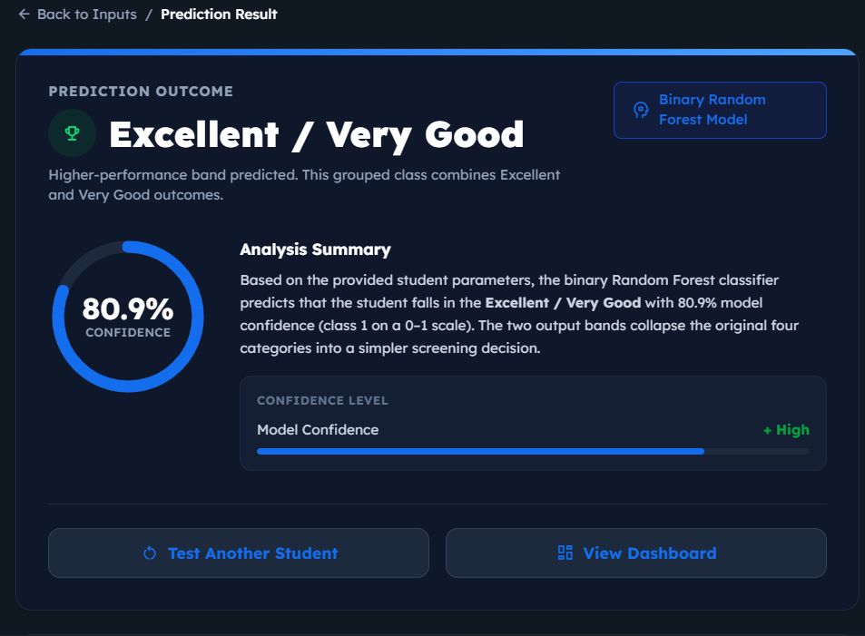

Figure 11: The Prediction Result interface displaying the model outcome, confidence score, and analysis summary.

As shown in Figure 17 the system provides a clear, high-visibility classification of the student’s predicted performance band. A critical feature of this interface is the Model Confidence score, expressed as a percentage. This value represents the probability score generated by the Random Forest algorithm, providing the user with a measure of the prediction's reliability. The interface also includes a brief Analysis Summary to help academic counselors interpret the binary classification in the context of the original dataset categories. This transparency ensures that the tool acts as a decision-support system rather than a "black box" algorithm.

Appendix C
Certificate of Proofreading

Appendix D
Certificate of Originality

Appendix E
CURRICULUM VITAE

 |  | 
Personal Information
Name  Age  Gender  Birth Date  Birthplace  Civil Status  Religion  Nationality  Home Address  Email Address | : Arjay J. Artigas  : 24  : Male  : May 31, 2001  : Calbayog City, Samar  : Single  : Roman Catholic  : Filipino  : Brgy. East Awang, Calbayog City, Samar, 6710  : arjayartigas8@gmail.com
Role in the Development of the System
Role and Responsibilities: Project Manager/Lead Programmer/NLP Specialist

Educational Background
Tertiary:  Secondary:  Secondary:  Primary: | Northwest Samar State University  Rueda St. Calbayog City  Bachelor of Science in Computer Science  SY: 2025 – 2026  La Milagrosa Academy  J.D. St., Samar, Avelino, Calbayog City, Philippines  SY: 2020 - 2021  La Milagrosa Academy  J.D. St., Samar, Avelino, Calbayog City, Philippines  SY: 2017-2018  Calbayog City Sped Center  Nijaga Street, East Awang, Calbayog City, Samar.  SY: 2013 – 2014
 |  | 
Personal Information
Name  Age  Gender  Birth Date  Birthplace  Civil Status  Religion  Nationality  Home Address  Email Address | : Arlan C. Guiapal  : 22  : Male  : January 23, 2004  : Calbayog City, Samar  : Single  : Roman Catholic  : Filipino  : Brgy. Napuro 2 Sta. Margarita, Samar, 6709  :arlanguiapal1@gmail.com
Role in the Development of the System
Role and Responsibilities: Researcher/Quality Assurance (QA)

Educational Background
Tertiary:  Secondary:  Primary: | Northwest Samar State University  Rueda St. Calbayog City  Bachelor of Science in Computer Science  SY: 2025 – 2026  Sta. Margarita National High School  Barangay Monbon, Sta. Margarita, Samar  SY: 2019 - 2020  Napuro Elementary School  Barangay Napuro, Sta. Margarita, Samar  SY: 2015 – 2016

 |  | 
Personal Information
Name  Age  Gender  Birth Date  Birthplace  Civil Status  Religion  Nationality  Home Address  Email Address | : Alvin Jester S. Barroga  : 23  : Male  : January 7, 2003  : Las Pinas District, Calbayog  : Single  : Roman Catholic  : Filipino  : Brgy. Aguit-itan Purok 2 Calbayog City, Samar  : alvinbarroga56@gmail.com
Role in the Development of the System
Role and Responsibilities: Researcher

Educational Background
Tertiary:  Secondary:  Secondary:  Primary: | Northwest Samar State University  Rueda St. Calbayog City  Bachelor of Science in Computer Science  SY: 2025 - 2026  Costarica National high school  Costarica Almagro, Samar, 6724  SY: 2021 - 2022  Costarica National high school  Costarica Almagro, Samar, 6724  SY: 2019 - 2020  Lunang II Elementary School  SY: 2014 - 2015
 |  | 
Personal Information
Name  Age  Gender  Birth Date  Birthplace  Civil Status  Religion  Nationality  Home Address  Email Address | : John benedict F. Oyao  : 22  : Male  : June 24, 2003  : Sta. Margarita, Samar  : Single  : Roman Catholic  : Filipino  : Brgy. Monbon, Sta. Margarita, Samar, 6709  : johnbenedict06242003@gmail.com
Role in the Development of the System
Role and Responsibilities: UI/UX Designer

Educational Background
Tertiary:  Secondary:  Secondary:  Primary: | Northwest Samar State University  Rueda St. Calbayog City  Bachelor of Science in Computer Science  SY: 2025 – 2026  Clarencio Calagos Memorial High School  Brgy. Monbon, Sta. Margarita, Samar, 6709  SY: 2021 - 2022  Calape National High school  Sta. Cruz Calape, Bohol  SY: 2019 - 2020  Sta. Margarita I Elementary School  Brgy. Monbon, Sta. Margarita, Samar, 6709  SY: 2015 - 2016

