VOIP Network diagram

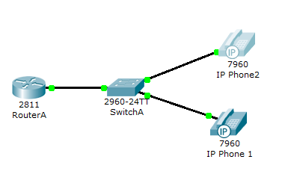

RouterA>enable

RouterA#configure terminal

RouterA(config)#interface FastEthernet0/0

RouterA(config-if)#ip address 192.168.10.1 255.255.255.0

RouterA(config-if)#no shutdown

RouterA(config)#ip dhcp pool VOICE

RouterA(dhcp-config)#network 192.168.10.0 255.255.255.0

RouterA(dhcp-config)#default-router 192.168.10.1

RouterA(dhcp-config)#option 150 ip 192.168.10.1

 RouterA(config)#telephony-service

RouterA(config-telephony)#max-dn 5

RouterA(config-telephony)#max-ephones 5

RouterA(config-telephony)#ip source-address 192.168.10.1 port 2000

RouterA(config-telephony)#auto assign 4 to 6

RouterA(config-telephony)#auto assign 1 to 5

RouterA(config)#ephone-dn 1

RouterA(config-ephone-dn)#number 54001

RouterA(config)#ephone-dn 2

RouterA(config-ephone-dn)#number 54002

SwitchA(config)#interface range fa0/1 – 5

SwitchA(config-if-range)#switchport mode access

SwitchA(config-if-range)#switchport voice vlan 1

