Ninja Stealth Game

*By Joshua Petherick*

*Ci328 Internet game design and development*

Table of Contents

Game Summary 2

Objectives 2

Rules 2

Game play 2

Game Structure 3

Implementation Specification 4

Code Structure 5

NSG 5

Button 11

BackgroundTile 12

Player 12

Enemy 12

BehaviourTree 13

Floor 17

Wall 17

Light 17

Stairs 18

Exit 18

Intel 18

Signals 18

Music 19

Assets 19

Investigation and Research 20

Review of Final Product 20

References 20

Appendix 20

# Game Summary

## Objectives

NSG (Ninja Stealth Game) is a stealth-oriented platformer where the players goal is to reach to the door at the end of every level. The player is, essentially, climbing up the many levels of the building in the hopes of reaching the important Intel at the top floor. Once the player has collected the Intel they must then make their way back down to the bottom floor to escape the building. The goal is to do all of this in as short a time as possible.

## Rules

The rules are simple and should be simple for the player to grasp. Please see the list of them below:

1. Player can move Left, Right and Jump.
2. Ladders allow the player to go up or down.
3. Dark spots make the player invisible to guards’ vision however if player is spotted in lighted areas then guards will pursue.
4. Player must NOT be caught by guards. Being caught will reset the player to the last checkpoint.
5. High score will be earned by time-taken to complete the game (e.g. 5:12).
6. Progressing to the next level will create a new checkpoint.

## Game play

Players interact with the game using the on-screen arrows found at the bottom of the screen. Each arrow follows the rules seen above, moving the player left or right and the up and down arrows moving the player up and down the ladder.

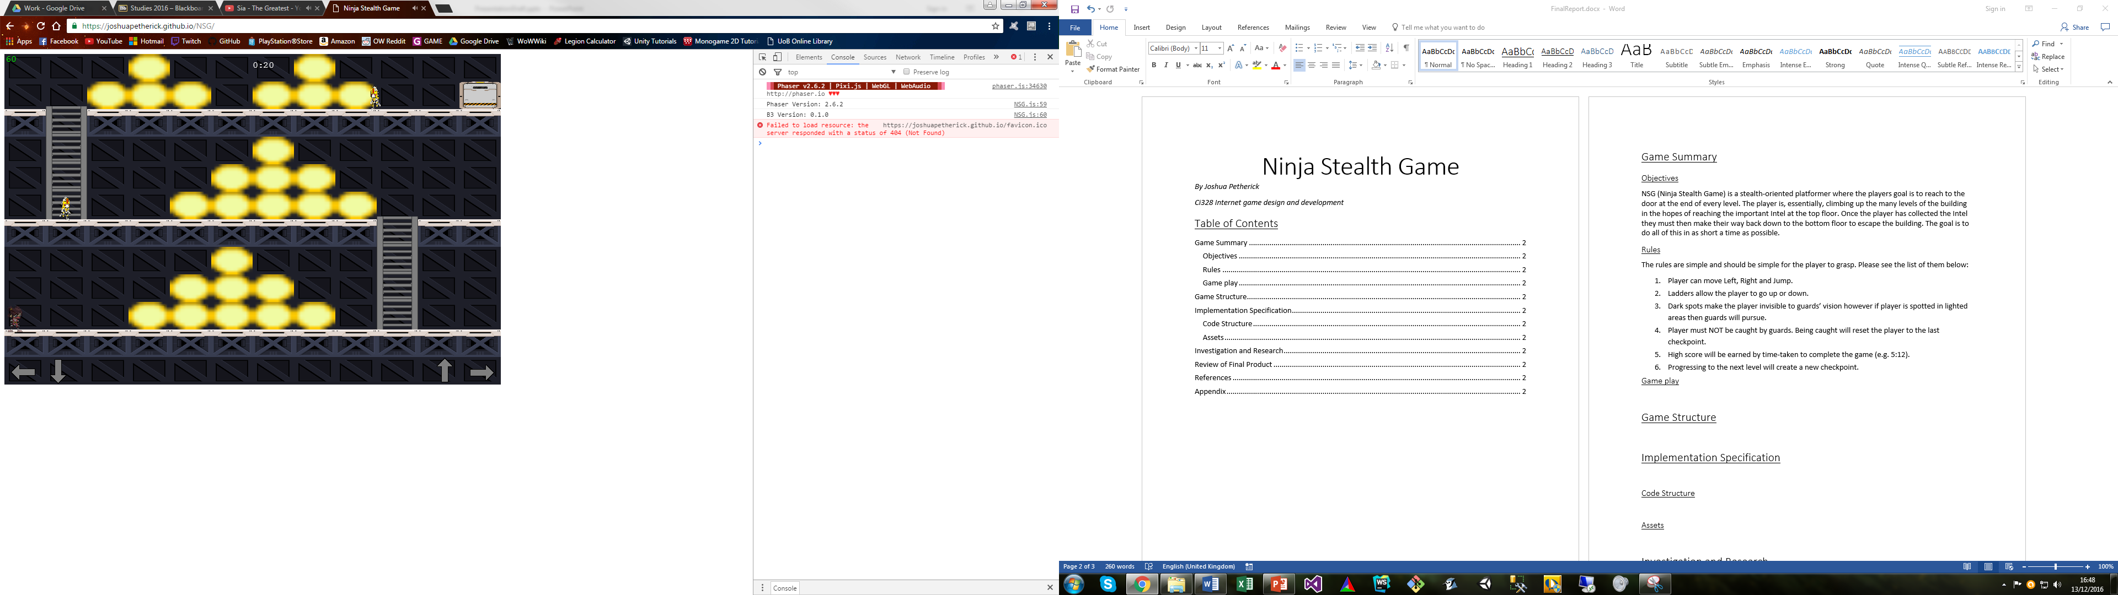

*Figure 1. Screenshot of Level 1*

# Game Structure

This section will present the different screens which the user will see.

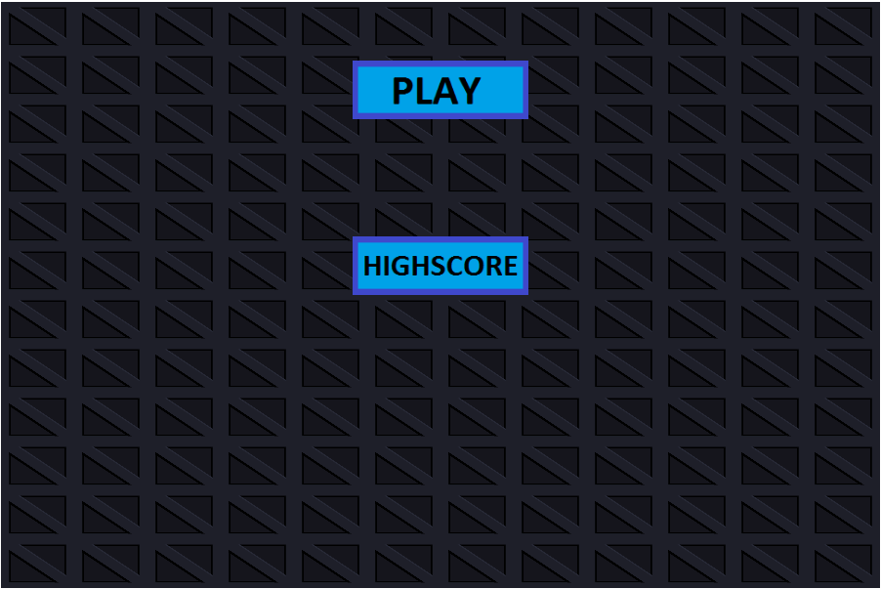

*Figure 2. The main menu*

Shows the main menu.

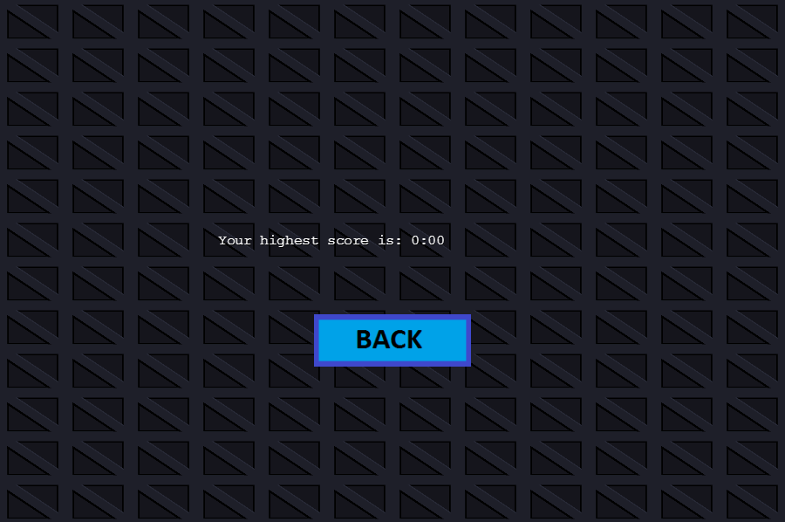

*Figure 3. The Highscore display menu*

Shows the High score screen.

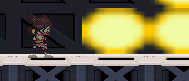 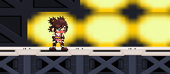

*Figure 4. & 5. Players visibility indicator*

Left image shows shadow. Right image shows in light.

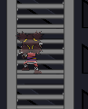

*Figure 6. Player climbing a ladder*

Casually climbing up the ladder.

# Implementation Specification

This section will go through the design, structure and implementation of the code used to create NSG. It will also briefly discuss the used of assets.

## Code Structure

I’ll start by going through each of the classes that are part of this project, discussing their purpose and the parameters they hold.

### NSG

This file contains the body of the game, and is responsible for starting and managing the games flow. It holds all the global variables (i.e. GAMEHEIGHT, GAMEWIDTH, Level, etc) and even the game object itself (see below).

**var *game*** = **new** *Phaser*.Game(***GAMEWIDTH***, ***GAMEHEIGHT***, *Phaser*.**AUTO**, **'Ninja Stealth Game'**, {  
 preload: *preload*,  
 create: *create*,  
 update: *update*,  
 render: *render*});

The first function to be run is the preload function which maintains loading all the assets that are to be used within the game. I saw this as the initialiser of the game and therefore put in other bits of code which I only wanted to be called once, such as changing the screen size and loading the image groups.

**function** *preload*() {  
 **if** (**window**.**screen**.**availHeight** > (***GAMEHEIGHT***\*2) && **window**.**screen**.**availWidth** > (***GAMEWIDTH***\*2)) {  
 *// Adjust for bigger screens* ***GAMEHEIGHT*** = ***GAMEHEIGHT***\*2;  
 ***GAMEWIDTH*** = ***GAMEWIDTH***\*2;  
 ***game***.**scale**.setGameSize(***GAMEWIDTH***, ***GAMEHEIGHT***)  
 }  
 **console**.log(**'Phaser Version: '** + *Phaser*.**VERSION**);  
 **console**.log(**'B3 Version: '** + **b3**.**VERSION**);  
 *// Start state* ***gameState*** = ***gameStates***.**MENU**;  
 **var** ASSETPATH = **'assets/images/'**;  
 **var** SOUNDPATH = **'assets/sounds/'**;  
 **var** TREEPATH = **'assets/behaviourTrees/'**;  
 *// XML Files* ***game***.**load**.atlasXML(**'player'**, ASSETPATH + **'Player/playerSpriteSheet.png'**, ASSETPATH + **'Player/playerSpriteSheet.xml'**);  
 ***game***.**load**.atlasXML(**'enemy'**, ASSETPATH + **'Enemy/enemySpriteSheet.png'**, ASSETPATH + **'Enemy/enemySpriteSheet.xml'**);  
 *// Images* ***game***.**load**.**image**(**'background'**, ASSETPATH + **'Background/BGTile.png'**);  
 ***game***.**load**.**image**(**'floor'**, ASSETPATH + **'Background/Floor.png'**);  
 ***game***.**load**.**image**(**'wall'**, ASSETPATH + **'Background/Wall.png'**);  
 ***game***.**load**.**image**(**'light'**, ASSETPATH + **'TestImages/light.png'**);  
 ***game***.**load**.**image**(**'stairs'**, ASSETPATH + **'Background/Ladder.png'**);  
 ***game***.**load**.**image**(**'exit'**, ASSETPATH + **'Background/Door.png'**);  
 ***game***.**load**.**image**(**'intel'**, ASSETPATH + **'Background/Intel.png'**);  
 *// Buttons* ***game***.**load**.**image**(**'leftArrow'**, ASSETPATH + **'Buttons/ArrowLeft.png'**);  
 ***game***.**load**.**image**(**'rightArrow'**, ASSETPATH + **'Buttons/ArrowRight.png'**);  
 ***game***.**load**.**image**(**'downArrow'**, ASSETPATH + **'Buttons/ArrowDown.png'**);  
 ***game***.**load**.**image**(**'upArrow'**, ASSETPATH + **'Buttons/ArrowUp.png'**);  
 *// Spritesheets* ***game***.**load**.spritesheet(**'buttonPlay'**, ASSETPATH + **'Buttons/buttonPlay.png'**, 194, 66);  
 ***game***.**load**.spritesheet(**'buttonHighscore'**, ASSETPATH + **'Buttons/buttonHighscore.png'**, 194, 66);  
 ***game***.**load**.spritesheet(**'buttonBack'**, ASSETPATH + **'Buttons/buttonBack.png'**, 194, 66);  
 *// Audio* ***game***.**load**.audio(**'background1'**, SOUNDPATH + **'background_eerie.mp3'**);  
 ***game***.**load**.audio(**'background2'**, SOUNDPATH + **'background_epic.wav'**);  
 ***game***.**load**.audio(**'steps'**, SOUNDPATH + **'steps.wav'**);  
 ***game***.**load**.audio(**'alert'**, SOUNDPATH + **'robot_intruder.wav'**);  
 *// Text* **var** maxLvls = 15;  
 **for** (**var** i = 1; i <= maxLvls; i++) {  
 *// Load all level text files!* ***game***.**load**.text(**'level'** + i, **'assets/levels/lvl'** + i + **'.txt'**)  
 }  
 ***game***.**load**.text(**'AITree'**, TREEPATH + **'aiTree.json'**);  
 *// Init Groups* ***TILEBACKGROUND*** = ***game***.**add**.group();  
 ***background*** = ***game***.**add**.group();  
 ***wallLayer*** = ***game***.**add**.group();  
 ***lightLayer*** = ***game***.**add**.group();  
 ***stairLayer*** = ***game***.**add**.group();  
 ***exitLayer*** = ***game***.**add**.group();  
 ***foreground*** = ***game***.**add**.group();  
 *// Used for FPS counter* ***game***.**time**.**advancedTiming** = **true**;  
} *//preload();*

The next function to be run is the create method, which I saw as the “state loader” meaning that it loads all the objects and assets required when loading or changing the gameState. I used a switch statement so it would only load certain stuff based on what state the game was in. For example, if the game state was MENU then it would load the squared background and the two buttons (See fig. 1).

**function** *create*() {  
 *// Will create objects for the game* **switch**(***gameState***)  
 {  
 **case *gameStates***.**MENU**:  
 *// Load game background!* **var** text = *prepLevel*();  
  
 ***TileSizeY*** = **Math**.round(***GAMEHEIGHT***/text.**length**);  
 ***TileSizeX*** = **Math**.round(***GAMEWIDTH***/(text[0].**length**));  
 *loadLevel*(text); *// Will only load the background!* ***buttons***.push(**new** *button*(**"PLAY"**));  
 ***buttons***.push(**new** *button*(**"HIGHSCORE"**));  
 **break**;  
  
 **case *gameStates***.**SCORE**:  
 ***buttons***.push(**new** *button*(**"BACK"**));  
 **break**;  
  
 **case *gameStates***.**PLAY**:  
 ***game***.**physics**.startSystem(*Phaser*.***Physics***.**ARCADE**); *// ARCADE physics as fits game best* ***game***.**physics**.**arcade**.**gravity**.**y** = 350;  
 ***timer*** = ***game***.**time**.*create*(**false**);  
  
 ***playerDied*** = **new** *Signal*();  
 ***newLevel*** = **new** *Signal*();  
 ***getIntel*** = **new** *Signal*();  
  
 ***newLevel***.addSignal(*nextLevel*);  
 ***getIntel***.addSignal (**function**() {  
 ***exit*** = **new** *Exit*(***player***.**origX**, ***player***.**origY**);  
 ***backgroundMusic***.queueSong(**'background2'**);  
 });  
  
 ***level*** = 1; *// Reset level for every create!* **var** text = *prepLevel*();  
 *loadLevel*(text);  
  
 ***backgroundMusic*** = **new** *sound*(**'background1'**); *// Background music, open to update* ***backgroundMusic***.musicVol(0.75);  
 ***backgroundMusic***.musicLoop();  
  
 ***timer***.start(); *// Timer to begin starts last!* **break**;  
 }  
} *// create()*

After calling create the game would now go into the self-described “running” state, meaning it would loop the update and render functions until the game is over. The update function manages logical updates to the game such as player inputs or updating the enemy positions.

**function** *update*() {  
 *// Change game states and call update for all objects* **switch**(***gameState***) {  
 **case *gameStates***.**PLAY**:  
 ***player***.playerInput(); *// Check input* ***player***.playerUpdate(); *// Update Player  
 handleCollision*(); *// Handle all collisions* **for**(**e in *enemies***) {  
 ***enemies***[**e**].enemyUpdate(); *// Update enemy AI, collision, etc* }  
 ***backgroundMusic***.musicUpdate();  
 **break**;  
 }  
} *// update()*

The render function handles drawing text onto the screen, such as the timer and the FPS.

**function** *render*() {  
 *//game.debug.text.clean;* **switch**(***gameState***) {  
 **case *gameStates***.**SCORE**:  
 **var** score = **localStorage**.getItem(**'timerScore'**);  
 **if** (!score) { score = **'0:00'**; } *// If null then add value!* ***game***.**debug**.text(**'Your highest score is: '** + score, (***GAMEWIDTH***/2)-200, (***GAMEHEIGHT***/2)-20); *// Prints Timer* **break**;  
  
 **case *gameStates***.**PLAY**:  
 ***game***.**debug**.text(***game***.**time**.**fps** || **'--'**, 2, 14, **'#00ff00'**); *// Prints FPS* ***game***.**debug**.text(*sortTimer*(***timer***.**seconds**), ***GAMEWIDTH*** / 2, 25); *// Prints Timer* **break**;  
 }  
} *// render()*

Next I’ll discuss the two methods responsible for loading in the different levels within the game.

The “loadLevel” function reads in an array of text, generated by the .txt files found within the assets/levels folder to determine the position of objects. It reads the array line-by-line and then passes the character to the “addObject” method.

**function** *loadLevel*(text) {  
 *// For each Line in Text - Determines Y* **for** (**i** = 0; **i** < text.**length**; **i**++) {  
 *// For each Character in Line - Determines X* **for** (**j** = 0; **j** < text[**i**].**length**; **j**++) {  
 *// Initialise based on character in txt file* **var** x = (**j**\****TileSizeX***); *// X based on position in txt file* **var** y = (**i**\****TileSizeY***); *// Y based on position in txt file  
 // Designed so will only load background when in MENU state* **if** (***gameState*** === ***gameStates***.**MENU**) {  
 **new** *BGTile*(x, y);  
 }  
 **else** {  
 *addObject*(text[**i**].charAt(**j**), x, y);  
 }  
 }  
 }  
}

The “addObject” method is responsible for loading an object based on the character type passed across from the “loadLevel” method. I tried to redo this function several times, so it looked less messy, but ultimately this was the best way of managing and loading each new object.

**function** *addObject* (char, x, y) {  
 **switch** (char) {  
 **case "P"**:  
 ***player*** = **new** *Player*(x, y);  
 **break**;  
  
 **case "G"**:  
 ***enemies***.push(**new** *Enemy*(x, y)); *// Add new to Array* **break**;  
  
 **case "F"**:  
 **new** *Floor*(x, y); *// Add new to Array* **break**;  
  
 **case "W"**:  
 **new** *Wall*(x, y); *// Add new to Array* **break**;  
  
 **case "S"**:  
 **new** *Stair*(x, y); *// Add new to Array* **break**;  
  
 **case "L"**:  
 **new** *Light*(x, y); *// Add new to Array* **break**;  
  
 **case "X"**:  
 ***enemies***.push(**new** *Enemy*(x, y)); *// Add new to Array* **new** *Light*(x, y); *// Add new to Array* **break**;  
  
 **case "Y"**:  
 ***player*** = **new** *Player*(x, y);  
 **new** *Stair*(x, y); *// Add new to Array* **break**;  
  
 **case "Z"**:  
 ***player*** = **new** *Player*(x, y);  
 **new** *Light*(x, y); *// Add new to Array* **break**;  
  
 **case "I"**:  
 ***intel*** = **new** *Intel*(x, y);  
 **new** *Light*(x, y); *// Add new to Array* **break**;  
  
 **case "E"**:  
 ***exit*** = **new** *Exit*(x, y);  
 **break**;  
 }  
}

The next method is designed to take the value of the timer and present it into the value that is seen on the screen.

**function** *sortTimer*(time) {  
 **var** mins = 0;  
 **if** (**Math**.round(time) >= 60) {  
 mins = **Math**.floor(time/60);  
 }  
 **var** secs = **Math**.floor(time) - (mins*60);  
 **if** (secs < 10) {  
 secs = **"0"** + secs;  
 }  
 **return** mins + **":"** + secs;  
}

Next is our collision method, which handles collision for most of the objects in this game (Aside from the enemy class which has their own collision). It uses the phaser physics mechanic to determine whether something is colliding, but my personal methods for the results.

**function** *handleCollision* () {  
 ***game***.**physics**.**arcade**.collide(***player***.**playerSprite**, ***wallLayer***); *// Checks if player is colliding with Walls* **for** (**e in *enemies***) {  
 **if** (***game***.**physics**.**arcade**.overlap(***player***.**playerSprite**, ***enemies***[**e**].**enemySprite**)) {  
 *// For each enemy, check if overlapping, if so then reset level* ***playerDied***.call();  
 }  
 }  
 **if** (***game***.**physics**.**arcade**.overlap(***player***.**playerSprite**, ***lightLayer***)) {  
 *// If overlapping with LIGHT then change state* ***player***.updateState(***player***.**playerStates**.**LIGHT**);  
 }  
 **else** {  
 ***player***.updateState(***player***.**playerStates**.**DARK**);  
 }  
 **if** (***game***.**physics**.**arcade**.overlap(***player***.**playerSprite**, ***stairLayer***)) {  
 *// If overlapping with STAIR then no gravity, so can climb up/down* ***player***.setGravity(**false**);  
 }  
 **else** {  
 ***player***.setGravity(**true**);  
 }  
 **if** (***intel***) {  
 **if** (***game***.**physics**.**arcade**.overlap(***player***.**playerSprite**, ***intel***.**intelSprite**)) {  
 ***getIntel***.call();  
 }  
 }  
 **if** (***game***.**physics**.**arcade**.overlap(***player***.**playerSprite**, ***exitLayer***)) {  
 *// Check if player has collidied with exit, if so progress to next level* ***newLevel***.call();  
 }  
}

The “nextLevel” method does precisely what the name suggests, and that is to prep everything for loading the next level. It does this by emptying all the variables and groups, incrementing level and then called “loadLevel”. It is also responsible for calling the “gameComplete” method.

**function** *nextLevel*() {  
 *// Empty arrays* ***player*** = **null**;  
 ***enemies*** = [];  
 ***exit*** = **null**;  
 *// Empty phaser group* ***background***.removeAll();  
 ***wallLayer***.removeAll();  
 ***lightLayer***.removeAll();  
 ***stairLayer***.removeAll();  
 ***foreground***.removeAll();  
 ***exitLayer***.removeAll();  
 *// Load next level* ***level***++;  
 **if** (***level*** < 16 ) {  
 **var** text = *prepLevel*();  
 *loadLevel*(text);  
 }  
 **else** {  
 *gameComplete*();  
 }  
}

The “gameComplete” method gets called once the player has completed level 15. It simply stops the timer, records the users score and then changes the gameState to SCORE (Meaning it will load the high score screen, see figure 2).

**function** *gameComplete*() {  
 ***timer***.pause(); *// Pause* **localStorage**.setItem(**'timerScore'**, *sortTimer*(***timer***.**seconds**)); *// Store local time score for player* ***timer***.stop(); *// Kill timer off*  
 ***gameState*** = ***gameStates***.**SCORE**;  
 *create*();  
}

Lastly the “prepLevel” method gets the text from the text file, removes any line breaks and then returns it.

**function** *prepLevel*() {  
 **var** txt = ***game***.**cache**.getText(**'level'** + ***level***).split(**'\n'**); *// Stores it as an array* **for**(**i** = 0; **i** < txt.**length**; **i**++) {  
 txt[**i**] = txt[**i**].replace(/\n|\r/g, **""**); *// Cleans up Line breaks* }  
 **return** txt;  
}

Finally here is a list of all the global variables which are stored in the NSG file.

*// Core-game variables***var *GAMEHEIGHT*** = 300;  
**var *GAMEWIDTH*** = 450;  
**var *backgroundMusic***;  
**var *level*** = 1;  
**var *timer***;  
  
*// Phaser draw groups***var *background***;  
**var *wallLayer***;  
**var *lightLayer***;  
**var *stairLayer***;  
**var *foreground***;  
**var *exitLayer***;  
**var *TILEBACKGROUND***;  
  
*// Tile Info***var *TileSizeX***;  
**var *TileSizeY***;  
  
*// Sprite Variables***var *player***;  
**var *enemies*** = []; *// Array of Enemies***var *buttons*** = []; *// Array of Menu buttons***var *intel***;  
**var *exit***;  
  
*// State variables***var *gameState***;  
**var *gameStates*** = {  
 **MENU**: 0,  
 **PLAY**: 1,  
 **SCORE**: 2  
};  
  
*// Signals***var *playerDied***; *// https://phaser.io/docs/2.6.2/Phaser.Signal.html***var *newLevel***;  
**var *getIntel***;

### Button

This object class handles all the buttons you can see on the Main Menu. The type gets passed during the creation of the button, which then goes into a switch statement. The difference between the three is the position and the method which gets called when the button is clicked. The buttons position is designed to change based on the size of the screen.

**function** *button*(type) {  
 **this**.**height** = ***GAMEHEIGHT***/10;  
 **this**.**width** = ***GAMEWIDTH***/5;  
 **switch**(type) {  
 **case "PLAY"**:  
 **this**.**button** = ***game***.add.button(0 + **this**.**width**\*2, 0+**this**.**height**, **'buttonPlay'**, *playClick*, **this**, 1, 0, 1);  
 **break**;  
  
 **case "HIGHSCORE"**:  
 **this**.**button** = ***game***.add.button(0 + **this**.**width**\*2, (***GAMEHEIGHT***/2)-**this**.**height**, **'buttonHighscore'**, *highscoreClick*, **this**, 1, 0, 1);  
 **break**;  
  
 **case "BACK"**:  
 **this**.**button** = ***game***.add.button(0 + **this**.**width**\*2, (***GAMEHEIGHT***/2)+**this**.**height**, **'buttonBack'**, *backClick*, **this**, 1, 0, 1);  
 **break**;  
 }  
 **this**.**button**.**width** = **this**.**width**;  
 **this**.**button**.**height** = **this**.**height**;  
 ***background***.add(**this**.**button**);  
  
 **this**.destroyButton = **function**() {  
 **this**.**button**.destroy();  
 }  
}

The remainder of the class holds the methods which got called when the button gets clicked on. Each method changes the gameState and then calls the create method from NSG.

**function** *playClick*() {  
 *clear*();  
 ***gameState*** = ***gameStates***.**PLAY**;  
 *create*();  
}  
  
**function** *highscoreClick*() {  
 *clear*();  
 ***gameState*** = ***gameStates***.**SCORE**;  
 *create*();  
}  
  
**function** *backClick*() {  
 *clear*();  
 ***gameState*** = ***gameStates***.**MENU**;  
 *create*();  
}  
  
**function** *clear*() {  
 **for** (**i in buttons**) {  
 **buttons**[**i**].destroyButton();  
 }  
 ***background***.removeAll();  
 ***buttons*** = [];  
}

### BackgroundTile

This object class manages the squares in the background, which are loaded in from the “levelLoad” method. BGTile is a basic function which only requires an x and y position.

**function** *BGTile*(x, y) {  
 **this**.**tileSprite** = ***game***.add.sprite(x, y, **'background'**);  
 **this**.**tileSprite**.**width** = ***TileSizeX***;  
 **this**.**tileSprite**.**height** = ***TileSizeY***;  
 ***TILEBACKGROUND***.add(**this**.**tileSprite**);  
}

### Player

### Enemy

The enemy class handles everything related to the enemy class, following a similar design and parameters to the player class. A main difference is the AITree class, which I’ll explain in the next section, and the states are different.

**function** *Enemy*(x, y) {  
 **this**.**enemySprite** = ***game***.add.sprite(x, y, **'enemy'**);  
 **this**.**enemySprite**.**width** = (***TileSizeX***/2);  
 **this**.**enemySprite**.**height** = ***TileSizeY***;  
 **this**.**origX** = x;  
 **this**.**origY** = y;  
  
 ***game***.physics.enable(**this**.**enemySprite**, *Phaser*.***Physics***.**ARCADE**);  
 **this**.**enemySprite**.**body**.**allowGravity** = **true**;  
 **this**.**enemySprite**.**body**.**mass** = 0;  
 **this**.**baseSpeed** = 75; *// Base speed required as it gets updated by Behaviour tree* **this**.**speed** = **this**.**baseSpeed**;  
  
 ***foreground***.add(**this**.**enemySprite**);  
  
 **this**.**walkAnimation** = **this**.**enemySprite**.**animations**.add(**'Walk'**, *Phaser*.Animation.generateFrameNames(**'Run_'**, 0, 7, **''**, 3));  
 **this**.**walkAnimation**.**speed** = 10;  
  
 **this**.**climbAnimation** = **this**.**enemySprite**.**animations**.add(**'Climb'**, *Phaser*.Animation.generateFrameNames(**'Climb_'**, 0, 4, **''**, 3));  
 **this**.**climbAnimation**.**speed** = 10;  
  
 **this**.**yell** = **new** *sound*(**'alert'**);  
 **this**.**yell**.musicVol(0.75);  
  
 **this**.**enemyStates** = {  
 **LEFT**: 0,  
 **RIGHT**: 1,  
 **CHASING**: 2  
 };  
 **this**.**state** = **this**.**enemyStates**.**RIGHT**;  
 **this**.**ai** = **new** *AITree*(**this**);  
  
 *// Add functions below*

*...*

*}*

There are also functions, such as the update method and the resetPos method. The enemyUpdate method gets called every frame, and updates the enemies state and position accordingly. It also handles it’s collision with other objects. The other methods are almost identical to the player class.

*// Add functions below* **this**.enemyUpdate = **function** () {  
 *// Update* **this**.**enemySprite**.**body**.**velocity**.**x** = 0;  
 *//this.enemySprite.body.velocity.y = 0;* **this**.**ai**.treeUpdate();  
  
 ***game***.physics.**arcade**.collide(**this**.**enemySprite**, ***background***);  
 *// Turn around if colliding with a wall!* **if** (***game***.physics.**arcade**.collide(**this**.**enemySprite**, ***wallLayer***)) {  
 **if** (**this**.**state** === **this**.**enemyStates**.**LEFT**) {  
 **this**.**state** = **this**.**enemyStates**.**RIGHT**;  
 }  
 **else if** (**this**.**state** === **this**.**enemyStates**.**RIGHT**) {  
 **this**.**state** = **this**.**enemyStates**.**LEFT**;  
 }  
 }  
 **if** (***game***.physics.**arcade**.overlap(**this**.**enemySprite**, ***stairLayer***)) {  
 **this**.setGravity(**false**);  
 }  
 **else** {  
 **this**.setGravity(**true**);  
 }  
 }  
  
 **this**.setGravity = **function**(gravity) {  
 **this**.**enemySprite**.**body**.**allowGravity** = gravity;  
 }  
  
 **this**.resetPos = **function**() {  
 **this**.**state** = **this**.**enemyStates**.**RIGHT**;  
 **this**.**enemySprite**.**body**.**allowGravity** = **false**;  
 **this**.**enemySprite**.**x** = **this**.**origX**;  
 **this**.**enemySprite**.**y** = **this**.**origY**;  
 **this**.**speed** = **this**.**baseSpeed**;  
 }  
  
 **this**.stopAnimations = **function**() {  
 **this**.**walkAnimation**.stop();  
 **this**.**climbAnimation**.stop();  
 }  
  
 ***playerDied***.addSignal(**function**() {  
 **for** (**e in *enemies***) {  
 ***enemies***[**e**].resetPos();  
 }  
 });  
 ***getIntel***.addSignal(**function**() {  
 **for** (**e in *enemies***) {  
 ***enemies***[**e**].**speed** = ***enemies***[**e**].**baseSpeed** + **Math**.round(***enemies***[**e**].**baseSpeed**/4); *// Increase speed by a quarter!* }  
 });  
}

### BehaviourTree

Using the [Behavior3JS](http://behavior3js.guineashots.com/) class by Renato Pereira I was able to produce an AI tree for the game, following the design of the image below. I created the diagram using <http://behavior3js.guineashots.com/editor/>, a visual edit for creating behaviour trees and then exporting them as .json**.**

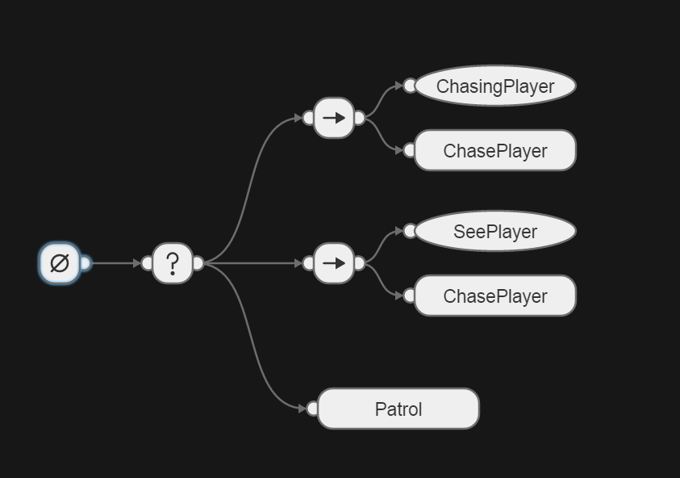

The code to create the design above was complicated, and I had to use an example repository by efbenson call [behavior3Test](https://github.com/efbenson/behavior3Test). Using his example I was able to create a code structure which read my tree above and ran personalised functions. The code below shows the base of the AITree class, where it creates the load methods (loadAction, loadCondition) then calls the initaliser at the bottom.

**var *tree*** = {};  
  
**function** *AITree*(enemy) {  
  
 **this**.treeUpdate = **function**() {  
 **this**.**ai**.**guy**.tick(**this**.**character**, **this**.**character**.**memory**);  
 }  
  
 **this**.loadAction = **function**(name, properties) {  
 **return** *loadTreeNode*(name, properties, **b3**.**Action**);  
 }  
  
 **this**.loadCondition = **function**(name, properties) {  
 **return** *loadTreeNode*(name, properties, **b3**.**Condition**);  
 }

...

**this**.treeInit = **function**(action, condition) {  
 *// Initalise custom actions & conditions* **this**.actions(action);  
 **this**.conditions(condition);  
 }  
 *// Constructor:* **this**.treeInit(**this**.loadAction, **this**.loadCondition);  
  
 **this**.**ai** = {**'guy'**: **new b3**.**BehaviorTree**()};  
 **this**.**ai**.**guy**.load(**JSON**.parse(***game***.**cache**.getText(**'AITree'**)), ***tree***);  
  
 **this**.**character** = {  
 **memory**: **new b3**.**Blackboard**()  
 };  
 **this**.**character**.**memory**.set(**'pointer'**, enemy);  
}

The initialiser is passing across the custom conditions and actions, which return either a SUCCESS or FAILURE result. These will all get passed into the loadTreeNode class which will create a code version of the tree diagram above.

To summarise the loadAction and loadCondition grab all the actions and conditions then passes them into the loadTreeNode. This code creates a new type, so either an action or condition, passes across the action/conditions name (i.e. ChasePlayer) and stores the function as the property. Finally it adds that node to the tree (An array of nodes), using the name as a key. It then returns the array to confirm that it was added to the tree.

**function** *loadTreeNode*(name, properties, type) {  
 **var** node = **b3**.Class(type);  
 **var** nodeProto = node.**prototype**;  
 nodeProto.**name** = name;  
 **for** (**var** prop **in** properties) {  
 nodeProto[prop] = properties[prop];  
 }  
 ***tree***[name] = node;  
 **return** node;  
}

And below are the methods will all the custom functions inside of them.

**this**.actions = **function**(action) {  
 action(**'ChasePlayer'**, {  
 tick: **function**(tick) {  
 **var** enemy = tick.**blackboard**.get(**'pointer'**);  
 enemy.**enemySprite**.**body**.**velocity**.**x** = 0;  
  
 *// Handles moving Left & Right* **if** (***player***.**playerSprite**.**x** < enemy.**enemySprite**.**x** ) {  
 enemy.**enemySprite**.**body**.**velocity**.**x** = -enemy.**speed**;  
 **if** (enemy.**enemySprite**.**width** > 0) { *// Flip image vertically (Face Left)* enemy.**enemySprite**.scale.**x** *= -1;  
 enemy.**enemySprite**.**x** -= enemy.**enemySprite**.**width**; *// Prevents position from changing after flip* }  
 }  
 **else if** (***player***.**playerSprite**.**x** > enemy.**enemySprite**.**x**) {  
 enemy.**enemySprite**.**body**.**velocity**.**x** = enemy.**speed**;  
 **if** (enemy.**enemySprite**.**width** < 0) { *// Flip image vertically (Face Right)* enemy.**enemySprite**.scale.**x** *= -1;  
 enemy.**enemySprite**.**x** -= enemy.**enemySprite**.**width**; *// Prevents position from changing after flip* }  
 }  
 **if** (!enemy.**walkAnimation**.**isPlaying** && !enemy.**climbAnimation**.**isPlaying**) {  
 enemy.stopAnimations();  
 enemy.**walkAnimation**.play();  
 }  
 *// Handles moving Up or Down* **if** (***player***.**playerSprite**.**y** != enemy.**enemySprite**.**y**) {  
 *// Check if player above or below AI* **if** (***game***.physics.**arcade**.overlap(enemy.**enemySprite**, ***stairLayer***)) {  
 **if** (***player***.**playerSprite**.**y** < enemy.**enemySprite**.**y**) {  
 enemy.**enemySprite**.**body**.**velocity**.**y** = -enemy.**speed**/2; *// Move at half speed* }  
 **else** {  
 enemy.**enemySprite**.**body**.**velocity**.**y** = enemy.**speed**/2; *// Move at half speed* }  
 **if** (!enemy.**climbAnimation**.**isPlaying**) {  
 enemy.stopAnimations();  
 enemy.**climbAnimation**.play();  
 }  
 }  
 **if** (!enemy.**walkAnimation**.**isPlaying** && !enemy.**climbAnimation**.**isPlaying**) {  
 enemy.stopAnimations();  
 enemy.**walkAnimation**.play();  
 }  
 }  
 **return b3**.**SUCCESS**;  
 }  
 });  
 action(**'Patrol'**, {  
 tick: **function**(tick) {  
 **var** enemy = tick.**blackboard**.get(**'pointer'**);  
 **if**(enemy.**state** === enemy.**enemyStates**.**LEFT**) {  
 enemy.**enemySprite**.**body**.**velocity**.**x** = -enemy.**speed**;  
 **if** (enemy.**enemySprite**.**width** > 0) { *// Flip image vertically (Face Left)* enemy.**enemySprite**.scale.**x** *= -1;  
 enemy.**enemySprite**.**x** -= enemy.**enemySprite**.**width**; *// Prevents position from changing after flip* }  
 **if** (enemy.**enemySprite**.**x** <= (0 - enemy.**enemySprite**.**width**) ) {  
 *// Needs to be minus as width becomes negative when flipped* enemy.**state** = enemy.**enemyStates**.**RIGHT**;  
 }  
 }  
 **else** {  
 enemy.**enemySprite**.**body**.**velocity**.**x** = enemy.**speed**;  
 **if** (enemy.**enemySprite**.**width** < 0) { *// Flip image vertically (Face Right)* enemy.**enemySprite**.scale.**x** *= -1;  
 enemy.**enemySprite**.**x** -= enemy.**enemySprite**.**width**; *// Prevents position from changing after flip* }  
 **if** (enemy.**enemySprite**.**x** >= (***GAMEWIDTH*** - enemy.**enemySprite**.**width**)) {  
 enemy.**state** = enemy.**enemyStates**.**LEFT**;  
 }  
 }  
 **if** (!enemy.**walkAnimation**.**isPlaying**) {  
 enemy.stopAnimations();  
 enemy.**walkAnimation**.play();  
 }  
 **return b3**.**SUCCESS**;  
 }  
 });  
}  
  
**this**.conditions = **function**(condition) {  
 condition(**'ChasingPlayer'**, {  
 tick: **function**(tick) {  
 **var** enemy = tick.**blackboard**.get(**'pointer'**);  
 **if** (enemy.**state** === enemy.**enemyStates**.**CHASING**) {  
 **return b3**.**SUCCESS**;  
 }  
 **return b3**.**FAILURE**;  
 }  
 });  
 condition(**'SeePlayer'**, {  
 tick: **function**(tick) {  
 **var** enemy = tick.**blackboard**.get(**'pointer'**);  
 **if**(enemy.**state** === enemy.**enemyStates**.**LEFT**) {  
 **if**(***player***.state === ***player***.**playerStates**.**LIGHT** && ***player***.**playerSprite**.**x** <= enemy.**enemySprite**.**x** && ***player***.**playerSprite**.**y** === enemy.**enemySprite**.**y**) {  
 enemy.**state** = enemy.**enemyStates**.**CHASING**;  
 enemy.**speed** = enemy.**baseSpeed**+50;  
 enemy.**yell**.musicPlay();  
 **return b3**.**SUCCESS**;  
 }  
 }  
 **else** {  
 **if**(***player***.state === ***player***.**playerStates**.**LIGHT** && ***player***.**playerSprite**.**x** >= enemy.**enemySprite**.**x** && ***player***.**playerSprite**.**y** === enemy.**enemySprite**.**y**) {  
 enemy.**state** = enemy.**enemyStates**.**CHASING**;  
 enemy.**speed** = enemy.**baseSpeed**+50;  
 enemy.**yell**.musicPlay();  
 **return b3**.**SUCCESS**;  
 }  
 }  
 **return b3**.**FAILURE**;  
 }  
 });  
}

### Floor

Very similar to the BGTile in design except that the arcade physics apply, so that the player and enemy can collide with them. Despite this the gravity has been turned off and the floor objects are immovable, meaning objects can’t move them.

**function** *Floor*(x, y) {  
 **this**.**floorSprite** = ***game***.add.sprite(x, y, **'floor'**);  
 **this**.**floorSprite**.**width** = ***TileSizeX***;  
 **this**.**floorSprite**.**height** = ***TileSizeY***;  
  
 ***game***.physics.enable(**this**.**floorSprite**, *Phaser*.***Physics***.**ARCADE**);  
 **this**.**floorSprite**.**body**.**allowGravity** = **false**;  
 **this**.**floorSprite**.**body**.**immovable** = **true**;  
 ***background***.add(**this**.**floorSprite**);  
}

### Wall

The Wall class is almost identical to the Floor object, the only difference being the graphic passed being used.

**function** *Wall*(x, y) {  
 **this**.**wallSprite** = ***game***.add.sprite(x, y, **'wall'**);  
 **this**.**wallSprite**.**width** = ***TileSizeX***;  
 **this**.**wallSprite**.**height** = ***TileSizeY***;  
  
 ***game***.physics.enable(**this**.**wallSprite**, *Phaser*.***Physics***.**ARCADE**);  
 **this**.**wallSprite**.**body**.**allowGravity** = **false**;  
 **this**.**wallSprite**.**body**.**immovable** = **true**;  
 ***wallLayer***.add(**this**.**wallSprite**);  
}

### Light

The Light class is almost identical to the Wall object, the only difference being the graphic passed being used.

**function** *Light*(x, y) {  
 **this**.**lightSprite** = ***game***.add.sprite(x, y, **'light'**);  
 **this**.**lightSprite**.**width** = ***TileSizeX***;  
 **this**.**lightSprite**.**height** = ***TileSizeY***;  
  
 ***game***.physics.enable(**this**.**lightSprite**, *Phaser*.***Physics***.**ARCADE**);  
 **this**.**lightSprite**.**body**.**allowGravity** = **false**;  
 **this**.**lightSprite**.**body**.**immovable** = **true**;  
 ***lightLayer***.add(**this**.**lightSprite**);  
}

### Stairs

The Stair class is almost identical to the Light object, the only difference being the graphic passed being used.

**function** *Stair*(x, y) {  
 **this**.**stairSprite** = ***game***.add.sprite(x, (y-5), **'stairs'**);  
 **this**.**stairSprite**.**width** = ***TileSizeX***;  
 **this**.**stairSprite**.**height** = (***TileSizeY***+5);  
  
 ***game***.physics.enable(**this**.**stairSprite**, *Phaser*.***Physics***.**ARCADE**);  
 **this**.**stairSprite**.**body**.**allowGravity** = **false**;  
 **this**.**stairSprite**.**body**.**gravity**.**y** = 0;  
 **this**.**stairSprite**.**body**.**immovable** = **true**;  
 ***stairLayer***.add(**this**.**stairSprite**);  
  
 **this**.stairCollision = **function** () {  
 *// Turn player gravity off!* ***player***.setGravity(**false**);  
 }  
}

### Exit

The Exit class is almost identical to the Stair object, the only difference being the graphic passed being used.

**function** *Exit*(x, y) {  
 **this**.**exitSprite** = ***game***.add.sprite(x, y, **'exit'**);  
 **this**.**exitSprite**.**width** = ***TileSizeX***;  
 **this**.**exitSprite**.**height** = ***TileSizeY***;  
  
 ***game***.physics.enable(**this**.**exitSprite**, *Phaser*.***Physics***.**ARCADE**);  
 **this**.**exitSprite**.**body**.**allowGravity** = **false**;  
 **this**.**exitSprite**.**body**.**immovable** = **true**;  
 ***exitLayer***.add(**this**.**exitSprite**);  
}

### Intel

The Intel class is similar to the Exit object except for the graphic passed being used, having a destroy method and adding to the “getIntel” signal. Signals will be explained in the next session.

**function** *Intel*(x, y) {  
 **this**.**intelSprite** = ***game***.add.sprite(x, (y+(***TileSizeY***/2)), **'intel'**);  
 **this**.**intelSprite**.**width** = (***TileSizeX***/2);  
 **this**.**intelSprite**.**height** = (***TileSizeY***/2);  
  
 ***game***.physics.enable(**this**.**intelSprite**, *Phaser*.***Physics***.**ARCADE**);  
 **this**.**intelSprite**.**body**.**allowGravity** = **false**;  
 **this**.**intelSprite**.**body**.**immovable** = **true**;  
 ***foreground***.add(**this**.**intelSprite**);  
  
 **this**.destroy = **function**() {  
 **this**.**intelSprite**.destroy();  
 }  
  
 ***getIntel***.addSignal (**function**() {  
 ***intel***.destroy();  
 })  
}

### Signals

A signal is like an event listener (or a middle man) where certain functions related to objects will get called when an event occurs. For example if the playerDied signal gets called then 2 functions will be run, one resets the players position and the other resets the enemies positon. Below is the object class that each signal is based off.

**function** *Signal*() {  
 **this**.**signal** = **new** *Phaser*.Signal();  
  
 **this**.addSignal = **function** (func) {  
 **this**.**signal**.add(func);  
 }  
 **this**.call = **function** () {  
 **this**.**signal**.dispatch();  
 }  
}

### Music

The name music may be a little misleading as this object handles all sounds, but it was originally designed to just handle the background music. I treated this as a juke box, where you could pass across a song, play it, loop it, stop it or queue a replacement song.

**function** *sound*(song) {  
 *// Init* **this**.**music** = ***game***.add.audio(song);  
  
 **this**.musicUpdate = **function**() {  
 **if**(!**this**.**music**.**loop** && !**this**.**music**.**isPlaying**) {  
 **this**.**music** = ***game***.add.audio(**this**.**nextSong**);  
 **this**.musicLoop();  
 }  
 }  
  
 **this**.queueSong = **function**(song) {  
 **this**.**nextSong** = song;  
 **this**.**music**.**loop** = **false**;  
 **this**.**music**.fadeOut(5000);  
 }  
  
 **this**.musicPlay = **function**() {  
 **this**.**music**.play();  
 }  
  
 **this**.musicLoop = **function**() {  
 **this**.**music**.play();  
 **this**.**music**.loopFull();  
 }  
  
 **this**.musicStop = **function**() {  
 **this**.**music**.stop();  
 }  
  
 **this**.musicVol = **function**(vol) {  
 **this**.**music**.**volume** = vol;  
 }  
}

## Assets

My image assets, apart from the Ladder.png, have come from [Game Art 2D](http://www.gameart2d.com/freebies.html) and are under the “Creative Common Zero (CCO) a.k.a Public Domain license” (GameArt, 2016). They provided me with a large amount of PNG files and I used a tool to merge them into a single spritesheet image, and created an xml file for them. The tool I used was [Sprite Sheet Packer](http://spritesheetpacker.codeplex.com/) which is an open-source tool for merging PNGs.

For my sounds assets I used [freesound](http://www.freesound.org/), a website which provides sounds under the Creative Commons license. I’ve got details for all the sounds I’ve used below:

*background_eerie.wav* - Ambient electronic loop 001 by frankumjay

*background_epic.wav* – “Mike TheTunk Woloszyn" or "Mike Woloszyn" and [www.Senproductions.de](http://www.Senproductions.de)

*robot_intruder.wav* - Mudkip2016 robot requested by kennysvoice

*Steps.wav* - Footsteps on an interior wooden floor by ftpalad

# Investigation and Research

Started by investigating intelligent agents but ended up with…

… behaviour trees.

I looked up and implemented phaser signals.

# Review of Final Product

In this section I’ll give three pros to the design and implementation of the application and then list three improvements and how I might implement them.

* Stores time so solid goal to achieve for different runs

* Behaviour trees work well, and could easily be expanded upon

* Level design is very fluid, and more levels can easily be added or updated

** Implement various difficulties (Enemy move speed and/or multiple enemies)

# References

<http://www.freesound.org/>

<http://www.gameart2d.com/freebies.html>

<http://spritesheetpacker.codeplex.com/>

<http://behavior3js.guineashots.com/>

<http://behavior3js.guineashots.com/editor/>

<https://github.com/efbenson/behavior3Test>

# Appendix