Week 03 Assignment 02_datasets

Josh Pickel

10 September 2020

#github.path = 'https://raw.githubusercontent.com/JoshuaPickel/WSU_STATS419_FALL2020/';  
#source_url(paste0(github.path,'master/functions/libraries.R'));  
#source_url( paste0(github.path,"master/functions/functions-imdb.R") );

plot(cars)

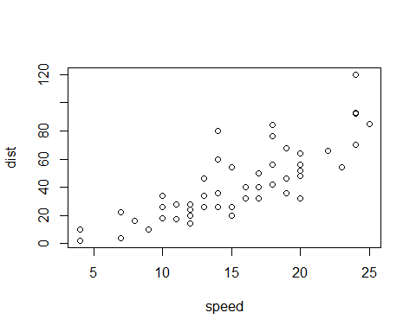

cars plot