PrjRemote Java Version User Manual

Yao Sun
yaosun@cs.pitt.edu

- Introduction

The purpose of the prjRemote is to provide administrative view of all the messages routing around through the SISServer. PrjRemote will display all the messages the SISServer receives. It also provides a way for SIS system administrator to send individual or list of messages with no restrictions to the SIS system, these include Initialization messages, Data messages and even System messages(messages not supposed to be sent from SIS components). It could be used to initialize SIS components, monitor the SIS components and interrupt or turn on/off SIS components.

- System Requirements

- JRE 1.5 or higher is needed to run the prjRemote Java version.
- Before the prjRemote starts, an SISServer is up and running.

- How to Use PrjRemote

  - Start the PrjRemote

To start the PrjRemote, just double click the prjRemote.jar and the prjRemote should run.
If your system does not support direct execution of jar files, then open your terminal and type the following command

Java -jar prjRemote.jar

The prjRemote should run, and the following window should appear.
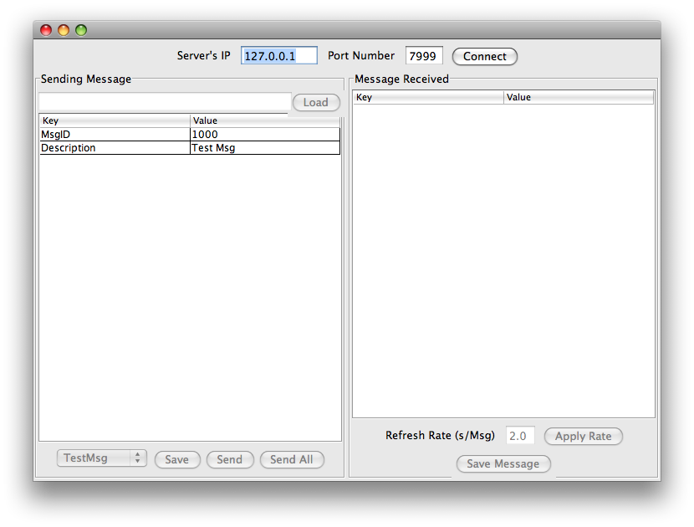
  - Connect to SISServer

Note that all the buttons, textfields, etc are not available except for the Connect to Server button. Simply specify the IP address and port number of the SISServer and click the “connect” button. PrjRemote should connect to the SISServer immediately. If the connection is failed, it will pop up an error message dialog. Users could try again or restart the SISServer then connect. If the connection is successful, all the other buttons will be available and the Connect to Server button will be disabled.
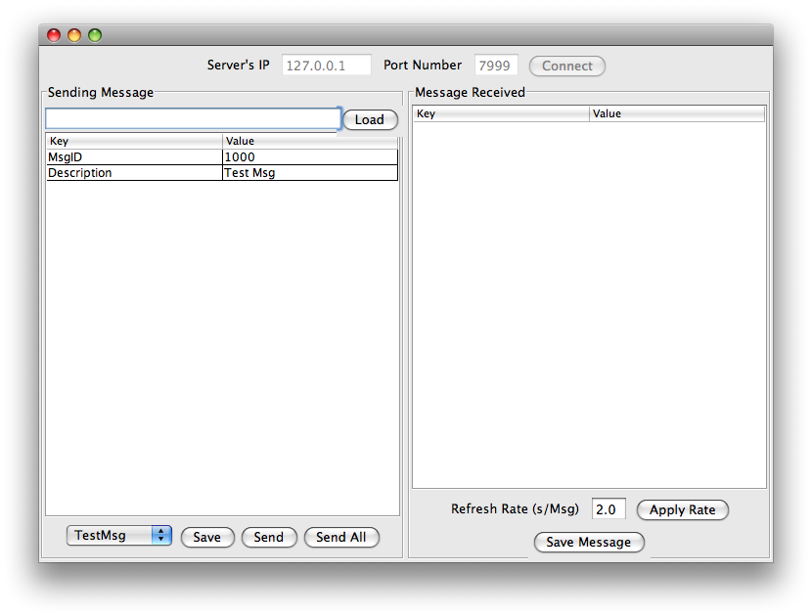
  - Sending Message Pane

3.3.1 Load Messages

Sending Message Pane is the bottom left pane of prjRemote. In this pane, users could load a single message or a list of messages by clicking “load” button. A file chooser dialog will pop up for user to choose desired file, if the file extension is XML, prjRemote will directly parse the XML file as a message, if the file extension is TXT or the file has no extension, prjRemote will treat the file as a message list file, it will try to parse all the messages specified in the message list file.

The format of a message list file is simple. Every line of the message list file specify an address to an XML(message) file. The address could be either absolute address or relative address(relative to the prjRemote’s address). A message file could appear in a message list file multiple times, prjRemote will load the same message multiple times. And messages can have identical names.

By Default, a test message with MsgID 1000 is loaded.

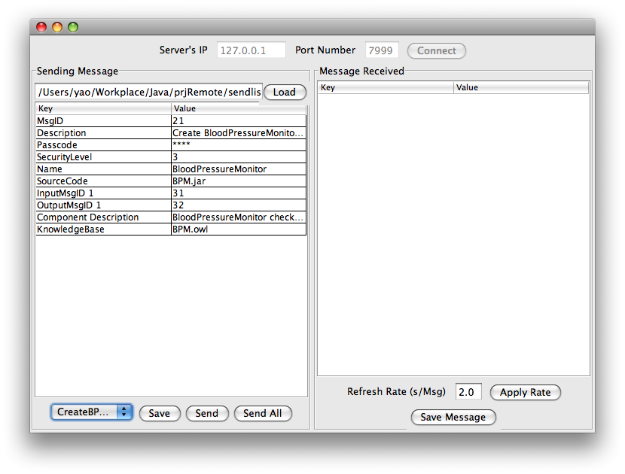

3.3.2 Edit, Save and Send Messages

Users could browse certain messages by selecting from the drop down list below the message pane. The first message loaded by prjRemote will be selected by default.

To edit a message, users could directly edit on the message pane by clicking the corresponding cell. Both Keys and Values could be edited. To add a new line, simply double click on the white space of the message pane. Some rules apply on editing the messages. First, a Key must correspond to a Value and vice versa. Second, No ‘$’ character is allowed in either Key or Value. Third, users could leave a line blank, prjRemote will automatically ignore it. Fourth, if the message pane lost focus, the message in the pane will be synchronized with prjRemote’s internal data structure, so make sure the message is complete before save or send a message.

To save the current displayed message in the message pane, click the “save” button and a file chooser dialog will pop up, users could specify the name and path for the message to be saved.

To send messages to SISServer, click the “send” button to send current displayed message, click “send all” button to send all the messages in the message list. If there’s one message in the message list, for example, user loaded a single message, the “send” button and the “send all” button will have same effect.

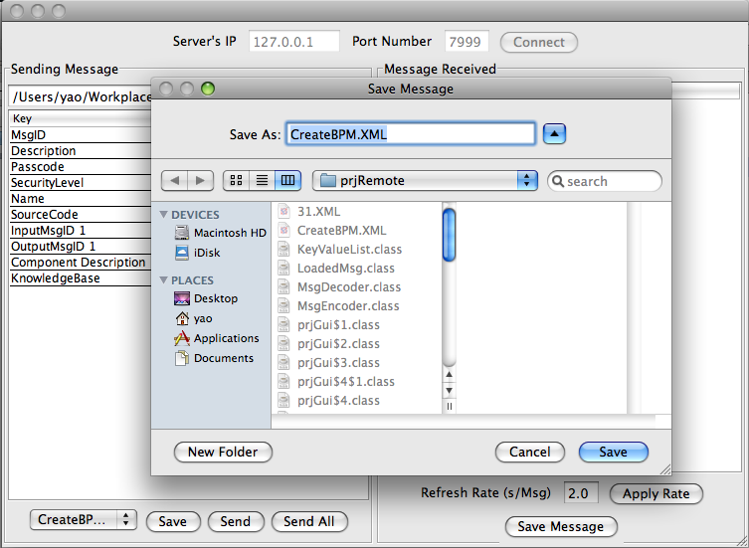

  - Message Received Pane

Message Received Pane is the bottom right pane of prjRemote. It will display all the messages received and routed by SISServer. The message pane is not editable in the Message Received Pane. But still users could save messages displayed in the message pane through “save” button.

Another option is the refresh rate of the message pane, by default, the refresh rate is set to be 2s/msg. If there’re a lot of messages received by SISServer, users could specify a faster rate, say 0.5s/msg, and then click “apply rate”. The messages will be displayed faster.
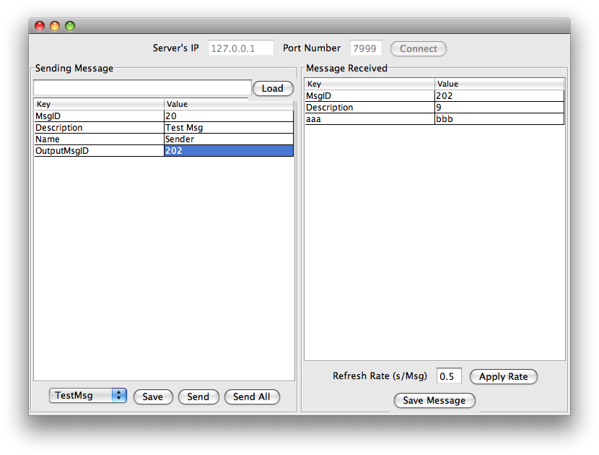

- Contents of Saved Messages

Below is a snapshot of contents of saved messages.

