SISProjectCreator User Manual

Yao Sun
yaosun@cs.pitt.edu

- Introduction
SISProjectCreator is a tool to help SIS system developers create SIS project templates. An SIS project template created by SISProjectCreator basically includes template codes of SIS components and SIS system components, together with related scripts and XMLs. With SISProjectCreator, SIS developers could concentrate on the code to do the actual work, while leaving template codes to handle low level message communications within the SIS system.

- How to use SISProjectCreator
  - Start SISProjectCreator
To successfully run SISProjectCreator, the system’s default JRE version should be 1.5 or higher. The folder named “Templates” with 8 files inside should be in the same directory as SISProjectCreator.jar.
To start the SISProjectCreator, just double click the SISProjectCreator.jar and the SISProjectCreator should run. If the operating system does not support direct execution of jar files, then open the terminal and type the following command
java -jar SISProjectCreator.jar
The SISProjectCreator should run, and the following Create Project window should appear. Type in a Project Name and select the desired Project Type, press OK button and SISProjectCreator will go to General Component-Based System page or Specific Purpose SIS System page.

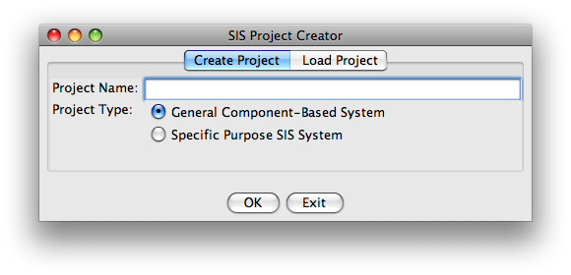
SISProjectCreator is also able to load a previous saved project specification file. Click on the Load Project tab, choose the specification file path, and press OK button. SISProjectCreator will automatically detect the project type and go to General Component-Based System page or Specific Purpose SIS System page.
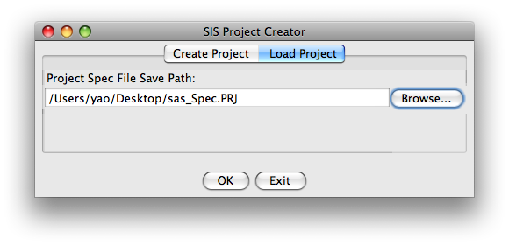
  - General Component-Based System page
Below is a sample of General Component-Based System page.
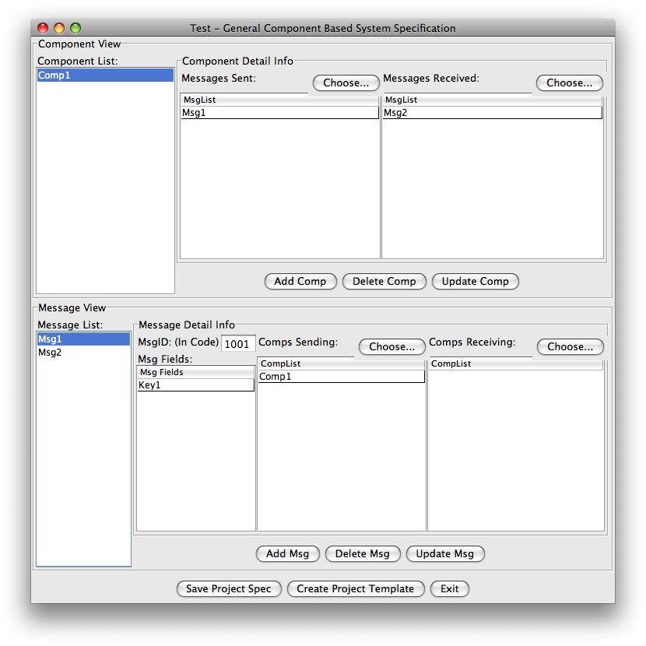
The Component View panel lists all the components in the system. When a component is selected, all its sending and receiving messages will be listed in the Component Detail Info panel to the right. SIS developers could edit the sending and receiving messages by pressing the Choose… button or directly editing the message list table, click the Update Comp button to update the change to the selected component. The Add Comp, Delete Comp buttons by their names do the jobs of adding a new component, deleting a selected component respectively. Any changes within the Component View panel will be automatically updated in the Message View panel. For example, if a message is removed from a component’s sending list, then the component is automatically removed from the message’s sending comps list. If a component is added or deleted, SISProjectCreator will check all the messages’ sending comps lists and receiving comps lists and do necessary updates to ensure consistency.

The Message View panel lists all the messages in the system. When a message is selected, all its sending and receiving components will be listed in the Message Detail Info panel to the right. SIS developers could edit the sending and receiving components by pressing the Choose… button or directly editing the component list table, click the Update Msg button to update the change to the selected message. The Add Msg, Delete Msg buttons by their names do the jobs of adding a new message, deleting a selected message respectively. Any changes within the Message View panel will be automatically updated in the Component View panel. For example, if a component is removed from a message’s sending comps list, then the message is automatically removed from the component’s sending list. If a message is added or deleted, SISProjectCreator will check all the components’ sending lists and receiving lists and do necessary updates to ensure consistency. When a new message is added, its MsgID is automatically assigned, its Description field will be its message name. So in Msg Fields table, MsgID and Description must NOT be added.

  - Specific Purpose SIS System page
2.3.1 Cycles information page
Below is the sample of the 1st part of the Specific Purpose SIS System page. In this page, all the SIS cycles information is listed.
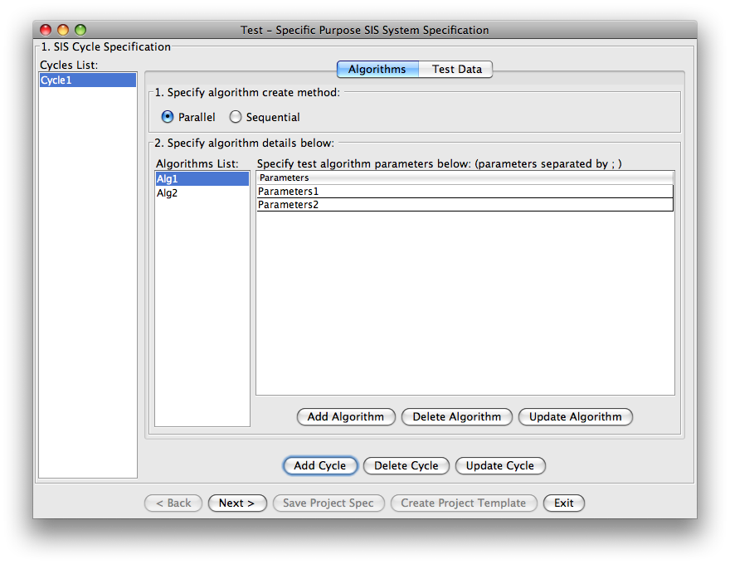
If a cycle is selected, the cycle’s algorithms are listed. How the algorithms should be created could be specified as Parallel or Sequential. If a certain algoritm is selected, the algorithm’s parameters lists are shown. SIS developers could directly edit on the parameters lists table. Add Cycle, Delete Cycle and Update Cycle buttons are used to add a new cycle, delete a selected cycle or update a selected cycle. If a cycle is selected, Add Algorithm, Delete Algorithm and Update Algorithm buttons can be used to add a new Algorithm, delete a selected Algorithm or update a selected Algorithm.

Click on Test Data tab, the Test Data view is shown as below.
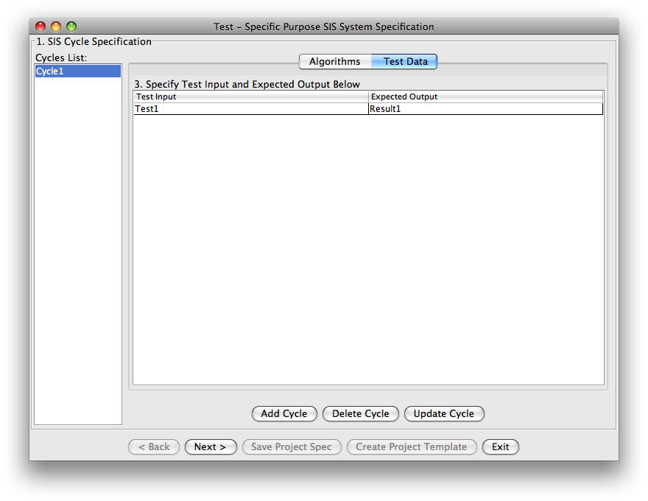
If a cycle is selected, all the selected cycle’s test data and expected output are listed as pairs. Expected output could be empty for a specific test data. SIS developers could directly edit on the test data table. Add Cycle, Delete Cycle and Update Cycle buttons are used to add a new cycle, delete a selected cycle or update a selected cycle.

2.3.2 TimeController information page
Below is the sample of the 2nd part of the Specific Purpose SIS System page. In this page, all the TimeController information is listed.
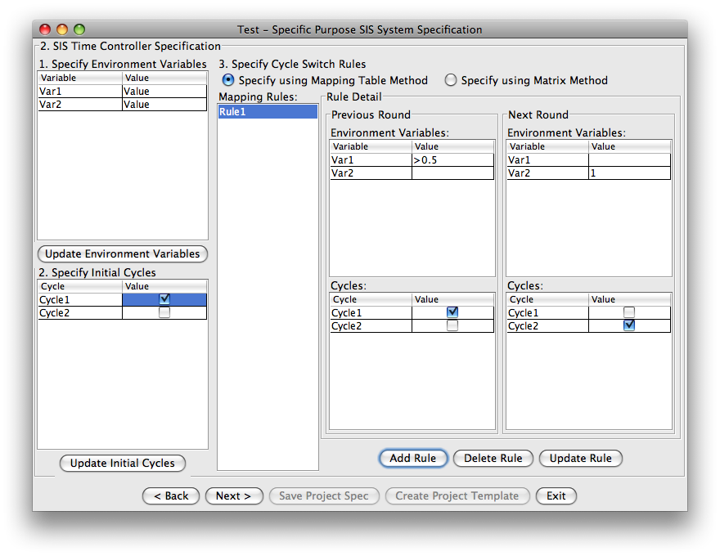
In the top left table, all environment variables with their initial values are listed, SIS developers could edit on the table directly and save the changes by clicking the Update Environment Variables button. The value of an environment variable could be empty, meaning default 0. In the bottom left table, SIS developers could specify whether a cycle should be started in the initial round of SIS system running, save the changes by clicking Update Initial Cycles button. Checked means yes, unchecked means no.

In the right panel, TimeController’s cycle switch rules are listed. By default, mapping table method is selected. It defines a series of cycle switch rules. If a rule is selected, the rule detail is shown. Previous Round panel lists the condition when the rule should be applied, if the environment variable’s value is empty, then it means the environment variable can be any value. The environment variable’s value accepts the following operators: >=, <=, >, <, =, !=. If none of the operators appears, it means =. The cycles value means whether a cycle is started in the previous round of running. Next Round panel lists the environment variables’ values and which cycles should be run in the next round. If an environment variable’s value is empty, the environment variable’s value is not updated in the next round. If a cycle is checked, this means in the next round of running, the cycle should be started. TimeController uses the rules to determine next round of running, including environment variables’ values and which cycles to start. If no rule can be applied or no cycles will be started in the next round, the SIS system finishes running.
Another method to specify TimeController’s cycle switching rules is to use matrix method. Click the Specify using Matrix Method button and Matrix view is shown as below. The matrix should be square matrix and the size should be equal to the sum of number of environment variables and number of cycles.
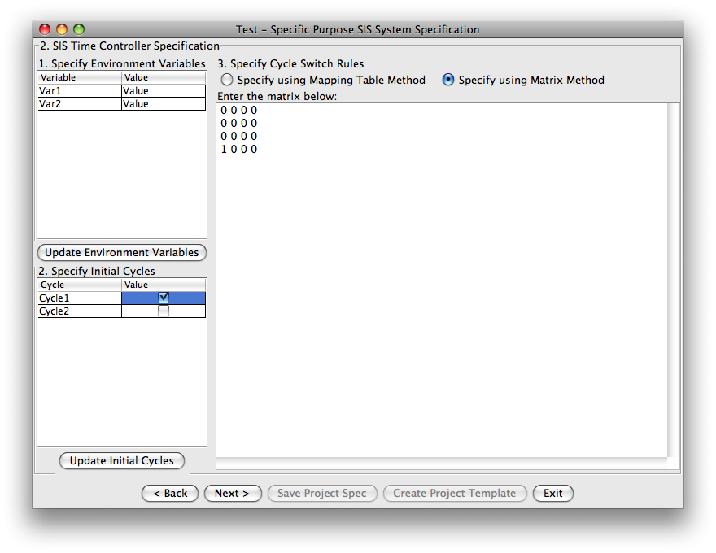
2.3.3 Other system behavior specification page
Below is the sample of the 3rd part of the Specific Purpose SIS System page. In this page, all the other SIS system behavior information is listed. SIS developers could change the values to adjust SIS system’s behavior.
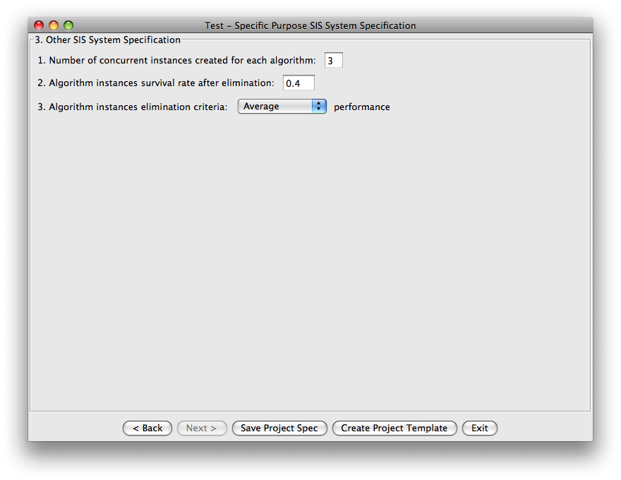
  - Save specification file or create project template
To save the specification for future use, click Save Project Spec button and choose a path, the specification will be saved as a file with extension PRJ. It could be loaded when SISProjectCreator starts.
To create project templates, click Create Project Template button and choose a directory. If the directory name is equal to the project name, the selected directory’s contents will be erased and project templates will be created. If the directory name is not equal to the project name, SISProjectCreator will create a new directory with project name under the selected directory and project templates will be created under the new directory. A specification file will be saved under the same directory as project templates.

- How to Run Generated SIS Systems
3.1 SISProjectCreator Generated General Component Based System
For General Component Based System created using SISProjectCreator, follow the steps below to start the system.
- run SISServer following instructions in section 4.2
- run prjRemote, the SISServer address is 127.0.0.1 if SISServer is running on local machine, port number is always 7999, and then click Connect button
- in prjRemote, load init xmls from
ProjectFolder/xml/InitXML/list_InitXML.txt
and then click Send All button, if list_InitXML.txt cannot be loaded, open the file and check if the paths are correct, or manually load all the xmls under ProjectFolder/xml/InitXML directory
- run the runAllComps.bat under ProjectFolder/Scripts to start all the components at once or start components individually using scripts under ProjectFolder/Scripts/runIndividualComp. If using operating system other than Windows, open the runAllComps.bat and type the javac and java commands in the scripts under command line terminal to manually start all the components under ProjectFolder/Components
3.2 SISProjectCreator Generated Specific Purpose SIS System
For Specific Purpose SIS System created using SISProjectCreator, follow the steps below to start the system.
- run SISServer following instructions in section 4.2
- run prjRemote, the SISServer address is 127.0.0.1 if SISServer is running on local machine, port number is always 7999, and then click Connect button
- in prjRemote, load init xmls from
ProjectFolder/xml/InitXML/list_InitXML.txt
and then click Send All button, if list_InitXML.txt cannot be loaded, open the file and check if the paths are correct, or manually load all the xmls under ProjectFolder/xml/InitXML directory, they are CreateEnumerator.XML, CreateEliminator.XML, CreateDataSender.XML, CreateVerifier.XML, CreateTimeController.XML
- run the 5 scripts under ProjectFolder/Scripts, they are runEnumerator.bat, runEliminator.bat, runDataSender.bat, runVerifier.bat and runTimeController.bat. Note runTimeController.bat should be started after all other 4 scripts are started. If using operating system other than Windows, open the 5 scripts and type the javac and java commands in the scripts under command line terminal to manually start all the system components under ProjectFolder/System, they are Enumerator, Eliminator, DataSender, Verifier and TimeController.

- Other tips or notes in using SISProjectCreator
- When editing a table in the SISProjectCreator, double click on any empty space of the table to append a new empty line at the end of the table.
- After project templates are created, SIS developers should add or modify the template codes to do actual work. For General Component-Based System templates, the components’ codes should be modified according to commented instructions in the template codes. For Specific Purpose SIS System templates, look into Eliminator, Verifier and Algorithms’ template codes and add or modify the codes according to commented instructions. For SIS developers not using Windows, the following code in Enumerator(Line: 346) should be modified accordingly.
Runtime.getRuntime().exec("cmd.exe /k start \""+cycle+"_"+name+ "_"+enumeratecount+"\" java -cp "+compdir+algpath+" "+algfile+" "+enumeratecount+" "+parlist);

- For Specific Purpose SIS Systems, the running result of the system is under
ProjectDirectory/Data/Result/EliminatorLog.txt.
- Script files under ProjectDirectory/Scripts directory can only be used under Windows, for other operating systems, look into the scripts files and modify accordingly or directly start the system in Terminal as what the scripts do.
For Specific Purpose SIS Systems, the system behavior could be manually adjusted by editing the configuration file
ProjectDirectory/System/Config/Config.txt
following commented instructions.
- For Specific Purpose SIS Systems, TimeController should always be started in the last(after all other 4 system components).
- For detailed information about SIS systems, refer to sisv3n5readme.txt under SISv3/Testbed/Documents. For setup information about SISServer, refer to SISsetup under SISv3/Testbed/System/SISServer.

