Tutorial for specifying Parallel SIS System

Introduction
This tutorial is designed to help you develop a parallel SIS system by the tool SISProjectCreator. We give an example of face recognition to show how to use this tool. Four face databases of Yale, ORL, FERET and Chinese are used in this experiment. We have three parameterized face recognition algorithms to deal with those face databases, namely, principal component analysis (PCA), independent component analysis (ICA) and 3-neighbor classification (TNC). The users would be confused as they don’t know which algorithm they should select in recognizing a given subject. Through our system, the most efficient algorithm can be found.
In chapter 1, we use the given tool SISProjectCreator to create a template face recognition project. You will know how to specify a parallel SIS system and how to run it. You can also check the specified cycles and algorithms while running. However, the template project only show the basically principal and framework of SIS system because the algorithms are still not implemented.
In chapter 2, we implement face recognition system based on the previous template project. All algorithms are implemented and files are modified in this stage. In the end of this chapter, a useful and integrated face recognition system is done. The recognition rates of each component are achieved.
In chapter 3, we show more features of our SIS system by introducing another cycle. We also specify environment variable to control cycles. The flow diagram is shown below.
Cycle 1:
parallel components
ICA 1
ICA 2
TON 2
TON 1
Cycle 2:
parallel components

PCA 1
PCA 2
Only when image quality in face databases > 0.5
Four face databases of Yale, ORL, FERET and Chinese

- Create a template project for parallel SIS system
  - Create Project
Run Testbed\SISProjectCreator\SISProjectCreator.jar as shown in figure 1.1, input project name and select specific purpose SIS System to create.
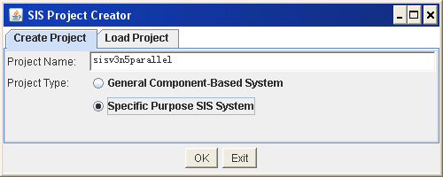
Figure 1.1 create project
Click OK button, the main interface is shown as figure 1.2.
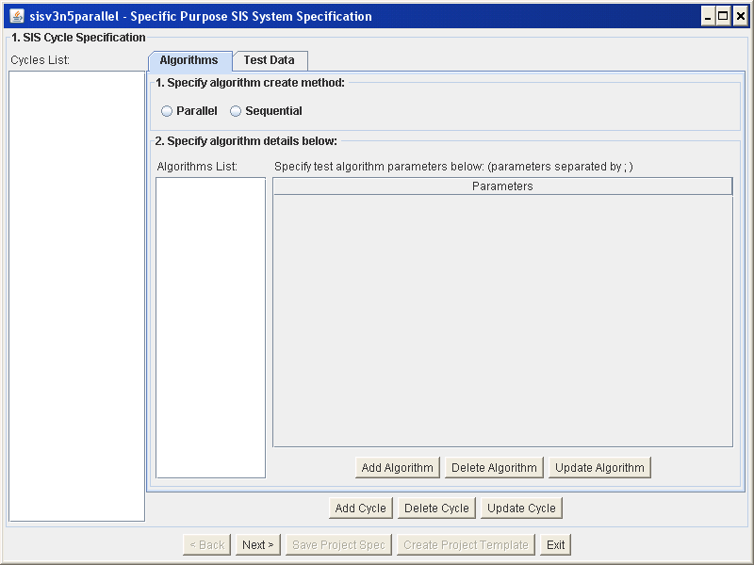
Figure 1.2 main interface
  - Cycle specification
Click Add Cycle button, input cycle name and select parallel modal for algorithms. Then specify cycle algorithms’ names in the bottom textbox.
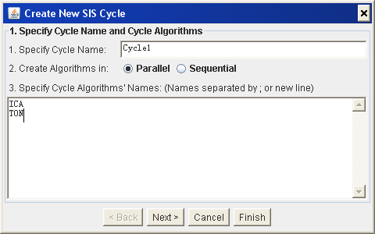
Figure 1.3 Cycle specification
  - Algorithm parameters specification
Click next to specify algorithm parameters as shown in figure 1.4. Double click the parameters textbox on the right of interface, a new line will shown and parameters can be appended now.
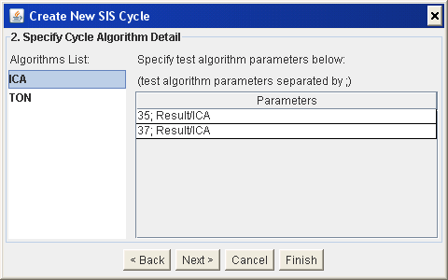
Figure 1.4(a) algorithm parameters specification for ICA
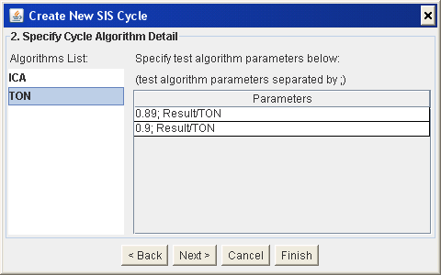
Figure 1.4(b) algorithm parameters specification for TON
  - input/output data specification
Click next to specify test data and expected result as shown in figure 1.5. Double click the textbox on the right of interface, a new line will shown and input/output data can be appended now. The expected result can be empty.
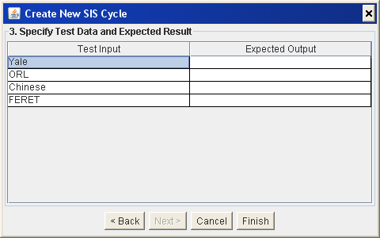
Figure 1.5 input/output data specification

  - modification of specification
Click Finish button. The basic speciation is done as shown in figure 1.6. The specification of cycle, algorithms and input/output data can be modified in this interface.
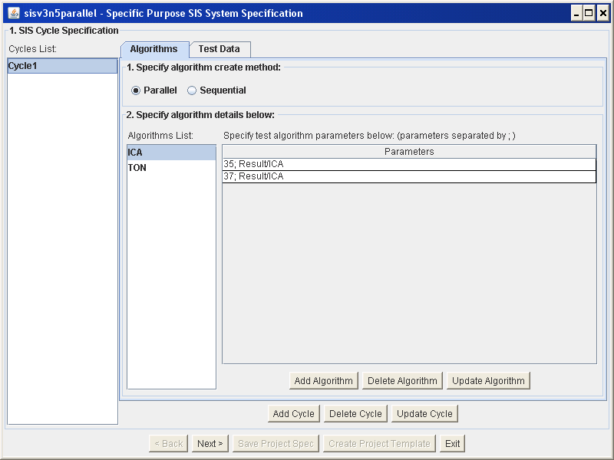
Figure 1.6 modification of specification
  - Timer Controller specification
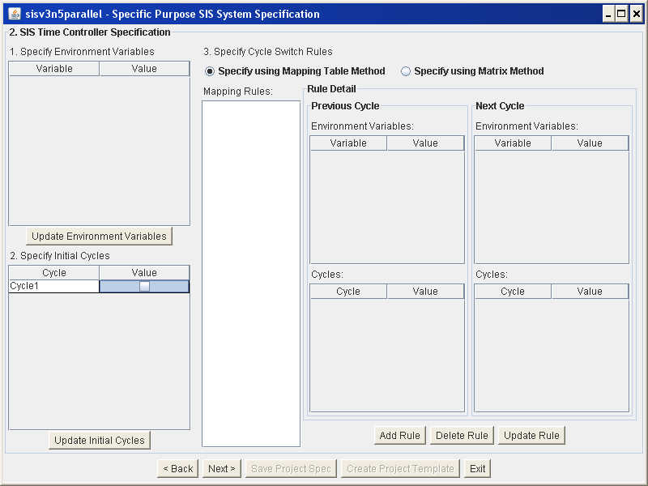
Figure 1.7 timer controller specification
Click Next button to specify Timer Controller as shown in figure 1.7. As only one cycle is defined, we needn’t to specify it. We will define it in chapter 3 when we have more cycles.
  - Other specification
Click Next button to specify other variables as shown in figure 1.8.
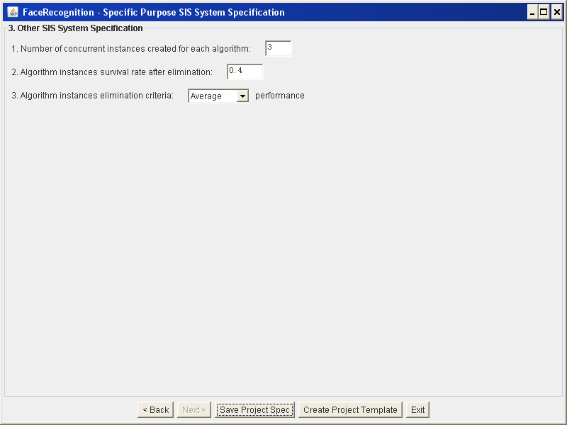
Figure 1.8 other specification
  - Create Project Template
Click ‘Create Project Template’ button, select your project folder as figure 1.9. Then a template project is built on your specified folder as shown in figure 1.10.
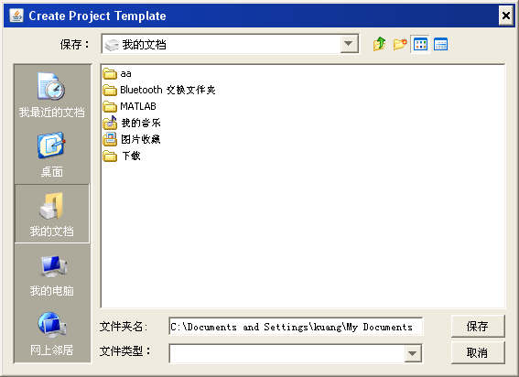
Figure 1.9 folder select for template project
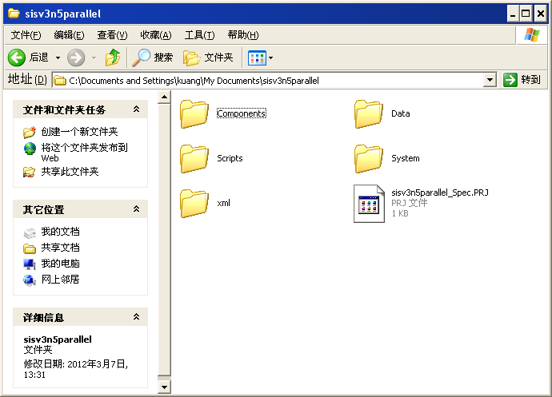
Figure 1.10 detail files in template project
  - Run it
Now the template project is built. We can simply run it following the below steps.
  - Start SISServer by double clicking the runServer.bat under Testbed/Scripts/runServer.bat
  - Start prjRemote by double clicking prjRemote.jar under Testbed/prjRemote.jar
  - Load initialization XMLs from prjRemote, click "Load" button in prjRemote, browse to the following file Testbed/sisv3n5parallel/xml/InitXML/list_InitXML.txt and then click "Send all" button in prjRemote
  - Start the SIS/SIA components by double clicking the following scripts
Testbed/Sisv3n5parallel/Scripts/runDataSender.bat
Testbed/Sisv3n5parallel/Scripts/runEliminator.bat
Testbed/Sisv3n5parallel/Scripts/runEnumerator.bat
Testbed/Sisv3n5parallel/Scripts/runVerifier.bat
Testbed/Sisv3n5parallel/Scripts/runTimeController.bat
Note: runTimeController.bat should be started in the last, after all the other 4 scripts started.
  - Now the SIS should start running, in the end, only SISServer and prjRemote live.
  - Trace messages and results
While the SIS is running, you can trace the messages transfer among all components through prjRemote as shown in figure 1.11.
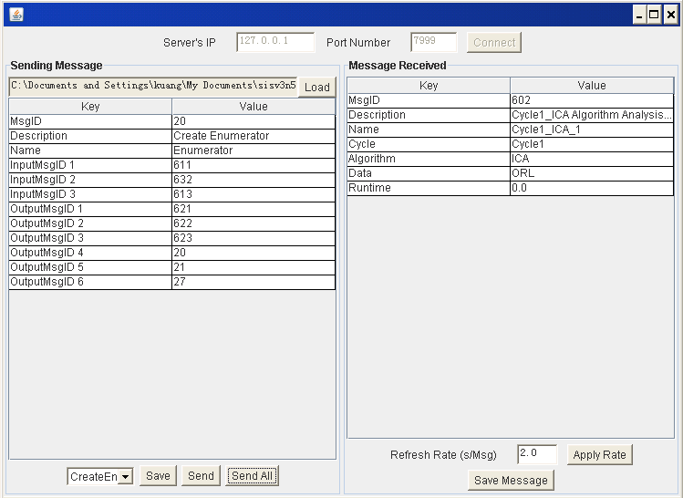
Figure 1.11 messages tracing through prjRemote
After the SIS is finished, only SISServer and prjRemote are alive, and the result is wrote into file Data\Result\ EliminatorLog.txt, as shown in figure 1.12.
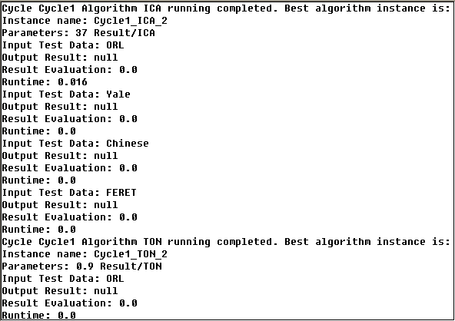
Figure 1.12 simulated output result in file Data\Result\ EliminatorLog.txt
Remember: The result of facial recognition is just simulated and not true yet, as our facial recognition images and algorithms are not introduced in the system. We are going to do that in next chapter.
- System implementation based on the previous template project
  - Prepare Matlab R2010b or R2011a
Before starting the SIS/SIA application, make sure the Matlab R2010b is installed. If Matlab R2011a is installed, please replace all the four .jar files with corresponding files under Testbed\sisv3n5parallel\lib\backup\backup_R20011a. Otherwise, recompile .m files under Testbed\sisv3n5parallel\lib\matlabCode to .jar package.
  - Prepare .jar package files
We have implemented three parameterized algorithms: principal component analysis (PCA), independent component analysis (ICA) and 3-neighbor classification (TNC) respectively. All of three face recognition algorithms are programmed by Matlab and deploy in the form of JAR so that Java can call them. You should copy all .jar files under Testbed\sisv3n5parallel\lib to your own project.
  - Prepare face databases
Copy face databases in directory Testbed\sisv3n5parallel\Data\face to your project. Here we have 4 face databases: Yale, ORL, Chinese and FERET. Each database is a folder which includes a great deal of images of different person’s faces.
  - Algorithm Implementation
Modify Sisv3n5parallel\Components\Cycle1\ICA\ CreateCycle1_ICA.java,
Sisv3n5parallel\Components\Cycle1\PCA\ CreateCycle1_PCA.java. and
Sisv3n5parallel\Components\Cycle2\TON\ CreateCycle2_TON.java respectively.
You should implement receiving algorithm’s parameters in main function and program your algorithm in ProcessMsg function as shown in figure 2.1 and 2.2 respectively.
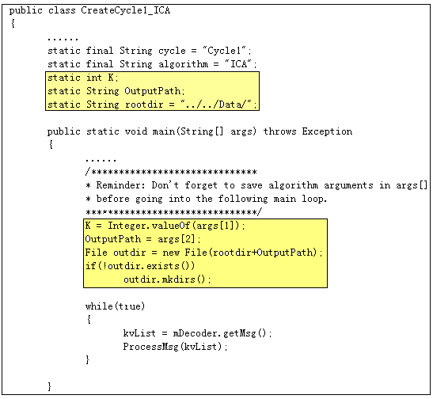
Figure 2.1(a) codes of ICA for receiving algorithm’s parameters

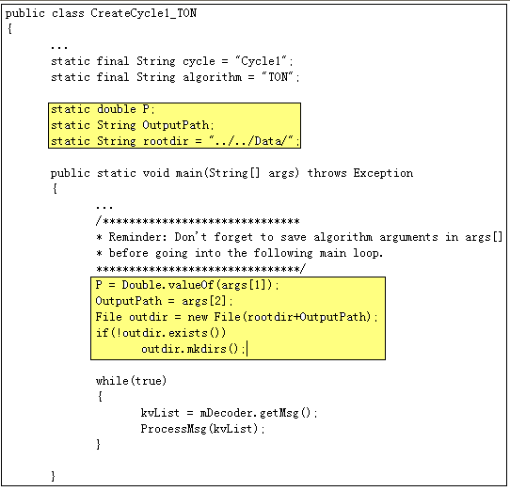
Figure 2.1(b) codes of TON for receiving algorithm’s parameters
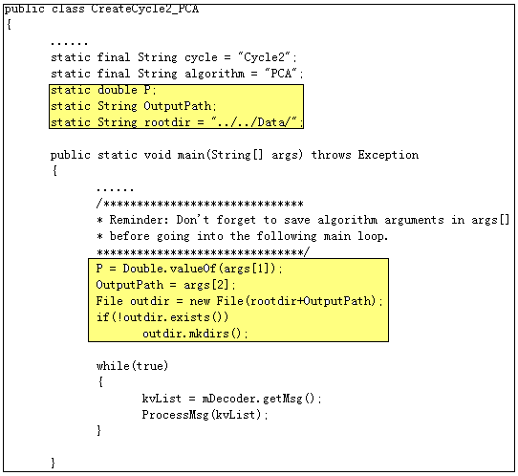
Figure 2.1(c) codes of PCA for receiving algorithm’s parameters

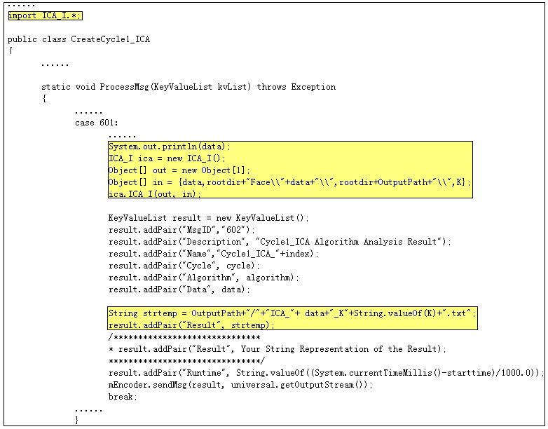
Figure 2.2(a) codes of ICA for process message in algorithm
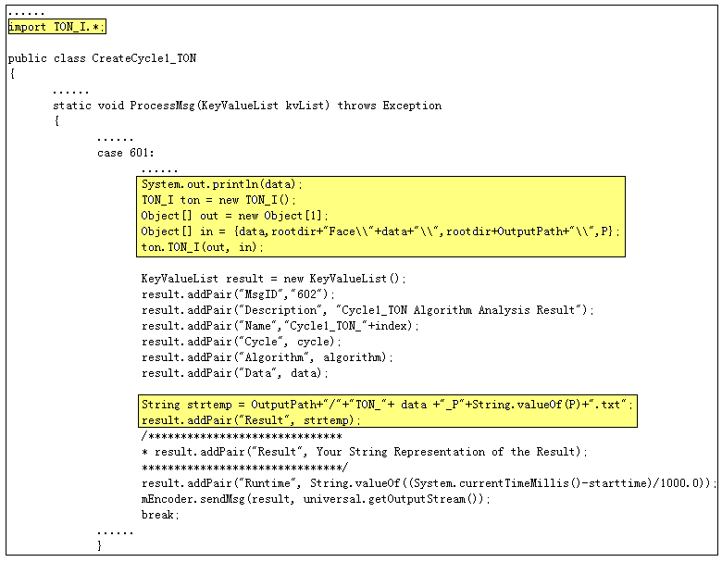
Figure 2.2(b) codes of TON for process message in algorithm
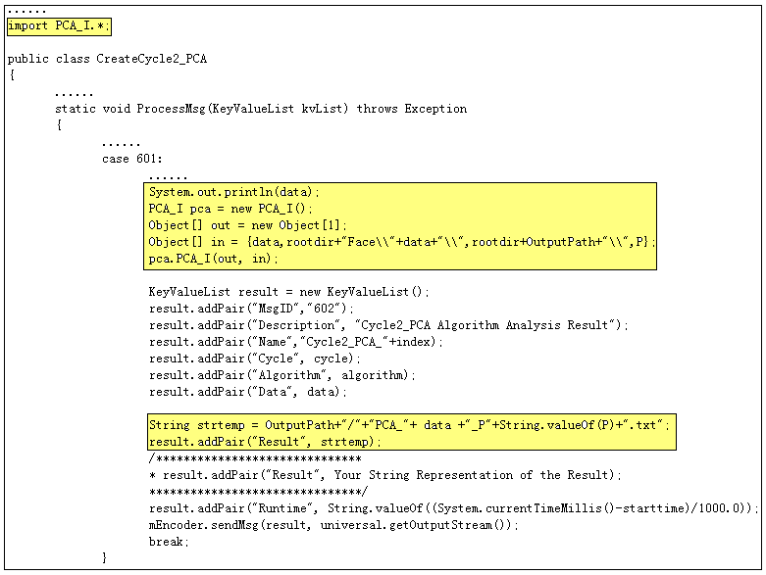
Figure 2.2(c) codes of PCA for process message in algorithm
  - Introduce .jar files for compiling
- Modify file Sisv3n5parallel\Scripts\runEnumerator.bat for right compile as shown in figure 2.3.
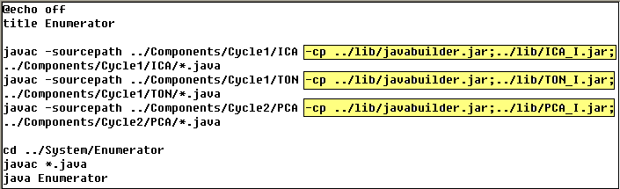
Figure 2.3 Introducing .jar files in runEnumerator.bat
- Modify file Sisv3n5parallel\System\Enumerator\ Enumerator.java for right enumerating components with jar files as shown in figure 2.4.
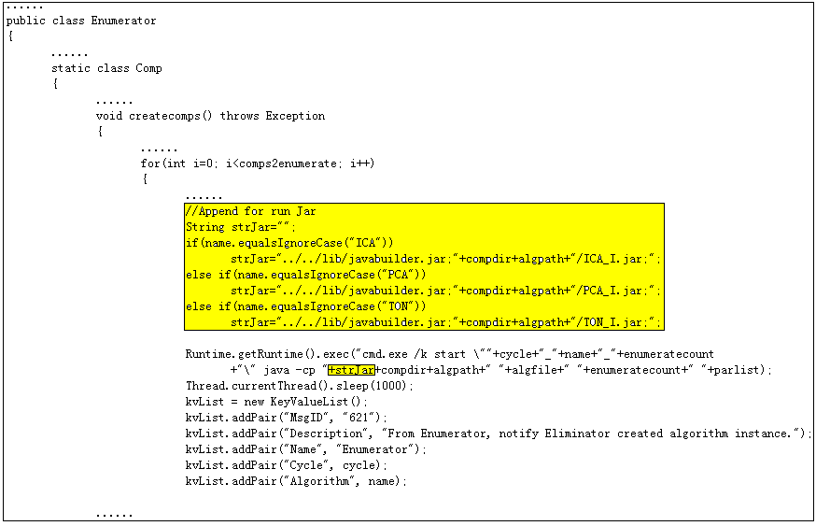
Figure 2.4 Introducing .jar files in Enumerator.java
  - Implementation of verifier
Modify Sisv3n5parallel\System\Verifier\Verifier.java by finishing evaluatePerformance function as shown in figure 2.5.
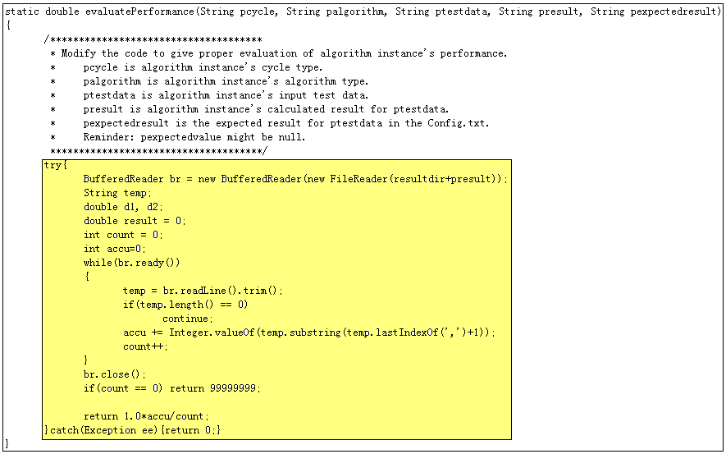
Figure 2.4 Implementation of verifier
  - An optional component, result displayer
Here we provide a visualized component to show facial recognition result, named ResultDisp. This component is not compulsory. Follow the below steps to introduce this component to your face recognition system.
Copy Testbed\sisv3n5parallel\Components\ResultDisp to corresponding folder in your system;
Copy Testbed\sisv3n5parallel\runResultDisp.bat to corresponding folder in your system;
  - Run your project
Follow steps shown as section 1.9. The running results could be browsed from the file, sisv3n5parallel\Data\Result\ EliminatorLog.txt. If you prefer to look result in a visualized method, please start the component ResultDisp by run sisv3n5parallel\Scripts\ runResultDisp.bat. In the end, the ResultDisp is also alive besides SISServer and prjRemote. Again, runTimeController.bat should be started in the last, after all the other 5 scripts started.
  - Trace messages and results
Follow steps shown as section 1.9. In addition, if you start component ResultDisp, you can also browse the result from it, as shown as figure 2.5.
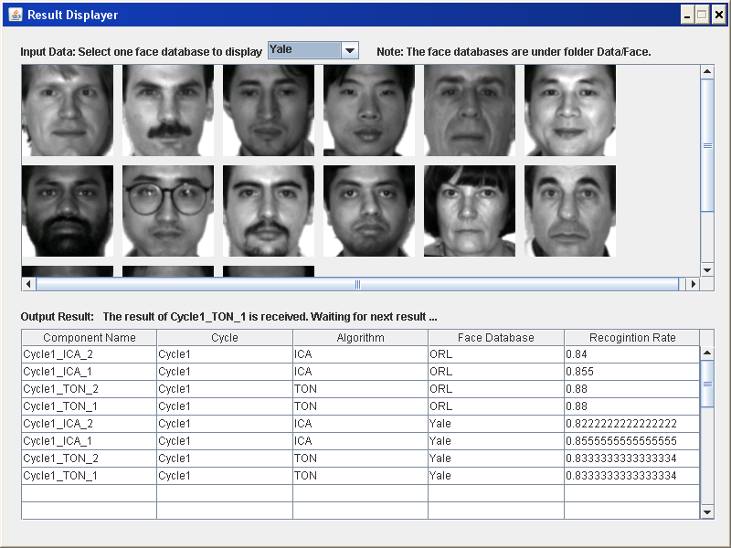
Figure 2.5 screen shot of component ResultDisp
- Adding Another Cycle
  - Create the second cycle
Run Testbed\SISProjectCreator\SISProjectCreator.jar as shown in figure 1. Load your project file Testbed\sisv3n5parallel\ sisv3n5parallel_Spec.PRJ. Click ‘Add Cycle’ button to create another cycle shown as figure 3.1.
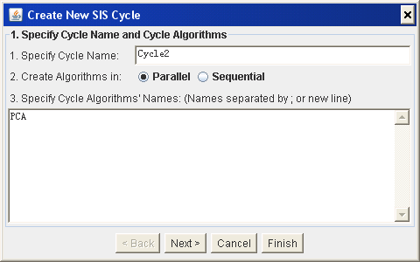
Figure 3.1 Create another cycle
Click Next button to specify cycle algorithm detail shown as figure 3.2. Then click Next button to specify input/output data shown as figure 1.5.
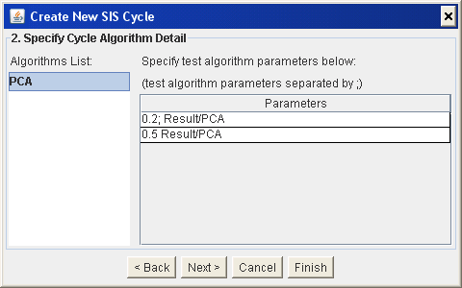
Figure 3.2 specify cycle algorithm detail
  - Define Timer Controller
In this section, we define timer controller rule that control Cycle1 transfer to Cycle2.
Click finish button to define timer controller shown as figure 3.3.
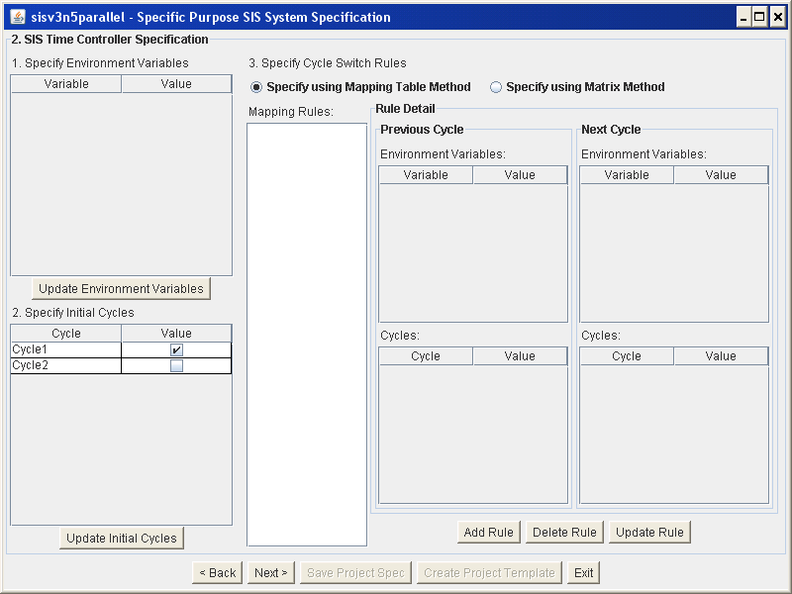
Figure 3.3 timer controller specification
Click Add rule to create a rule for timer controller shown as figure 3.4.
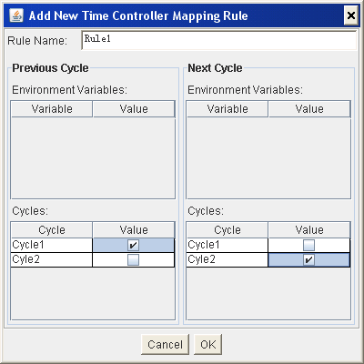
Figure 3.4 create rule for timer controller
Specify cycle1 as initial cycle, shown in figure 3.5.
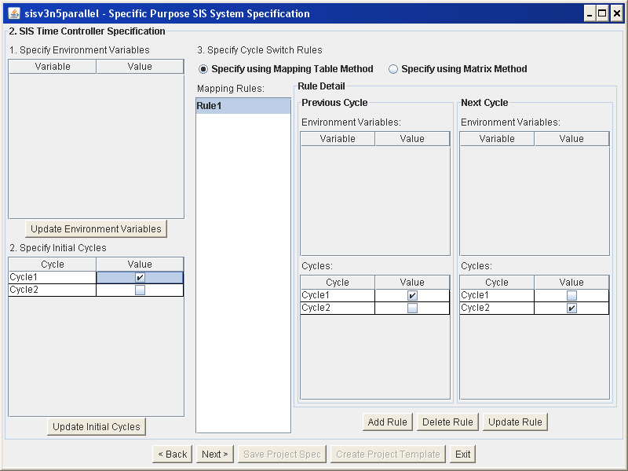
Figure 3.5 an example of timer controller specification
  - Optional operation, Specifying environment variables
In previous section, we specify a rule to transfer Cycle1 to Cycle2. We can also define environment variables to specify whether this rule is effective or not. As we know the variation degree of light, facial expression and face angle is very important to any face recognition method. We may define an environment variable, imageQuality, to control whether the defined rules is applicable to a certain quality images.
Double click the textbox on the top left of interface shown as figure 3.5, a new line will shown and environment variables can be appended now. Then click ‘Update Environment Variables’ button and the defined variables will be displayed on the right, so that you can specify the condition value for each variable. An example of environment variables specification is shown as figure 3.6. In this case, rule1 can be effective because the default value of variable imageQuality is 0.6, which is greater than 0.5, so Cycle1 can transfer to Cycle2. If we change the default value of imageQuality from 0.6 to 0.4, the rule1 will not be effective and Cycle1 will not transfer to Cycle2.
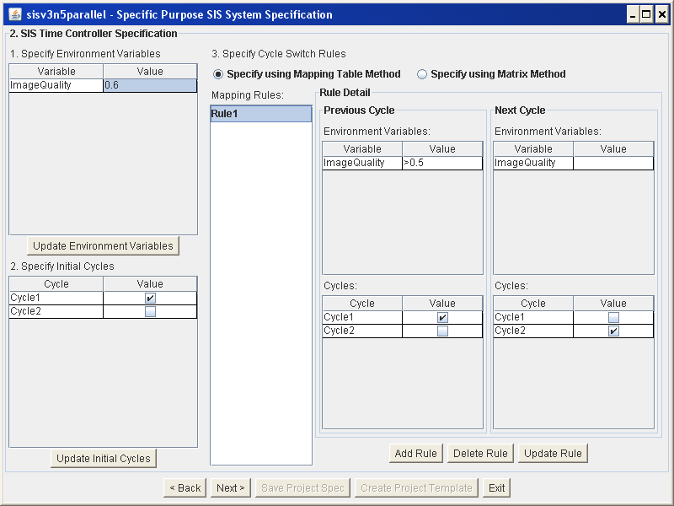
Figure 3.6 an example of environment variables specification
  - Create project template
Look back 1.8
  - System implementation
Follow chapter 2.
  - Run it
Follow chapter 2.8
  - Trace messages and results
Follow chapter 2.9

