Serial SIS system
Test case: Given a sequence of numbers, generate the same amount of following numbers. There are three algorithms S1, S2, S3, each one performs a specific method to generate following numbers.
Algorithm S1: use Fibonacci sequence to generate following numbers
Algorithm S2: use Random method to generate following numbers
Algorithm S3: generate consecutive numbers

Case one: Serial SIS system with one cycle:
There is only one cycle including three algorithms. All of these algorithms have the same input test data and expected results. They are executed in the serial pattern, S2 execute after S1, then S3, that is S1->S2->S3.
Test input data: 0 1 1 2 3 5
(These numbers are part of Fibonacci sequence)
Expected output result: 8 13 21 34 55

Case two: Serial SIS system with two cycles:
There are two cycles in the system. The first cycle is the same as case one. The second cycle includes only algorithm S1. It has the different test data and expected result, which also are parts of Fibonacci sequence. Since S1 is the best selected algorithm in cycle one, the goal in cycle 2 is to test S1 on new data to verify its accuracy. The two cycles are executed in the serial pattern, that is Cycle1->Cycle2.
Test input data: 2 3 5 8 13 21
(These numbers are part of Fibonacci sequence)
Expected output result: 34 55 89 144 233 377

Case one: Serial SIS system with one cycle:
Step 1: Open “SISProjectCreator.jar”, name the project “sisv3n5serial_singlecycle”, and select “Specific purpose SIS system”, click OK.
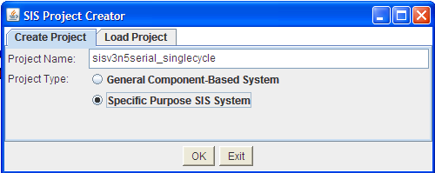
Step 2: Click “Add Cycle”, then edit cycle name, select “sequential” since these three algorithms execute consecutively. Also we need to add three algorithms names as shown below. Then click “next”.
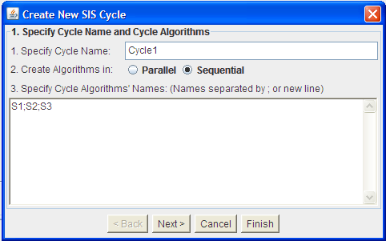
Step 3: Since these three algorithms do not have parameters, thus we do not need to add parameter here. Click “Next”.
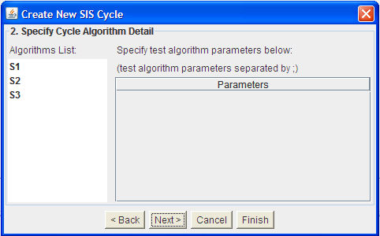
Step 4: Edit the test input data and expected output result for Cycle1. Note that algorithms in the same cycle should have same test data.
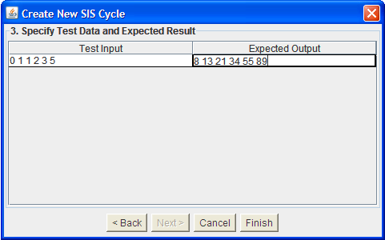
After clicking “Finish”, the interface should be shown like below:
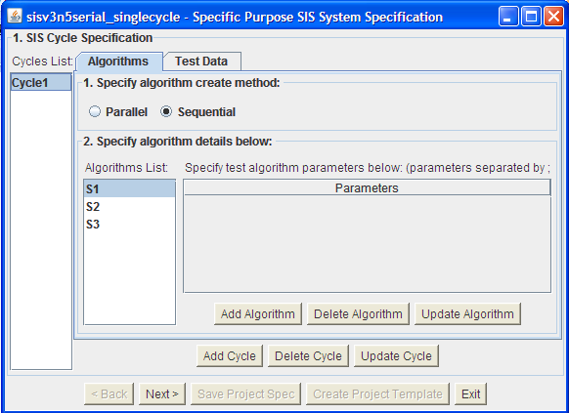
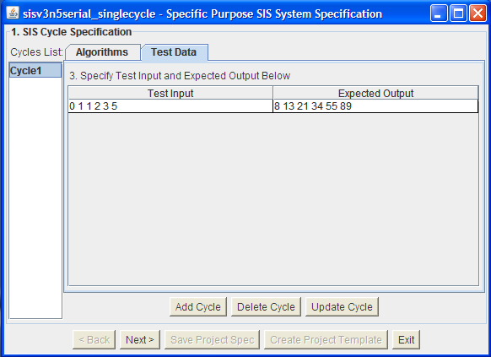
Step 5: Click “Next”, we edit the SIS time controller which controls the sequence of execution of different Cycles. Since in this test case, we only have one cycle, thus, we need to specify initial cycle be “Cycle 1” by checking that box. We don’t need to edit any rules.
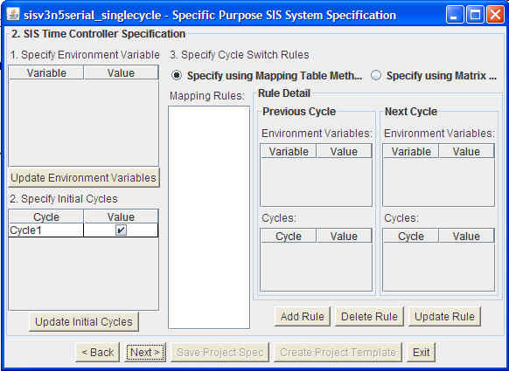
Step 6: Specify other configuration parameters in SIS system, in this example, we use default value. Finally click “Create Project Template”.
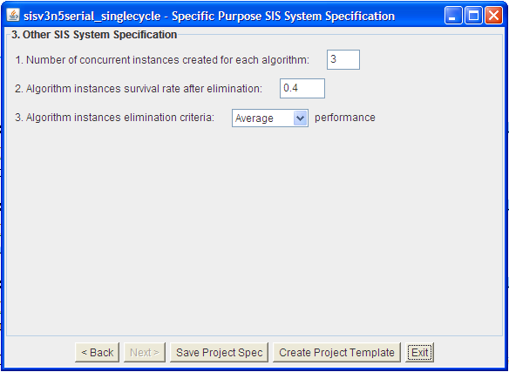
After creating the project template, the folder should be like:
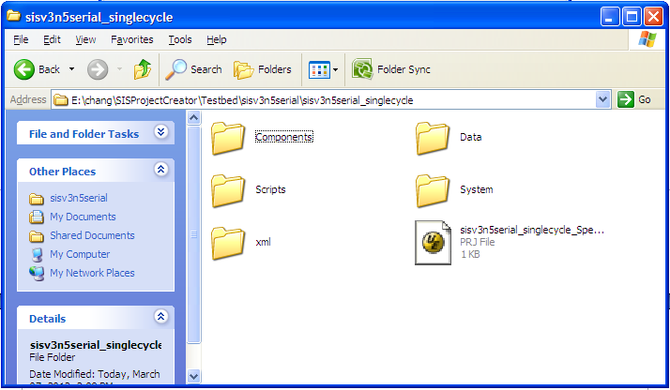
Step 7: we should add some code in “CreateCycle1_S1.java”, which is located in directory “sisv3n5serial_singlecycle\Components\Cycle1\S1”.
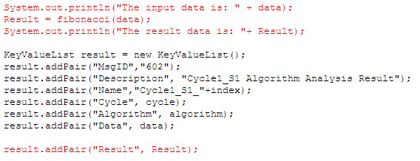
The main part of Fibonacci sequence generator is:
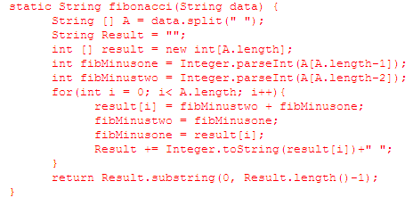
The way of editing “CreateCycle1_S2.java”,”CreateCycle1_S3.java” is similar to “CreateCycle1_S1.java”. The difference is the sequence generator method.
Step 8: We should also add some code in “Verifier.java”, which is located in directory “sisv3n5serial_singlecycle\System\Verifier”.
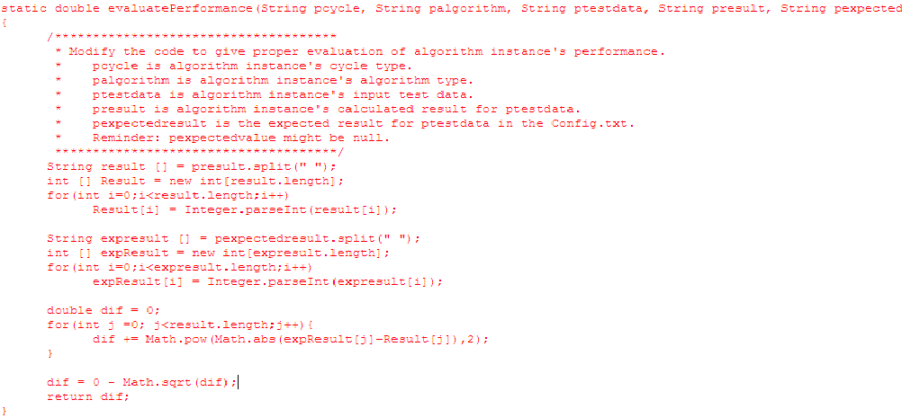
Step 9: Run SIS system to test the experiment.
- Click “runSISServer.bat”.
- Click “prjRemote.jar”.
- Load “sisv3n5serial_singlecycle\xml\InitXML\ list_InitXML.txt”, and send.
- Run datasender, eliminator, enumerator, Verifier and Time controller in “sisv3n5serial_singlecycle\Scripts”. Note that Time controller should run at last.

Step 10: The Screenshot is shown below:

Cycle1_S1 output messages:

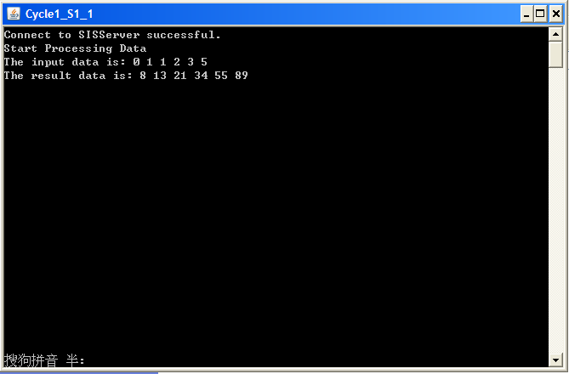

Cycle1_S2 output messages:
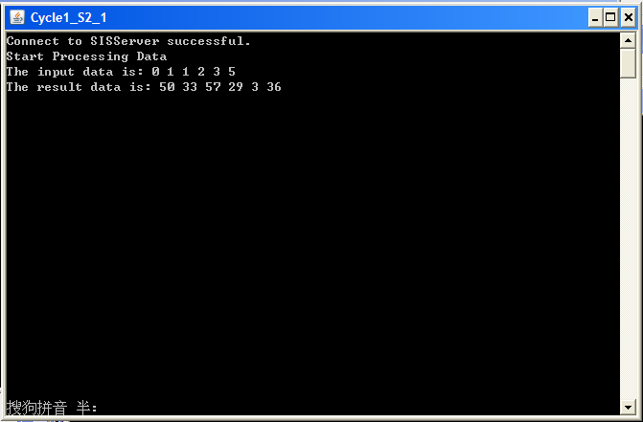

Cycle1_S3 output messages:
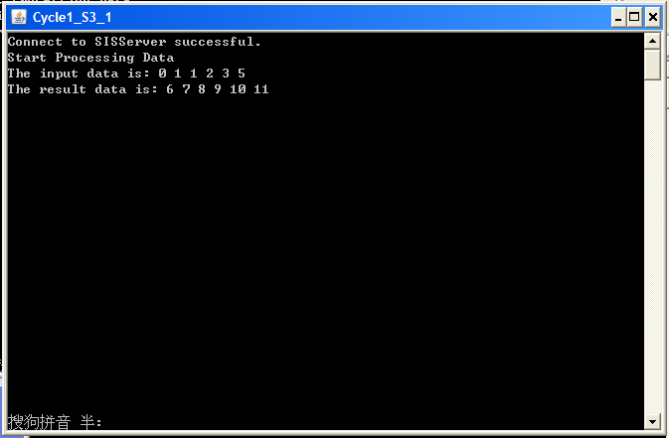

Also you can view the messages communicated on SIS systems in prjRemote screen:
Output result for algorithm Cycle1_S1:
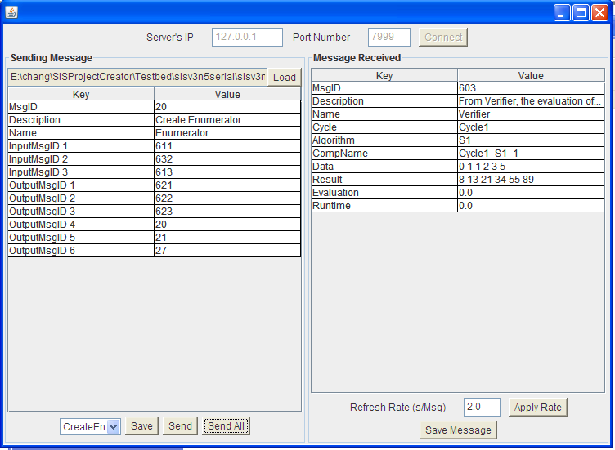
Output result for algorithm Cycle1_S2:
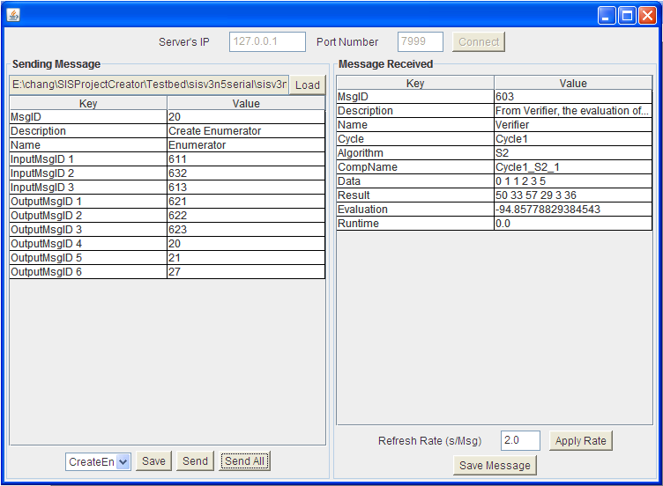

Output result for algorithm Cycle1_S3:
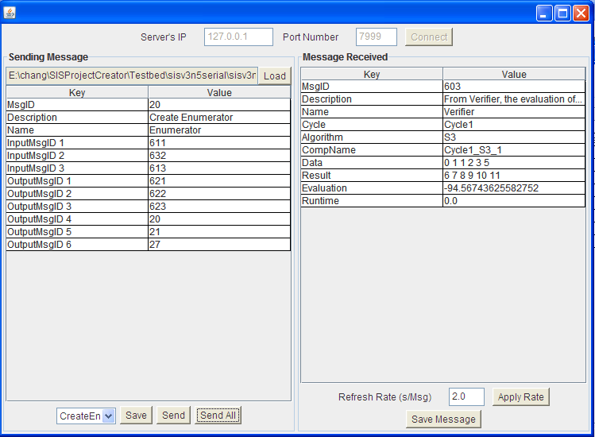

Step 11: Result is also shown in “\sisv3n5serial_singlecycle\Data\Result\ EliminatorLog.txt”.

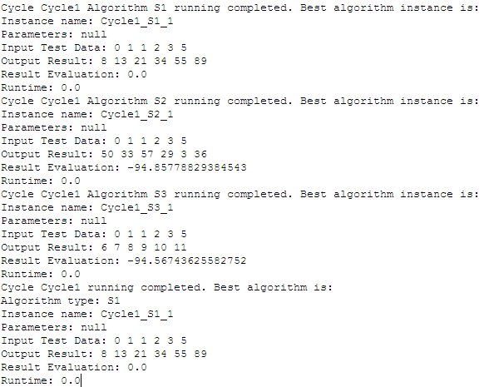

From the result, we can see that S1 is the best algorithm to generate the sequence of numbers since the test data and expected result are part of Fibonacci sequence.

Case two: Serial SIS system with multiple cycles:
Step 1: Open “SISProjectCreator.jar”, name the project “sisv3n5serial_multicycles”, and select “Specific purpose SIS system”, click OK.
Step 2-4: Similar to step2-4 above in case one.
Step 5: Add Cycle2, which contains only one algorithm S1, and the test data is 2 3 5 8 13 21, expected result is 34 55 89 144 233 377.
The interface should be shown like this:
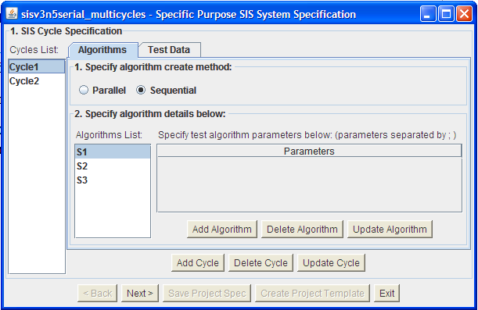
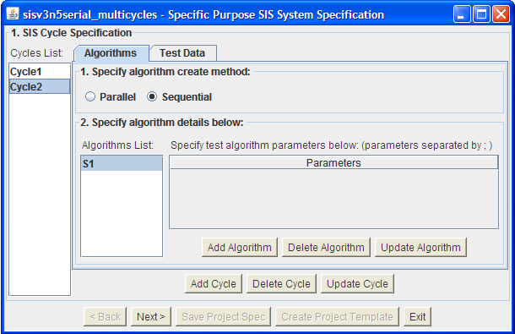
Step 6: Click “Next”, we edit the SIS time controller which controls the sequence of execution of different Cycles. Since the two cycles are executed consecutively, thus we build two rules. Click ”Add Rule”, edit rule1and rule 2 as:
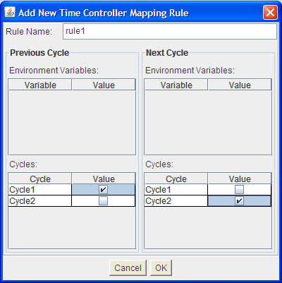
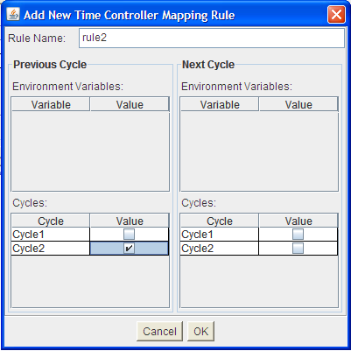
The interface should be shown like:
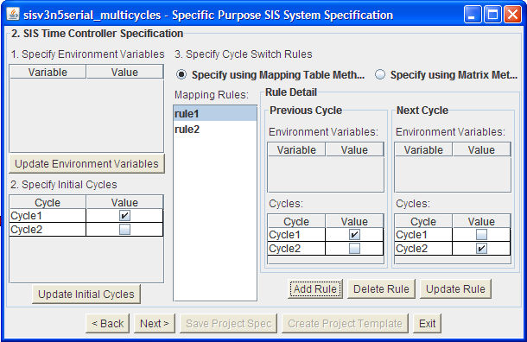
Step 7: similar to step 6 in case one.
Step 8: Edit component code, similar to step 7 in case one. We also need to edit “CreateCycle2_S1.java” in directory “sisv3n5serial_multicycles\Components\Cycle2\S1”. It is the same as “CreateCycle1_S1.java”.
Step 9: similar to step 8 in case one.
Step 10: Run the experiment, similar to step 9 in case one.
Step 11: The Screenshot is shown below:
The output messages of Cycle1_S1, Cycle1_S2, Cycle1_S3 are similar in case one.
Screenshot of output messages of Cycle2_S1:
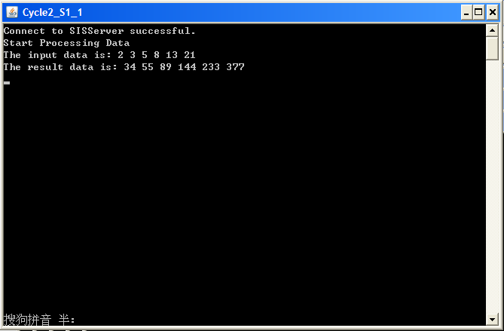
Also the output results shown in prjRemote for algorithms Cycle1_S1, Cycle1_S2, Cycle1_S3 are similar in case one.
Screenshot of output result shown in prjRemote of Cycle2_S1:
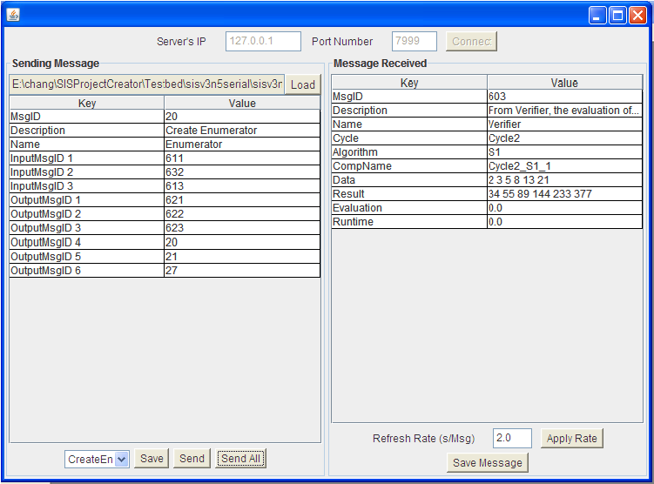
Step 12: The result is also shown in “\sisv3n5serial_multicycles\Data\Result\ EliminatorLog.txt”.
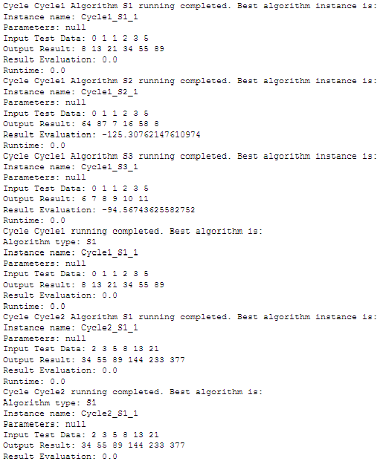
From the above results, we can see that S1 is the best algorithm selected in cycle 1. In Cycle2 with different new test data and expected result, S1 is proved to be the perfect algorithm to generate the Fibonacci sequence of numbers.

