1) Does Integer class parseInt() have a checked or unchecked exception? Why?

1A) Integer.parseInt() has an unchecked exception because it throws a NumberFormatException, which itself extends RuntimeException. RuntimeExceptions are not enforced by the compiler, which means you do not have to have a try-catch statement or throws clause in the method header.

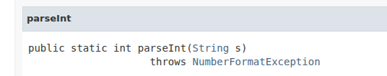

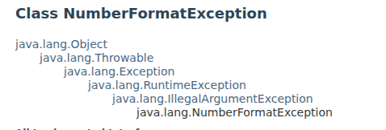

2) Does Scanner class constructor, public Scanner(File source) have a checked or unchecked

exception? Why?

2A) The constructor, Scanner(File source), has a checked exception because it throws a FileNotFoundException, which itself extends IOException. IOExceptions are enforced by the compiler, which means you must handle the exception somewhere in your code before your code can compile.

