

]

Tdytdrhtdrh

Dtf
H

F
Hd
Ft
Hfd
Th
Fd
Hdf
Th
Dfh
F
h

ftyufuftyu
r
Local AI Engine Lab
Cisco Certified Networking Program

By Joshua Santjer

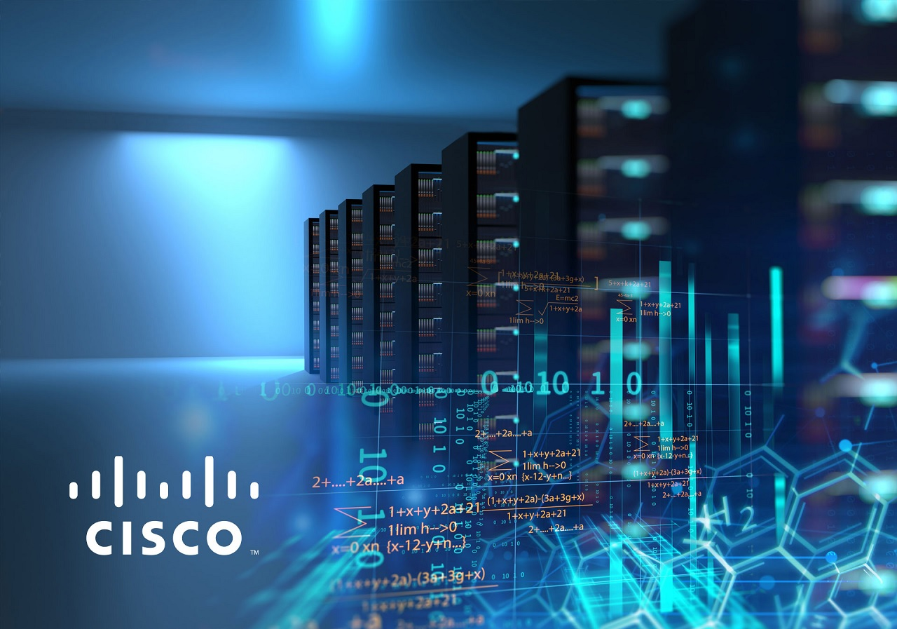

Purpose
The Purpose of this lab was to run a local AI engine utilizing the software Docker to virtually run it on the machine and open it using an open-source
Background
Artificial Intelligence has become a very important technology across many different industries due to its many use cases. AI systems use large language models (LLMs), which are trained on large sets of data to understand and generate human sounding text. Usually, these models are accessed through cloud-based services, where the models are hosted on a remote server. However, there can be issues with privacy and security with these methods as that data is stored by whatever company or group hosts the servers, as well as the fact that the data moves over the internet, which can be stolen. Therefore, there is a rising amount of interest into running AI models on local machines to alleviate these issues.
Running a model locally requires software that can manage the model, and isolate the system. Docker is the software that was chosen for its ability to run applications in self-contained environments, which are called containers. These containers are separated from the host operating system, as well as being very lightweight, allowing many containers to be run simultaneously, and on a virtual machine.
The model that was actually run was a model created from Ollama, an open-source platform that was designed to run LLMs locally. It gives pre-configured models released by Meta AI. These can range in size from 1 billion to 2 trillion parameters. Initially, these models were only available to researchers, but now they can be downloaded and run without requiring large amounts of setup. Ollama integrates with Docker to allow users to pull AI models into containers and run them locally. By running the models through Ollama and Docker, users can have full control over their data and avoid sending the data through external servers.
To interact with the model in a user-friendly way, a user interface is needed. OpenWebUI is an open-source web interface that can connect to a local AI engine and provide a user interface similar to what other AI models have. OpenWebUI allows users to send in prompts and receive responses from the AI model through a browser. This makes it easier for a typical user to be able to get the benefits of a local AI model, like its added security and choice of model, without having to go through a complicated process to access it.
Lab Summary
In this lab we ran an AI model locally by using the software Docker to create a virtual container, pulling an AI model from Ollama, and used OpenWebUI to give an interface to use the AI. After downloading Docker and installing it, we created a virtual container to run the AI model from Ollama. We set up the AI model using the command prompt, and used the UI to access the AI model from the web, allowing us to access it from our mobile devices.
Lab Commands:
docker run –d –gpus=all -v ollama:/root/.ollama -p 11434:11434 –name ollama ollama/ollama
This command starts a new docker container and runs it with the name ollama with the port number 11434
docker exec -it ollama ollama run llama3:
This command tells the container where and what you want to run which in this case is the llama3 model
Configs
Download Docker from its website
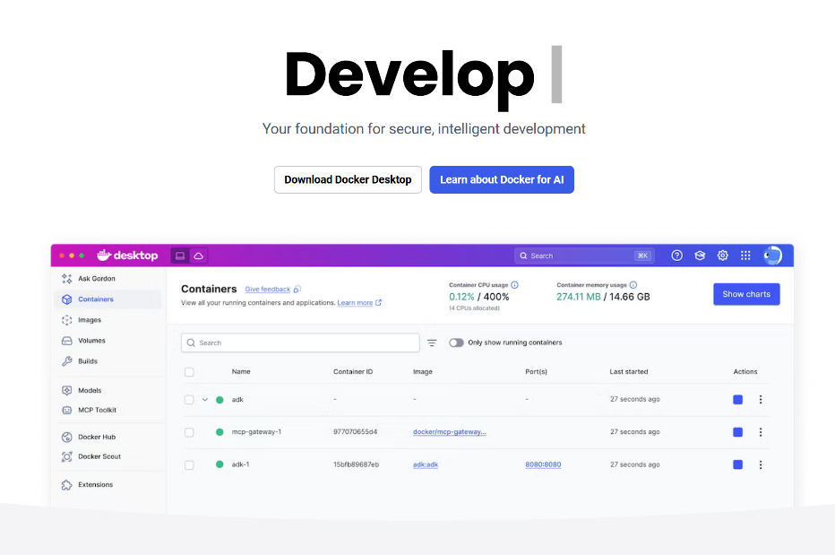

Open and hit OK to the configuration menu

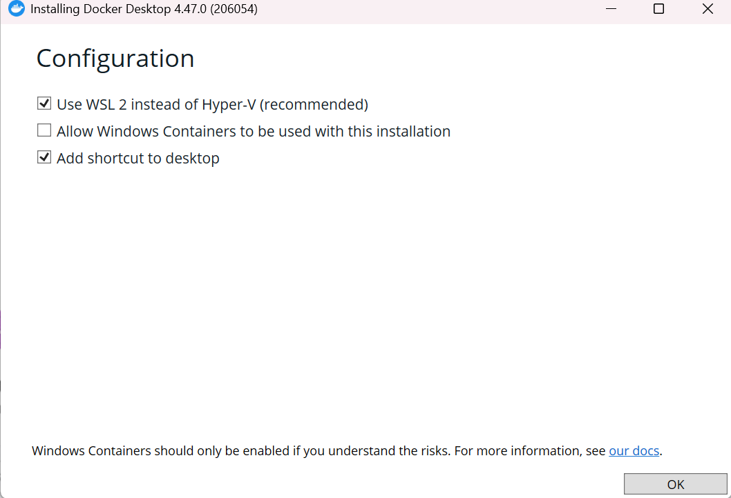

Click Restart once it opens
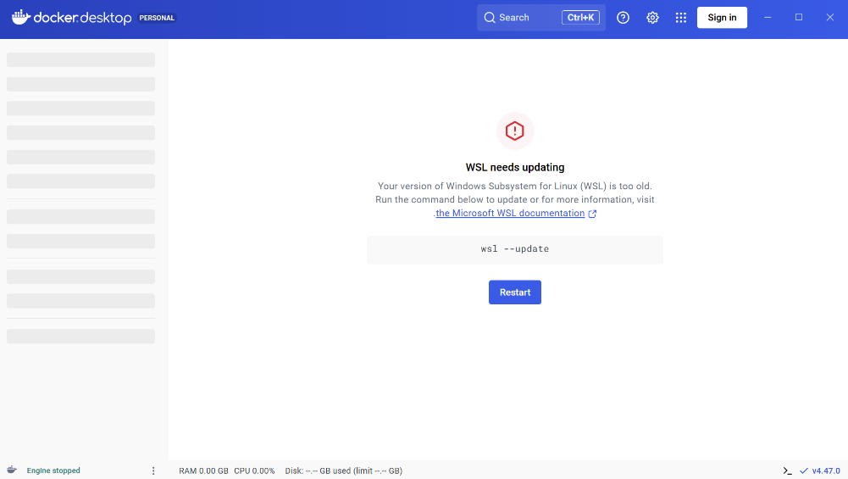
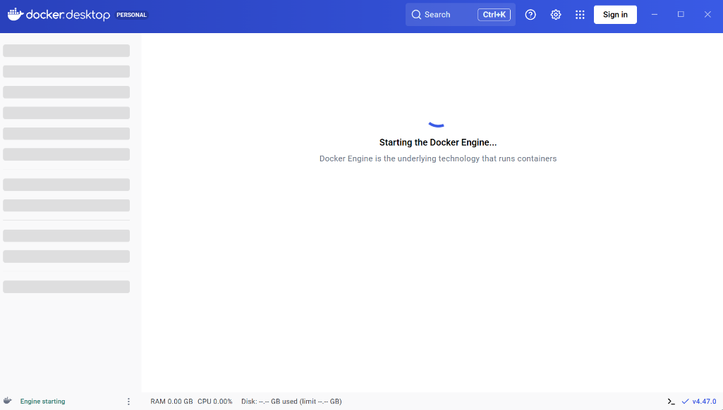
Wait for the Docker Engine to start up

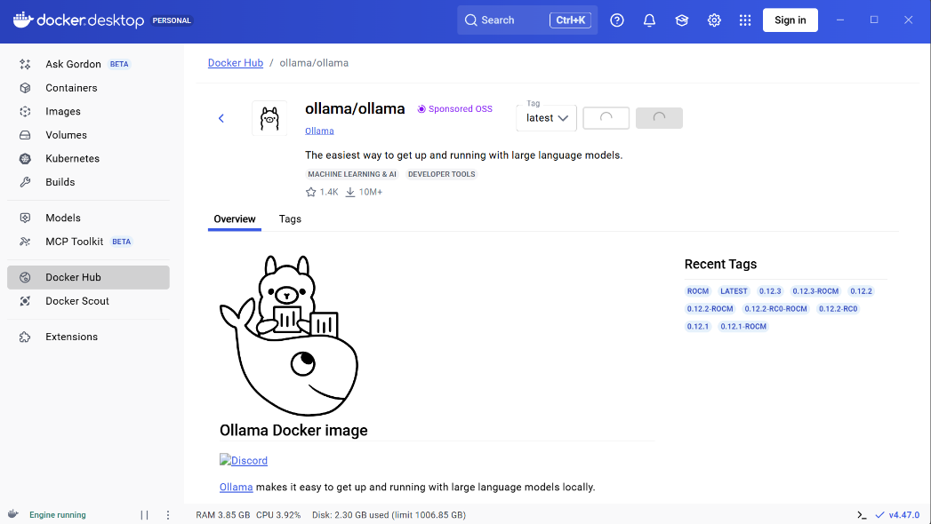
Go to the Docker Hub, search Ollama, and select “Pull”

Use the “docker run –d –gpus=all -v ollama:/root/.ollama -p 11434:11434 –name ollama ollama/ollama” command, and then enter the command “docker exec -it ollama ollama run llama3” command to run the Ollama AI mode
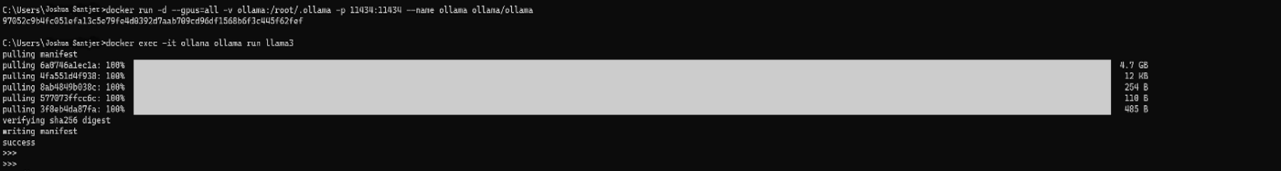

Find an open-source UI template (we used OpenWebUI) and enter the run command for it, and wait for the resources to be pulled
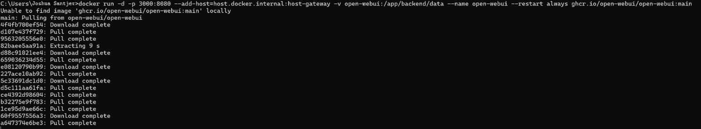

Navigate to the containers tab and it should now show the UI template with the AI model in the list. Click the port number, and a tab will open in your browser

In the new tab, you will now see a text box to utilize the AI model now running locally with the UI
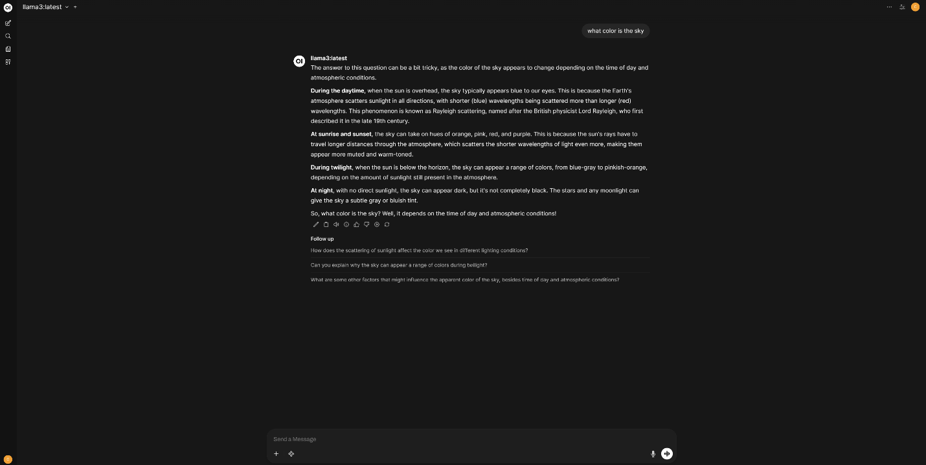

Problems
We ran into one main problem during the completion of this lab. The problem we had was finding and entering the correct commands. When we initially loaded Docker and found the command interface, we weren’t sure what we were supposed to do next. We knew we had to enter some command to connect Docker to the AI engine we had pulled, but we weren’t sure what it was. So we watched several videos on setting up AI models using Docker, and got several different results, none of which ended up working. We decided to go to the Ollama website, and found that under the download button, there were commands that were meant to be entered in the interface. Using these commands, we were finally able to get the AI model loaded into the Docker Container.
Conclusion:
In conclusion, this lab was useful because we learned how to use Docker software by pulling an AI model using Ollama and running it using an open-source UI template. We were able to access it wirelessly from mobile devices, and since it is run locally, this means that the AI model is private, and all the data remains only on our local machine.

